n | Insertion (seconds) | Merge (seconds) | Quick (seconds)
50,000 | 0.7658 | 0.0068 | 0.0038
500,000 | 77.574 | 0.0792 | 0.0439
5,000,000 | na | 0.8498 | 0.5096

Time Complexities:
Insertion sort: O(n²)
Merge sort: O(n)
Quick sort: O(nLogn)

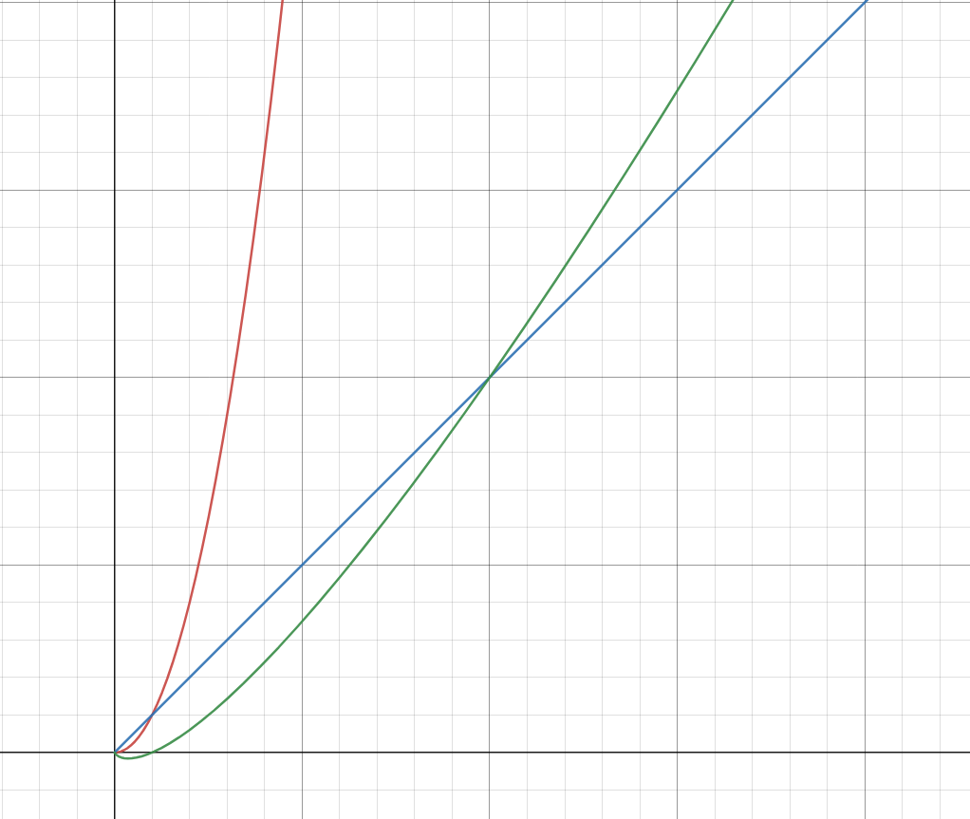Figure 1

