Meta Description:
Stretch your body completely to warm up your voice. Aside from planting your feet shoulder-width apart, you can also lean to one side to perform side stretches.
Humming in all pitch ranges from the highest to the lowest, take a deep breath.

7 Best Warm Up Vocal Exercises For Voice Actors

Voice actors need a lot of practice in order to improve their skills. They need to be flexible and versatile with their voices. Voices must be trained and practiced.If you haven't mastered your voice skills, don't rush into sending demos. To prepare for an audition, you will need a high level of training.

The benefit of voice exercises is that they enhance your voice and your confidence, which is crucial for auditioning successfully. You can customize your voice exercises based on the role you're auditioning for. To be a successful voice actor, you have to read the copy in a manner that makes sense for the voice acting you are doing.

Voice actors must fit the character they portray for the words to flow naturally. It is difficult to avoid sounding like you have a paper in front of you, and it takes a lot of practice and vocal exercises to do this well. Excellent voice actors can assume new roles rapidly and provide voices even without any previous experience by practicing vocal cord exercises.

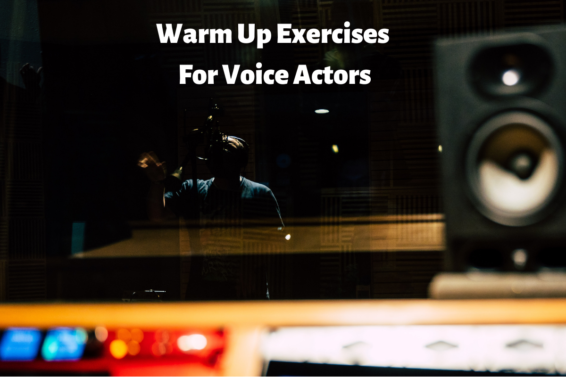7 best warm up vocal exercises for voice actors

Vocal Exercises: Why They Are Important
How do you warm up your voice and prepare for the day? Which are your favorite word or words in your vocabulary? What are some "articulations" you find compelling (pardon the pun!)?

Having toned vocal folds makes it easier for you to sing or do voice acting. It is important to perform vocal exercises in advance of an extended vocal session to minimize your chances of injury.

You will undoubtedly produce a stressed and tense sound if you feel tense before getting behind the mic. Then your vocal performances will reflect that state if you feel relaxed, limber, and physically prepared when you enter the booth.
Following are some vocal exercises to level up your voice acting skills and fit into any role you want to do.

Stretch Your Body
Raising your arms to the sky and breathing deeply is all you need. Lean-to the left while exhaling and lengthening your side body. Then inhale to the center and exhale to the right." Hold the breath for a few seconds and then inhale to the center."

Step two is to place your feet hip-width apart. Bend your waist and extend your arms to the sky as you slowly exhale. Then, as you inhale, extend your hands towards the ground. The simple act of bending over will stretch you nice and warm no matter how far you can go! On an inhalation, slowly raise yourself into a standing position. Take a few deep breaths while holding the position.

Breathing Exercises
It would help if you warmed up with some breathing exercises in addition to your body stretches. By doing breathing exercises before a big recording, you can relax your vocal folds and increase your range.
You might want to include the following breathing exercises in your warm-up:

The Straw Trick
Humming or exhaling with a straw in your mouth is appropriate for using it. While holding your face and body still, your lips will automatically close around the straw so that your attention can be concentrated on breathing.
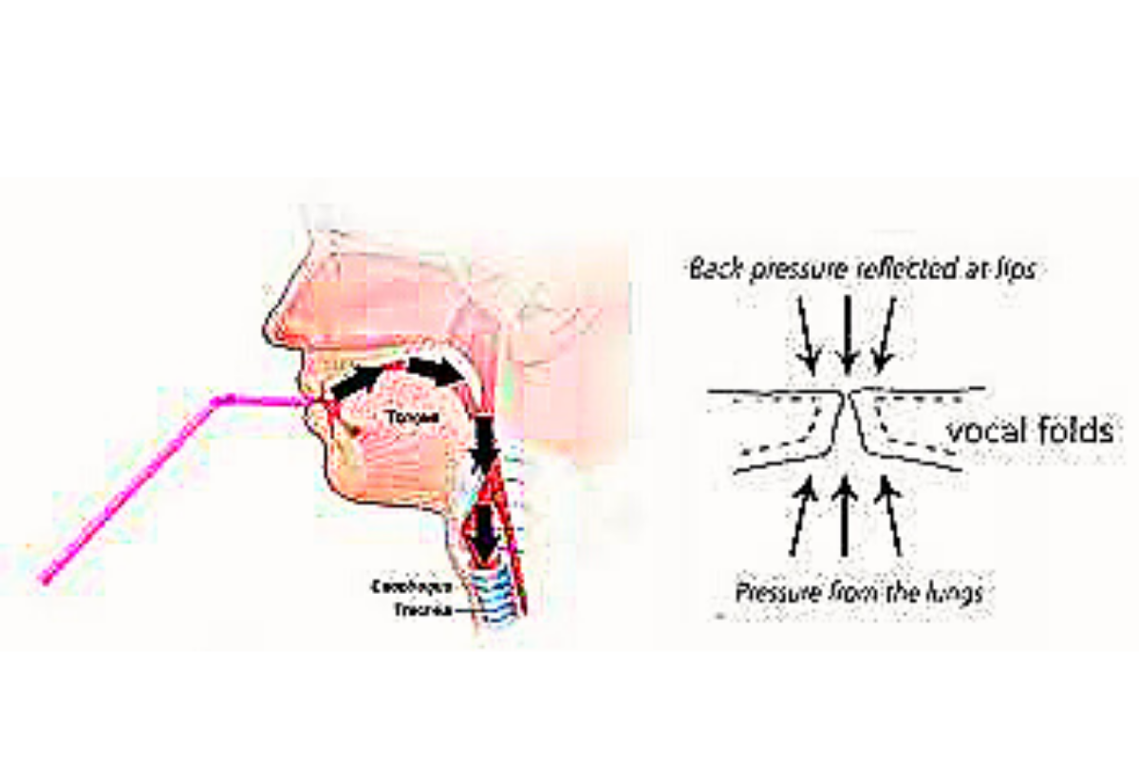
7 best warm up vocal exercises for voice actors

Lay on the Floor

How about laying on your back on the ground and singing a vocal piece? Try to concentrate on feeling your diaphragm move as your hands rest on your stomach. With practice, you'll adapt to it, even though it might seem strange at first. Concentration is improved by focusing on your breath.

The Hissing Exhale
You may wish to incorporate this breathing exercise into your vocal warm-up. As you breathe in, start by producing an "sss" hissing sound, then exhale for a time you feel comfortable. Rethink how long you will inhale and hiss each time, hoping to go longer and longer until you run out of breath.

Humming and Lip Trills
Creating a space for your voice to resonate requires that you modulate a soft and loose hum. After sleeping several hours,voice practice exercises, hunch and trill your lips to reawaken your resonators, restoring the quality of your voice. This is an excellent practice for you to begin your day with.

In addition to loosening your facial muscles and warming your vocal cords, lips fluttering and trills will also loosen your lips. In the shower, you'll benefit even more!

Descending on Nasal Consonants
In addition to making nasal consonant sounds, singers and voice actors should also be able to open their nasal passageways. The International Phonetic Alphabet (IPA) student or fan of IPA and voices city will probably be aware that there are several methods for warming up sinuses and nasal passages.

Its second syllable yields the "gn" sound, as is the case for the English word "onion." What would it sound like if you could stretch, slide, and descend GN glissando-style?

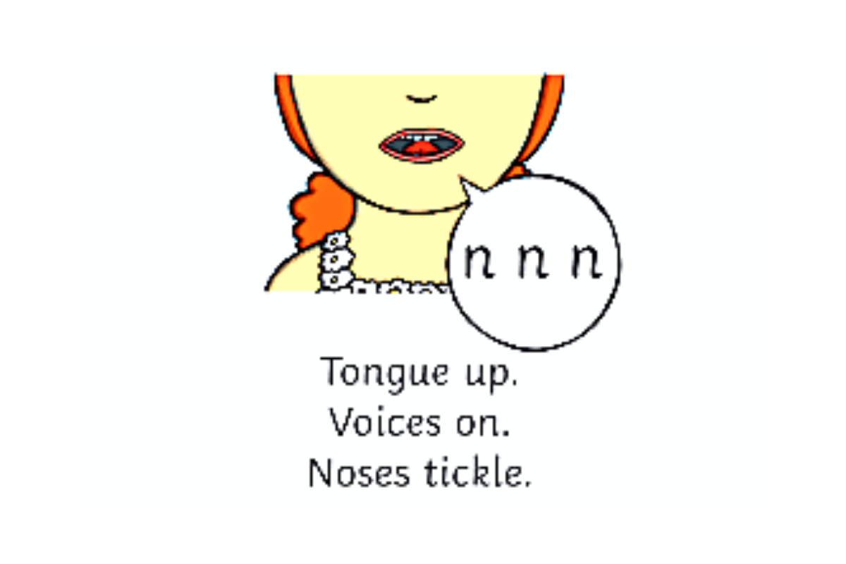7 best warm up vocal exercises for voice actors

Go from the fifth to the root with an "ah" sound on that scale. Use the Z to get the resonance going on other words that end in a Z, such as 'buzz' or 'fuzz.' Other vocal practices can be performed with such words.

Fricatives
An airflow is impeded to produce a consonant sound when friction occurs. You can learn how to produce fricatives from vocal coaches.Most commonly, Fs, Ths, and Vs. are consonants.

Tongue Twisters

Clarity of pronunciation is key to voice-over performance. Nobody will understand what you are saying if you do not articulate or enunciate clearly.

Yawn
After you have warmed up your articulators and resonators, let's talk range.
Your soft palate is extended when you yawn, lowering your jaw and regulating oxygen.

Freeman recommends yawning a lot to improve your voice. When you yawn, your throat muscles relax. Vocal cords are relaxed as well by practicing this voice exercises. The tone drops as soon as your vocal cords relax. You sound better with a lower voice."

In addition to feeling more alert, you will also have more oxygen flowing into your brain.

Yawn-Sigh: How to Do It
You can add a yawn-sigh to your toolbox of vocal warm-ups by learning how to do it properly.

- Step 1: Yawning with your mouth open.
- Step 2: start at the top of your vocal range and slide down until you are grumbling at your lowest.
- Step 3: As soon as you reach the bottom, you will know you've reached your lowest point.

When you warm up your voice, you should only repeat the exercise a few times. The ideal situation is not to start on this one but rather to wait until you have already demonstrated your voice before moving on to this one.

Vocal Warm-Up in 5 Minutes
The muscles supporting your voice work in much the same way as your other body parts. Your tongue and diaphragm, as well as your facial muscles. Muscles need to remain toned and limber for anyone who uses their voice professionally.
Keeping that support system in shape doesn't just consist of talking. You have to do vocal exercises it as well. It would be best to exercise your articulation muscles every day to maintain and improve your voice by doing voice exercises.

7 best warm up vocal exercises for voice actors

Mouth, Tongue, and Lip Stretches
Practice this voice exercise for approximately one minute:
- Take a few seconds to grunt your teeth, then purse your lips with all your strength. Then quickly stick your tongue out a few times after doing this back and forth. Stretch it out as much as possible. Do this by touching your tongue to the back of your upper teeth. Count to five.

- Watch your mouth as you say the word "wow." How do you position your lips? When you begin the word, do you purse your lips, and do they open when you finish the word? By this point, you will be able to feel the facial muscles around and in your mouth comfortably. Exaggerate the positions while reciting the words "wow."

Using the obstruction drill to improve your articulation
Practice this voice exercise for approximately 2 minutes:
- Ensure you have some copy and obstruction on hand to hold your mouth open. A bottle cap would work best. It would help if you stood or sat straight.

- Readout loud as clearly as possible with the obstruction placed between your front teeth. The result will be overcompensation on the part of your muscles. Continue reading for about two minutes.

- Read the paragraph again when the obstruction in your mouth is removed. Your words should now sound effortless.

Plosives: A Guide to Mastery
For approximately 2 minutes:
- You would normally place your microphone just above your mouth, with your palm just a few inches. After saying this, you'll likely experience a rush of air when saying, "Pam's preppy pal Peter." You'll hear a popping sound through your mic due to this voice exercises.

- Until no air comes from your mouth when you say "Pam's preppy pal Peter," practice saying, "Pam's preppy pal Peter." You will soon become used to it, even during your day-to-day conversations. Practice this vocal exercise for about two minutes each day, and you will soon be free from plosives.

Conclusion:
In order to become a better actor, one must prepare their voice for the part. It is important to increase the strength and quality of your voice. They will be able to avoid strain or hoarseness after a long day of voice-overs, which will allow them to be more productive the next day.

You know how hoarse you feel after spending a long day talking, so when your job depends on it, try to keep it away from your mouth. Taking good care of your voice can prevent hoarseness as well as enhance it. In addition to preventing injury, all of the above mentioned voice exercises help you increase the variety of your voice.

