# **Meta Description**

Find out who the famous British voice actors are! If you like your voice to sound like something different from the usual, you're in the right place!

# **Top 10 Famous Voice Actors in the UK**

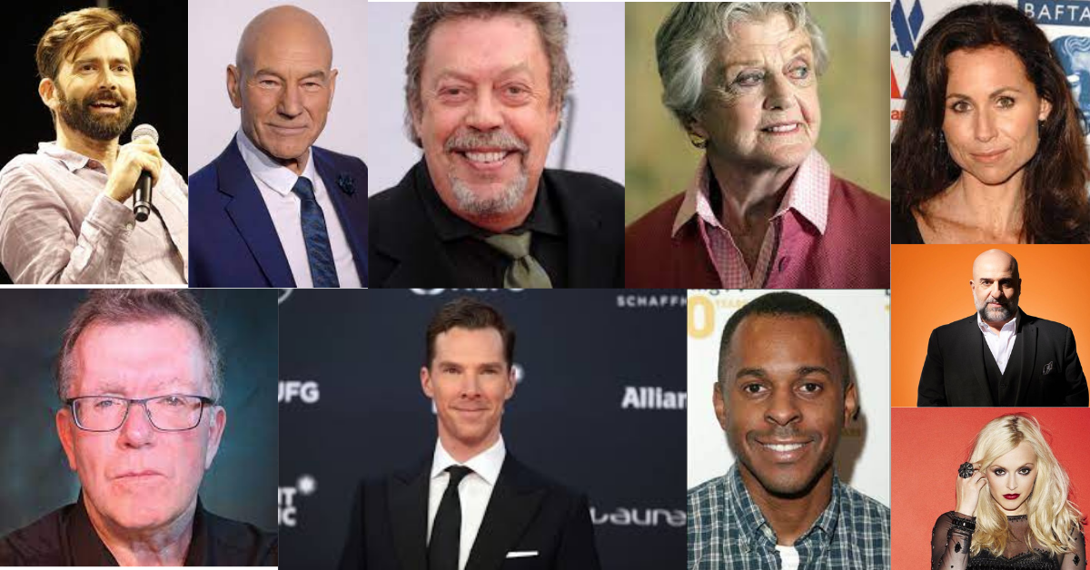

The UK is home to some of the most talented and **versatile voice actors** in the world. We have voice actors who can do everything from providing voices for animated characters and characters in video games, to providing voices for TV commercials and audiobooks. So whether you're looking for a voice that fits perfectly into your brand or a voice that will help you tell your story, we are sure to have a British voice actor that will suit your needs.

The **British voiceover** industry is a thriving one, with top stars earning thousands of pounds per film. Some of the most successful British voiceover actors include David Tennant, Sir Patrick, Tim Curry, Angela Lansbury, and many more.

Voice acting is a booming industry that is growing more and more popular each day. If you're looking for a new career, [voices city](https://voicescity.com/)will help you understand the industry and the different ways you can get involved.

**Top 10 Best Voice-Over Actors in the UK according to their net worth.**

1. **David Tennant With a Worth of $7 Million**

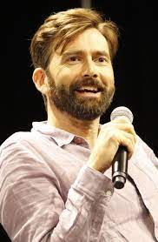

David Tennant is an **English actor** who is best known for his roles as the Tenth Doctor in the BBC television series Doctor Who, and the companion characters Jack Harkness and Harry Potter.

He got his first break playing the role of the young Scrooge in a stage production of A Christmas Carol. After that, he was cast as the lead in a TV adaptation of the same play, which aired on BBC in Scotland. He has since gone on to appear in other TV series, including The Inbetweeners, Casualty, and The Great British Bake Off.

His career has spanned four decades, and he has earned numerous accolades. He is currently starring in the BBC's Sherlock, a series based on the best-selling books by Sir Arthur Conan Doyle. He will also star in the sequel to the blockbuster movie Doctor Who, entitled "The Eleventh Hour."In addition to his work on the screen, he is a prolific **theatre actor**, having performed on stage in several shows.

### Sir Patrick Stewart OBE With a Worth of $70 million

### 

The best-known British actor is Patrick Stewart. He is famous for his roles in Star Trek and Star Wars as well as in other sci-fi films. He was also the narrator of the popular cartoon series Ted. He's also been the voice of Avery Bullock in American Dad!

 Another notable voice acting role includes the voice of the Magic Mirror in Disneyland’s live show, Snow White – An Enchanting Musical. He also has roles in Jimmy Neutron: Boy Genius, The Pagemaster, The Prince of Egypt, and Chicken Little. Stewart has been a part of some of the greatest animated shows of all time, including Family Guy and the Simpsons. In 2019, there was an announcement of his return to the Star Trek series in his role as Picard.

### 3. Tim Curry's With a Worth of $14 million

### 

Tim Curry has voiced characters such as the title character in the popular "Pinky and Perky" children's book series, Emperor Palpatine in the Star Wars prequels, and he has also done voices for a number of television programs including the Emmy-award winning series, "The Simpsons." In addition to his acting career, Curry has been a **professional voice actor** since 1983 and has worked on more than 500 productions.

Tim's animated series, the show that started it all, was "The Real Ghostbusters". He's been seen on dozens of other shows including: "A Pup Named Scooby-Doo", "The Real Adventures of Jonny Quest" and "The New Adventures of Ocean Girl." He also voiced the title character in the PBS animated series, "Pinky and the Brain".

The story of how Tim Curry got the role in the Rocky Horror Picture Show should inspire all of us to take risks and seize opportunities.

### 4. Angela Lansbury's With a Worth of $70 million

### 

Angela Lansbury is an actress who has been acting for more than 60 years. She is known for her roles on stage and on television. She was born in 1922 in London, England. Her father was a music teacher. She began her career at age 14, playing a young boy in a touring production of The Boyfriend.

She is currently starring as Aunt Vivienne in the upcoming movie The Secret Life of Pets. Angela is a gifted singer/songwriter who has written many songs for herself and others. Her most recent album is called "Ain't No Way Out. She has been featured in TV commercials for MasterCard, and the Beatrix Potter Company.

### 5. Minnie Driver's With a Worth of $14 million

### 

Minnie has a beautiful voice and an incredible ability to transform herself into any character. She is also very talented at singing. I would love to see her sing on Broadway someday!

Her first major role was in the Disney movie Bigger Longer & Uncut, which was released in 1999. In that movie, she played the daughter of a billionaire who was kidnapped by a group of terrorists. She spent time with them and ended up becoming their leader.

**Voice acting** is a tough business to break into. But if you want to succeed in this field, it is important to invest in training and learn as much as you can about the business side of voice acting. This way you will be able to build your brand, network, and get noticed by the right people.

### 6- David McClelland With a Worth of $100K-$1M

### 

Born in Sheffield, Dave moved to Toronto, Canada in 1987. Returning to the UK in 2006, he has worked extensively in the UK and Canadian television, film, theatre, and radio. Most recently, he's been appearing on British TV shows including Coronation Street, Doctors, Emmerdale, and Girlfriends. He's also appeared in British films Broken and In The Dark, and on TV shows like Law & Order: the UK, A Touch of Frost, The Royal Today, and Homefront. He's played Sean Bean's brother on two different British TV shows and had a bit part in the crime drama In The Dark. He's also appeared on US TV shows like The West Wing, Law & Order: the UK, and in the BBC series Broken, as well as voicing the character Gordon in a series of Coronation Street DVDs.

### 7- Benedict Cumberbatch With a Worth of ****$40 Million****

### 

In the case of **voice acting**, this man is one of the best in the business. He's got an amazing range and a great understanding of how to use his voice.

Cumberbatch's career has seen him in several blockbuster movies, such as The Hobbit trilogy, The Fifth Estate, The Imitation Game, Star Trek Into Darkness, 12 Years A Slave, and Doctor Strange. He has also won several awards including a BAFTA, a Golden Globe, an Emmy, a Screen Actors Guild Award, and a Tony Award.

### 8-Andi Peters With a Worth of ****$4 Million****

### 

Born on 29 July 1970 in Chelsea, London, United Kingdom, Andi Peters is a British television personality, currently working for the ITV network. His career started with presenting for Children’s BBC in 1989 where he presented The Broom Cupboard, a program focusing on stories and adventures for children. He was a part of the show from 1989 to 1993, eventually leaving the show and moving to the BBC to work for Live & Kicking, a show which focuses on celebrity interviews. After working for the BBC for a few years, he decided to move to the US to continue his career as a journalist and **voice actor.**

### 9-Fearne Cotton With a Worth of ****$4 Million****

### 

Fearne Wood has been a regular presenter on the Radio 1 chart show since 2007, replacing Scott Mills as the longest-serving presenter. In 2009, she co-hosted The Xtra Factor, a spin-off from the main show. In 2010, she was replaced by Holly Willoughby. In 2011, Cotton made a return to Radio 1, to cover for Craig Charles while he took time off. In 2009, she presented her own Radio 1 show, airing every weekday morning from 2015. Since 2016, she has co-presented the Radio 1 breakfast show with Greg James, making her the first female presenter on the station. In 2017, she joined BBC Radio 2. She hosted the show for three years until being replaced by Zoe Ball.

### 10- Omid Djalili With a Worth of  $13 Million

### 

Omid Djalili is a **famous Voice actor** and Comedian. Iranian comedy star Roya Sadat has been touring the UK for the past 10 years and is considered to be one of the best comedians in the world. In the 2000s she won multiple awards at the prestigious Edinburgh Festival Fringe, including being named Comedian of the Year in 2005. She also became the first woman ever to perform on Britain's Top Gear show. In 2007 she took part in a charity event for Comic Relief, raising funds for poverty-stricken people. She also appeared on a BBC show called The World's Funniest Jokes, hosted by Stephen Fry. Her own TV show, Roya Sadat: No More Mr. Nice Guy, premiered on BBC One in 2007.

### FAQs

**Where can I find a voice actor in the UK?**

**Voice actors** can be found in most of the major cities across the UK, including London, Manchester, Birmingham, Leeds, Edinburgh, Bristol, Glasgow, Belfast, Liverpool, Sheffield, Coventry, and Newcastle. You can search online for voice actors in the UK, or visit an online marketplace like [Voicescity.com](https://voicescity.com/) for voice-over services.

**How much does it cost to hire a voice actor?**

**Voice acting** is a profession that requires a lot of time, talent, and dedication. As a result, it's a very competitive field, and you can expect to pay anywhere from $25-$50 per minute. A voice actor should be able to read, record, and edit a variety of scripts, and provide sound effects as well. In addition to this, he/she should also have good communication skills, and be able to deliver the script effectively.

### Conclusion

There are so many **amazing voice actors** in the world and I have put together a list of the best of the best that I believe you should study. These are some of the most talented people that you can learn from. If you want to know how to become a voice actor, then this is the place to start.

I've seen a lot of actors who didn't take up their roles because they were intimidated by the work. And although many people enjoy acting, some actors don't have the right personality for the job.