**REG NO : 953621243053**

**NAME : SHESHAN N**

**I. Introduction**

The dataset under examination pertains to a telecommunications company's customer information and their churn status. Churn, in this context, refers to the phenomenon where customers discontinue their services with the company. Understanding the factors that influence churn is crucial for business sustainability and growth.

**II. Customer Demographics and Churn**

* *Gender*: Analysis reveals that gender does not have a significant impact on churn. The churn rate is relatively similar for both male and female customers.
* *Senior Citizen*: The churn rate among senior citizens is notably higher than that of non-senior customers. This suggests that the company may need to explore strategies to retain senior citizen customers.
* *Partner and Dependents*: Customers with partners and dependents are indeed less likely to churn. Those who have a partner and dependents tend to have a stronger commitment to the service, resulting in lower churn rates.

**III. Customer Tenure and Churn**

* *Tenure Distribution*: The distribution of customer tenure reveals that a significant number of customers are relatively new, with shorter tenures, while a smaller proportion have long tenures.
* *Churn vs. Tenure*: There is a clear negative correlation between customer tenure and churn. Newer customers are more likely to churn, while longer-tenured customers tend to stay with the company.

**IV. Service Usage and Churn**

* *Phone Service*: Surprisingly, having or not having phone service does not significantly impact churn. The churn rates are fairly similar for both groups.
* *Multiple Lines*: Having multiple phone lines also does not seem to be a major factor in churn. Churn rates are similar for those with and without multiple lines.
* *Internet Service*: The type of internet service plays a crucial role. Customers with fiber-optic internet are less likely to churn compared to those with DSL or no internet service.

**V. Online Services and Churn**

* *Online Security*: Customers with online security services are indeed less likely to churn. This is a significant factor influencing churn.
* *Online Backup*: Similarly, customers with online backup services have a lower churn rate.
* *Device Protection*: Customers with device protection services also exhibit a lower churn rate.
* *Tech Support*: Access to tech support services positively impacts customer retention.

**VI. Entertainment Services and Churn**

* *Streaming TV*: Subscribing to streaming TV services does not significantly affect churn. The churn rates are similar for both users and non-users of this service.
* *Streaming Movies*: Likewise, streaming movies do not seem to have a significant impact on customer churn.

**VII. Contract and Billing Options and Churn**

* *Contract Types*: Customers on a month-to-month contract have higher churn rates compared to those on one-year or two-year contracts. Long-term contracts are more effective in retaining customers.
* *Paperless Billing*: Opting for paperless billing has a slightly positive impact on churn reduction.
* *Payment Method*: The choice of payment method does not appear to be a major factor affecting churn.

**VIII. Financial Information and Churn**

* *Monthly Charges Distribution*: Monthly charges are positively correlated with churn. Customers with higher monthly charges are more likely to churn.
* *Churn vs. Monthly Charges*: Analysis indicates a strong correlation between higher monthly charges and increased churn rates.
* *Total Charges*: The distribution of total charges is influenced by customer tenure and contract type.

**IX. Key Features to Churn**

Key features that strongly influence churn include customer tenure, the availability of online security, online backup, device protection, and access to tech support services. Monthly charges also play a significant role in customer churn.

**X. Recommendations**

* Implement customer retention strategies that specifically target senior citizens, as they have a higher churn rate.
* Promote long-term contracts and the use of online security, online backup, device protection, and tech support services to reduce churn.
* Consider pricing strategies to mitigate the impact of high monthly charges on churn.
* 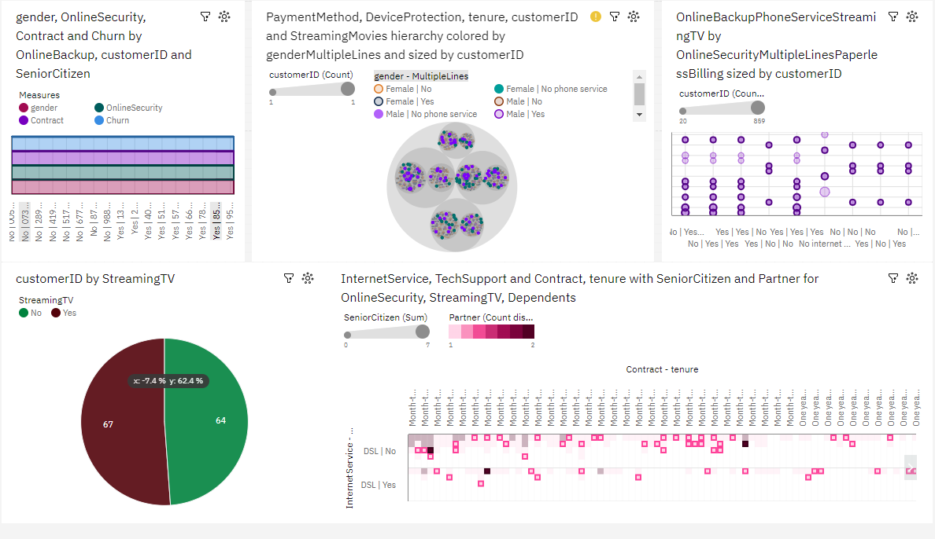
* 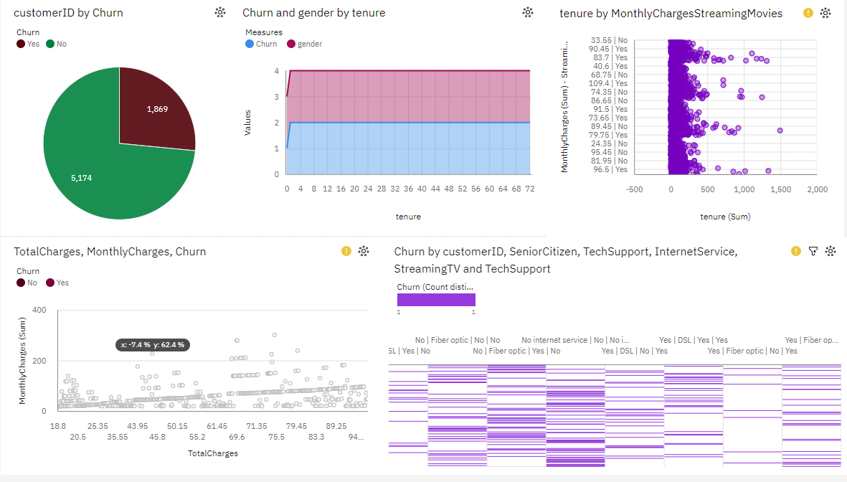
* 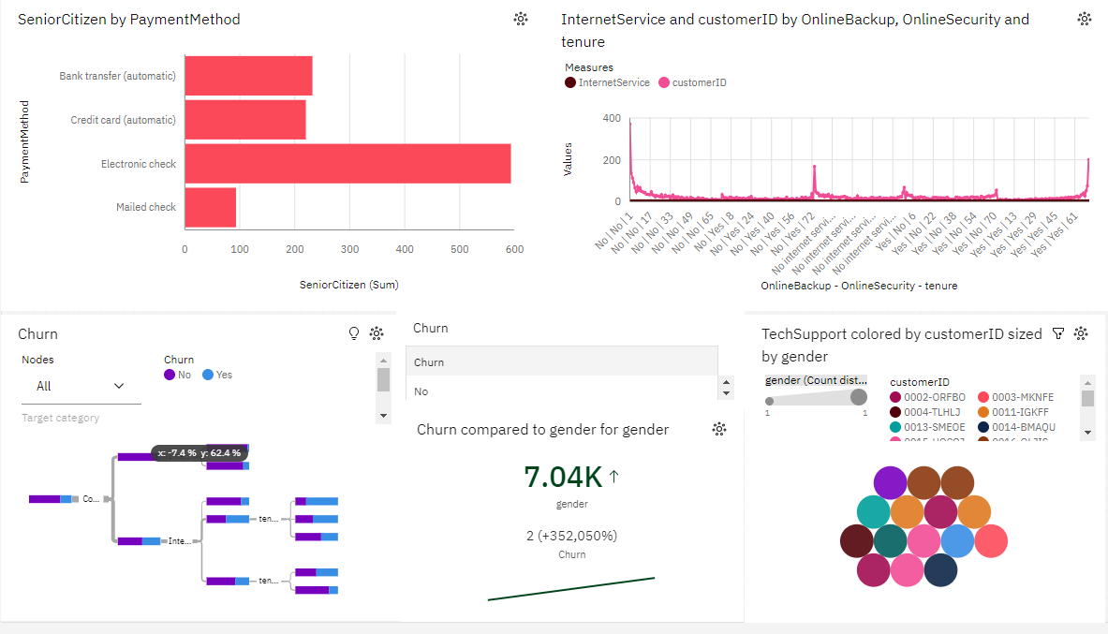

**XI. Conclusion**

In conclusion, the analysis reveals that customer demographics, service usage, contract types, online services, and financial factors all contribute to customer churn. To enhance customer retention, it is crucial for the company to focus on these key factors and implement targeted strategies to address them