SHESHAN N, Ramco Institute of Technology, 953621243053

EDA and Prediction
Churn is a one of the biggest problem in the telecom industry. Research has shown that the average monthly churn rate among the top 4 wireless carriers in the US is 1.9% - 2%.
import numpy as np # linear algebra
import pandas as pd # data processing, CSV file I/O (e.g. pd.read_csv)
import seaborn as sns # For creating plots
import matplotlib.ticker as mtick # For specifying the axes tick format
import matplotlib.pyplot as plt
sns.set(style = 'white')
Let us read the data file in the python notebook
telecom_cust = pd.read_csv('Dataset.csv')
telecom_cust.head()
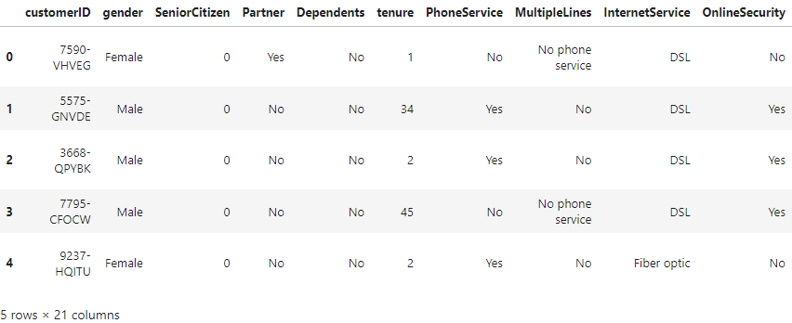
telecom_cust.columns.values
array(['customerID', 'gender', 'SeniorCitizen', 'Partner', 'Dependents',
'tenure', 'PhoneService', 'MultipleLines', 'InternetService',
'OnlineSecurity', 'OnlineBackup', 'DeviceProtection',
'TechSupport', 'StreamingTV', 'StreamingMovies', 'Contract',
'PaperlessBilling', 'PaymentMethod', 'MonthlyCharges',
'TotalCharges', 'Churn'], dtype=object)
Let's explore the data to see if there are any missing values.
# Checking the data types of all the columns
telecom_cust.dtypes
customerID object
gender object
SeniorCitizen int64
Partner object
Dependents object
tenure int64
PhoneService object
MultipleLines object
InternetService object
OnlineSecurity object
OnlineBackup object
DeviceProtection object
TechSupport object
StreamingTV object
StreamingMovies object
Contract object
PaperlessBilling object
PaymentMethod object
MonthlyCharges float64
TotalCharges object
Churn object
dtype: object
# Converting Total Charges to a numerical data type.
telecom_cust.TotalCharges = pd.to_numeric(telecom_cust.TotalCharges, errors='coerce')
telecom_cust.isnull().sum()
customerID 0
gender 0
SeniorCitizen 0
Partner 0
Dependents 0
tenure 0
PhoneService 0
MultipleLines 0
InternetService 0
OnlineSecurity 0
OnlineBackup 0
DeviceProtection 0
TechSupport 0
StreamingTV 0
StreamingMovies 0
Contract 0
PaperlessBilling 0
PaymentMethod 0
MonthlyCharges 0
TotalCharges 11
Churn 0
dtype: int64
After looking at the above output, we can say that there are 11 missing values for Total Charges. Let us replace remove these 11 rows from our data set
#Removing missing values
telecom_cust.dropna(inplace = True)
#Remove customer IDs from the data set
df2 = telecom_cust.iloc[:,1:]
#Convertin the predictor variable in a binary numeric variable
df2['Churn'].replace(to_replace='Yes', value=1, inplace=True)
df2['Churn'].replace(to_replace='No', value=0, inplace=True)
#Let's convert all the categorical variables into dummy variables
df_dummies = pd.get_dummies(df2)
df_dummies.head()

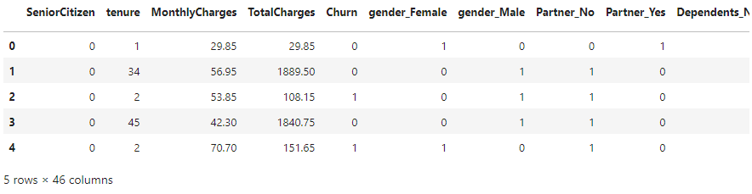

#Get Correlation of "Churn" with other variables:
plt.figure(figsize=(15,8))
df_dummies.corr()['Churn'].sort_values(ascending = False).plot(kind='bar')
<Axes: >
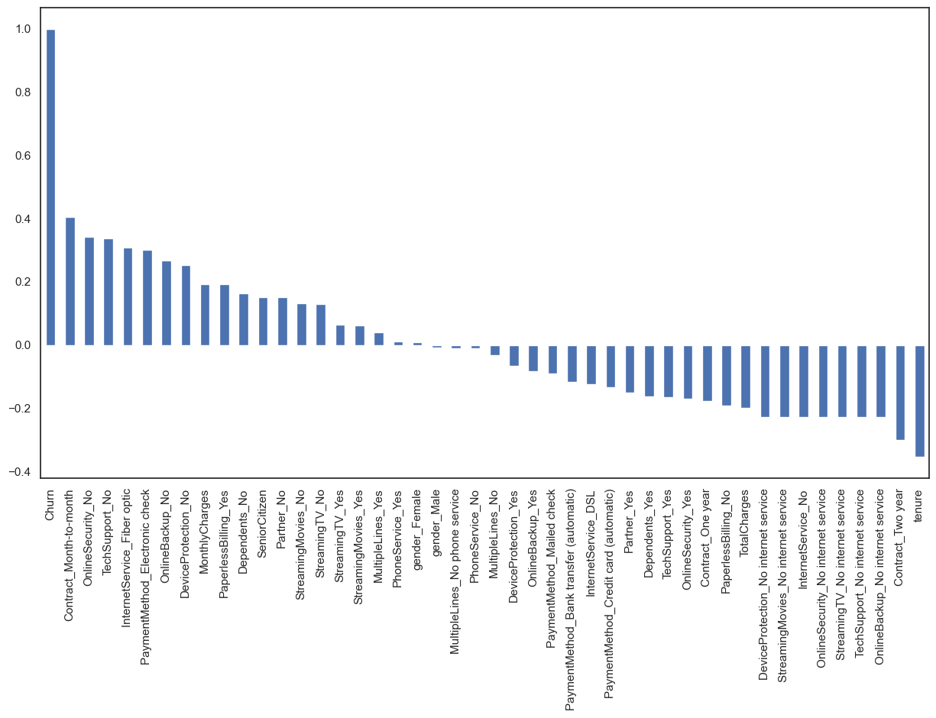
Month to month contracts, absence of online security and tech support seem to be positively correlated with churn. While, tenure, two year contracts seem to be negatively correlated with churn.
Interestingly, services such as Online security, streaming TV, online backup, tech support, etc. without internet connection seem to be negatively related to churn.
We will explore the patterns for the above correlations below before we delve into modelling and identifying the important variables.

Now let's take a quick look at the relation between monthly and total charges
We will observe that the total charges increases as the monthly bill for a customer increases.
telecom_cust[['MonthlyCharges', 'TotalCharges']].plot.scatter(x = 'MonthlyCharges',
y='TotalCharges')
C:\ProgramData\anaconda3\lib\site-packages\pandas\plotting\_matplotlib\core.py:1070: UserWarning: No data for colormapping provided via 'c'. Parameters 'cmap' will be ignored
scatter = ax.scatter(
<Axes: xlabel='MonthlyCharges', ylabel='TotalCharges'>
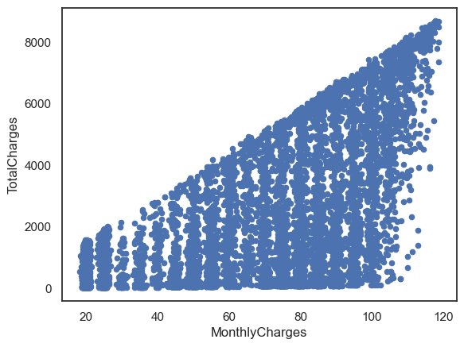

Finally, let's take a look at out predictor variable (Churn) and understand its interaction with other important variables as was found out in the correlation plot.
- Lets first look at the churn rate in our data
In our data, 74% of the customers do not churn. Clearly the data is skewed as we would expect a large majority of the customers to not churn. This is important to keep in mind for our modelling as skeweness could lead to a lot of false negatives. We will see in the modelling section on how to avoid skewness in the data.
- Lets now explore the churn rate by tenure, seniority, contract type, monthly charges and total charges to see how it varies by these variables.
i.) Churn vs Tenure: As we can see form the below plot, the customers who do not churn, they tend to stay for a longer tenure with the telecom company.
sns.boxplot(x = telecom_cust.Churn, y = telecom_cust.tenure)
<Axes: xlabel='Churn', ylabel='tenure'>
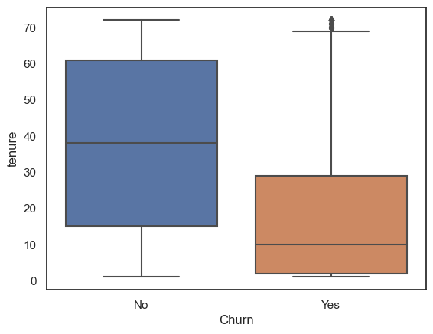
ii.) Churn by Contract Type: Similar to what we saw in the correlation plot, the customers who have a month to month contract have a very high churn rate.
colors = ['#4D3425','#E4512B']
contract_churn = telecom_cust.groupby(['Contract','Churn']).size().unstack()
ax = (contract_churn.T*100.0 / contract_churn.T.sum()).T.plot(kind='bar',
width = 0.3,
stacked = True,
rot = 0,
figsize = (10,6),
color = colors)
ax.yaxis.set_major_formatter(mtick.PercentFormatter())
ax.legend(loc='best',prop={'size':14},title = 'Churn')
ax.set_ylabel('% Customers',size = 14)
ax.set_title('Churn by Contract Type',size = 14)
# Code to add the data labels on the stacked bar chart
for p in ax.patches:
width, height = p.get_width(), p.get_height()
x, y = p.get_xy()
ax.annotate('{:.0f}%'.format(height), (p.get_x()+.25*width, p.get_y()+.4*height),
color = 'white',
weight = 'bold',
size = 14)
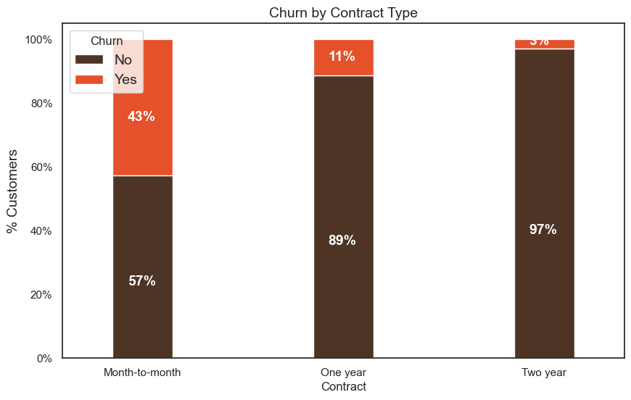
iii.) Churn by Seniority: Senior Citizens have almost double the churn rate than younger population.
colors = ['#4D3425','#E4512B']
seniority_churn = telecom_cust.groupby(['SeniorCitizen','Churn']).size().unstack()
ax = (seniority_churn.T*100.0 / seniority_churn.T.sum()).T.plot(kind='bar',
width = 0.2,
stacked = True,
rot = 0,
figsize = (8,6),
color = colors)
ax.yaxis.set_major_formatter(mtick.PercentFormatter())
ax.legend(loc='center',prop={'size':14},title = 'Churn')
ax.set_ylabel('% Customers')
ax.set_title('Churn by Seniority Level',size = 14)
# Code to add the data labels on the stacked bar chart
for p in ax.patches:
width, height = p.get_width(), p.get_height()
x, y = p.get_xy()
ax.annotate('{:.0f}%'.format(height), (p.get_x()+.25*width, p.get_y()+.4*height),
color = 'white',
weight = 'bold',size =14)
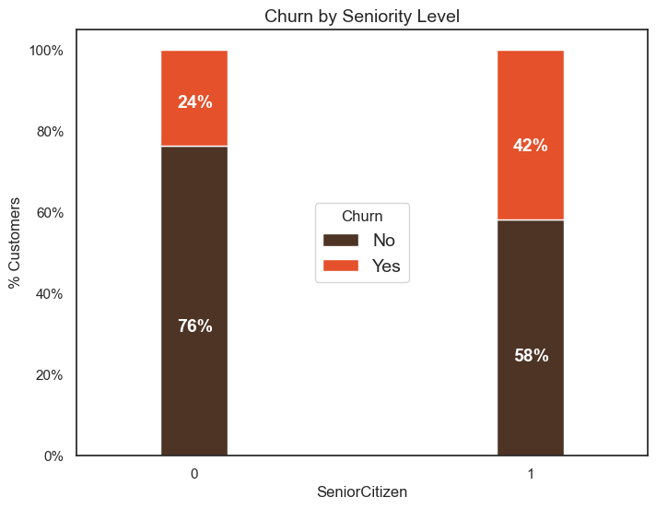
iv.) Churn by Monthly Charges: Higher % of customers churn when the monthly charges are high.
ax = sns.kdeplot(telecom_cust.MonthlyCharges[(telecom_cust["Churn"] == 'No') ],
color="Red", shade = True)
ax = sns.kdeplot(telecom_cust.MonthlyCharges[(telecom_cust["Churn"] == 'Yes') ],
ax =ax, color="Blue", shade= True)
ax.legend(["Not Churn","Churn"],loc='upper right')
ax.set_ylabel('Density')
ax.set_xlabel('Monthly Charges')
ax.set_title('Distribution of monthly charges by churn')
C:\Users\Administrator\AppData\Local\Temp\ipykernel_14052\2862132292.py:1: FutureWarning:
`shade` is now deprecated in favor of `fill`; setting `fill=True`.
This will become an error in seaborn v0.14.0; please update your code.
ax = sns.kdeplot(telecom_cust.MonthlyCharges[(telecom_cust["Churn"] == 'No') ],
C:\Users\Administrator\AppData\Local\Temp\ipykernel_14052\2862132292.py:3: FutureWarning:
`shade` is now deprecated in favor of `fill`; setting `fill=True`.
This will become an error in seaborn v0.14.0; please update your code.
ax = sns.kdeplot(telecom_cust.MonthlyCharges[(telecom_cust["Churn"] == 'Yes') ],
Text(0.5, 1.0, 'Distribution of monthly charges by churn')
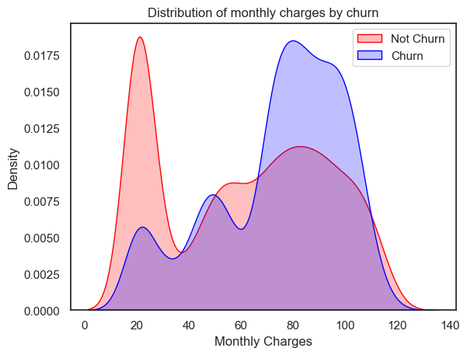
v.) Churn by Total Charges: It seems that there is higer churn when the total charges are lower.
ax = sns.kdeplot(telecom_cust.TotalCharges[(telecom_cust["Churn"] == 'No') ],
color="Red", shade = True)
ax = sns.kdeplot(telecom_cust.TotalCharges[(telecom_cust["Churn"] == 'Yes') ],
ax =ax, color="Blue", shade= True)
ax.legend(["Not Churn","Churn"],loc='upper right')
ax.set_ylabel('Density')
ax.set_xlabel('Total Charges')
ax.set_title('Distribution of total charges by churn')
C:\Users\Administrator\AppData\Local\Temp\ipykernel_14052\3097405637.py:1: FutureWarning:
`shade` is now deprecated in favor of `fill`; setting `fill=True`.
This will become an error in seaborn v0.14.0; please update your code.
ax = sns.kdeplot(telecom_cust.TotalCharges[(telecom_cust["Churn"] == 'No') ],
C:\Users\Administrator\AppData\Local\Temp\ipykernel_14052\3097405637.py:3: FutureWarning:
`shade` is now deprecated in favor of `fill`; setting `fill=True`.
This will become an error in seaborn v0.14.0; please update your code.
ax = sns.kdeplot(telecom_cust.TotalCharges[(telecom_cust["Churn"] == 'Yes') ],
Text(0.5, 1.0, 'Distribution of total charges by churn')
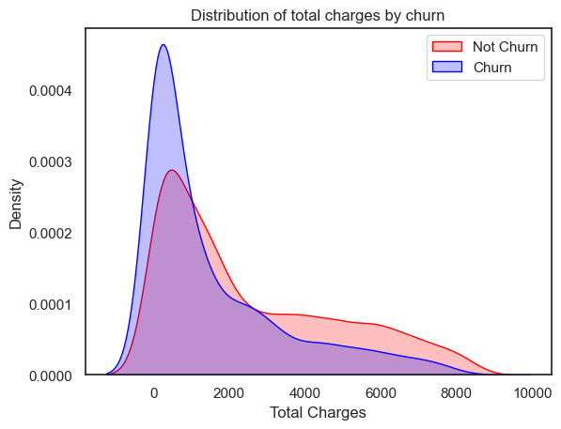

After going through the above EDA we will develop some predictive models and compare them.
We will develop Logistic Regression, Random Forest, SVM, ADA Boost and XG Boost
1. Logistic Regression
# We will use the data frame where we had created dummy variables
y = df_dummies['Churn'].values
X = df_dummies.drop(columns = ['Churn'])
# Scaling all the variables to a range of 0 to 1
from sklearn.preprocessing import MinMaxScaler
features = X.columns.values
scaler = MinMaxScaler(feature_range = (0,1))
scaler.fit(X)
X = pd.DataFrame(scaler.transform(X))
X.columns = features
It is important to scale the variables in logistic regression so that all of them are within a range of 0 to 1. This helped me improve the accuracy from 79.7% to 80.7%. Further, you will notice below that the importance of variables is also aligned with what we are seeing in Random Forest algorithm and the EDA we conducted above.
# Create Train & Test Data
from sklearn.model_selection import train_test_split
X_train, X_test, y_train, y_test = train_test_split(X, y, test_size=0.3, random_state=101)
# Running logistic regression model
from sklearn.linear_model import LogisticRegression
model = LogisticRegression()
result = model.fit(X_train, y_train)
from sklearn import metrics
prediction_test = model.predict(X_test)
# Print the prediction accuracy
print (metrics.accuracy_score(y_test, prediction_test))
0.8075829383886256
logit_model = metrics.accuracy_score(y_test, prediction_test)
# To get the weights of all the variables
weights = pd.Series(model.coef_[0],
index=X.columns.values)
print (weights.sort_values(ascending = False)[:10].plot(kind='bar'))
Axes(0.125,0.11;0.775x0.77)
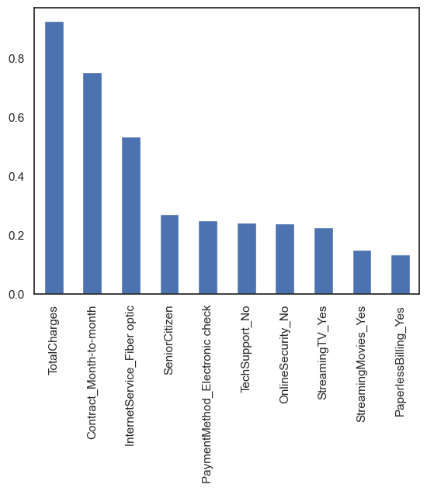
print(weights.sort_values(ascending = False)[-10:].plot(kind='bar'))
Axes(0.125,0.11;0.775x0.77)
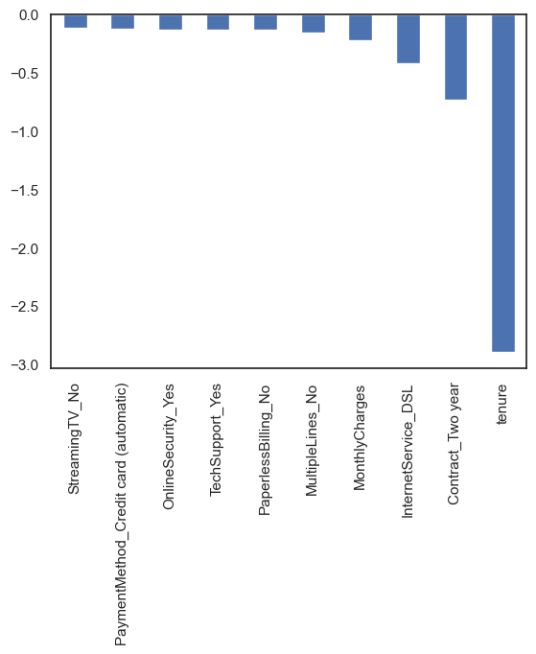
Observations
We can see that some variables have a negative relation to our predicted variable (Churn), while some have positive relation. Negative relation means that likeliness of churn decreases with that variable. Let us summarize some of the interesting features below:
- As we saw in our EDA, having a 2 month contract reduces chances of churn. 2 month contract along with tenure have the most negative relation with Churn as predicted by logistic regressions
- Having DSL internet service also reduces the proability of Churn
- Lastly, total charges, monthly contracts, fibre optic internet services and seniority can lead to higher churn rates. This is interesting because although fibre optic services are faster, customers are likely to churn because of it. I think we need to explore more to better understad why this is happening.
Any hypothesis on the above would be really helpful!
2. Random Forest
from sklearn.ensemble import RandomForestClassifier
X_train, X_test, y_train, y_test = train_test_split(X, y, test_size=0.2, random_state=101)
model_rf = RandomForestClassifier(n_estimators=1000 , oob_score = True, n_jobs = -1,
random_state =50, max_features = "auto",
max_leaf_nodes = 30)
model_rf.fit(X_train, y_train)
# Make predictions
prediction_test = model_rf.predict(X_test)
print (metrics.accuracy_score(y_test, prediction_test))
C:\ProgramData\anaconda3\lib\site-packages\sklearn\ensemble\_forest.py:424: FutureWarning: `max_features='auto'` has been deprecated in 1.1 and will be removed in 1.3. To keep the past behaviour, explicitly set `max_features='sqrt'` or remove this parameter as it is also the default value for RandomForestClassifiers and ExtraTreesClassifiers.
warn(
0.8088130774697939
rf_model = metrics.accuracy_score(y_test, prediction_test)
importances = model_rf.feature_importances_
weights = pd.Series(importances,
index=X.columns.values)
weights.sort_values()[-10:].plot(kind = 'barh')
<Axes: >
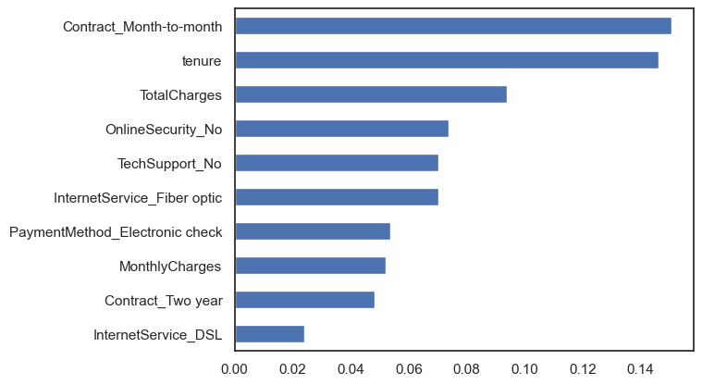
Observations:
- From random forest algorithm, monthly contract, tenure and total charges are the most important predictor variables to predict churn.
- The results from random forest are very similar to that of the logistic regression and in line to what we had expected from our EDA
3. Support Vecor Machine (SVM)
X_train, X_test, y_train, y_test = train_test_split(X, y, test_size=0.2, random_state=99)
from sklearn.svm import SVC
model.svm = SVC(kernel='linear')
model.svm.fit(X_train,y_train)
preds = model.svm.predict(X_test)
metrics.accuracy_score(y_test, preds)
0.820184790334044
svm_model = metrics.accuracy_score(y_test, preds)
# Create the Confusion matrix
from sklearn.metrics import classification_report, confusion_matrix
print(confusion_matrix(y_test,preds))
[[953 89]
[164 201]]
Wth SVM I was able to increase the accuracy to upto 82%. However, we need to take a deeper look at the true positive and true negative rates, including the Area Under the Curve (AUC) for a better prediction. I will explore this soon. Stay Tuned!
ax1 = sns.catplot(x="gender", kind="count", hue="Churn", data=telecom_cust,
estimator=lambda x: sum(x==0)*100.0/len(x))
#ax1.yaxis.set_major_formatter(mtick.PercentFormatter())
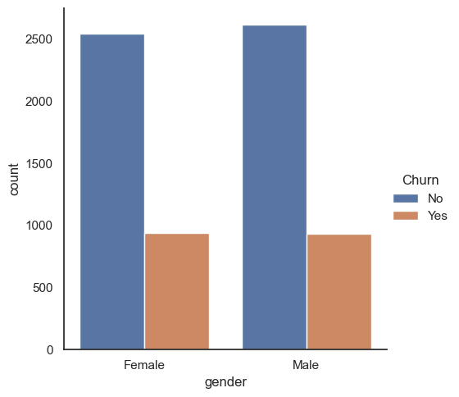
4. ADA Boost
# AdaBoost Algorithm
from sklearn.ensemble import AdaBoostClassifier
model = AdaBoostClassifier()
# n_estimators = 50 (default value)
# base_estimator = DecisionTreeClassifier (default value)
model.fit(X_train,y_train)
preds = model.predict(X_test)
metrics.accuracy_score(y_test, preds)
0.8159203980099502
adab_model = metrics.accuracy_score(y_test, preds)
import matplotlib.pyplot as plt
# Model names and accuracies
models = ["Logistic Regression", "Random Forest", "Support Vector Machine", "Ada Boost"]
accuracies = [logit_model, rf_model, svm_model, adab_model]
# Create a bar chart
plt.figure(figsize=(10, 6))
plt.bar(models, accuracies, color=['blue', 'green', 'orange', 'red'])
plt.xlabel("Models")
plt.ylabel("Accuracy")
plt.title("Model Accuracies")
# Adding accuracy values on top of the bars
for i, accuracy in enumerate(accuracies):
plt.text(i, accuracy, f"{accuracy:.2f}", ha='center', va='bottom')
# Show the chart
plt.tight_layout()
plt.show()

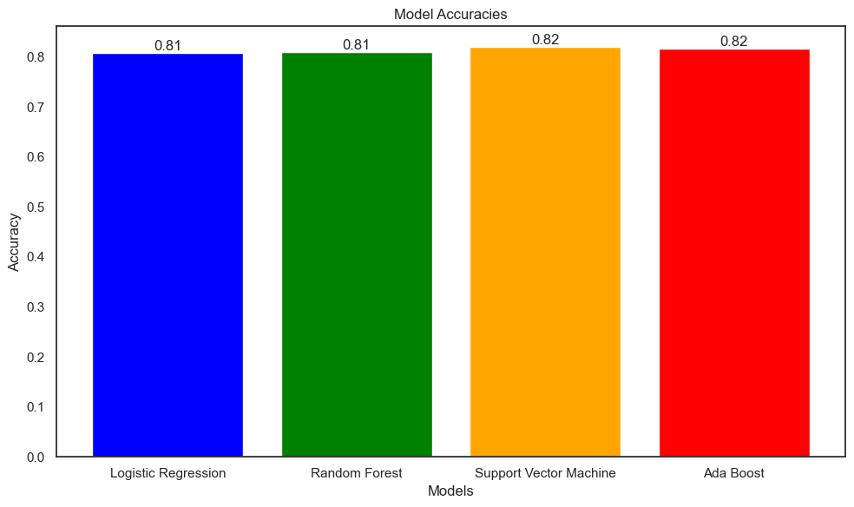

IBM COGNOS ANALYTICS :

