Liver Cirrhosis Prediction
Health care analysis(mini project)
SHESHAN N
953621243053
Introduction
The goal of this project is to predict liver cirrhosis using XGBoost, a powerful machine learning algorithm. The dataset includes various features related to patients' details and blood tests. The project involves exploratory data analysis (EDA) and utilizes XGBoost for prediction.

Exploratory Data Analysis (EDA)
The dataset contains 19 features, including patient details and blood test results. Initial inspection reveals missing values in some columns. To better understand the data, summary statistics and visualizations are employed.
The summary statistics indicate the presence of numerical features with varying ranges. Handling missing values becomes crucial for model training. Imputation is performed separately for numerical and categorical data, using the median for numerical and the mode for categorical.

Handling Missing Values
Imputation successfully fills missing values, ensuring a complete dataset for analysis. The dataset is now ready for exploration.

Exploratory Data Analysis (EDA)
Visualizations are used to uncover patterns and relationships within the data. Class imbalances are observed in the target variable (disease stage). Features such as Ascites and Spiders show positive correlations with disease risk.
Distribution plots reveal insights into the relationship between specific features and disease stages. For instance, age, prothrombin content, and copper accumulation positively correlate with disease probability, while platelets, albumin, and cholesterol show negative correlations.
Regression plots further confirm the relationships, providing a visual representation of how certain features impact disease probability.

Preprocessing Data
Categorical data is encoded into integers, preparing the data for model training. Features like 'Status' and 'N_Days' are excluded to avoid data leakage.
Model Selection
A logistic regression model is initially implemented, achieving a mean accuracy of around 70%. The area under the curve (AUC) is approximately 0.65. Further improvement is sought by trying the XGBoost model.
XGBoost Model
The XGBoost model is trained using stratified k-fold cross-validation. With a learning rate of 0.75 and max depth of 3, the XGBoost model achieves a mean accuracy of 73.44% and an AUC of 0.74. The precision-recall curve and ROC curve visually demonstrate the model's performance.
CODE:
import numpy as np
import pandas as pd
import matplotlib.pyplot as plt
import seaborn as sns
df = pd.read_csv('/content/cirrhosis.csv', index_col='ID')
df.head()
N_Days Status Drug Age Sex Ascites Hepatomegaly Spiders \
ID
1 400 D D-penicillamine 21464 F Y Y Y
2 4500 C D-penicillamine 20617 F N Y Y
3 1012 D D-penicillamine 25594 M N N N
4 1925 D D-penicillamine 19994 F N Y Y
5 1504 CL Placebo 13918 F N Y Y
Edema Bilirubin Cholesterol Albumin Copper Alk_Phos SGOT \
ID
1 Y 14.5 261.0 2.60 156.0 1718.0 137.95
2 N 1.1 302.0 4.14 54.0 7394.8 113.52
3 S 1.4 176.0 3.48 210.0 516.0 96.10
4 S 1.8 244.0 2.54 64.0 6121.8 60.63
5 N 3.4 279.0 3.53 143.0 671.0 113.15
Tryglicerides Platelets Prothrombin Stage
ID
1 172.0 190.0 12.2 4.0
2 88.0 221.0 10.6 3.0
3 55.0 151.0 12.0 4.0
4 92.0 183.0 10.3 4.0
5 72.0 136.0 10.9 3.0
CODE:
df.info()
<class 'pandas.core.frame.DataFrame'>
Int64Index: 418 entries, 1 to 418
Data columns (total 19 columns):
# Column Non-Null Count Dtype
--- ------ -------------- -----
0 N_Days 418 non-null int64
1 Status 418 non-null object
2 Drug 312 non-null object
3 Age 418 non-null int64
4 Sex 418 non-null object
5 Ascites 312 non-null object
6 Hepatomegaly 312 non-null object
7 Spiders 312 non-null object
8 Edema 418 non-null object
9 Bilirubin 418 non-null float64
10 Cholesterol 284 non-null float64
11 Albumin 418 non-null float64
12 Copper 310 non-null float64
13 Alk_Phos 312 non-null float64
14 SGOT 312 non-null float64
15 Tryglicerides 282 non-null float64
16 Platelets 407 non-null float64
17 Prothrombin 416 non-null float64
18 Stage 412 non-null float64
dtypes: float64(10), int64(2), object(7)
memory usage: 65.3+ KB
CODE:
df.describe()
N_Days Age Bilirubin Cholesterol Albumin \
count 418.000000 418.000000 418.000000 284.000000 418.000000
mean 1917.782297 18533.351675 3.220813 369.510563 3.497440
std 1104.672992 3815.845055 4.407506 231.944545 0.424972
min 41.000000 9598.000000 0.300000 120.000000 1.960000
25% 1092.750000 15644.500000 0.800000 249.500000 3.242500
50% 1730.000000 18628.000000 1.400000 309.500000 3.530000
75% 2613.500000 21272.500000 3.400000 400.000000 3.770000
max 4795.000000 28650.000000 28.000000 1775.000000 4.640000
Copper Alk_Phos SGOT Tryglicerides Platelets \
count 310.000000 312.000000 312.000000 282.000000 407.000000
mean 97.648387 1982.655769 122.556346 124.702128 257.024570
std 85.613920 2140.388824 56.699525 65.148639 98.325585
min 4.000000 289.000000 26.350000 33.000000 62.000000
25% 41.250000 871.500000 80.600000 84.250000 188.500000
50% 73.000000 1259.000000 114.700000 108.000000 251.000000
75% 123.000000 1980.000000 151.900000 151.000000 318.000000
max 588.000000 13862.400000 457.250000 598.000000 721.000000
Prothrombin Stage
count 416.000000 412.000000
mean 10.731731 3.024272
std 1.022000 0.882042
min 9.000000 1.000000
25% 10.000000 2.000000
50% 10.600000 3.000000
75% 11.100000 4.000000
max 18.000000 4.000000
CODE:
df.isna().sum()
N_Days 0
Status 0
Drug 106
Age 0
Sex 0
Ascites 106
Hepatomegaly 106
Spiders 106
Edema 0
Bilirubin 0
Cholesterol 134
Albumin 0
Copper 108
Alk_Phos 106
SGOT 106
Tryglicerides 136
Platelets 11
Prothrombin 2
Stage 6
dtype: int64
CODE:
df.select_dtypes(include=(['int64', 'float64'])).isna().sum()
N_Days 0
Age 0
Bilirubin 0
Cholesterol 134
Albumin 0
Copper 108
Alk_Phos 106
SGOT 106
Tryglicerides 136
Platelets 11
Prothrombin 2
Stage 6
dtype: int64
CODE:
df.select_dtypes(include=(['int64', 'float64'])).isna().sum()
df_num_col = df.select_dtypes(include=(['int64', 'float64'])).columns
for c in df_num_col:
df[c].fillna(df[c].median(), inplace=True)
df.select_dtypes(include=(['int64', 'float64'])).isna().sum()
N_Days 0
Age 0
Bilirubin 0
Cholesterol 0
Albumin 0
Copper 0
Alk_Phos 0
SGOT 0
Tryglicerides 0
Platelets 0
Prothrombin 0
Stage 0
dtype: int64
CODE:
df.select_dtypes(include=('object')).isna().sum()
Status 0
Drug 106
Sex 0
Ascites 106
Hepatomegaly 106
Spiders 106
Edema 0
dtype: int64
CODE:
df_cat_col = df.select_dtypes(include=('object')).columns
for c in df_cat_col:
df[c].fillna(df[c].mode().values[0], inplace=True)
df.select_dtypes(include=('object')).isna().sum()
Status 0
Drug 0
Sex 0
Ascites 0
Hepatomegaly 0
Spiders 0
Edema 0
dtype: int64
CODE:
df['Stage'].value_counts()
3.0 161
4.0 144
2.0 92
1.0 21
Name: Stage, dtype: int64
CODE:
plt.figure(figsize=(21,5))
sns.countplot(y=df['Stage'], palette="flare", alpha=0.8, )
sns.despine(top=True, right=True, bottom=True, left=True)
plt.tick_params(axis='both', which='both', bottom=False, top=False, left=False)
plt.xlabel('')
plt.title('Number of Example Per Class')
Text(0.5, 1.0, 'Number of Example Per Class')
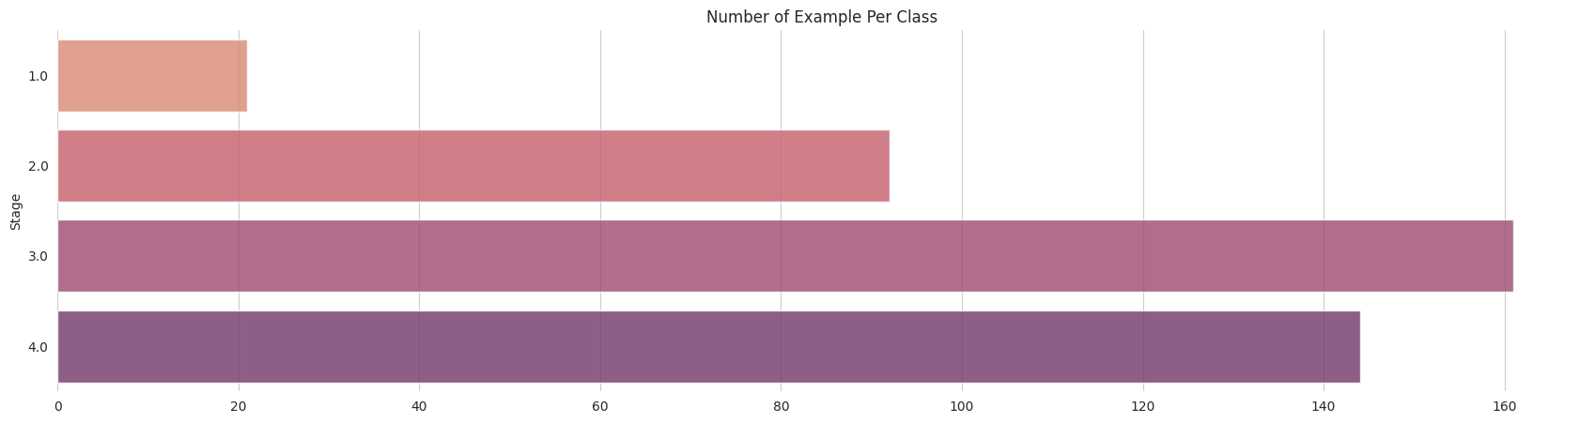
CODE:
df['Stage'] = np.where(df['Stage'] == 4,1,0)
plt.figure(figsize=(21.2,10))
plt.subplot(2,3,1)
sns.countplot(x=df['Stage'], hue=df['Sex'], palette='Blues', alpha=0.9)
sns.despine(top=True, right=True, bottom=True, left=True)
plt.tick_params(axis='both', which='both', bottom=False, top=False, left=False)
plt.xlabel('')
plt.title('Disease Stage Across Gender')
plt.subplot(2,3,2)
sns.countplot(x=df['Stage'], hue=df['Ascites'], palette='Purples', alpha=0.9)
sns.despine(top=True, right=True, bottom=True, left=True)
plt.tick_params(axis='both', which='both', bottom=False, top=False, left=False)
plt.xlabel('')
plt.title('Ascites proportion across Stages')
plt.subplot(2,3,3)
sns.countplot(x=df['Stage'], hue=df['Drug'], palette='Blues', alpha=0.9)
sns.despine(top=True, right=True, bottom=True, left=True)
plt.tick_params(axis='both', which='both', bottom=False, top=False, left=False)
plt.xlabel('')
plt.title('Medications prescribed across Stages');
plt.subplot(2,3,4)
sns.countplot(x=df['Stage'], hue=df['Hepatomegaly'], palette='Purples', alpha=0.9)
sns.despine(top=True, right=True, bottom=True, left=True)
plt.tick_params(axis='both', which='both', bottom=False, top=False, left=False)
plt.xlabel('')
plt.title('Hepatomegaly');
plt.subplot(2,3,5)
sns.countplot(x=df['Stage'], hue=df['Spiders'], palette='Blues', alpha=0.9)
sns.despine(top=True, right=True, bottom=True, left=True)
plt.tick_params(axis='both', which='both', bottom=False, top=False, left=False)
plt.xlabel('')
plt.title('Presence of Spiders across stages');
plt.subplot(2,3,6)
sns.countplot(x=df['Stage'], hue=df['Edema'], palette='Purples', alpha=0.9)
sns.despine(top=True, right=True, bottom=True, left=True)
plt.tick_params(axis='both', which='both', bottom=False, top=False, left=False)
plt.xlabel('')
plt.title('Edema');
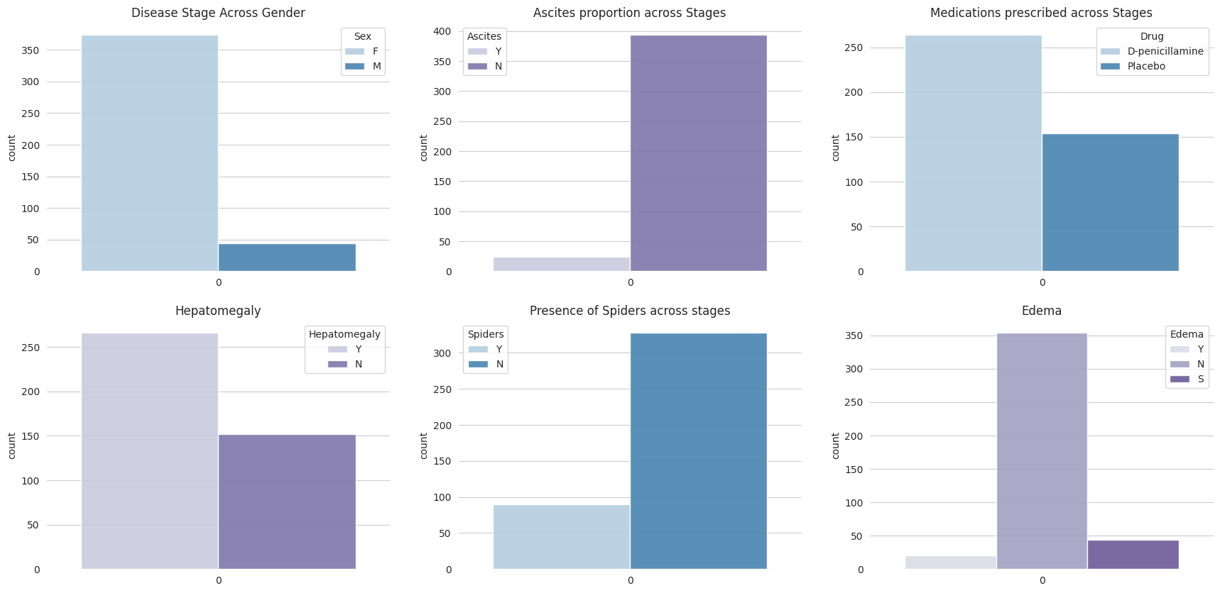
CODE:
#@title Distribution Plots
import matplotlib.pyplot as plt
import seaborn as sns
plt.figure(figsize=(20.6, 15))
stages = df['Stage'].unique()
for i, stage in enumerate(stages, start=1):
plt.subplot(3, 3, i)
sns.kdeplot(df[df['Stage'] == stage]['Cholesterol'], fill=True, palette='Purples', common_norm=True)
sns.despine(top=True, right=True, bottom=True, left=True)
plt.tick_params(axis='both', which='both', bottom=False, top=False, left=False)
plt.xlabel('')
plt.title(f'Cholesterol Distribution in {stage}')
plt.tight_layout()
plt.show()
Ignoring `palette` because no `hue` variable has been assigned.
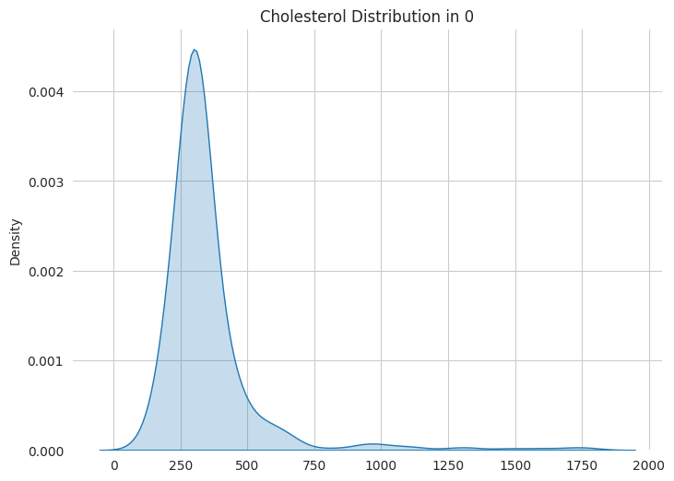

Index(['N_Days', 'Status', 'Drug', 'Age', 'Sex', 'Ascites', 'Hepatomegaly',
'Spiders', 'Edema', 'Bilirubin', 'Cholesterol', 'Albumin', 'Copper',
'Alk_Phos', 'SGOT', 'Tryglicerides', 'Platelets', 'Prothrombin'],
dtype='object')
CODE:
plt.figure(figsize=(21,12))
plt.subplot(3,1,1)
sns.regplot(x=df['Age'], y=df['Stage'], scatter=False, logistic=True, color='royalblue')
sns.despine(fig=None, ax=None, top=True, right=True, left=True, bottom=True, offset=None, trim=False);
plt.tick_params(axis='both', which='both', bottom=False, top=False, left=False)
plt.xlabel('');
plt.ylabel('Cirrhosis Probability');
plt.setp(plt.title('Cirrhosis Probability with increasing Age(in days)'), color='royalblue') ;
plt.subplot(3,1,2)
sns.regplot(x=df['Prothrombin'], y=df['Stage'], scatter=False, logistic=True, color='orchid');
sns.despine(fig=None, ax=None, top=True, right=True, left=True, bottom=True, offset=None, trim=False);
plt.tick_params(axis='both', which='both', bottom=False, top=False, left=False)
plt.xlabel('');
plt.ylabel('Cirrhosis Probability');
plt.setp(plt.title('Cirrhosis Probability with increasing Prothrombin Content'), color='darkmagenta');
plt.subplot(3,1,3)
sns.regplot(x=df['Copper'], y=df['Stage'], scatter=False, logistic=True, color='royalblue')
sns.despine(fig=None, ax=None, top=True, right=True, left=True, bottom=True, offset=None, trim=False);
plt.tick_params(axis='both', which='both', bottom=False, top=False, left=False)
plt.xlabel('');
plt.ylabel('Cirrhosis Probability');
plt.setp(plt.title('Cirrhosis Probability with increasing Copper Accumulation'), color='royalblue') ;
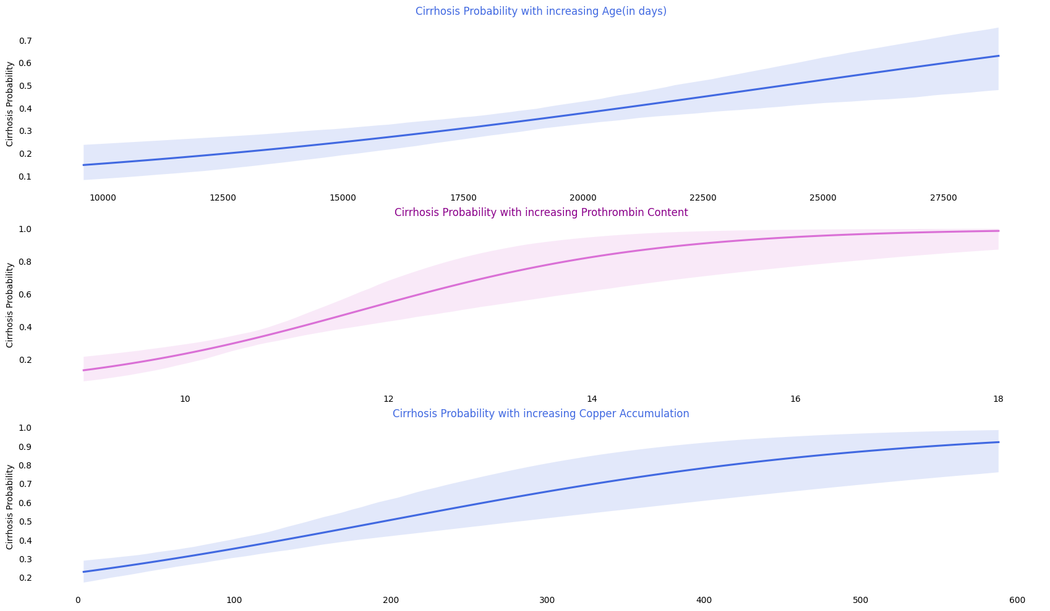
CODE:
plt.figure(figsize=(21,12))
plt.subplot(3,1,1)
sns.regplot(x=df['Platelets'], y=df['Stage'], scatter=False, logistic=True, color='orchid')
sns.despine(fig=None, ax=None, top=True, right=True, left=True, bottom=True, offset=None, trim=False);
plt.tick_params(axis='both', which='both', bottom=False, top=False, left=False)
plt.xlabel('');
plt.ylabel('Cirrhosis Probability');
plt.setp(plt.title('Cirrhosis Probability with Platelets'), color='darkmagenta');
plt.subplot(3,1,2)
sns.regplot(x=df['Albumin'], y=df['Stage'], scatter=False, logistic=True, color='royalblue');
sns.despine(fig=None, ax=None, top=True, right=True, left=True, bottom=True, offset=None, trim=False);
plt.tick_params(axis='both', which='both', bottom=False, top=False, left=False)
plt.xlabel('');
plt.ylabel('Cirrhosis Probability');
plt.setp(plt.title('Cirrhosis Probability with Albumin Content'), color='royalblue');
plt.subplot(3,1,3)
sns.regplot(x=df['Cholesterol'], y=df['Stage'], scatter=False, logistic=True, color='orchid')
sns.despine(fig=None, ax=None, top=True, right=True, left=True, bottom=True, offset=None, trim=False);
plt.tick_params(axis='both', which='both', bottom=False, top=False, left=False)
plt.xlabel('');
plt.ylabel('Cirrhosis Probability');
plt.setp(plt.title('Cirrhosis Probability Cholesterol'), color='darkmagenta') ;
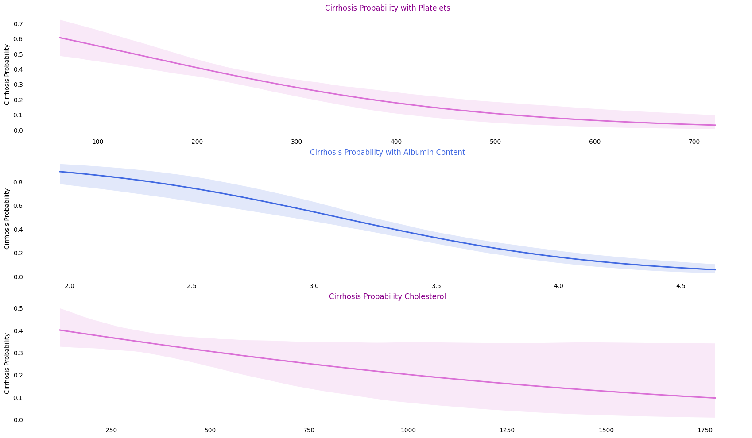
CODE:
df['Sex'] = df['Sex'].replace({'M':0, 'F':1})
df['Ascites'] = df['Ascites'].replace({'N':0, 'Y':1})
df['Drug'] = df['Drug'].replace({'D-penicillamine':0, 'Placebo':1})
df['Hepatomegaly'] = df['Hepatomegaly'].replace({'N':0, 'Y':1})
df['Spiders'] = df['Spiders'].replace({'N':0, 'Y':1})
df['Edema'] = df['Edema'].replace({'N':0, 'Y':1, 'S':-1})
df['Status'] = df['Status'].replace({'C':0, 'CL':1, 'D':-1})
X = df.drop(['Status', 'N_Days', 'Stage'], axis=1)
y = df.pop('Stage')
CODE:
from sklearn.linear_model import LogisticRegression
from sklearn.model_selection import StratifiedKFold
log_model = LogisticRegression(max_iter=5000, solver='saga')
skf = StratifiedKFold(n_splits=10, random_state=1, shuffle=True)
acc=[]
def training(train, test, fold_no):
X_train = train
y_train = y.iloc[train_index]
X_test = test
y_test = y.iloc[test_index]
log_model.fit(X_train, y_train)
score = log_model.score(X_test,y_test)
acc.append(score)
print('For Fold {} the accuracy is {}'.format(str(fold_no),score))
fold_no = 1
for train_index,test_index in skf.split(X, y):
train = X.iloc[train_index,:]
test = X.iloc[test_index,:]
training(train, test, fold_no)
fold_no += 1
print()
print('Logestic Regression Mean Accuracy = ', np.mean(acc))
For Fold 1 the accuracy is 0.6904761904761905
For Fold 2 the accuracy is 0.7857142857142857
For Fold 3 the accuracy is 0.6190476190476191
For Fold 4 the accuracy is 0.6666666666666666
For Fold 5 the accuracy is 0.8095238095238095
For Fold 6 the accuracy is 0.6666666666666666
For Fold 7 the accuracy is 0.6904761904761905
For Fold 8 the accuracy is 0.7380952380952381
For Fold 9 the accuracy is 0.7317073170731707
For Fold 10 the accuracy is 0.6341463414634146
Logestic Regression Mean Accuracy = 0.7032520325203252
CODE:
from sklearn.metrics import classification_report
log_model_predict = log_model.predict(test)
log_model_predict_proba = log_model.predict_proba(test)
print(classification_report(y.iloc[test_index], log_model_predict))
precision recall f1-score support
0 0.70 0.78 0.74 27
1 0.45 0.36 0.40 14
accuracy 0.63 41
macro avg 0.58 0.57 0.57 41
weighted avg 0.62 0.63 0.62 41
from sklearn.metrics import roc_auc_score
from sklearn.metrics import roc_curve, auc
fpr, tpr, threshold = roc_curve(y.iloc[test_index], log_model_predict_proba[:,1])
roc_auc = auc(fpr, tpr)
print('AUC : ', roc_auc_score(y.iloc[test_index], log_model_predict_proba[:,1]))
AUC : 0.6507936507936508
CODE:
sns.set_style('whitegrid')
plt.figure(figsize=(21,6))
plt.subplot(1,2,1)
plt.title('Receiver Operating Characteristic for Logestic Regression')
sns.lineplot(x=fpr, y=tpr, label = 'AUC = %0.2f' % roc_auc, palette='purple', linewidth=3)
plt.legend(loc = 'lower right')
plt.plot([0, 1], [0, 1],'r--')
plt.xlim([0, 1])
plt.ylim([0, 1])
plt.ylabel('True Positive Rate')
plt.xlabel('False Positive Rate')
plt.tick_params(left=False, bottom=False)
sns.despine(top=True, bottom=True, left=True)
# calculate precision-recall curve
from sklearn.metrics import precision_recall_curve, f1_score
precision, recall, thresholds = precision_recall_curve(y.iloc[test_index], log_model_predict_proba[:,1])
plt.subplot(1,2,2)
plt.plot(precision, recall, linewidth=3, color='orchid')
sns.despine(top=True, bottom=True, left=True)
plt.xlabel('Precision')
plt.ylabel('Recall')
plt.title('Precision Recall Curve for Logestic regression');
<ipython-input-24-9f1b208f8e91>:6: UserWarning: Ignoring `palette` because no `hue` variable has been assigned.
sns.lineplot(x=fpr, y=tpr, label = 'AUC = %0.2f' % roc_auc, palette='purple', linewidth=3)
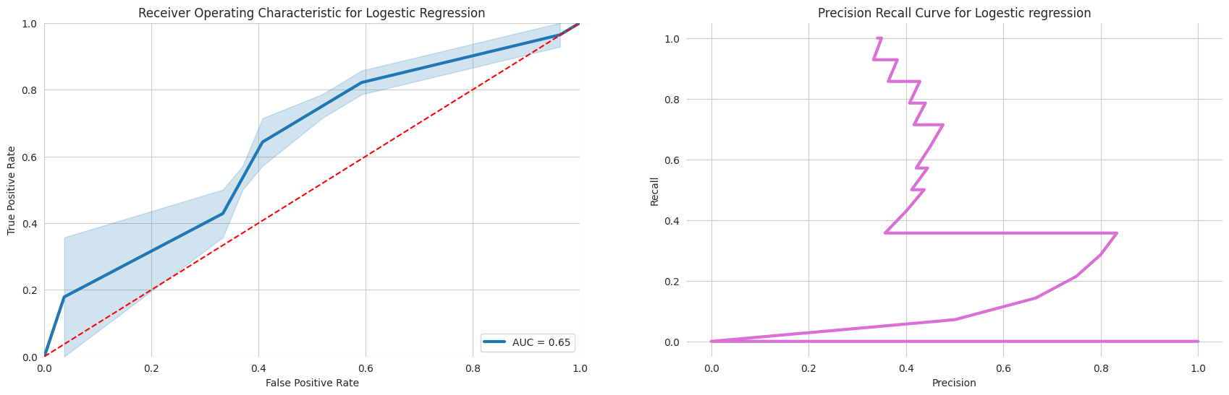
CODE:
from sklearn.model_selection import StratifiedKFold
from xgboost import XGBClassifier
skf = StratifiedKFold(n_splits=10, random_state=1, shuffle=True)
model = XGBClassifier(learning_rate=0.75, max_depth=3, random_state=1, gamma=0, eval_metric='error') # tried learning rate values between range [0.01 - 10] & depth [2-8]
acc=[]
def training(train, test, fold_no):
X_train = train
y_train = y.iloc[train_index]
X_test = test
y_test = y.iloc[test_index]
model.fit(X_train, y_train)
score = model.score(X_test,y_test)
acc.append(score)
print('For Fold {} the accuracy is {}'.format(str(fold_no),score))
fold_no = 1
for train_index,test_index in skf.split(X, y):
train = X.iloc[train_index,:]
test = X.iloc[test_index,:]
training(train, test, fold_no)
fold_no += 1
print()
print('XGboost model Mean Accuracy = ', np.mean(acc))
For Fold 1 the accuracy is 0.7619047619047619
For Fold 2 the accuracy is 0.7857142857142857
For Fold 3 the accuracy is 0.7380952380952381
For Fold 4 the accuracy is 0.7619047619047619
For Fold 5 the accuracy is 0.8095238095238095
For Fold 6 the accuracy is 0.7380952380952381
For Fold 7 the accuracy is 0.7619047619047619
For Fold 8 the accuracy is 0.7857142857142857
For Fold 9 the accuracy is 0.7073170731707317
For Fold 10 the accuracy is 0.7560975609756098
XGboost model Mean Accuracy = 0.7606271777003484
from sklearn.metrics import classification_report
XGB_model_predict = model.predict(test)
XGB_model_predict_proba = model.predict_proba(test)
print(classification_report(y.iloc[test_index], XGB_model_predict))
precision recall f1-score support
0 0.77 0.89 0.83 27
1 0.70 0.50 0.58 14
accuracy 0.76 41
macro avg 0.74 0.69 0.71 41
weighted avg 0.75 0.76 0.74 41
from sklearn.metrics import roc_auc_score
from sklearn.metrics import roc_curve, auc
fpr, tpr, threshold = roc_curve(y.iloc[test_index], XGB_model_predict_proba[:,1])
roc_auc = auc(fpr, tpr)
print('AUC : ', roc_auc_score(y.iloc[test_index], XGB_model_predict_proba[:,1]))
AUC : 0.7433862433862434
CODE:
sns.set_style('whitegrid')
plt.figure(figsize=(21,6))
plt.subplot(1,2,1)
plt.title('Receiver Operating Characteristic')
sns.lineplot(x=fpr, y=tpr, label = 'AUC = %0.2f' % roc_auc, palette='purple', linewidth=3)
plt.legend(loc = 'lower right')
plt.plot([0, 1], [0, 1],'r--')
plt.xlim([0, 1])
plt.ylim([0, 1])
plt.ylabel('True Positive Rate')
plt.xlabel('False Positive Rate')
plt.tick_params(left=False, bottom=False)
sns.despine(top=True, bottom=True, left=True)
# calculate precision-recall curve
from sklearn.metrics import precision_recall_curve, f1_score
precision, recall, thresholds = precision_recall_curve(y.iloc[test_index], XGB_model_predict_proba[:,1])
plt.subplot(1,2,2)
plt.plot(precision, recall, linewidth=3, color='orchid')
sns.despine(top=True, bottom=True, left=True)
plt.xlabel('Precision')
plt.ylabel('Recall')
plt.title('Precision Recall Curve');
<ipython-input-28-6b8c041d600b>:6: UserWarning: Ignoring `palette` because no `hue` variable has been assigned.
sns.lineplot(x=fpr, y=tpr, label = 'AUC = %0.2f' % roc_auc, palette='purple', linewidth=3)
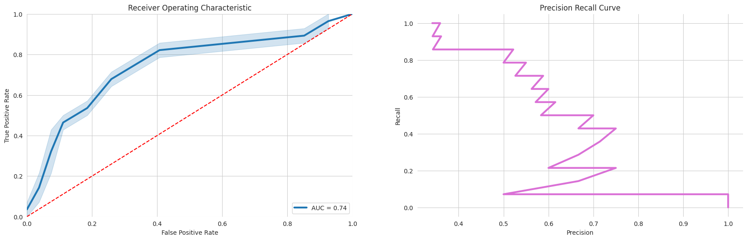
CODE:
import shap
from sklearn.ensemble import RandomForestClassifier # using random forest to explain for ease
rfc = RandomForestClassifier(max_features=2,n_estimators=100,bootstrap=True)
rfc.fit(train, y.iloc[train_index])
explainer = shap.TreeExplainer(rfc)
# calculate shap values. This is what we will plot.
shap_values = explainer.shap_values(test)
shap.summary_plot(shap_values, train, plot_size=(20,11), alpha=0.2, plot_type='bar')
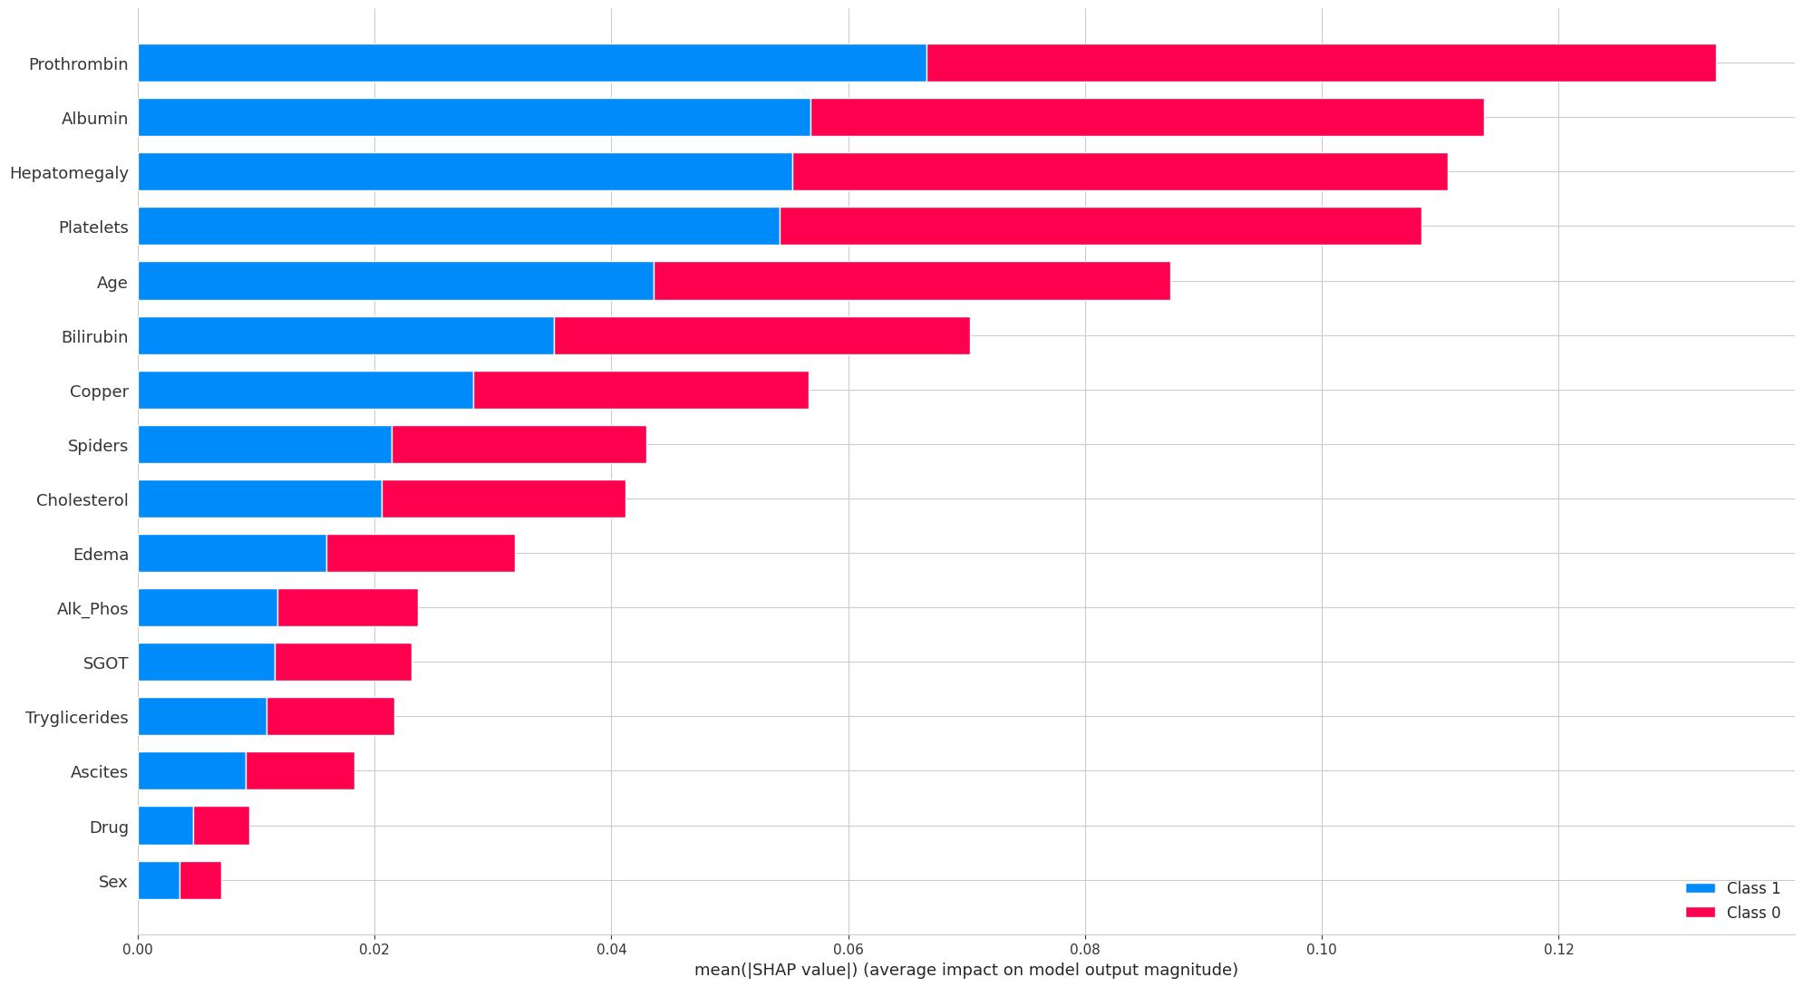

Conclusion
In conclusion, the XGBoost model outperforms the logistic regression model, providing a more accurate prediction of liver cirrhosis. Further analysis could delve into feature importance to understand which factors contribute the most to the prediction.

