**1**.**Download vechile sales data** -> <https://github.com/shashank-mishra219/Hive-Class/blob/main/sales_order_data.csv>

**2.** **Store raw data into hdfs location**

Hadoop fs -put /config/workspace/sales_order_csv /uday/

**3.** **Create internal sales_data table**

hive> create table sales_data_csv(

> Order_number int, Quantity_ordered int, Price_each float, Orderline_number int, Sales float,

> Status string, Qtr_id int, Month_id int, Year_id int, product_line string, msrp int, product_code string,

> phone string,city string,state string, postal_code string, country string,territory string,contact_last_name string,

> contact_first_name string, deal_size string)

> row format delimited

> fields terminated by ','

> tblproperties("skip.header.line.count"="1");

**4. load data into internal table**

hive> load data inpath '/uday/sales_order.csv' into table sales_data_csv;

**5. Create sales_data table in ORC format**

hive> create table sales_data_orc(

> Order_number int, Quantity_ordered int, Price_each float, Orderline_number int, Sales float,

> Status string, Qtr_id int, Month_id int, Year_id int, product_line string, msrp int, product_code string,

> phone string,city string,state string, postal_code string, country string,territory string,contact_last_name string,

> contact_first_name string, deal_size string)

> row format delimited

> fields terminated by ','

> stored as orc;

**6. load data into sales_data_orc from sales_data_csv table**

hive> insert overwrite table sales_data_orc as select * from sales_data_csv;

**PROBLEMS**

**a.Calculate total sales per year**

hive> select year_id,sum(sales) as total_sales_per_year from sales_data_orc group by year_id;



**b. Find a product for which maximum orders were placed**

hive> select product_line from (select sum(quantity_ordered) as high,product_line from sales_data_orc group by product_line order by high desc limit 1) as tmp;



**c.** **Calculate the total sales for each quarter**

hive> select qtr_id,round(sum(sales),2) as tot_sales from sales_data_csv group by qtr_id;

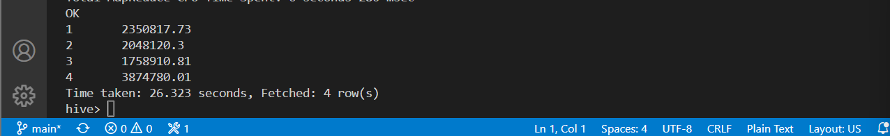

**d.** **In which quarter sales was minimum**

hive> select qtr_id from (select qtr_id,round(sum(sales),2) as tot_sales from sales_data_csv group by qtr_id order by tot_sales limit 1) as tmp;



**e.Which country sales was maximum & which country sales was minimum**

hive> select mis.country as minimum_sales ,mas.country as maximum_sales from (select country,sum(sales) as tot_sales from sales_data_orc group by country order by tot_sales limit 1) as mis,(select country,sum(sales) as tot_sales from sales_data_orc group by country order by tot_sales desc limit 1) as mas;



**f. Calculate quartelry sales for each city**

hive> select qtr_id,city,sum(sales) as tot_sales from sales_data_orc group by city,qtr_id ;

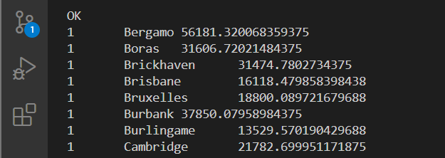

#ONLY FEW ARE DISPLAYED

**h.Find a month for each year in which maximum number of quantities were sold**

hive> with tmp as (select year_id,month_id,row_number()over(partition by year_id order by sum(quantity_ordered) desc) as row_num from sales_data_orc group by year_id,month_id) select year_id,month_id from tmp where row_num=1;

