**GDG PROJECT REPORT**

2 Credit Course

**Nikhil Verma (17BEC0440)**

**Abstract**

A GUI game has to be created in which whenever game starts, the game gives 10 randomly selected TV show names in jumbled format, the user has to predict the correct name of the TV show and accordingly gets 1 point per correct guess. In case of a wrong answer the game wont advance until a correct guess has been made.

**Introduction**

In this GUI game a list of 10 different TV shows are selected from a already existing TV shows pool, the elements in the list are then jumbled and then displayed in the GUI. Every correct guess rewards the player with one point, the GUI won’t move on the next phrase until the current one has been answered correctly. There is also a display of time which shows how many seconds it took to guess the complete list of TV shows.

**Methodology**

**Block Diagram**

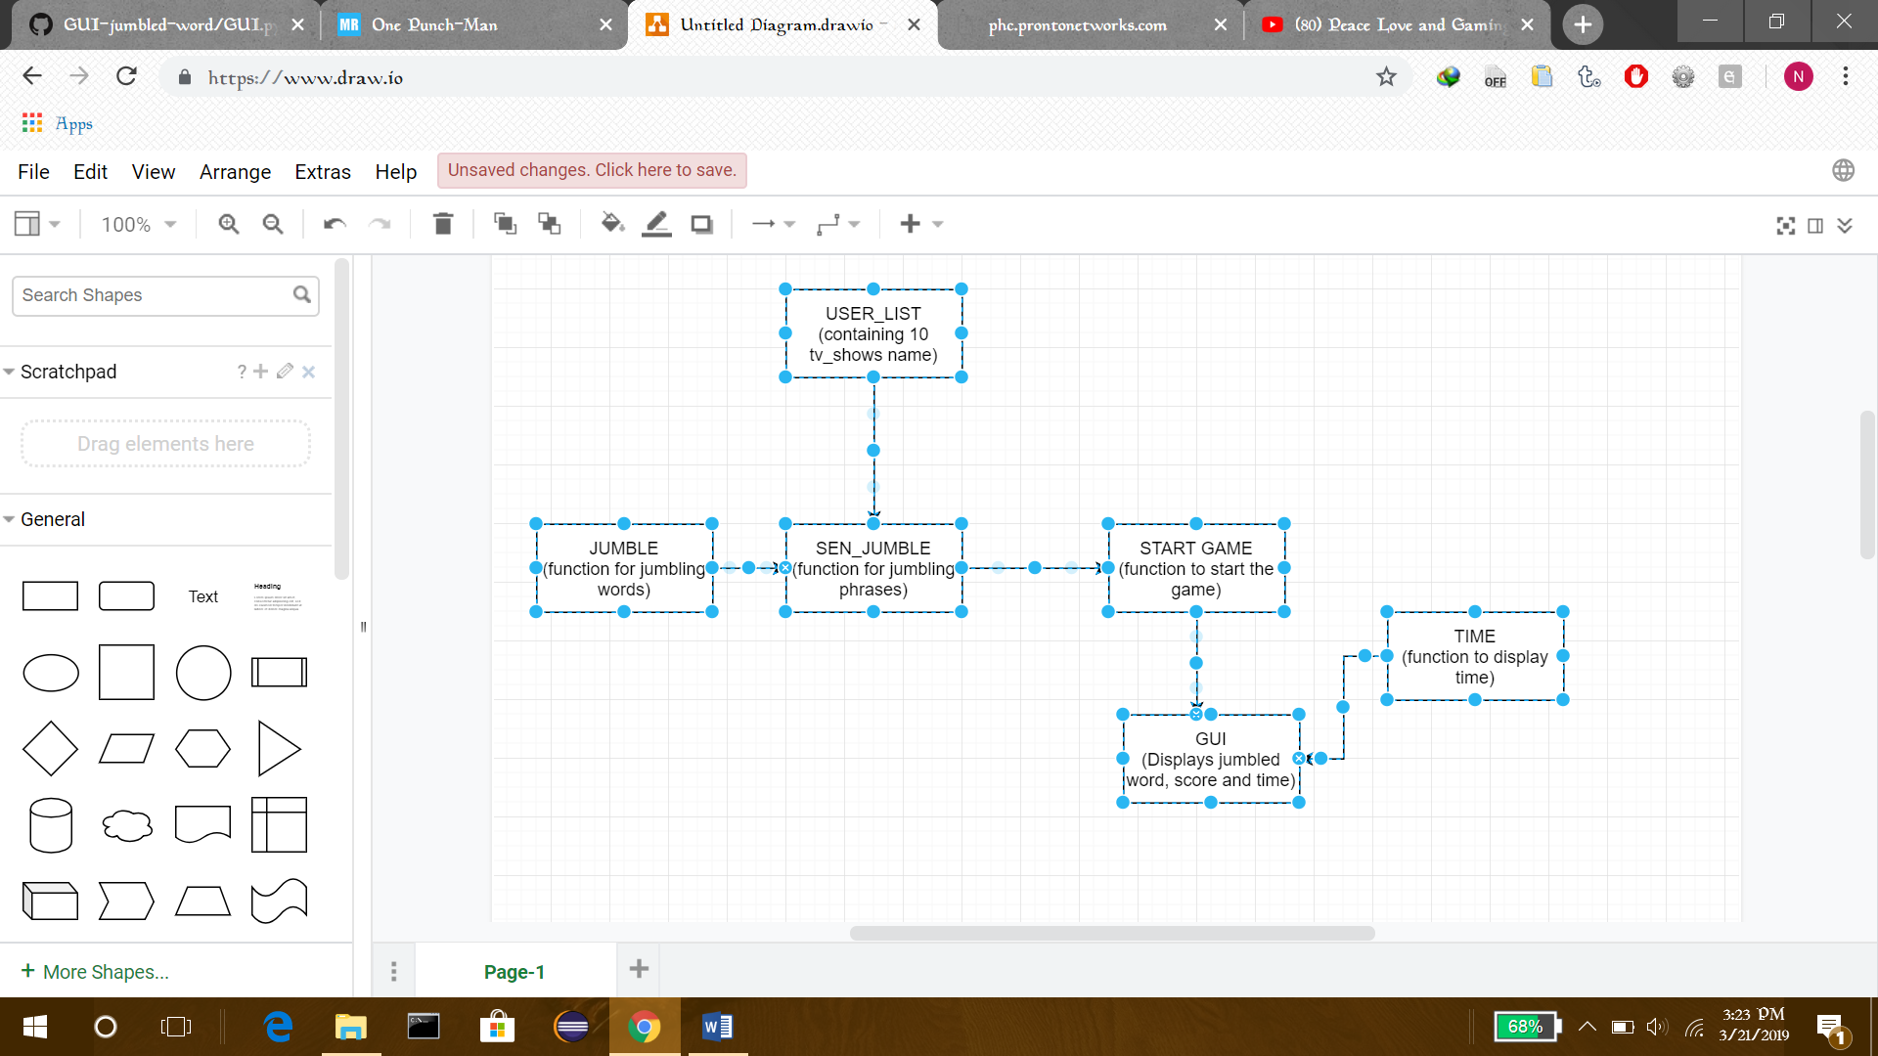

**Code**

*#GUI app logic*

*import random*

*from tkinter import \**

*tv_shows = ['Game of Thrones','Friends','How I Met Your Mother','Breaking Bad','Narcos','Flash','Arrow','Big Bang Theory','Walking Dead','Agents Of Shield','Blue Planet 2', 'Legion','The Grand Tour','Band Of Brothers','Westworld','Sherlock','The Punisher', 'True Detective', 'Daredevil','Luke Cage','Jessica Jones','Iron Fist','Stranger Things', 'Rick and Morty', 'House of Cards', '13 Reasons Why','House MD', 'Castle','Doctor Who','Dexter','Suits']*

*score = 0*

*user_list=[]*

*time= 0*

*for i in range(1,11,1): ***loop for chosing 10 random element from the*

*choice = random.choice(tv_shows) tv_shows list and appending them in the*

*user_list.append(choice) empty user_list \*\*\**

*tv_shows.remove(choice)*

*print(user_list)*

*def jumble(word): ***function for creating jumbled word*

*jum=" " in this first a string is taken then a*

*while word: letter is chosen from random position*

*pos=random.randrange(len(word)) in the string , and appended in a new*

*jum +=word[pos] variable , the string is then sliced*

*word=word[:pos]+word[(pos + 1):] to remove the already chosen letter*

*return jum \*\*\**

*def sen_jumble(w): *** function to jumble a phrase without*

*l=[] changing the order of the phrase\*\*\**

*for i in w:*

*new = jumble(i)*

*l.append(new)*

*l=" ".join(l)*

*return l*

*def start_game(event): *** function to start the game, in this first*

*timetaken() a list of jumbled phrases is made based on the user*

*jumb_list = [] list, this is then each word is compared with the*

*global score user made guess, here I have used score variable*

*for i in user_list: to iterate through the list with every instance run*

*r1 = sen_jumble(i.split()) of the game\*\*\**

*jumb_list.append(r1)*

*guess.focus_set()*

*word.config(text = "Jumbled Word => " + str(jumb_list[score]))*

*if guess.get().lower() == user_list[score].lower():*

*score += 1*

*score_display.config(text = str(score))*

*try:*

*word.config(text="Jumbled Word => " + str(jumb_list[score]))*

*except IndexError:*

*word.config(text="You Win!") *** here I have ran an exception because*

*score = 0 when score =11, it will show an index*

*guess.delete(0,END) error\*\*\**

*def timetaken(): *** function for displaying time in sec\*\*\**

*global time*

*if time>=0:*

*time += 1*

*timeout.config(text = "Time : "+ str(time))*

*timeout.after(1000, timetaken)*

*main = Tk()*

*main.title("Guess What")*

*main.geometry("550x300")*

*rules = Label(main, text="Guess the correct Tv-show name for the jumbled one shown, Press Enter to start the game",font = ('Times New Roman ',14),fg='Red')*

*rules.pack()*

*word = Label(main,font = ('Times New Roman bold', 14))*

*word.pack()*

*score_display = Label(main,font = ('Times New Roman bold', 13))*

*score_display.pack()*

*timeout = Label(main,font = ('Times New Roman', 13))*

*timeout.pack()*

*guess = Entry(main,font = ('Times New Roman', 13))*

*main.bind('<Return>',start_game)*

*guess.pack()*

*guess.focus_set()*

*main.mainloop()*

**Result**

The program displays a GUI, which shows a jumbled word, a text field for entering the guessed word, a score display and a time display in seconds.

**Problem faced**

1. Using just the jumble() function on a phrase resulted in a phrase which is not jumbled in a proper order.

**Solution:** Created a new function sen_jumble() which maintained the proper order of the jumbled phrases.

1. Kept getting index error because of the loop used , in which the variable used to iterate exceeded the number of elements in the list.

**Solution:** Removed the loop as the whole start_game() function would executed with every enter press, so no point in using a loop. Also created a try and except command to take into account the index error

**Conclusion**

The program has been created with all the desired condition

**References**

* <https://www.geeksforgeeks.org/color-game-python/>
* https://docs.python.org/3/library/tk.html