
Executive Summary
Customer Churn


Solomon bibinu

My current churn analysis has identified a critical revenue leak within the company’s most valuable customer segment: Fiber Optic users. This segment currently represents a $70,000 + monthly revenue risk.
To address this, I developed a predictive behavioral model and a targeted intervention framework. Simulations indicate that deploying this strategy can reduce churn volume by 34% in the target cohort, generating a projected $12,600 in monthly revenue savings (on the test pilot alone) with a 380% ROI on retention spend.

Strategic Diagnosis: Why Are They Leaving?
Data analysis revealed that churn was not random, it was structural and driven by two specific failures:
- The Protection gap:
  - Our highest-paying customers (Fiber Optic) are the least protected.
  - While they pay premium rates, 73% lack retention anchors (Online Security or Tech Support).
  - Insight: Customers with these anchors are less likely to churn and we are currently selling speed, not security

- The Month 1 Cliff:
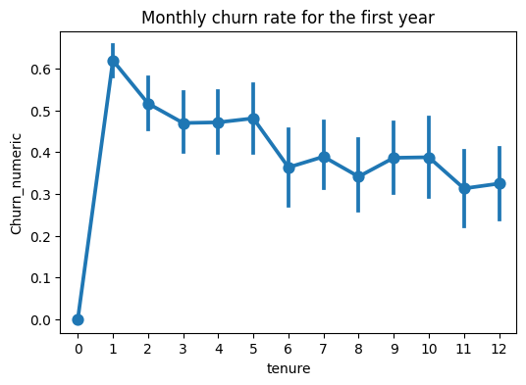
  - 60% of Month-to-Month users churn within the first 30 days.
  - Insight: This indicates a failure in onboarding or technical setup, rather than price sensitivity

The Solution: Predictive Retention Engine
Moving from reactive “save teams” to proactive intervention.
- The Mechanism: A Logistic Regression model tuned for Recall (72%). This ensures we capture 7 out of 10 at-risk customers before they cancel
- The Strategy:
- Immediate: Target vulnerable veterans (High Tenure, No Anchors) with a bundled security upgrade.
- Structural: Target High-Risk month-to-month users with incentive to migrate them to higher tenure contracts

Financial Impact and ROI Simulation
Two counterfactual simulations were conducted to forecast the financial impact of potential interventions.

Scenario A: Contract Migration
Objective: Address the structural root cause by migrating M2M users to 1-year contracts.
- Mechanism: Incentivize high-risk month to month users to upgrade to a 1-Year plan
- Projected Impact: Reduced churn volume by 34% (499 -> 328 churners).
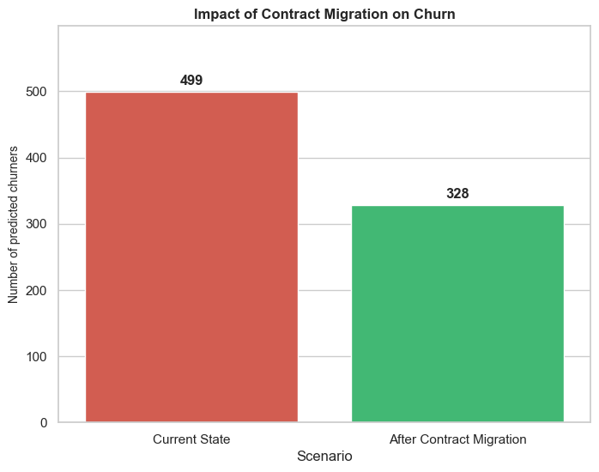
- Revenue Upside: ~$12,600 per month in retained revenue.
Scenario B: Targeted Retention Campaign
Objective: Stop the bleeding of churning customers via agent outreach or discounts.
- Investment Required: $14,400 (Modeled on a conservative $30/customer intervention cost).
- Projected Savings: $5,772/month (Assumes a 30% success rate in reconverting high-risk profiles)
- Payback Period: ~2.5 Months (Recurring savings fully cover the upfront cost in <90 days).
- 1-Year ROI: 380% (Based on the Lifetime Value of retained customers.)
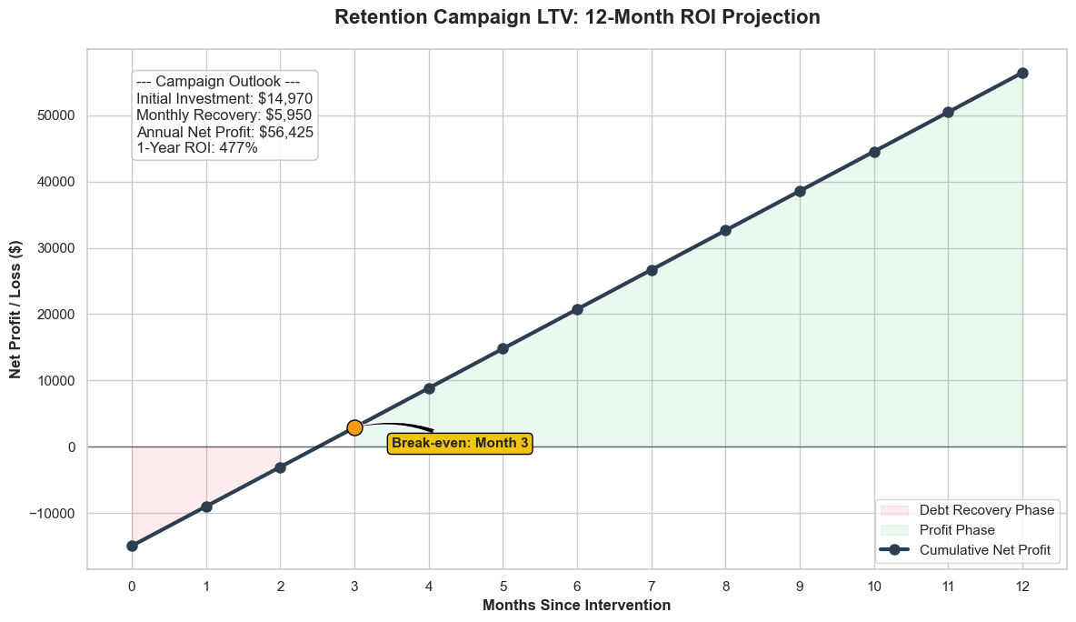This assumes the “saved” cohort extends their tenures by 12 months as in scenario A above.

