By: SOLOMON BIBINU

Technical Report:
Customer Churn Prediction and Retention Drivers

Table of Contents

1. Problem Definition and Business Context 3
2. Dataset Overview 5
3. Exploratory Data Analysis (EDA) 7
4. Feature Engineering 19
5. Data Preprocessing 21
6. Modeling Strategy 23
7. Model Evaluation 25
8. Business Impact and ROI Simulation 27
9. Limitations, Recommendations and Next Steps 30

Problem Definition and Business Context

Marketing spend represents a significant and recurring operational investment. In this dataset, weekly media expenditures across seven channels drive revenue, yet the incremental return on each dollar remains unquantified. When budget is allocated inefficiently, the business not only foregoes potential revenue but actively subsidizes low-impact activities at the expense of high-performing channels.
The core risk is "wasted spend." The objective is to predict the incremental sales impact of each marketing channel and to identify which media variables meaningfully drive weekly revenue fluctuations after controlling for seasonality, trend, and division-level heterogeneity.
From a business perspective, over-allocating to a low-impact channel is more costly than under-allocating to a high-impact one, because the former locks capital into diminishing returns while the latter merely delays upside. Therefore, my modeling approach prioritized accurate directional attribution (identifying which channels move the needle) over marginal gains in point-prediction accuracy.

The intended use of this model is budget scenario planning: enabling marketing leadership to simulate "what-if" spend reallocations before committing capital. Consequently, model stability and interpretability via SHAP were emphasized over black-box performance gains. The model is not designed for real-time bidding or causal inference, it is a decision-support tool for quarterly budget reviews.

Dataset Overview

The dataset contains ~120 weekly observations spanning approximately 2018–2020
The target variable, Sales, represents the total weekly revenue generated across all divisions.
Features were grouped into four main categories:
Category | Variables | Type after Processing | Purpose
Media Channels | paid_views, organic_views, google_impressions, facebook_impressions, email_impressions, affiliate_impressions, overall_views | All int64 | Quantify channel-level exposure volume
Temporal Controls | calendar_week, trend, month_* dummies | datetime / int | Separate organic growth and seasonality from media effects
Organizational Context | division (A–Z) | str → one-hot encoded | Control for regional/business-unit heterogeneity
Derived Features | *_adstock (post-engineering) | float | Capture carryover effects of media exposure

3. Exploratory Data Analysis (EDA)

3.1 Methodology:
To gain a clear understanding of the data and guide feature engineering, a structured EDA approach was employed:
- Univariate Analysis:
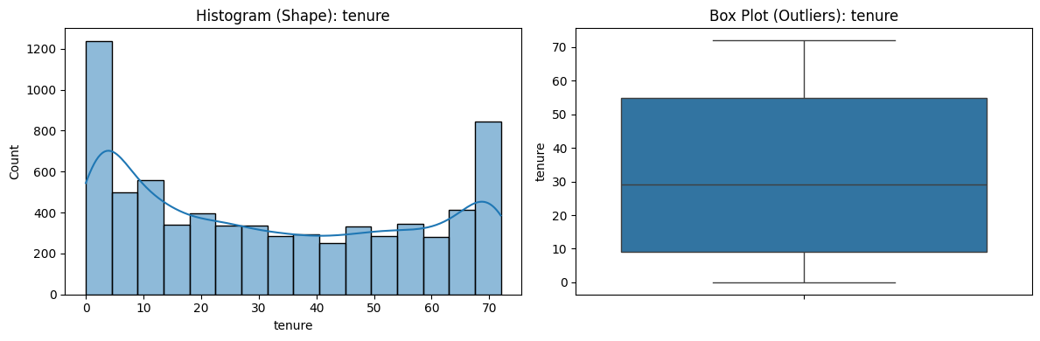
Examined the distribution of each feature individually to detect anomalies, skew and missing values. For categorical features, frequency counts and proportions were analyzed. For continuous features, histograms, boxplots and descriptive statistics were used
Tenure plots

- Bivariate Analysis:
Explored relationships between each feature and the target variable, Churn. For categorical features, churn rates were compared across groups. While continuous features were visualized against churn to identify trends
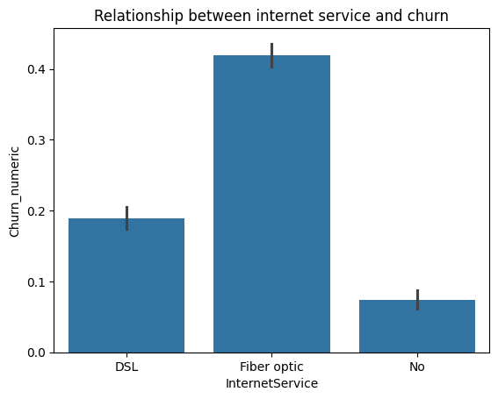

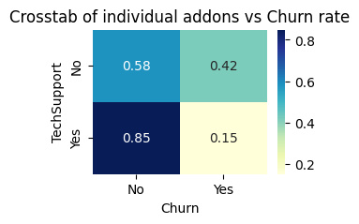

- Multivariate Analysis:
Investigated interactions between multiple features and their combined effect on churn. The analysis was structured around key business questions:

- Payment method vs. churn:
Examined which customer segments primarily use e-checks and whether this correlates with higher churn rates
- Customer Stickiness:
Identified the types of users exhibiting higher engagement or loyalty (“stickiness”) and explored factors contributing to this behavior.
- High Spender Churn:
Analyzed why approximately 70% of high-ARPU customers leave within a year, seeking patterns in service usage, contracts, and support features.
- Contract Tenure vs. conversion:
Investigated why customers on month-to-month contracts for several years do not convert to longer-term contracts, identifying potential barriers to retention.
- Service Type Concerns:
Assessed whether specific service types, such as fiber optic internet, inherently contribute to elevated churn risk.

This structured approach allowed for targeted insights that directly informed feature engineering and model design.

3.2 Insights:
Following the multivariate analysis framework, the following critical patterns were identified:
- Insight 1: The E-Check proxy effect:

  - Finding: Electronic Check users exhibit a churn rate of ~45%, significantly higher than the average churn rate of ~15-18% for automatic payment methods (Credit Card/Bank Transfer), and more than double the churn rate of Mailed Checks ~20% 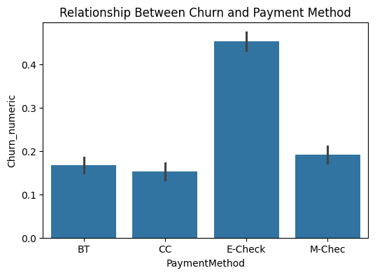
  - Root-Cause Analysis: Multivariate analysis revealed that this was a proxy for inherently risky customers, not a payment method issue.
    - ~67% of E-Check users are subscribed to fiber-optic (our highest churning product)
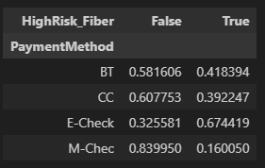
Crosstab showing the distributions of payment methods and Subscription to fiber optic

    - ~78% of E-Check users are on month to month contracts
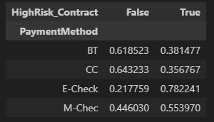
Crosstab showing the distributions of payment methods and contracts

    - ~66% of E-Check users also exhibit low stickiness (defined as <= 1 sticky service)
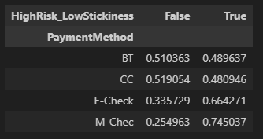
Crosstab showing the distributions of payment methods and Stickiness.

  - Business Implication: Simply changing payment options will yield limited ROI. Retention efforts must focus on migrating these users to longer-term contracts or bundling them with sticky services

- Insight 2: The Stickiness Ecosystem and the Retention Wall:
  - Finding: “Stickiness” (adoption of ancillary services) is not evenly distributed
    - Demographic Driver: Users with partners have a 50% higher stickiness score (mean of 1.53) than single users (mean of 1.01)
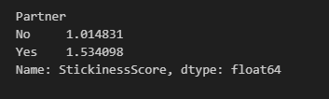
Crosstab showing the distributions of stickiness and partner status

    - The “Retention Wall”: Stickiness does not grow linearly. It remains sluggish (~0.55) -> (~0.94) for the first 24 months and then accelerates (to ~1.76) after the 2-year mark
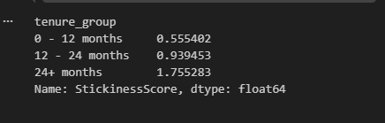
Crosstab showing the distribution of stickiness and tenure

  - The “Protection Gap”: There is a critical misalignment in our product tiers
    - DSL users (Lower ARPU): Highly embedded with “Retention Anchors” (Tech support/security)
    - Fiber users (Highest ARPU): ~56% have Streaming (Entertainment), but only ~27% have Online Security. We are selling our most expensive product with the weakest "lock-in" features.
  - Business Implication:
    - Immediate Action: Launch a "Year 2 Anniversary" campaign to pull stickiness forward into the 12-18 month window, rather than waiting for organic adoption.
    - Strategic Shift: Stop selling Fiber as just "Fast Internet." Sell it as "Secure Internet" by defaulting new Fiber sign-ups into a "Security First" bundle (Tech Support + Online Security) for the first 3 months to reduce early-life churn.

- Insight 3: The Month to Month paradox (High value, High risk)
  - Finding: Month-to-Month users have the highest average revenue per user (ARPU) ($66 vs. $60 for 2-year-contracts). However, this segment is structurally unstable due to two distinct failure modes.
    - Failure Mode A: The Month 1 “cliff” (Early Failure)
      - Data: ~60% of M2M users churn in the very first month with a further decline of ~50%, the next month however from here onwards, where users are statistically less likely to churn than to churn. However, at this point a vast number of the cohort is gone already (from 100% down to 30%) with a churn rate of ~45% until month 6
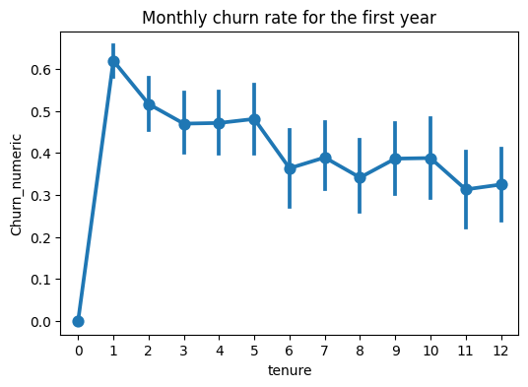
      - Root Cause: This immediate exit suggests an onboarding failure (expectations mismatch or technical issues) rather than price sensitivity.

    - Failure Mode B: The “Vulnerable Veteran” (Late Failure)
      - Data: A sub-segment of users with >24 months tenure remain on M2M contracts. They pay a premium (~$79 ARPU) monthly, yet 91% of them are “unanchored” (missing tech support/online security).
      - The Anchor Gap: While 79% of these users purchase some add-ons (mostly Streaming/Entertainment), 91% are "Unanchored" (lacking Tech Support or Online Security)
      - Risk: While these users are loyal, with them having – 0 stickiness score only 21% of the time, their churn (45%) risk remains 2.5x higher than anchored users (18%), despite their loyalty
  - Business Implication:
    - Fix the Onboarding: Audit onboarding flows for possible leaks and shift retention resources to days 0-60 as this has proven to be our most volatile period of the customer journey. Mandatory “Setup support” calls for new M2M users may mitigate the month 1 cliff.
    - Anchor the Veterans: Do not force the vulnerable veterans into long contracts (which adds friction). Instead, incentivize them to add one anchor service (e.g., "Free Tech Support Upgrade") to lock them in via product utility.

- Insight 4: The “Unprotected” High spenders
  - Finding: High-spending new customers (>$75/mo.) represent a "High Value / High Risk" paradox, churning at a rate of ~70% within the first year.
    - Spend vs. Churn: The high churn correlates linearly with increased spend, indicating this is not a budget issue (lack of funds) but a value realization issue (lack of perceived utility.)
  - The “Stickiness” void:
    - Data: A staggering 82% of these high-value users fall into the “Low-Stickiness” zone (~55% chance of churn) with 0-1 sticky services.
    - Risk Multiplier:
      - Users with 0 stickiness churn at 65%
      - Adding just one service drops churn to 46%
    - Conclusion: We are successfully upselling them on price, but failing to cross-sell them on Retention Anchors. We have successfully captured their wallet, but not their loyalty
  - Service Spread Analysis (The Adoption Mismatch):
    - Finding: First year high spenders are spending money on the wrong ancillary services. There is a massive misalignment between what they buy and what actually retains them.
      - The “Placebo” Products:
        - High Adoption: Online Backup (~24%) and Device Protection (~29%) are the most popular add-ons.
        - Low Impact: These services are statistically ineffective at preventing churn for this cohort (Churn remains extremely high at ~67-68% even with them.)
      - The “Real” Anchors:
        - Low Adoption: Only ~13% subscribe to Online Security and ~14% to Tech Support.
        - High Impact: These services provide a statistically significant “Retention Shield”, dropping churn risk to ~54-57%
    - Conclusion: We have a 15 point adoption gap. Out highest value customers are opting for passive “insurance” (backup/device protection) rather than active “utility” (security/support). This suggests our onboarding flow pushes the wrong upsells
    - Business Implication:
      - Re-Rank Upsells: Update the sales script and website UI to prioritize Online Security and Tech Support as the default add-ons for high-tier plans.
      - Bundle Logic: Create a new “Customer Safety Pack” that bundles tech support with device protection. Use the popularity of the device protection to “Trojan Horse” the Tech support service that actually makes them stay

4. Feature Engineering

Driven by the strategic insights from the EDA, the feature engineering process focused on capturing behavioral risk rather than just raw metrics. The goal was to transform business logic (e.g. “The Protection Gap”) into model-ready inputs.
4.1. Retained Engineered Features:
- Is_Anchored: A Boolean flag, identifying users subscribed to both Tech Support and Online Security.
  - Rationale: EDA showed that while “Stickiness” (count of services) was generally good, these two services specifically acted as a distinct “Retention Shield”, whereas other services (like streaming) do not.
4.2. Tested but Dropped Features:
- StickinessScore: Dropped. The model performed better with the specific binary is_anchored flag than a raw count of services, further proving that the quality of service matters more than the quantity of services.
- High_ARPU_Newbie: Dropped. The model successfully inferred this risk profile from the interaction of MonthlyCharges and Tenure, without needing a hard-coded flag. Testing this feature also slightly dropped both recall and precision by 0.1, hence it was binned
- Charges_by_Tenure: Dropped due to introduced noise

4.3 Features for Analysis only (EDA)
Certain features were created strictly to aid visual analysis and business segmentation but were excluded from the training pipeline to avoid data redundancy (multicollinearity)
- Binning Features: tenure_group, MonthlyCharges_group
- Risk Flags: HighRisk_Fiber, HighRisk_Contract, HighRisk_LowStickiness
- Rationale: These concepts were already captured by the model through the raw features (tenure, InternetService, Contract) and their coefficients. Feeding the bins alongside the raw data would cause information duplication

5. Data Preprocessing

To ensure model generizability and prevent data leakage, a rigorous preprocessing pipeline was implemented prior to training.
- 5.1 Manual Binary Encoding:
Variables with a simple Yes/No structure (e.g., Partner, PhoneService, is_anchored), were manually mapped to binary format (Yes=1, No=0).
This ensured consistent handling of custom Boolean flags created during feature engineering
- 5.2 One-Hot Encoding(with Multicollinearity Prevention):
  - Nominal variables(e.g., PaymentMethod, InternetService) were converted using pd.get_dummies
  - The parameter drop_first = True was applied. This removes the first category of each variable.
  - Rationale: This prevents Perfect Multicollinearity (The Dummy Variable Trap), which is critical for linear models like Logistic Regression to function correctly.
- 5.3 Train-Test Split (Stratified):
  - The dataset was split into training (80%) and testing (20%) sets.
  - Stratification was used to ensure the churn distribution (26%) remained consistent across both sets, preventing a non-representative test set
- 5.4 Feature Scaling:
  - StandardScaler was applied to the continuous features (tenure, MonthlyCharges) to normalize their range. This ensures numerical stability and allows coefficient magnitudes to be meaningfully compared.
  - Leakage Prevention: The scaler was fitted only on the training set and then applied to the test set. This ensures that statistical information from the test set (mean/variance) did not leak into the model training process

6. Modeling Strategy

The modeling phase prioritized performance on the minority class (churners) and interpretability
- 6.1 Algorithm Selection: Logistic Regression
  - Choice: Logistic regression was selected as the final model.
  - Performance Lead: Logistic Regression consistently outperformed the challenger model (Random Forest). During validation, Random Forest exhibited material degradation in minority-class performance, particularly in recall, despite the increased model complexity
  - Rationale: The dataset contains strong linear risk factors (e.g., Price increase correlates to higher churn risk). The Random Forest model likely struggled to generalize these relationships given the class imbalance, whereas the weighted logistic regression successfully captured the signal.
  - Interpretability: Beyond performance, Logistic regression offered transparent coefficients (e.g., quantifying exactly how much “Fiber Optic” increases the odds of churn), which is critical for explaining the model to stakeholders.

- 6.2 Handling Class Imbalance:
  - Method: The model was configured with (class_weight = ‘balanced’).
  - Mechanism: This hyper parameter automatically adjusts weights inversely proportional to class frequencies. It penalizes the model more heavily for missing a “Churner” than for flagging a “Non-Churner”.
  - Business Logic: This aligns with the financial reality that the cost of missing a churner ($74/month ARPU + LTV) is significantly higher than the cost of a retention intervention.

7. Model Evaluation

The model performance was evaluated based on the financial trade-off between precision and recall, rather than raw Accuracy.
- 7.1 Key Metrics:
  - Recall (~72%): The model correctly identifies 72 out of every 100 churners. This was the primary optimization target to minimize revenue leakage.
  - Precision (~54%): When the model predicts churn, it is correct 54% of the time. While statistically moderate, this represents a >2x Lift relative to the baseline churn rate (26%).
  - ROC-AUC (0.84): This indicates strong separability between the classes, confirming the model can effectively rank customers by risk.
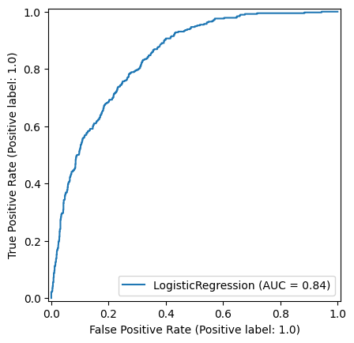
- 7.2 The strategic Trade-Off:
  - A lower precision (more “False Alarms”) was accepted to maximize recall as the cost of missing a churner exceeds that of retaining a non-churner
  - Business Justification: Intervening on a “False positive” remains cost effective, because retention efforts are cheaper than acquiring a new customer.

These metrics indicate that the model effectively prioritizes high-risk customers for proactive retention, supporting targeted interventions.

8. Business Impact and ROI Simulation

To translate model performance into business value, a profitability simulation was conducted on the test set. This simulation estimates the operational impact of deploying the model for a targeted retention campaign.

8.1 Simulation Assumptions
- Revenue at Risk (ARPU): $74 (Average monthly spend of predicted churners).
- Intervention Cost: $30 per customer (Estimated cost of a discount, incentive or agent time
- Retention Success Rate: 30% (Conservative benchmark, assumes every 1 in 3 contacted churners is saved)
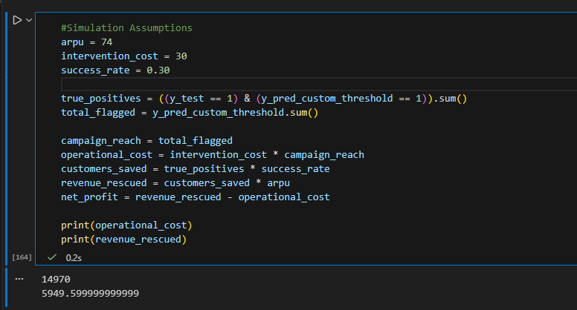

8.2 The Calculation
Using the model’s precision of ~54% and recall of ~72%,
- Campaign Reach: The model flags ~480 high-risk customers in the test set.
- Operational Cost: Contacting these 480 customers costs $14,400 ($30 * 480)
- True Churners Found: Within this group, ~260 are actual churners (True Positives).
- Customers Saved: With a 30% success rate, we retain ~78 customers (260 * 0.3)
- Monthly Revenue Rescued: These 78 customers represent $5,772 in monthly recurring revenue ($74 * 78)

8.3 ROI Conclusion
- Net Monthly Benefit (Month 1): -$8,628 (Initial investment).
- Payback Period: ~2.5 Months. The recurring revenue saved ($5,772/mo.) fully covers the one time intervention cost ($14,400) midway through the third month.
- 12-Month LTV Impact:
  - If the saved customers stay for 1 year, the total revenue rescued is ~$69,264.
  - This yields a ~380% ROI on the $14,400 spend over a 12-month horizon
- Strategic Verdict: While this campaign requires upfront working capital, it is highly profitable on a Lifetime Value (LTV) basis. It trades a one-time expense for long-term recurring cash flow.

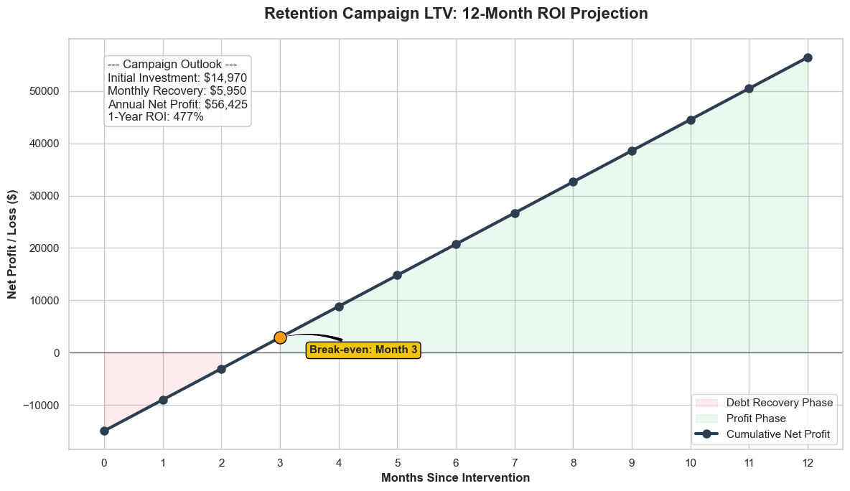

9. Limitations, Recommendations and Next Steps

While the current model delivers immediate ROI, the analysis acknowledges specific constraints and outlines a roadmap for future optimization.
9.1 Strategic Recommendations:
Based on the model’s findings and counterfactual simulations, two actions are recommended:
- The Anchor Campaign:
  - Action: Target “Vulnerable Veterans” (High tenure, Month-to-Month) with a bundle offer for Online Security or Tech Support.
  - Rationale: EDA confirmed these services act as a retention shield, significantly lowering churn probability for fiber users.
- The Contract Migration Strategy (Validated via Simulation):
  - Action: Target high risk Month to Month users with a “12th Month Free” offer to incentivize upgrading to a 1 year contract.
  - Model Validation: I ran a counterfactual simulation on the test set, artificially migrating all high-risk users to a 1 year contract.
  - Result: The model predicts this single action would reduce churn volume by ~34% (499 -> 328 churners).
  - Financial Impact: This represents a potential $12,600 monthly revenue retention upside on the test population alone

9.2 Technical Limitations
- Snapshot View vs. Time-Series: The dataset treats customer behavior as a static snapshot. There is no capture of temporal trends (e.g. “Usage dropped by 50% last month”), which Is often a leading indicator of churn.
- Correlation vs. Causation: While the model successfully identifies who is at risk, it is heavily reliant on correlation. High pricing correlates with churn, but reducing pricing isn’t guaranteed to fix it if the root cause is poor service quality.
- Intervention Assumptions: The ROI analysis assumed a flat 30% success rate for retention offers. This is a heuristic; actual pilot data will be required to calibrate the true lift of specific interventions

