By: SOLOMON BIBINU

Technical Report:
Customer Churn Prediction and Retention Drivers

Customer churn represents a direct and recurring revenue loss. In this specific dataset, I identified a high-risk cohort (Month-to-Month Fiber users) representing over $70,000 in monthly recurring revenue exposure.
When a customer leaves, the business not only loses future cash flow but often incurs additional costs for new customer acquisition. As a result, reducing churn is typically far more cost-effective than driving new customer acquisition.
Churn is defined as a binary outcome indicating whether a customer discontinued the service during the observed period. The objective thereby is to predict which active customers are at the highest risk of churning and to identify behavioral and contractual factors that meaningfully influence that risk.
From a business perspective, failing to identify a churner is more costly than incorrectly flagging a non-churner. Therefore, my objective while modeling prioritized high recall on churners, while maintaining a sufficient precision which allows targeted retention efforts to remain operationally feasible.

The intended use of this model is decision making support: enabling retention teams to proactively engage a subset of high-risk customers with targeted interventions. Consequently, model interpretability and stability were emphasized over marginal gains in predictive performance.
The dataset contains 7,043 customers with 20 features, including demographics, service usage patterns, contract details, and billing information.
The target variable, Churn, is Boolean, indicating whether a customer discontinued the service (Yes) or remained active (No) during the observed period.
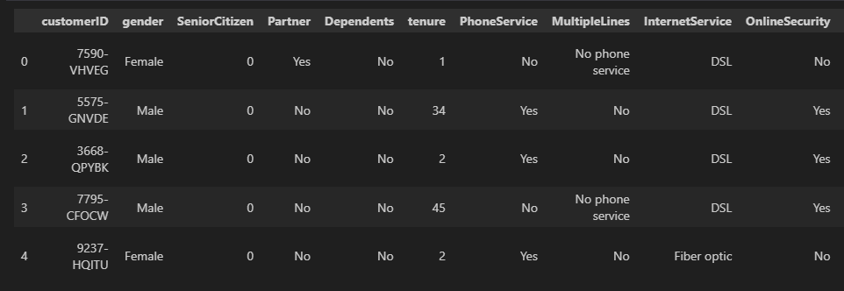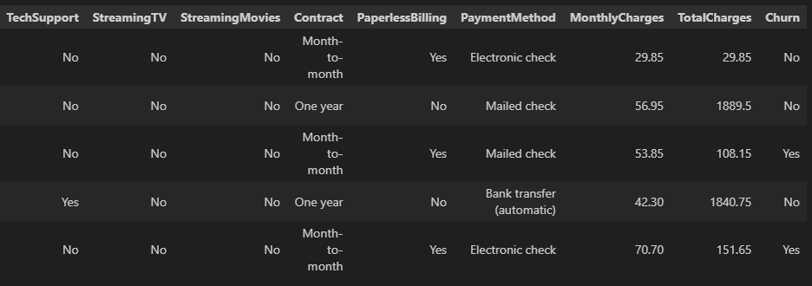

Features were grouped into four main categories:
- Demographics (e.g., tenure, age, gender),
- Service usage (e.g., Internet Service type, Tech Support, Online Security),
- Contract and Billing (e.g. Contract type, monthly charges, total charges), and
- Derived metrics such as ARPU-related features.

Redundant and highly correlated columns (e.g. Customer ID) were removed to avoid inflating model complexity, including derived totals and simple bins. Several engineered features were tested but excluded due to minimal predictive gain, such as Stickiness Score and Charges_by_Tenure, demonstrating a deliberate and disciplined feature selection process.
The dataset exhibits a churn rate of approximately 26%, creating a moderately imbalanced classification problem that informed subsequent modeling choices.

3.1 Methodology:
To gain a clear understanding of the data and guide feature engineering, a structured EDA approach was employed:
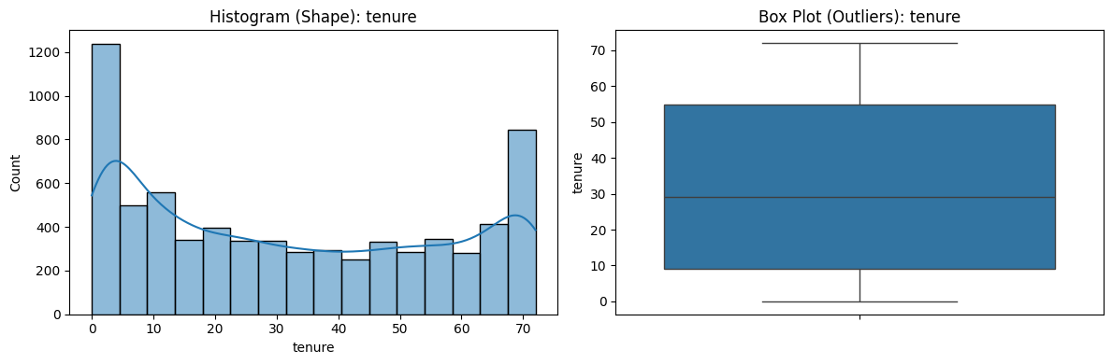
- Univariate Analysis:
Examined the distribution of each feature individually to detect anomalies, skew and missing values. For categorical features, frequency counts and proportions were analyzed. For continuous features, histograms, boxplots and descriptive statistics were used
Tenure plots, this is a regular distribution type for this type of data

- Bivariate Analysis:
Explored relationships between each feature and the target variable, Churn. For categorical features, churn rates were compared across groups. While continuous features were visualized against churn to identify trends

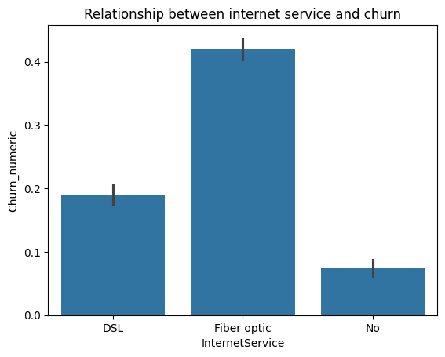

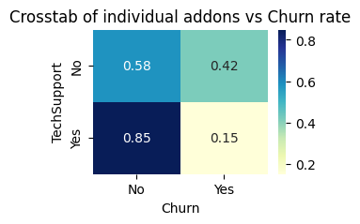

- Multivariate Analysis:
Investigated interactions between multiple features and their combined effect on churn. The analysis was structured around key business questions:

- Payment method vs. churn:
Examined which customer segments primarily use e-checks and whether this correlates with higher churn rates
- Customer Stickiness:
Identified the types of users exhibiting higher engagement or loyalty (“stickiness”) and explored factors contributing to this behavior.
- High Spender Churn:
Analyzed why approximately 70% of high-ARPU customers leave within a year, seeking patterns in service usage, contracts, and support features.
- Contract Tenure vs. conversion:
Investigated why customers on month-to-month contracts for several years do not convert to longer-term contracts, identifying potential barriers to retention.
- Service Type Concerns:
Assessed whether specific service types, such as fiber optic internet, inherently contribute to elevated churn risk.

This structured approach allowed for targeted insights that directly informed feature engineering and model design.

3.2 Insights:
Following the multivariate analysis framework, the following critical patterns were identified:
- Insight 1: The “E-Check” proxy effect:
  - Finding: Electronic Check users exhibit a churn rate of ~45%, significantly higher than the average churn rate of ~15-18% for automatic payment methods (Credit Card/Bank Transfer). 