

AEGIS: SMART CHILD SAFETY BAND
by
Barira Sarfraz
Nabeeha Zahid
Supervisor
Dr. Altaf Hussain

Department of Computer Science
Institute of Space Technology, KICSIT Kahuta Campus
January 2026



AEGIS: SMART CHILD SAFETY BAND
by
Barira Sarfraz
Nabeeha Zahid
Supervisor
Dr. Altaf Hussain
APPROVAL BY BOARD OF EXAMINERS
__________________
Dr Altaf Hussain
Supervisor
Committee Members
______________  Assistant Professor CS | ________________  Assistant Professor CS
_______________  Assistant Professor CS | ______________  Lecturer
______________________
Dr. Sehrish Khan Tayyaba
Project Coordinator

______________________
Dr. Altaf Hussain
HoD. Computer Science

_____________________________
Prof. Dr Syed Nasir Mehmood Shah
Head of Academics, KICSIT

AUTHORS DECLARATION
I take full responsibility of the research work conducted during the thesis titled “AEGIS: Child Safety Band”.
I solemnly declare that the research and development work presented in the thesis is done solemnly by me with no significant help from any other person; however, small help wherever taken is duly acknowledged. I have also written the thesis by myself. Moreover, I have not presented this thesis or any part of the thesis previously to any other degree awarding institution within Pakistan or abroad.
I understand that the management of IST has a zero-tolerance policy towards plagiarism. Therefore, I as an author of the above mentioned thesis solemnly declare that no portion of my thesis has been plagiarized and any material used in this Thesis does not contain any literal citing (verbatim) of more than 70 words (total) even by giving a reference unless I have obtained the written permission of the publisher to do so. Furthermore, the work presented in the thesis is my own original work and I have positively cited the related work of the other researchers by clearly differentiating my work from their relevant work.
I further understand that if I am found guilty of any form of plagiarism in my thesis work even after my graduation, the institute reserves the right to revoke my BS degree. Moreover, the Institute will also have the right to publish my name on its website that keeps a record of the students who plagiarized in their thesis work.
______________________
Nabeeha Zahid

______________________
Barira Sarfaraz

I hereby acknowledge that submitted thesis is final version and should be scrutinized for plagiarism as per IST policy

_____________________
Dr. Altaf Hussain

Dated: _________________

_____________________________
Verified by Plagiarism Cell Officer
Dated: _________________
CERTIFICATE
This is to certify that the research work described in this thesis is the original work of the author and has been carried out under my direct supervision. I have personally gone through all the data/results/materials reported in the manuscript and certify their correctness/authenticity. I further certify that the material included in this thesis is not plagiarized and has not been used in part or full in a manuscript already submitted or in the process of submission in partial/complete fulfillment of the award of any other degree from any institution. I also certify that the thesis has been prepared under my supervision according to the prescribed format and I endorse its evaluation for the award of Bachelor of Science in Compute Science degree through the official procedures of the Institute.

____________________
Dr Altaf Hussain

Copyright © 2026
This document is jointly copyrighted by the authors and the Institute of Space Technology (IST). Both authors and IST can use, publish or reproduce this document in any form. Under the copyright law no part of this document can be reproduced by anyone, except copyright holders, without the permission of authors.

DEDICATION
This research work is dedicated to our beloved Parents and Teachers and Friends who supported and motivated us in tough times and made us into what we are today.

Abstract
Child safety is a persistent challenge in Pakistan, where risks such as abduction, health emergencies, and delayed response mechanisms continue to endanger children due to the lack of reliable, real-time monitoring solutions. Existing technologies including commercial smartwatches, GPS trackers, and GSM-based panic systems are often expensive, internet-dependent, reactive in nature, and designed for adults, making them unsuitable for comprehensive child safety. AEGIS (Advanced Emergency Guardian and Intelligent Safety) proposes a preventive, child-centric wearable system that continuously monitors physiological signals and location to autonomously detect distress situations. The system integrates heart rate and SpO₂ monitoring, stress detection through galvanic skin response, non-contact body temperature sensing, and GPS-based geofencing, all managed by an ESP32-S3 microcontroller capable of lightweight on-device machine learning inference. A hybrid communication model using GSM and mobile application connectivity ensures timely alert delivery even in internet-limited environments. This design-phase project presents a complete architectural blueprint of AEGIS, including hardware selection, software architecture, system modeling, and data flow design, laying a robust foundation for future implementation of an affordable and reliable child safety solution tailored to local constraints.
Keywords:
Child Safety, Health Monitoring, Real-time Alert System, Embedded Systems, Machine Learning, Edge Computing, Physiological Sensors, Heart Rate Monitoring, Temperature Sensing, Stress Detection, Galvanic Skin Response, GPS Tracking, Geofencing, GSM Communication, Mobile Application, Anomaly Detection

Table of Contents
1. Introduction 2
1.1. Background and Context 2
1.2. Problem Statement 3
1.3. Motivation and Rationale 5
1.4. Project Objectives 6
1.5. Project Scope and Limitations 7
1.6. Document Organization 9
2. Background Information 12
2.1. Wearable Technology: Evolution and Current State 12
2.2. Internet of Things in Healthcare and Safety Applications 13
2.3. GSM Communication Systems and Their Advantages in Developing Nations 15
2.4. Physiological Signal Monitoring: Principles and Technologies 17
2.5. Embedded Machine Learning and Edge Intelligence 21
2.6. GPS Technology and Geofencing Implementation 23
2.7. Challenges in Child-Centric System Design 25
3. Related Work and Literature Review 30
3.1. Commercial Wearable Devices for Children 30
3.1.1. Academic Research Systems 33
3.2. Machine Learning in Wearable Health Monitoring 35
3.3. Comparison and Gap Analysis 38
4. System Design 43
4.1. Problem Statement 43
4.1.1. Limitations of Current Systems 43
4.1.2. Need for an Integrated, Low-Cost, Edge-Intelligent Solution 43
4.2. Overall Architecture Overview 44
4.2.1. System Topology 44
4.2.2. Component Interaction 44
4.2.3. Design Principles 45
4.3. System Actors and Roles 45
4.3.1. Parent/Guardian Role 45
4.3.2. Child (Wearable Band) 45
4.3.3. Cloud Backend 46
4.4. Communication and Data Design 46
4.4.1. Sensor-to-Edge Communication 46
4.4.2. Edge-to-Cloud Communication 46
4.4.3. Cloud-to-App Communication 47
4.5. Data Model 47
4.5.1. Parent and Child Profiles 47
4.5.2. Vital Records 47
4.5.3. Location Records and Geofencing 47
4.5.4. Alerts 48
4.5.5. Device State (AEGIS Band) 48
4.5.6. Data Lifecycle and State Management 48
4.6. Processing and Alert Flow 48
4.6.1. Sensing Phase 48
4.6.2. Edge Inference Phase 49
4.6.3. Transmission Phase 49
4.6.4. Alert and Notification Phase 49
5. Diagram Descriptions 51
5.1. Use Case Diagram 51
5.2. Descriptive Use Cases 53
5.3. Software Architecture Diagram 58
5.3.1. Architectural Layers 58
5.4. Entity Relationship Diagram and Database Design 59
5.5. Activity Diagram 60
5.5.1. Key Decisions and Flows 61
5.6. Sequence Diagram 62
5.7. Class Diagram 69
6. Implementation 71
6.1. Implementation Overview 71
6.2. Development Tools and Technologies 71
6.3. Wearable Firmware Implementation 72
6.3.1. Sensor Acquisition and Task Scheduling 72
6.3.2. Edge Anomaly Detection 73
6.3.3. Power Management and Alert Triggering 74
6.4. Network and Communication Implementation 74
6.5. Backend Implementation 75
6.5.1. Firebase Database Structure 75
6.5.2. Authentication and Push Notifications 76
6.6. Mobile Application Implementation 77
6.7. Summary 78
7. Testing 79
7.1. Overview 79
7.2. Verification and Validation 79
7.3. Testing Strategy and Tools 80
7.4. Unit Testing the Firmware 81
7.4.1. Test Harness 81
7.4.2. Coverage 81
7.4.3. Sensor Calibration and Accuracy Testing 82
7.5. Unit Testing the Mobile Application and Backend Integration 83
7.6. Hardware Prototype Testing 83
7.6.1. Sensor Integration Testing 83
7.6.2. Communication and Fallback Testing 84
7.6.3. Power and Battery Testing 84
7.7. Integration and System Testing 84
7.8. Representative Test Cases 84
7.8.1. Detailed Test Cases 85
7.9. A Sample Testing Cycle 90
7.10. Scope and Limitations of Testing 90
7.11. Summary 91
8. Conclusion and Future Work 92
8.1. Summary of the Work 92
8.2. Key Contributions 92
8.3. Limitations 93
8.4. Future Work 94
8.5. Closing Remarks 95
References 95

List of Figures
Figure 1 Use Case Diagram 52
Figure 2 Architecture Diagram 59
Figure 3 Entity Realtionship Diagram 60
Figure 4 Activity Diagram 62
Figure 5 ESP32 Wearable (Edge Processing) 64
Figure 6 Firebase Backend 65
Figure 7 GSM Module (SMS Alert) 66
Figure 8 Parent/Guardian App (Part 1 of 2) 67
Figure 9 Parent/Guardian App (Part 2 of 2) 69
Figure 10 Class Diagram 69

List of Tables
Table 1 Comparison of Existing Child Safety Solutions 38
Table 2: View Real-Time Vitals 53
Table 3: Monitor Heart Rate and SpO₂ 54
Table 4: Monitor Body Temperature 55
Table 5: Monitor Stress Level (GSR) 56
Table 6: View Live Location and History 57
Table 7: Development Tools and Technologies by Layer 71
Table 8: Sensor Interfaces and Driver Libraries 73
Table 9: Communication Path Selection Logic 75
Table 10: Firebase Realtime Database Structure 76
Table 11: Mobile Application Screens and Firebase Interactions 77
Table 12: Testing Tools and Frameworks by Layer 80
Table 13: Firmware Unit Test Coverage Summary 81
Table 14: Hardware Sensor Accuracy Test Plan 82

List of Abbreviations
AEGIS Advanced Emergency Guardian and Intelligent Safety
API Application Programming Interface
BLE Bluetooth Low Energy
BPM Beats Per Minute
CSV Comma-Separated Values
DXA Twentieths of a Point (measurement unit)
ESP32 Espressif Systems 32-bit Microcontroller
FIFO First In First Out (buffer)
GDOP Geometric Dilution of Precision
GPS Global Positioning System
GPRS General Packet Radio Service
GSM Global System for Mobile Communications
GSR Galvanic Skin Response
HAL Hardware Abstraction Layer
HTML HyperText Markup Language
HTTP HyperText Transfer Protocol
HTTPS HyperText Transfer Protocol Secure
I²C Inter-Integrated Circuit (communication protocol)
IoT Internet of Things
IST Institute of Space Technology
JSON JavaScript Object Notation
JWT JSON Web Token
Li-Po Lithium Polymer (battery)
MEMS Micro-Electromechanical Systems
ML Machine Learning
MQTT Message Queuing Telemetry Transport
MVVM Model-View-ViewModel (design pattern)
NMEA National Marine Electronics Association (protocol)
PDF Portable Document Format
PKR Pakistan Rupee
PPG Photoplethysmography
REST Representational State Transfer
RMSSD Root Mean Square of Successive Differences
SDNN Standard Deviation of NN Intervals
SMS Short Message Service
SpO₂ Peripheral Oxygen Saturation
TDMA Time Division Multiple Access
TLS Transport Layer Security
UART Universal Asynchronous Receiver-Transmitter
UI User Interface
URL Uniform Resource Locator
USB Universal Serial Bus
WiFi Wireless Fidelity (wireless networking)
XML Extensible Markup Language

CHAPTER 1
INTRODUCTION

Introduction

Background and Context
Child safety is one of the most crucial topics of the contemporary society, and it does not depend on geographical, economic, and cultural barriers. Nevertheless, the education levels and socioeconomic conditions of different areas differ greatly in the type and severity of threats to children. Child welfare and child safety are the main priorities in the country since in Pakistan, a developing country with a population of over 230 million people, it is estimated that forty percent of this population comprises children and as such, child welfare and child safety is the primary concern of the country. This demographic fact has exposed the children to inadequate, disjointed, and technologically backward infrastructure and systems meant to safeguard them. All the challenges are complex and comprise physical security threats like kidnapping and trafficking plus forcing and exploitation; health crises due to chronic health problems, acute illness, or natural hazards; incidental injuries in uncontrolled settings; and mental distress because of various factors such as bullying, abuse, or separation anxiety.
Traditional methods of child safety have been based mostly on supervision of the children by the adults, physical barriers, and reactive responses of the institutional framework. Although parental vigilance is never a substitute, the pressures of present day living often force children to spend large amounts of time in semi-supervised or barely supervised settings such as educational institutions, recreational centers, even transportation systems and even at home where parents may be off working or doing their household chores. This supervision loophole leads to the provision of windows of vulnerability whereby children might get themselves in emergencies without the immediate adult notice or capability to intervene. Moreover, despite the presence of adults, the fact that it is impossible to constantly check the physiological condition of a child, means that diseases or even psychological disorders progress, or signs of future danger are identified too late or even before they happen.
Due to the introduction of Internet of Things technology, miniaturized sensor systems, and wearable computing platforms, the opportunities available to complement conventional child safety strategies to the possibility of constant and automatic monitoring have never been as great. Wearable sensors, especially present a unique opportunity to be in continuous contact with the body of a wearer, therefore the possibility to monitor physiological processes in real-time and keep the wearer mobile and performing normal everyday tasks. Nonetheless, when the wearable technology is adapted to child safety purposes, it is critical to take into account child-specific needs that are not similar to those of adult usage as well. Physiological parameters such as heart rate ranges, body temperatures, stress response patterns of children are different compared to adults and also differ at various stages of development. Moreover, the cognitive development, concentration, and the possibility of using complicated devices of children requires the designs that can reduce the necessary interaction to the maximum and provide the maximum autonomy.

Problem Statement
The current child safety solution environment in both Pakistan and the rest of the world have severe shortcomings that inhibit the efficacy and availability. The existing wearable products like the Apple Watch and Samsung Galaxy Watch are technologically advanced but are created to appeal to adults with child-tracking capabilities introduced as an additional functionality but not as a design principle. The price of these devices is usually PKR 50,000 to PKR 150,000, which is out of the reach of the large majority of Pakistan families. Besides, they are not reliable on the Pakistani situation where internet penetration is low, especially in semi-urban and rural regions, and where the cost of data is a major recurring expenditure by an average household.
However, current Global Positioning System (GPS) tracking devices and panic button systems, though cheaper than smartwatches, are based on somewhat reactive principles in which the child or a third party has to press an alert button. This type of design has the intrinsic flaws of operating under the assumption that the child will be able to know the danger, be awake and able to use the device, have the adequate time to switch on the alert before something gets out of control, and have the mental maturity to correctly judge when to switch on the alert. When the child has a sudden health emergency like a cardiac event, acute allergic reaction or passes out, the child might lose consciousness before pressing a manual alert. Where abduction or coercion has taken place, the offenders can also deny the child access to the device or prevent its use. Moreover, psychological stress, anxiety, or cognitive impairment in situations of emergencies can impair the functioning of a child to recall and perform the procedure of activation.
Another serious gap is the lack of continuous monitoring on health in the current safety devices. Children who have chronic diseases like asthma, diabetes, heart diseases or epileptic conditions mandate the continuous physiological monitoring that will help spot worsening conditions, before they become life-threatening conditions. Equally, children irrespective of underlying conditions are susceptible to acute health events such as heat stroke, hypothermia, severe dehydration, or cardiac anomalies that have few or no external signs or symptoms. The existing safety devices have no system of identifying such health emergencies, just relying on the child or other adults around to identify symptoms and act accordingly.
Also, there are no solutions in place that would consider the psychological aspect of child safety. Stress, anxiety, fear, and psychological distress have a physiological expression in a set of measurable biomarkers such as nervous system increased heart rate, galvanic skin response, which is an indication of perspiration, changes in breathing patterns, and hormonal changes. These biochemical signals may be the first signs of distress behavioral manifestations and may offer an early warning signal that can prevent the intervention. Nevertheless, none of the current child safety systems combines stress-sensing features with emergency response systems, and they lack the chances to detect bullying, abuse, separation anxiety, or fear-provoking instances in an early manner possible.
The formal problem statement will look as follows: A critical gap exists in comprehensive, real-time child safety monitoring systems, which will work autonomously and do not require manual activations, will work in conditions that have limited Internet connectivity such as in developed countries and will be developed specifically to suit the physiology and cognitive capabilities of children instead of being the adult-centric devices adapted to the child-adapting uses.

Motivation and Rationale
The driving force to come up with AEGIS is the convergence between the technological and the societal need plus the situation specific to the child safety environment in Pakistan. The new developments in microelectronics, miniaturization of sensors, energy consumption efficient microcontrollers and machine learning algorithms that can run on edge devices have provided an unprecedented chance to develop highly detailed monitoring systems on wearable form factors. The ESP32-S3 particular microcontroller embodies a technological inflexion point, by introducing dual core processing with built-in WiFi and Bluetooth support, enough computing to support edge machine learning inferences, and such a low power consumption that it can be used in wearable applications by order of magnitude, as well as can be manufactured in large quantities at an affordable cost.
The social need that is leading to this project is basing on the fact that Pakistan is a country that has unique demographic and infrastructural environment. Having more than ninety million children, insufficient healthcare facilities especially in rural areas, high issues of child labor which exposes them to dangerous locations, ineffective school safety monitoring systems, and cultures that in some instances make them travel or engage in economic activities without supervision, technological safety augmentation is urgent. The spread of possession of mobile phones, even among families with less incomes, establishes an infrastructure base on which the device-to-parent communication systems can be developed. Moreover, relatively wide coverage of 2G GSM network even in those regions where 3G/4G data are not deployed creates a communication backbone that may be used to send alert without relying on the availability of internet services.
In the academic and technical front, this project will be tackling difficult interdisciplinary issues on the borderline between embedded systems engineering, biosignal processing, machine learning, real-time systems design, wireless communication protocols, mobile application development, and human-computer interaction design among pediatric users. The engineering problem of executing complex signal processing and machine learning inference on the extreme power and computational constraints of a wearable computer with a battery is a very alluring candidate of engineering problems. The necessity to develop strong anomaly detection algorithms which are sensitive and specific enough to avoid false alarms and at the same time detect true emergencies necessitates intensive development and validation of algorithms. The need to develop a simple maintenance free system that is user friendly and offers the benefit of working without any special care or special technical skills deals with the major challenges in human factors engineering.

Project Objectives
The general objective of AEGIS project is to come up with a comprehensive child safety monitoring system that can address the gaps in solutions that have been identified but which will remain technically achievable and economically feasible to the Pakistani environment. The following objectives are a decomposition of this goal and they are specific and measurable:
Primary Objective: To develop an independent, wearable children safety system that constantly measures physiological parameters and identifies the deviations that may indicate a health emergency or distress condition and automatically notify parents or guardians with no need of the child to turn it on.
Secondary Objectives are: First, to develop multi-sensor fusion that incorporates heart rate, galvanic skin response, body temperature, and GPS locating as a single monitoring system so that child safety could be fully covered. Second, to come up with and incorporate lightweight machine learning models that can be executed on embedded devices, allowing the intelligent differentiation of normal activity variations and actual anomalous conditions that need to raise an alert. Third, to implement a hybrid architecture of communication that integrates the GSM-form of SMS delivery with the internet-enabled push notifications, implementation of alert delivery reliability despite the network conditions. Fourth, in order to develop geofencing features that would enable parents to establish safe areas and be alerted when the children violate the pre-established boundaries, offering location-based safety tracking. Fifth, to design a mobile application with user friendly interfaces that will help parents keep track of the real time information, set up system settings, access historical trends as well as control several devices used by children using the same platform. Sixth, in order to make the system affordable by properly choosing its components, focusing on a bill of materials that will allow retail prices affordable to middle-income Pakistani families, in this case targeting a price point of less than PKR 15,000. Seventh, to develop power management systems that can support multi-day tasks even on a single charge even when the sensor is on and data is periodically transmitted, it is necessary to address the practicality of child wearables that do not need daily charging by small children. Eighth, a child safe physical enclosure design that is medical grade, waterproof, comfortable to wear all day, durable against hits and bangs that are characteristic of children and attractive to the pediatric users.

Project Scope and Limitations
The Final Year Project document will cover the entire design stage of the AEGIS system which includes the full development of the system architecture, the selection and specification of hardware components, software architecture development of both embedded firmware and mobile application layers, database schema development, communication protocol development and specification, user interface wireframing and design principles, and formal modeling in industry-standard methodologies such as use case analysis, entity-relationship modeling, activity diagrams, sequence diagrams, and class diagrams. This design stage determines the entire technical design that would be required in the implementation, testing, and deployment stages.
The project clearly addresses designing auto-detection based anomaly detection algorithms, using physiological signal threshold, pattern based anomaly detection, machine learning models using pediatric health data to validate detected anomalies, GSM based communication systems to transmit SMS alerts regardless of internet connection, GPS positioning and geofencing, mobile application interface to allow real time monitoring and historical data visualization, back-end database to store sensor data and alert logs, and power managements to allow extended battery life.
Nonetheless, there are some limitations and boundary conditions which characterize the scope of the project. The design phase is covered in this document but the implementation part is not present in the document because the implementation is a part of the later stages of the project and also some details like source code, circuit schematics, PCB layouts, physical prototypes, and empirical testing results are excluded in this document. The machine learning models used in this design are not designed via the primary research but are an adaptation of the existing pre-trained models to the ESP32-S3 platform since developing an algorithm is a different field of research in itself, which falls out of the terms of an engineering design project. The target of the system design is children between the age of 5-12 years old because this age group is a compromise between the capability of communication, the level of supervision and the willingness to wear the devices and younger and older children will pose different challenges in terms of security of the device and their lifespan and the older ones may be unwilling to be monitored at all times. The device is not eight hours but twenty-four hour continuous during the waking hours but not the sleeping hours, since the sleep monitoring has a different set of technical issues and application. The existing design can be used to track the most basic vital signs parameters other than in-depth medical-level diagnostics, placing the device in the role of an early warning tool and a safety watch instead of a medical diagnostic tool. The geofencing feature is limited by the accuracy shortcomings of the consumer GPS systems which on favorable conditions offer position accuracy of about 5-10 meters, which is sufficient to detect a boundary, but cannot offer the ability to determine the location of a position within a building.

Document Organization
The project is quite clear in its design of auto-detection based anomaly detection algorithms, physiological signal threshold, pattern based anomaly detection, machine learning models on pediatric health information to confirm identified anomalies, GSM based communication systems to send SMS alerts irrespective of internet connectivity, GPS positioning and geofencing, mobile application interface so as to enable real time monitoring and visualization of historical data, back-end database to save sensor data and logs of alerts and power managements to allow longer battery life.
However, the project is also limited and has a few boundary conditions that define the scope of the project. This document contains the design phase but not the implementation part because the implementation is a section of the subsequent stages of the project and also some of the information such as source code, circuit schematics, PCB layouts, physical prototypes and empirical testing results are not included in this document. The machine learning models in this design are not developed through the primary research but an adaption of the already developed pre-trained models to the ESP32-S3 platform because the development of an algorithm is a distinct branch of research in itself, which is not within the parameters of an engineering design project. The system design is focused on the children aged 5-12 years old since this age group is a compromise between the students being able to communicate, the extent of their supervision, and the eagerness to wear the devices and children under 5 and over 12 will be different problems regarding the security of the device used and their longevity and the elderly ones will be not keen on being constantly supervised. It is not an eight hours device but a twenty-four hour term during the awake hours, not the sleeping hours as the sleep tracking possesses another set of technical problems and usage. The available design should be capable of monitoring the simplest vital signs parameters without the in-depth medical diagnostics, which puts the device into the category of an early warning device and a safety watch, rather than a medical diagnostic device. The shortcoming of the consumer GPS systems in terms of accuracy limits the geofencing feature that at the best provides position accuracy of approximately 5-10 meters, which is adequate to detect a boundary, but not provide the capability to determine the position of a position in a building.

CHAPTER 2
BACKGROUND INFORMATION

Background Information

Wearable Technology: Evolution and Current State
Wearable technology is an example of a paradigm shift in the field of human-computer interaction where computing devices are no longer placed on a desktop but rather on body-worn solutions that do not disrupt the mobility and normal activity patterns of the user. The development of wearable devices dates back several decades, without leaving early calculator watches in the 1970s, then early fitness trackers and medical monitoring devices in the 1990s and 2000s, finally moving the mainstream adoption of wearable devices with the innovation of smartphones as the catalyst to miniaturized sensor systems, power management circuits, and wireless communication protocols. The modern wearable technology market includes wearables with different functionalities such as smartwatches that combine timekeeping with the notification management features, fitness tracking, and other medical-grade wearables that continuously monitor a particular health condition; specialty fitness trackers like step counting, sleep analysis, and exercise metrics, and the emerging trends such as smart clothing with embedded sensors and implantable products used in medicine.
Technical enablers of the current wearable revolution are the developments in various underlying technologies. The MEMS technology has facilitated reduction of sensors to a millimeter size such as accelerometers, gyroscopes, magnetometers, pressure sensors and microphones using microwatts of power. Advancements in semiconductor process technology have produced multi-core processor-based microcontrollers, large memory, built-in wireless communications peripherals, and full-fledged input/output capabilities in single-chip packages a few square centimeters in size. The lithium polymer battery technology has made such strides that it has reached energy densities that allow multi-day use of constantly active devices in grams and not ounces heavy batteries. Wireless protocols with low power such as Bluetooth Low Energy and WiFi have provided constantly connectivity between smartphones and wearables with minimum use of power [2]. Flexible electronics and material science has come up with electronic circuit boards which can be bent to body contours, displays which can bend and twist without disintegration, and biocompatible enclosure materials that can be used during prolonged contact with the skin.
Wearable technology used in child safety and health tracking is an extension of the technology, but it would need considerable modification of adult-oriented products. The smaller size of children demands more aggressive miniaturization than the adult wearables do. The mechanical limitations of design are more rigorous because of the presence of a rugged and tough construction that can endure impacts, submersion, and rough handling which children are known to perform. Minimal or no configuration Simple user interfaces are used to meet the low technical sophistication of children. Aesthetic designs that have an appeal to children and not professional adults will influence the form factor and styling choices. Above all, the development of monitoring algorithms that are sensitive to the physiological parameters of children, which does not correspond to adults, involves specific biomedical engineering concerns.

Internet of Things in Healthcare and Safety Applications
The Internet of Things paradigm pushes the concept of internet connectivity and computational intelligence to physical objects and environments to form networks of connected devices that read, process, communicate and respond to physical world data. The IoT implementations in the fields of healthcare and personal safety have a hierarchical structure comprising sensing layers to capture biometrical, environmental, or contextual information using sensory networks; edge processing layers to filter, aggregate, and process initial data to minimize communication overhead; communication layers to convey data between the edge devices and centralized systems by using different wireless protocols; cloud processing layers to undertake advanced analytics, long-term storage, and machine learning model training on the aggregated data across multiple devices; and application layers to give insights, alerts, and controls to end users via web interfaces, mobile apps [8].
The use of healthcare IoT applications has a variety of applications that reflect the potential of the technology and indicate design challenges that were applicable to the AEGIS system. Remote patient monitoring systems allow medical professionals to monitor vital signs of chronically ill patients at home settings, and in turn, this will result in lowering the number of hospital readmissions as well as early detection of worsening conditions. These systems normally use a variety of sensors such as blood pressure, pulse oximeter, scales and glucose meter that have an automatic transmission of readings to electronic health record systems. The elderly care monitoring solutions incorporate motion sensors, door sensors, and wearable products to detect falls, unusual activity habits, or wandering behavior as a safety issue of elderly citizens living alone. The medication adherence systems make use of smart pills or linked pill boxes that record when the medications are opened and give the notification in case of missed doses. Hospital inventory tracking solutions incorporate RFID or Bluetooth beacons to identify medical equipment, monitor inventory and streamline efficiencies in the workflow. The surgical room operating system combines various medical equipment and environmental monitoring equipment with video systems to generate a complete record of the surgery and allow the consultation of a specialist remotely.
The field of safety and security has also adopted the IoT paradigms in several ways. Personal safety gadgets such as panic buttons that can be worn and GPS-tracked allow their users to call in case of an emergency. Telematics features of vehicles track driving patterns, identify accidents and automatically call the emergency service. Home security systems combine motion sensors, door/window sensors, cameras and smart locks into ecosystems that can be controlled using mobile apps. Wearable sensors and environmental monitors are used in the industrial safety monitoring of hazardous conditions, tracking the location of workers in unsafe settings, and making sure that they adhere to safety measures. The most applicable category of AEGIS is child tracking devices, which has become a market segment, but the existing devices have the drawbacks mentioned above.
The AEGIS design approach is informed by critical issues in healthcare and safety internet of things devices. The data privacy and security is a primary issue because health information is considered as secured data in different regulatory measures and safety systems do have location data that could be misused in case of a breach. AEGIS can help solve these issues with encrypted chat, secure authentication, and minimal cloud storage with major processing on the edge. In cases where systems are monitoring life-critical functions, reliability and fault tolerance is critical; AEGIS uses a hybrid GSM/internet system and also includes watchdog timers and self-diagnostic routines to identify system failures. The draw of power consumption puts designers in a dilemma between frequency of sensing, complexity of processing, and bandwidth of communication versus battery capacity, AEGIS uses adaptive duty cycling, optimized algorithms, and efficient component selection to ensure that maximum battery life is achieved. Interoperability and compliance with standards make it easy to integrate with the existing healthcare infrastructure and emergency response systems; although extensive integration is beyond the scope of this project, the design has extensibility points to enable integration to take place in the future. Lastly, usability issues especially in pediatric/elderly users are met by more intuitive interfaces that need little training; AEGIS supports this by autonomous operation that does not necessarily involve a child and simplified parent interfaces.

GSM Communication Systems and Their Advantages in Developing Nations
The Global System of Mobile Communications (GSM) is currently the leading standard of cellular networks in the entire world, deployed in over 219 countries and serving in excess of four billion subscribers. GSM uses Multiple Access techniques such as Time Division Multiple access (TDMA) and frequency division multiple access (FDMA) to operate on multiple frequency bands of 850 MHz, 900 MHz, 1800 MHz, and 1900 MHz allowing a number of simultaneous users. GSM architecture has mobile stations (devices), base station subsystems (cell towers and controllers), network switching subsystems (routing and call management) and operations support systems (network management and maintenance). In addition to voice communication, GSM also implements the Short Message Service (SMS) text messaging system which does not use voice circuits, but instead uses the control channel making it possible to send messages even when voice circuits are occupied.
In the case of developing countries, in general and Pakistan, in particular, GSM technology has strong points on comparison with the internet-based forms of communication. To begin with, GSM has a much wider coverage compared to the data services offered by 3G/4G and 2G GSM networks which only serve an estimated eighty-five percent of the Pakistani population even in rural regions where data networks are still scarce. The ubiquitous nature of this coverage means that parents can receive GSM-based alerts at any point. Second, SMS-delivery is better than internet-based push notifications when the network is in a challenged state; SMS uses store-and-forward architecture in which the message is temporarily stored in the network infrastructure until it can reach the end-user, compared to push notifications which may silently fail to reach the target device when the device is not actively connected to the internet when the message is dispatched. Third, SMS does not need smartphones or data plans; any mobile phone even basic feature phones that are still prevalent in the lower-income segments of Pakistan have the ability to receive SMS messages. Such compatibility guarantees that AEGIS can be used by a wider range of socioeconomic spectrum in comparison with the solutions that need ownership of a smartphone. Fourth, the SMS communication fee is also small, and bulk SMS rate offered by other service providers range between PKR 0.50 to PKR 1.00 per message and the monthly running cost of the system is insignificant in relation to the cost of data plan.
The AEGIS is integrated with the GSM capability where the SIM800L module will allow the communication pathway to have a high fallback facility that will work without any connection to the internet. The SIM800L is a very integrated GSM / GPRS module with quad band (850/900/1800/1900 MHz) operation, providing global operation, a robust AT command set interface to allow easy integration with a microcontroller, low power consumption with a range of sleep modes, a small form factor to allow wearable uses, and an integrated TCP / IP stack to allow GPRS data transmission where necessary. The module connects to the microcontrollers through serial UART communication and supports industry standard AT commands to configure it in the network, send and receive SMS, place and accept calls, and manage the connection to a GPRS. The maximum currents of power usage are up to around 2A during bursts of transmission but the average currents are much lower during idleness, therefore special care must be given to the design of power supplies and capacitive buffering may be required to absorb current spikes.
SMS-based alert architecture of the AEGIS works based on hierarchical fallback strategy. In a normal situation, where the internet connection is active, the system sends the alert through internet-based push notifications with Firebase Cloud Messaging or other support which delivers more rich content and confirmation receipt and can be delivered instantly with little latency. But in case of lack of internet connectivity, when the connection is poor, in the event that delivery of the push notification has not been acknowledged within a specific period of time, then the system automatically upgrades to GSM-based SMS delivery. The dual mode strategy is the most reliable and keeps the minimum SMS expenses because it has the SMS reserved to the cases when it is really needed. This fallback logic is handled by ESP32-S3 microcontroller with connection monitoring, delivery confirmation tracking and automatic mode switching, which offer transparent reliability improvement without parent intervention or configuration.

Physiological Signal Monitoring: Principles and Technologies
Analyzing and monitoring of biological parameters that give insight into the functional status of the human body systems are known as physiological signal monitoring. Several vital signs are particularly informative in both the context of well-being and potential distress situations whenever a child is being tracked regarding its health and safety.
Heart Rate and Pulse Oximetry: Heart rate refers to the count of cardiac contractions or frequency which is normally measured in beats per minute (BPM). The normal resting heart rate in children varies considerably with age, with early childhood at 100-120 BPM and pre-adolescence at 70-100 BPM and, many times, greater than the normal rates in adults of 60-80 BPM. Changes in the physiological condition also affect the heart rate which increases when experiencing stress, engaging in bodily activities, when having a fever, dehydration, and other pathological processes. Another source of information on the respiratory activity and supply of oxygen to tissues is pulse oximetry (blood oxygen saturation, SpO 2). Normal values in SpO 2 are the values above ninety five percent and below ninety percent values represent hypoxemia that requires medical attention.
To measure pulse oximetry and heart rate, the sensor in AEGIS is the MAX30102 which is an optical technology based on photoplethysmography (PPG), which detects the variation in blood volume in microvascular tissue. This sensor has 660 nm and 880 nm light-emitting diodes (LEDs) that emit red and infrared light respectively, a photodetector to measure the strength of reflected light and analog front-end circuits to amplify and digitize the signal. It exploits the dissimilarities in the light absorption properties of oxygenated and deoxygenated hemoglobin, whereby oxygenated hemoglobin absorbs more infrared and less red light, and reverse to this absorption. The sensor can measure SpO2 values by computing relative absorption at the wavelengths as well as by considering tissue and bone absorption through the ratiometric computation. The heart rate extraction is based on the time domain analysis of the PPG signal to detect the peaks in the signal that indicate the cardiac cycles and calculate inter-beat periods [9].
The design of the MAX30102 enables its application to ease the system design in several ways. Internal digital filtering is used to eliminate the low frequency baseline drift as well as the high frequency noise which improves the quality of the signal. LED current can be customized to different skin tones, ages and the environment. Internal temperature sensor is used to compensate measurements on temperature. A built in buffers is a FIFO buffer of the maximum capacity of thirty two samples whereby interrupt frequency on the microcontroller is reduced and burst reading enables one to optimize power consumption. Addressing in seven bits communication occurs via I 2 C interface.
Galvanic Skin Response: Galvanic Skin Response (which is also referred to as electrodermal activity or skin conductance) is an electric conductance of skin, and varies with the liquid content in the sweat glands. The sympathetic nervous system controls eccrine sweat glands; emotional arousal, stress, cognitive load and other psychological arousal states result in increased sympathetic activity that leads to the acceleration of activity of the sweat glands before the onset of visible sweating. This kind of mechanism predisposes GSR to be an emotional and psychological condition sensitive parameter. GSR in children can measure anxiety, fear, excitement, stress, and cognitive effort and this may provide an insight into emotional well-being which can pre-dispose verbal expression or behavioral expression particularly in children with restricted ability to express their emotional condition.
The two electrode contacts on the skin in the sensors using GSR, and they have a constant current of small voltage (approximately 0.5V), and sense the current flowing. The more vigorous the glands of sweat are the more current flow increases with the increase in the skin conductance. The analogue circuitry converts a current into a voltage and then boosts the signal and usually filters it to remove motion artifacts, variations in contact with electrodes or electromagnetic interference. GSR signals bear tonic or constant signals which denote the levels of conductance at the base and phasic signals which denote the transient changes of the responses to stimuli or inner processes. The high-level tonic GSR or large amplitude phasic response in the long-term would indicate the presence of still continuing stress or acute distress events respectively in case of safety monitoring work.
Body Temperature Measurement: One of the most significant homeostatic processes and normal values are set at 37 C (98.6 F) core body temperature and control of the body temperature. One of the signs of stimulation of immune system by infection or the occurrence of inflammation is fever; the elevation of the body temperature to more than 38C (100.4F). Hypothermia is a disease in which the body temperature is below 35 C (95 F) and is caused by cold in the surrounding and can also lead to death within few minutes. The exposure to heat that is not offset by the thermoregulatory functions causes the development of the heat stroke causing potentially hazardous body temperatures of more than 40 o C (104 o F). Heat control in children is different in a number of aspects to heat control in adults; children have a high proportion of surface area to body mass ratio; heat exchange amplifies the surroundings; small children cannot perspire which diminishes the cooling effect of evaporation; and behavioral changes such as inability to stay individually regulated in clothing or comfortable climate conditions predisposes children to extremes in temperatures.
Contact thermometry Traditional temperature measurement In conventional temperature measurement, thermocouples, thermistors or resistance temperature sensors are employed; and have to make contact with the skin or have to be inserted through body orifices. MLX90614 sensor of AEGIS is a non-contact temperature sensor that operates on the principle of infrared thermopile and has vital aspects in as far as wearable applications are concerned. The device receives the infrared radiations that radiate the objects in accordance with the StefanBoltzmann law that states that radiation power is an inverse proportionality to the fourth power of the absolute temperature. A sensors-pack mounted on one end of a series of thermocouples make up a thermopile that produces a voltage that is proportional to the temperature difference between a sensor of interest and the sensor package itself. The MLX90614 uses the temperature of integrated thermistors and sensor package to compare the temperature with that of the target radiation in order to get the absolute target temperature. The device is accurate up to 0.5 o C with the temperature range that is used in the monitoring of body temperature and responds to a temperature change in one second and can be utilized at a distance of a few centimeters and can be utilized at a fore-arm to record the same on areas that have been previously exposed when pressed against the skin.
There are a number of benefits of non-contact measurement system to the pediatric wearables. It also does not require physical sensor- skin contact that might be uncomfortable and irritate the skin or give flawed results in case of pressure change in contact. It also enables opportunistic measurements, which can be made when the wearable is brought in close to the face or other body parts without necessarily calling certain processes of measuring it. It eliminates issues of complication during perspiration, skin oils or other pollutants of contact sensors. However, the procedure will be tuned to the extent that it will be able to consider the influence of ambient temperature and values of emissivity of different skin areas and in different skin tones.

Embedded Machine Learning and Edge Intelligence
The traditional methods of machine learning have been very computationally intensive and can only be performed on server-scale machines or in the cloud [6]. Nonetheless, a new branch of embedded machine learning, also known as TinyML or edge AI, portrays machine learning algorithms to run on resource-limited microcontroller systems. The paradigm shift allows the smart decision-making of IoT devices to be performed locally, instead of being linked to cloud services, which serves the following critical purposes: shortening latency in real-time applications, maintaining privacy through local processing of sensitive data, increasing the reliability of the internet of things by staying operational even without a network connection, and reducing the cost of communication and power consumption by limiting the volume of data sent and received [7].
A case of hardware platforms that make embedded machine learning possible is the ESP32-S3 microcontroller used in AEGIS. The device has a dual-core Xtensa LX7 processor with up to 240 MHz speed which is adequate to support real-time inference [12]. SRAM of 512 KB is a built-in RAM that stores model parameters and intermediate calculation results. There are instructions of efficient matrix operations and vector processing as hardware acceleration of the AI operations. Low power design It is designed with inference capability at milliwatts, not watts. Built-in wireless connectivity allows model upgrades and data gathering to achieve constant improvement without the physical access of devices.
There are other frameworks that can be used to develop and deploy machine learning models in embedded systems. TensorFlow Lite on Microcontrollers is a complete toolchain that helps to convert trained TensorFlow models into optimized representations that can run on microcontroller hardware, and provides inference engines runnable on a wide range of hardware types, such as Arm Cortex-M and Xtensa processors, and pre-optimized operators to specialized neural network layers. Edge Impulse provides an end to end development platform that is specifically aimed at embedded machine learning applications, giving data collection and labeling, automated feature extraction, model training with architecture search and automated optimization to target hardware. Espresso Espressif ESP-NN library Espressif offers optimized neural network kernels to ESP32-series processors that use efficient matrix multiplication, activation functions and pooling operations that take advantage of ESP32-specific architecture.
In the case of the AEGIS application, machine learning models will help to verify the choices of anomaly detection algorithms, separating the true health or safety issues of the anomaly verification and the variation in the normal activities or measurement artifacts. One of the popular methods is to use supervised learning along with labeled training data, which includes normal physiological patterns and known cases of anomaly. The raw data on the sensor is converted to statistical measures such as mean, variance, and frequency domain features obtained through feature extraction. Classification models possibly developed by either use of a decision tree in the interpretation and computational efficiency or a shallow neural network in pattern recognition ability, process features to produce anomaly probability scores. A threshold comparison of scores leads to the generation of alerts, and thresholds can be adjusted to give a compromise between false alarm rates and sensitivity to detection.
Pediatric data has a limitation in training data requirements, as privacy issues and relative lack of labeled child physiological data pose a problem. The methods to overcome this weakness are synthetic data generation on basis of physiological models and controlled additions, transfer learning with starting adult models and fine-tuning using limited child data, semi-supervised or unsupervised anomaly detection which needs primarily normal operation data, and continual learning where models are improved based on parent-confirmed or parent-rejected alerts during actual operation [11].

GPS Technology and Geofencing Implementation
Global Positioning System (GPS) is a three-dimensional positioning technology that provides world positioning by use of satellites that are governed by the United States government. This is achieved by trilateration where receiver position is calculated by distance measurements to several satellites which positions are known in precise values. GPS satellites keep on broadcasting signals that consist of timestamp information and ephemeris data that describe the satellite orbits. The receivers compute the transit time of a signal by comparing the received times with the internal clock, and transforming the time delay into distance by the speed of light. At least four simultaneous exhibitations of the distance between the receiver and a set of satellites make it possible to determine the coordinates of receiver positions and to correct clock offset. Further satellites enhance precision by being redundant and geometrically diverse.
Consumer GPS receivers like the NEO-6M used in AEGIS usually have a position accuracy of 2.5 meters when the sky is clear, and the distance deteriorates to 5-10 meters in urban areas where the sky is partially blocked or 15 or more meters when the receiver is in a difficult environment where there is serious multipath interference. Accuracy is subject to geometric dilution of precision (GDOP) to characterize the geometry of the satellites, signal strength due to atmospheric conditions and obstructions, multi-path propagation caused by the reflection of the signal, as well as the quality of the receiver such as through antenna design and signal processing algorithms. In the case of child safety applications, this level of accuracy is adequate in geofencing applications to define safe areas with a boundary in tens or hundreds of meters instead of having to achieve meter-level accuracy.
The u-blox NEO-6M GPS module is one of the very popular systems in use with good features as an embedded platform. It has a high sensitivity that allows it to work with weak signals in adverse conditions, it consumes low power averaging at 50mW in continuous mode, it has a small form factor of 16x12.2 mm to fit on the space-constrained time and space limits, and it supports the common NMEA and UBX protocols to simplify its integration into the microcontroller. The module outputs position updates at adjustable rates of 1 Hz to 10 Hz, but faster rate reduces power consumption. Communication is through asynchronous serial UART interface transmissions of ASCII-formatted NMEA sentences containing latitude, longitude, altitude speed, heading, and the number of satellites to get a fix, and the quality of the fix.
Geofencing is a method that provides monitoring of boundaries by a geographical area by establishing geographical safe zones and notifying when the device under surveillance is moving beyond these boundaries. To accomplish this, zone geometries, which can be circular geometries (e.g. a center and a radius) to make the computation simpler, or polygonal geometries (e.g. a vertex in a vertex geometry) to allow more freedom in adhering to real physical boundaries, need to be defined. Boundary detection algorithms provide a constant comparison of current position and zone definitions, which can be said to be inside or outside the zone. In the case of circular zones, the process of detection is reduced to the calculation of the distance between the current position and the center of the zone and the comparisons with the radius. In the case of polygonal zones, the containment of a point-in-polygon algorithm like ray casting or winding number can be used. The hysteresis mechanisms stop quality fast oscillation of the alerts when position borders almost borders because it demands that the device must move some minimum distance beyond the border to invoke alerts and must move minimum distance within the border to cancel alerts.
The implementation of AEGIS geofencing is aware of a number of realistic considerations. Multi zone definition allows defining home, school, and other common places of residence as individual safe zones. The activation of the temporal zones enables various zones to be used at various times which reflects the daily schedule of school zones that are used during the schooltime and home zones that are used during the evenings. A gradual response alerting is offered by the alert escalation, and may issue warnings approaching limits before full alerts sound on violation. Battery optimization is a balance of GPS sampling rate with power consumption, which may slow the sampling rate when the device is not in motion or is in a safe area and may speed it up when motion is detected, or when a safe area has been entered.

Challenges in Child-Centric System Design
When creating systems that target the needs of children instead of modifying adult-oriented solutions, it is necessary to consider special concerns on the physiological, cognitive, ergonomic, and ethical levels. Physiological distinctions between children and adults influence almost all the factors of health monitoring system design. Cardiovascular variables such as resting heart rate, blood pressure, and cardiac output significantly differ throughout the pediatric ages and are quite different as compared to adult values. The normal resting heart rate of a six years old child ranges between 75-120 BPM, a range that is lower than the adults; 60-100 BPM. The metabolic rates, oxygen rate of consumption, and thermal regulation vary, which influences the interpretation of temperature and activity measurements. The wearable positioning and sensor placement is influenced by the size of body parts, with the children having a higher head-to-body ratio and shorter limbs. The skin behavior such as skin thickness, skin hydration, and skin electrical properties influence the contact sensor. Such physiological differences require age-related thresholds, modified algorithms, and custom calibration to be well monitored.
The cognitive and developmental factors will have an effect on the user interface design and system interaction paradigm. The restricted ability to understand reading can only be reduced by minimizing text-based interfaces with visual, iconic, or sound feedback. Reduced attention span and reduced patience towards complex processes will require simplified interaction flows that will require less steps. Changeable interpretation of abstract concepts such as geofencing area or health indicators influence the information that can be presented to child end-users in a manner that it matters. Awareness of safety and risk perception is fostered over time during childhood with younger children having the possibility of not being able to identify dangerous situations or to comprehend the purpose of monitoring. These drive the design philosophy of the AEGIS that places an autonomous operation of the device that does not need interaction with children or comprehension, making the device a passive monitor that does not demand active interaction with its young user.
The ergonomic and relative factors are paramount in determining the adoption and usage of the device. The smaller size of the wrist of children necessitates smaller and lighter form factors; large sizes or weight result in discomfort and high likelihood of rejection. Safe attachment should be used so as to avoid the accidental removal when playing actively and skin irritation and tightness. Durability expectations are higher than adult wearables as children are prone to impacts, drops, rough treatment, and suffer water, dirt and other contaminants. Biocompatible with hypoallergenic materials that have been certified as safe with regard to use by children inhibit adverse reactions with prolonged contact with the skin. The aesthetic appeal is of importance, the devices that are viewed as cool, stylish or have an image of a favorite character raise the preference of wearability, whereas an utilitarian or medical-appearing device can be refused.
Pediatric wearables have specific issues with battery life and charging. Children under the age of eighteen cannot be trusted to learn or do daily charging practices, which puts an additional load on the parents who might already be occupied with taking care of their children. The battery life ensures that the frequency of charging is controlled to reasonable amounts. Child-safe charging systems avoid electrical risks, which may be either magnetic charging connections that can be removed safely when pulled or wireless charging that removes exposed electrical contacts. Protection against overheating, overcharging and physical damage which may lead to fire or chemical exposure are needed in terms of battery safety.
Privacy and ethical considerations are further enhanced when it is done on children. The tracking of location and constant physiological observation is a valid privacy issue which has to be weighed against the advantages of safety. Age appropriate consent mechanisms also takes into account the decision making ability of children and their autonomy is realized according to their developmental age. Access and data protection prevents unauthorized surveillance or data breach that may reveal the location patterns or health information of children. A clear policy on the retention, sharing, and use of data will create goodwill with parents who will be offering their information on behalf of their children to the system. Open practice which is understood by the parents and children themselves avoids the feeling of spying among them and healthy family relationships with parents.
Children-focused development of products is complicated by regulatory compliance. Depending on the desired marketing assertions and jurisdiction, child wearables could be regulated as medical device, consumer electronics, children product, or wireless communication equipment. Regulations of medical devices of governmental organizations such as the FDA (United States) or similar organizations across the world have very stringent demand on safety, efficacy, quality systems and clinical validation when health monitoring claims are suggested. The product safety laws governing the safety of children like CPSIA (United States) requires products to undergo testing on lead content, phthalates and mechanical hazards. Electromagnetic compatibility and safety is guaranteed by wireless communication regulations that govern radio frequency emissions and certification such as the FCC (United States) or CE marking (Europe). Although the field of research in the context of this academic project does not fall within the commercial regulation framework, regulatory pathways are regarded to inform the design-oriented decisions that would enable the commercialization in the future.

CHAPTER 3
RELATED WORK AND LITERATURE REVIEW

Related Work and Literature Review

Commercial Wearable Devices for Children
The wearable technology business in children has grown quite rapidly over the past few years and today, a wide range of gadgets targeted at parents in need of protection, exercising, or communicating with their children are available. The overall analysis of the major commercial offerings shows the state of art and the existing gaps that the AEGIS system wants to fill.
Apple Watch with Family Setup: Apple has entered the child wearable market by using the flagship smartwatch, the Family Setup feature, which was introduced as watchOS 7, allowing children who do not own an iPhone to use Apple Watch in conjunction with an iPhone belonging to a parent. The device has advanced hardware capabilities such as high-resolution OLED display, accurate heart rate monitoring with optical sensors, GPS tracking with frequent location updates, cellular connectivity with ability to make calls and messages, detailed activity tracking with animated activity rings that encourage children to move around, and emergency SOS systems that enables the child to call emergency services. The software ecosystem offers parental settings on the limitation of contacts, screen time and management of apps. Location sharing gives parents the ability to monitor the real-time location of children using Fall My app. Fall detection is a feature that was created to mainly support the elderly, but falls can be recorded and an emergency contact notified.
In spite of these functions, Apple Watch has a number of limitations that limit its use in the universal child safety in Pakistani settings. The price aspect is an obstacle, and the Apple Watch SE begins at approximately PKR 55,000 and cellular products cost more than PKR 85,000 which is out of the reach of all but the most affluent families. Independent operation requirement in cellular models also brings in the recurring monthly connectivity fees on data plans which further increases the total ownership cost. The size and design of the device, which fits adult wrists, seem to be oversized on the young children and do not have child-friendly aestheticism. The 18 hours battery life requires charging on a daily basis, which puts operation burden on children who may be too little to adhere to regularly. Most importantly the device has no automatic detection of anomaly; health monitoring monitors the heart rate and activity but fails to detect patterns of distress based on additional measures which it works as a passive data logger and not as an active guardian. The emergency SOS system should be activated consciously by the child, in a reactive and not a preventive mode of operation. Also, the ecosystem lock in demands that parents own iPhone and not the Android user who form the majority of Pakistani smartphone market.
Samsung Galaxy Family Care: Samsung Galaxy Watch Family Care is a family wearable that builds upon its existing adult smartwatch platform with additional Family Care features that work with Galaxy Watch4 and beyond. Technical features of the device can be compared with such aspects as the heart rate and GPS positioning, the LTE, extensive fitness tracking, and the two-way communication. Samsung Health integration is an application that offers health metric tracking and activity monitoring. It has such safety features as location sharing and SOS functionality reached by button combinations.
The restrictions are similar to those of Apple Watch with Samsung specific issues. Its pricing is also prohibitive with the price varying between PKR 50,000 and PKR 100,000 based on the model and connectivity. The problem associated with battery life still exists, as it needs to be charged either daily or almost daily. The machine also does not have active anomaly detection but acts as a tracker and not intelligent monitor. Design aesthetics are aimed at adults although they are marketed to the families. The smaller ecosystem and market share of Samsung in Pakistan makes the parental device compatibility lower, with Family Care asking the parent to have Samsung smartphone with certain software versions. The advanced interface of the device is rich in features, but younger children might be overwhelmed by it and it might take a lot of time to train parents and children to use the device.
Child GPS trackers A market niche of dedicated child GPS trackers, usually sold by Jiobit, AngelSense and several Chinese manufacturers that can be found on online marketplaces, provides an alternative to re-purposed smartwatches [4]. These products are often watch-sized or clip-on in shape, have GPS positioning as the main functionality, are relatively costly, and offer two-way voice calls between the child and a pre-set list of parent numbers, an SOS button to activate an emergency alert, geofencing with pre-set zones and alerts about zone violations, and have a battery life of several days due to their focus on core functions, not full-blown smartwatch capabilities. The prices are and are usually between PKR 8,000 and PKR 25,000, much more affordable than high-quality smartwatches, yet still, huge investment to the majority of families.
The main weaknesses of this type are that it still requires manual activation of SOS that does not offer automatic response of possible health or safety issues to geofencing. In case they exist, health monitoring functionality is usually limited to counting steps with a lack of physiological data or stress tracking. The accuracy of GPS devices also depends greatly on the quality of the device, and generally, cheap devices have severe position errors. Depending on the improved battery life compared to the smartwatches, the watch has to be charged after every few days. The quality of the build and waterproofing is very different and even low-end models may not be able to endure hard handling or exposure to the water. The non-unified platform or app ecosystem implies that every manufacturer offers its proprietary application of different qualities, some of which have bad user experience, minimal functionality or security flaws. Most of the models are produced by manufacturers that have little documentation, and the long-term support is unsure and it may be also problematic in terms of privacy of the information operations.
Telenor Safety Band: Pakistan-related products deserve special mention under the context of location-specific focus of this project. One of the largest telecommunications companies in the country Telenor Pakistan has also provided a safety band product that aims at the safety of women, sometimes with respect to child safety. The device has a panic button through which upon pressing it the device sends alert messages with location coordinates to pre-set contacts through SMS. Instead of using GPS, the location determination uses GSM tower triangulation, which gives the position accuracy of several hundred meters to several kilometers according to tower density. The phone is based on the GSM network of Telenor and the service fee is part of the phone purchase or billed with nominal monthly subscription. Form factor comprises of designs, e.g. wristband and pendant, in multiple colors.
Although the solution is locally-relevant in the need to solve the network infrastructure realities, it has significant constraints to its effectiveness in achieving child safety in full. The fully manual activation paradigm does not have automatic emergency or problematic situation detection, which is an issue in the situations when the user cannot use the device physically. Accuracy of location through tower triangulation is not accurate because it can only give the approximate location instead of the exact location. The device offers no health tracking options at all, but its sole action is the location-based notifications. Absence of tracking means that parents are not able to see the current location of child in real time but get information at the time of pressing the button.

Academic Research Systems
In the academic literature, one can find a variety of research prototypes and systems that consider different issues associated with wearable health monitoring, child safety, and IoT-based solutions of care [1]. Although these systems are not usually subject to the commercialization pressures of commercial products, they usually are represented as experimental sites with only limited applications to the real world, but they do offer useful technical solutions and validation of concepts.
The use of wearable physiological monitoring in children has been researched as a seizure detection system which uses accelerometers and signal electrodes in the form of EMG sensors to detect convulsive motion which is a symptom of epileptic activity, with proof of automatic seizure detection with sensitivity over 90% in controlled experiments. Acoustic sensors have been used in asthma monitoring devices to detect wheeze, respiratory rate sensors to detect an exacerbation before it occurs and pulse oximeters have been used to detect exacerbation before it occurs. In a bid to control anxiety or avoid meltdowns, autism intervention systems have tried wearables, which measure the changes in stress patterns and provide the user with a calming touch or a visual cue. Continuous temperature monitoring under alert limits has been applied to fever monitoring systems, but usually in a hospital environment not as a daily wear device.
Such research systems confirm technical viability of certain monitoring capabilities, but do not typically offer comprehensive safety platforms, but rather only a limited number of scenarios. A lot of them need to have obtrusive sensor positioning or several detachable devices instead of built-in wearable technologies. Its experimental character restricts robustness and reliability as well as user experience refinement needed in a real-life implementation. Most of the systems have been based on hospital or clinical environments with trained operators, the presence of electrical power and high bandwidth network connections, which are not applicable in everyday child safety monitoring scenarios.
The elderly care IoT platform research presents conceptually applicable ideas that are applicable to child safety. Smart home systems, which incorporate environmental sensors, wearables and activity inference algorithms, have shown the ability to identify falls, anomalous patterns in behavior and departure of routine [3]. The anomalies detected by machine learning systems trained on the patterns of normal activities have demonstrated potential to detect potential anomalies that could involve the occurrence of health deteriorations or even safety incidences. Such systems generally utilize distributed sensor networks, real-time response using the edge processing, and pattern learning and long-term trend analysis using cloud analytics.
The process of adapting elderly care to child safety needs significant changes that cover alternative activity patterns, since children are more variably and actively active; alternative health concerns, since child conditions such as falls and wandering are dissimilar to those of the elderly,; alternative monitoring environments, since children may move between different environments such as home, school, transportation, and recreation whereas elderly monitoring may be limited to home settings; and alternative user acceptance, since elderly users may not like monitoring thinking it deprives them of their independence whereas parents typically welcome child monitoring but have to find a balance between safety and privacy.
The academic literature on the application of wearable technology in research specifically on child safety is fairly sparse in relation to the adult or elderly population. In a 2018 study of wearable child trackers, essential features such as reduced weight, easy interfaces, long battery life, and correct positioning were identified, yet a majority of the devices sold commercially do not fulfill all of these features at the same time. A 2020 systematic review of child health monitoring wearables found that, despite the significant technical potential, there were relatively limited systems that combine multiple modalities of monitoring and that many could be used by children of sufficiently young ages or that the efficacy of those systems was proven by rigorous clinical or other field studies. The studies of the parental attitudes towards child monitoring technology present with the complicated relationships between the safety advantages and the privacy concerns, the wish to prevent over-parenting or prevent the development of a child whose independence is stunted by the same technology, and the fear of becoming addicted to technology or fearing the constant monitoring data.

Machine Learning in Wearable Health Monitoring
The scientific literature is full of prototypes of research and systems investigating many possibilities of wearing health monitoring, child safety and IoT-based care solutions. Although there is no actual limit to commercialization that these systems have as compared to the market products, they are usually in the form of experimental systems with little to no practical application, although they have useful technical methods and conceptual confirmation.
Wearable physiological monitoring studies in children have examined the use of accelerometers and EMG sensors to identify convulsive movements that define epileptic episodes and has shown that it is possible to identify convulsive movements in children with sensitivity greater than 90 percent in controlled clinical studies [5]. Asthma monitoring devices have used acoustical sensors to sense the sound of wheeze, respiratory rate sensors and pulse oximeters to sense exacerbations prior to the onset of all symptoms. There have been experiments with wearables that detect stress patterns and can offer either a tactile or visual relaxation feedback as a method of autism intervention systems to control anxiety or stop meltdowns. Continuous monitoring with alert limits Fever monitoring devices have also deployed continuous temperature monitoring with alert limits, usually in hospital use, but not daily use.
These research systems confirm technical feasibility of particular monitoring functions but do not usually offer many-to-many safety platforms. They usually demand invasive sensor insertion or rather several independent gadgets instead of integrated wearable capabilities. Its experimental nature does not provide much robustness, reliability or user experience polish to use in the real world. Most of the systems are based on hospital or clinical systems with trained staff, power supply and high bandwidth network connections which are not realistic in the daily child safety monitoring situations.
The research on IoT platforms in elderly care provides conceptually applicable solutions to the child safety research. A combination of environmental sensors, wearables, and activity inference algorithms have been proven to identify falls, abnormal behavior patterns, and an abnormality of routine in a smart home system. It has demonstrated that machine learning systems trained on standard activity patterns are useful in detecting anomalies that may signify damages to health or safety accidents. Such systems typically can use distributed sensor networks, real-time response processing at the edge, and pattern learning and long-term trend analytics on a cloud platform.
Elderly care adaptation to child safety would need significant changes in the nature of activity patterns with children having much more variable and energetic behavior making activity-based anomaly detection more difficult [10]; to different health needs, conditions common to elderly populations such as falls and wandering are not primary child safety threats and different monitoring settings, since children move across different settings, such as home, school, transportation, and recreation, unlike elderly monitoring settings, which is often focused on home settings, and different user acceptance factors, with elderly users likely to be resistant to monitoring, seeing it as a loss of independence and primary child safety risks;
The studies that explicitly examine the concept of child safety in the context of wearable technology are relatively few in scholarly sources in comparison to adults or older people. Another option of study that investigated wearable child trackers (2018) found that many essential features such as lightness, easy-to-use interfaces, long battery life, and proper positioning are common requirements of the trackers, and most of the commercial trackers did not meet all the requirements at the same time. In a 2020 systematic review of child health monitoring wearables, it was determined that although there is considerable technical potential, there are few systems that combine multiple modalities of monitoring, are usable enough by young children, and their effectiveness has been demonstrated in rigorous clinical or field experiments. A literature review of parental attitudes toward child monitoring technology shows that there are intricate, conflicting relationships between the advantage of safety and the disadvantage of privacy, the need to prevent over-parenting or preventing child autonomy, and the fear of technology addiction or the fear caused by continuous surveillance information.

Comparison and Gap Analysis
A systematic comparison of existing solutions against the requirements of comprehensive child safety monitoring reveals persistent gaps that AEGIS specifically addresses.

Table 1 Comparison of Existing Child Safety Solutions
Capability | Apple Watch | Samsung Watch | GPS Trackers | GSM Pendants | Research Systems | AEGIS
Automatic Detection | No | No | No | No | Limited | Yes
Health Monitoring | Basic | Basic | No | No | Specialized | Comprehensive
Stress Detection | No | No | No | No | Experimental | Yes
GSM Backup | No | No | Varies | Yes | No | Yes
Child-Specific Design | No | No | Some | No | Varies | Yes
Affordability (PKR < 20K) | No | No | Some | Yes | N/A | Yes
Multi-day Battery | No | No | Yes | Yes | Varies | Yes
Multi-sensor Fusion | Partial | Partial | No | No | Limited | Yes
The table illustrates that no existing solution combines all desired characteristics. Premium smartwatches offer sophisticated health monitoring but lack automatic emergency detection, operate reactively rather than proactively, maintain high costs, and exhibit poor battery life. Dedicated GPS trackers improve affordability and battery life but sacrifice health monitoring entirely and retain manual activation paradigms. GSM-based safety devices provide network-independent alerting but offer no physiological monitoring or automatic detection. Research systems demonstrate technical feasibility of specific capabilities but lack integration, robustness, and real-world validation.
The key gaps that AEGIS can include are:
Absence of Preventative Surveillance: Current commercial offerings of all types motivate manual intervention of emergency functions, assuming that an operator will be aware of a possible danger and will have time to enable the device. This reactive paradigm does not work in the case as long as the user loses consciousness, has suddenly worsened health, is pressured or bound, or is not cognitively mature to evaluate the severity of the situation. AEGIS employs uninterrupted monitoring along with automatic anomaly detection, which can be used to intervene before situations involving distress take place.
Lack of Built in Health Tracking: GPS monitors are only concerned with location and not physiological conditions and thus they miss chances of identifying health crises. The Smartwatches measure the heart rate, but they do not actively analyze it but passively log it. None of the existing child-centric devices combine heart rate/stress detection/temperature sensors into integrated safety platform with intelligent interpretation. AEGIS is an application that integrates several physiological sensors with machine learning validation to be able to differentiate between normal changes and actual concerns.
Internet Addiction: The latest wearable devices heavily rely on WiFi or mobile data connectivity, becoming a single point of failure and shunning those populations that do not have reliable and affordably available data connectivity. In Pakistan, in particular, unreliability of the internet-based systems is due to periods of disconnection and the cost of data transfer. AEGIS uses hybrid communication that sends and receives based on the availability of the internet but reverts to ubiquitous GSM SMS in case of necessity, so as to deliver all the alerts.
Adult-Centric Design: The use of old adult devices by children disregards certain physiological parameters, ergonomic needs, aesthetics and cognitive abilities of children. AEGIS design begins with child requirements such as age-based vital signs, small size, durability, long battery life when children do not work with charging, and working independently without any child intervention.
Prohibitive Cost: High-tier smartwatches priced above PKR 50,000 are only purchased in wealthy families, and result in safety technology disparity where protection is a privilege instead of a right. AEGIS aims at affordable deployment with sensible component choices (it is not needed to deploy costly display and interface features), an emphasis on critical safety functionality, instead of rich smartwatch capabilities, and the use of mass-produced IoT components with known supply chains.
In this literature review, it is confirmed that, whereas all the personal technical requirements needed to make AEGIS work are known and have been proven in other studies and commercial procedures, there is no current system that incorporates these requirements into a child-specific, all-in-one safety platform that can be deployed in developing nations. This is the difference between AEGIS and its competitors, which does not focus on creating new algorithms or new hardware but instead integrates established technologies into new architecture to fill unmet demands.

CHAPTER 4
SYSTEM DESIGN

System Design

Problem Statement

Limitations of Current Systems
The systems reviewed in the previous chapter share three recurring weaknesses that directly shaped the design choices made for AEGIS. First, almost every commercial device on the market activates only when someone presses a button, which assumes the child is conscious, aware of the danger, and physically able to act — an assumption that fails in exactly the moments it matters most. Second, devices that do track location rarely track the body. A GPS tracker can confirm a child has not left the school grounds, but it says nothing about a fever climbing past a dangerous threshold or a stress response building toward a panic episode. Third, almost all of these systems lean on a constant internet connection, which is a fragile assumption in much of Pakistan, where coverage thins out fast once you leave a city center.
These three gaps are not independent. A device that depends on manual activation and constant connectivity fails a child twice over — once when they cannot reach for the button, and again when the network is down anyway. AEGIS was designed to close all three gaps at once rather than patch them individually.

Need for an Integrated, Low-Cost, Edge-Intelligent Solution
Closing those gaps calls for a system that senses continuously, decides locally, and communicates through more than one channel. Continuous sensing means the band reads heart rate, oxygen saturation, temperature, skin response, and location without anyone telling it to. Local decision-making means the ESP32-S3 on the band runs its own anomaly detection instead of shipping raw data to a server and waiting for an answer that might never arrive if the connection drops. Dual-channel communication means an alert that cannot reach Firebase over WiFi still has a second route home through the SIM800L's SMS link.
None of this works if the resulting device costs as much as the smartwatches it is meant to replace. Every design decision in this chapter — which sensors to fuse, how much processing to push to the edge, which cloud services to rely on — was made with a target retail price in mind, not just a target feature set. The result is a system built from inexpensive, already-proven components, arranged so the wearable does the time-critical thinking and the cloud does the rest.

Overall Architecture Overview

System Topology
AEGIS is organized as four subsystems rather than one monolithic device. The Wearable Device Subsystem is everything worn by the child: the sensors, the ESP32-S3, the GSM module, and the power supply. The Communication Subsystem covers how that hardware talks to the outside world, over WiFi when it is available and over GSM when it is not. The Backend Services Subsystem is the cloud side, with Firebase handling storage, authentication, and push delivery. The Mobile Application Subsystem is the Flutter app a parent actually opens and looks at.
Splitting the system this way is what makes the GSM fallback possible in the first place. Because the wearable subsystem already makes its own decisions before any data leaves the device, it does not need a live connection to the backend to know a reading is dangerous — only to report it.

Component Interaction
Data moves through the system in one direction most of the time and in reverse only for configuration. Sensors feed raw readings to the ESP32-S3, which filters and fuses them and checks the result against per-child thresholds and a lightweight on-device model. Confirmed readings and any alerts are pushed outward, first attempted over WiFi to Firebase, with GSM as the fallback path when that attempt fails or times out. Firebase stores the data and forwards alerts to the parent's Flutter app through push notifications. The reverse path exists mainly for configuration: a parent sets a geofence or adjusts a threshold in the app, that change is written to Firebase, and the band pulls it down on its next check-in.
This keeps the band from depending on a live round-trip to act. It senses, decides, and reports, in that order, and configuration changes simply wait until the next sync rather than blocking real-time monitoring.

Design Principles
Four principles guided the architecture. The system has to keep working when the internet does not, which is why detection logic lives on the band rather than the cloud and why GSM exists as a fallback at all. It has to run for days on a small battery, which pushes toward duty-cycled sensing and power-aware firmware rather than constant high-rate sampling. It has to fail one piece at a time without losing the whole system, since the four subsystems can be developed, tested, and even repaired independently of each other. And it has to leave room to grow, so an extra sensor or a new alert type can be added to one subsystem without redesigning the rest.

System Actors and Roles

Parent/Guardian Role
The parent is the only human actor who actively operates the system. Through the Flutter app, a parent registers an account, links a child's profile to a specific band, sets up geofences, reviews vitals history, and receives alerts. Everything the system does is ultimately in service of giving this person enough information, early enough, to act.

Child (Wearable Band)
The child is a passive actor in the system's logic, by design. Beyond putting the band on, no action is expected of them — no button to press, no app to check, no step to remember during a crisis. The band itself acts as their proxy, continuously generating the sensor data and location updates that stand in for direct input from the child.

Cloud Backend
Firebase functions as an automated actor rather than a passive data store. It authenticates parent accounts, persists vitals and location history, evaluates incoming data against stored thresholds, and triggers push notifications when an alert needs to reach a parent. It also holds the configuration — geofence boundaries, per-child thresholds — that the band retrieves on each sync, closing the loop between what a parent sets and what the band enforces.

Communication and Data Design

Sensor-to-Edge Communication
All sensors on the band talk to the ESP32-S3 over short, simple buses rather than anything that needs its own protocol stack. The MAX30102 and MLX90614 use I2C, the GSR sensor returns an analog voltage read through the ESP32's ADC, and the NEO-6M GPS module streams NMEA sentences over UART. None of these links leave the board, so they carry no encryption or addressing overhead; the ESP32 reads each one on its own schedule and assembles the readings into a single per-cycle snapshot.

Edge-to-Cloud Communication
Once a snapshot is ready, the ESP32 tries to send it to Firebase over WiFi using HTTPS. If that attempt fails — no WiFi in range, a timeout, no acknowledgment within the configured window — the firmware switches to the SIM800L and sends the same alert as an SMS instead. Routine vitals data is not worth the cost of an SMS, so only alerts and confirmed anomalies take the GSM path; ordinary readings that fail to upload are simply queued and retried the next time WiFi is available.

Cloud-to-App Communication
The Flutter app does not poll Firebase on a timer. It subscribes to the relevant documents and receives updates as they are written, so a new vitals reading or an alert appears on the parent's screen within moments of the band reporting it. Configuration changes flow the same way in reverse: the app writes a geofence or threshold update to Firebase, and that document is what the band reads back on its next check-in.

Data Model

Parent and Child Profiles
A Parent record holds the guardian's contact details and links to every child they monitor; a Child record holds the basic profile — name, age, gender — that the anomaly-detection thresholds are calibrated against. The relationship between the two is one-to-many: a single parent account can be tied to more than one child, but each child belongs to exactly one parent.

Vital Records
Every sensing cycle that produces a usable reading is stored as a Vital_Record, timestamped and tagged with heart rate, SpO₂, GSR value, and temperature. Because a child generates many of these over time, the relationship to the Child record is one-to-many, and this history is what the app's trend views are built from.

Location Records and Geofencing
Location_Record entries capture latitude, longitude, and a timestamp each time the GPS module produces a fix, again in a one-to-many relationship with the child being tracked. A separate Geofence record — center coordinates and a radius — defines the boundary a parent has set for that child; the band checks each new fix against this boundary locally rather than waiting for the cloud to do it.

Alerts
An Alert record is created whenever a reading crosses a threshold or a geofence is breached, carrying a type, a timestamp, and a status that moves from pending to acknowledged as the parent responds. Alerts are linked to the child that triggered them and, through that child, to the parent who needs to see them.

Device State (AEGIS Band)
Each physical band is represented by an AEGIS_Band record holding its device ID, firmware version, and current battery level. The relationship to a child is one-to-one — a band is assigned to a single child for as long as that child is wearing it — which keeps device-level diagnostics like battery state separate from the health data the band collects.

Data Lifecycle and State Management
Data moves through three states on its way from sensor to app: captured on the band, queued if no connection is available, and committed once Firebase acknowledges receipt. The band keeps a small local buffer specifically so a temporary WiFi outage does not mean lost readings; queued records are flushed in order as soon as connectivity returns, and alerts that cannot wait take the SMS path instead of sitting in that queue.

Processing and Alert Flow

Sensing Phase
Each cycle begins with the ESP32 polling its sensors in sequence — heart rate and SpO₂ from the MAX30102, temperature from the MLX90614, skin response from the GSR sensor, and a position fix from the NEO-6M when one is available. The cycle length is tuned to balance responsiveness against battery life rather than sampling as fast as the hardware allows.

Edge Inference Phase
The raw readings are filtered to remove obvious noise and then checked two ways: against fixed thresholds calibrated to the child's profile, and against the lightweight on-device model that looks for patterns a simple threshold would miss, such as a stress signature building gradually rather than spiking. A reading only counts as confirmed once both checks agree, which is what keeps an isolated sensor glitch from triggering a false alarm.

Transmission Phase
Confirmed readings and any alerts are handed to the communication subsystem, which attempts the WiFi-to-Firebase path first and falls back to GSM SMS only when that attempt does not succeed within its timeout. Routine data that fails to send is queued rather than discarded; alerts are not queued the same way, since a delayed emergency notification defeats the purpose of sending one.

Alert and Notification Phase
On the receiving end, Firebase stores the incoming record and, if it is flagged as an alert, immediately triggers a push notification to the parent's app. If the alert arrived by SMS instead, the parent gets it directly on their phone without needing the app open at all. Either way, the alert's status starts as pending and updates to acknowledged once the parent has opened it, giving a simple way to confirm that a warning actually reached someone.

CHAPTER 5
DIAGRAM DESCRIPTIONS

Diagram Descriptions

Use Case Diagram
Use case analysis provides a systematic method for identifying system functionality from user perspectives, documenting interactions between external actors and the system, and establishing functional requirements that subsequent detailed design must satisfy. Use Case Diagram Analysis
The AEGIS Use Case Diagram (Figure 1) models the Child Safety Wearable System with one human actor, Parent/Guardian, and three system actors the application integrates with: the ESP32 Wearable (edge device), the Firebase Backend (cloud sync), and the GSM Module (SIM800L). Inside the system boundary, use cases are grouped by concern: edge processing (Perform Baseline Calibration, Collect Sensor Readings, Apply Z-Score Normalization, Sliding Window Filtering, Classify Stress, Detect Geofence Breach, Sync Data to Firebase), parent-facing app features (Register/Login, Onboard Child Profile, View Real-Time Location, Define/Edit Safe Zones, View Vitals Analytics & History, Configure Alert Thresholds, View Calibration Status, Manage App Settings, View Privacy/Data Policy, View Alerts in App), and the alert dispatch layer (Push FCM Notification, Send SMS Alert). The dashed «include» relationships show that calibration and the sensor-processing pipeline (normalization → filtering → classification) are mandatory sub-steps of onboarding and monitoring, while the dashed «extend» relationships show that a stress or geofence event optionally triggers the alert use cases.
This structure captures the system's core safety loop: continuous vitals and location sensing on the wearable, classification and geofencing at the edge, synchronization to Firebase, and alerting the parent through both the mobile app (FCM) and SMS (GSM) when the wearable or backend is offline.
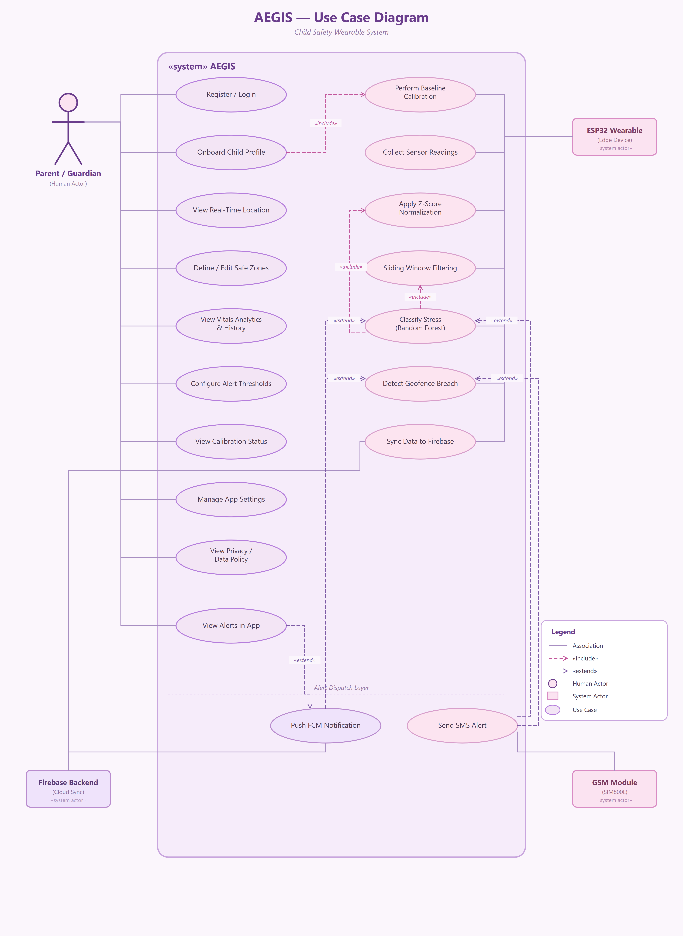
Figure 1 Use Case Diagram

Descriptive Use Cases
Formal use case specifications elaborate brief use case descriptions into detailed technical specifications documenting preconditions that must be satisfied before use case execution, main success scenarios describing normal execution flows, alternate flows handling exceptions and variations, postconditions defining system state after completion, and special requirements specifying non-functional considerations.
Detailed specifications follow standard use case templates with typical, alternative, and exception flows for key use cases identified in the diagram.

Use Case 1: View Real-Time Vitals
Description:
This use case allows the parent to view the child's current vital signs like heart rate, SpO₂, body temperature, and stress level in real time through the mobile app.

Table 2: View Real-Time Vitals
Actor Action | System Response
Typical Course of Action
Flow | Response
1. Parent logs into the app. | 1. System authenticates the credentials and grants access.
2. Parent selects the child profile. | 1. System retrieves the data associated with the selected child's band.
3. Parent opens the vitals dashboard. | 1. System fetches the latest heart rate, SpO₂, temperature, and stress values from the cloud.  2. System displays the values on the dashboard in real time.
Alternative Course of Action
Flow | Response
1. Parent opens the app while offline. | 1. System displays the last cached reading received from the band.
2. Connectivity is restored. | 1. System resumes the typical flow and refreshes the dashboard with live data.
Exception Flow
Flow | Response
1. Parent enters incorrect login credentials. | 1. System prompts re-entry of credentials.
2. Login fails three times. | 1. System locks the account for five minutes.

Use Case 2: Monitor Heart Rate and SpO₂
Description:
This use case continuously measures the child's heart rate and blood oxygen saturation (SpO₂) and notifies the parent if a reading falls outside the safe threshold.
Table 3: Monitor Heart Rate and SpO₂
Actor Action | System Response
Typical Course of Action
Flow | Response
1. MAX30102 sensor reads pulse and oxygen data. | 1. ESP32 processes the raw signal and computes heart rate and SpO₂ values.
2. ESP32 compares the readings against baseline thresholds. | 1. System uploads the validated readings to the cloud.
3. Parent opens the app to check vitals trends. | 1. App fetches and displays the heart rate and SpO₂ history.
Alternative Course of Action
Flow | Response
1. Sensor noise is detected during reading. | 1. Band filters the signal using the onboard ML model.  2. System resumes the typical flow once a clean reading is obtained.
Exception Flow
Flow | Response
1. MAX30102 sensor fails to respond. | 1. Band logs the sensor error.  2. System sends a fallback alert via GSM.

Use Case 3: Monitor Body Temperature
Description:
This use case continuously tracks the child's body temperature using the MLX90614 sensor and alerts the parent if the reading is abnormal.
Table 4: Monitor Body Temperature
Actor Action | System Response
Typical Course of Action
Flow | Response
1. MLX90614 sensor reads the child's body temperature. | 1. ESP32 compares the value against the configured threshold.
2. Reading is within the normal range. | 1. System stores the reading in the cloud.
3. Parent views the temperature trend on the app. | 1. App displays the latest and historical temperature data.
Alternative Course of Action
Flow | Response
1. Ambient temperature interference affects the reading. | 1. Band recalibrates the sensor.  2. System resumes the typical flow with a corrected reading.
Exception Flow
Flow | Response
1. Reading falls out of range (above 50°C or below 20°C). | 1. System immediately activates anomaly detection.  2. System triggers an alert.

Use Case 4: Monitor Stress Level (GSR)
Description:
This use case assesses the child's stress level using galvanic skin response (GSR) and notifies the parent of sustained elevated stress.
Table 5: Monitor Stress Level (GSR)
Actor Action | System Response
Typical Course of Action
Flow | Response
1. GSR sensor measures skin conductance continuously. | 1. ESP32 runs the on-device ML model to infer the stress level.
2. Stress level is classified. | 1. System streams the classified data to the cloud for trend storage.
3. Parent opens the app. | 1. App displays the current and historical stress trend.
Alternative Course of Action
Flow | Response
1. GSR signal is weak or unstable. | 1. System applies the child's historical baseline to adjust the reading.  2. System resumes the typical flow.
Exception Flow
Flow | Response
1. Stress remains persistently high. | 1. System extends the flow to trigger an alert without waiting for cloud confirmation.

Use Case 5: View Live Location and History
Description:
This use case allows the parent to view the child's current GPS location and movement history on a map within the app.
Table 6: View Live Location and History
Actor Action | System Response
Typical Course of Action
Flow | Response
1. Parent opens the location tab. | 1. App requests the latest location data from the cloud.
2. NEO-6M GPS module provides coordinates. | 1. ESP32 checks the coordinates against the configured geofence.
3. Band reports the verified position. | 1. System uploads the coordinates to the cloud.  2. System updates the map view.
Alternative Course of Action
Flow | Response
1. GPS signal is weak or unavailable. | 1. Band falls back to cell-tower-based location.  2. System resumes the typical flow with an approximate position.
Exception Flow
Flow | Response
1. Location upload fails. | 1. System stores the data locally.  2. System retries the upload once reconnected.

Software Architecture Diagram

Architectural Layers
The AEGIS software architecture decomposes functionality across three primary layers, each encapsulating specific responsibilities and interfacing through well-defined contracts enabling independent development, testing, and maintenance of components. The architecture diagram details the Edge Layer on the AEGIS Band with ESP32-S3 as main controller handling sensors (MAX30102 for HR/SpO₂, GSR, MLX90614 temp, NEO-6M GPS, SIM800L GSM). It shows data flow to ESP32 for ML processing, power management, and cloud upload.​
This hardware setup enables on-device anomaly detection and SMS alerts, reducing latency in emergencies for child safety wearables.
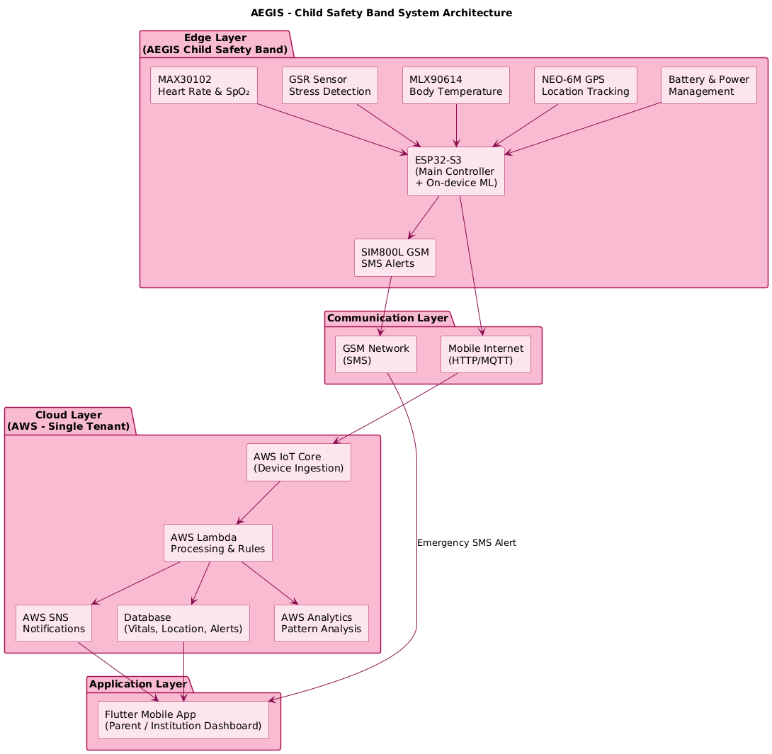
Figure 2 Architecture Diagram

Entity Relationship Diagram and Database Design
The Entity Relationship Diagram (ERD) of the AEGIS system represents the database structure designed to monitor children’s health and safety using the AEGIS smart band. The system connects parents, children, wearable devices, health data, location tracking, alerts, and geofencing into an integrated monitoring framework.
The diagram defines the entities, their attributes, and the relationships among them.

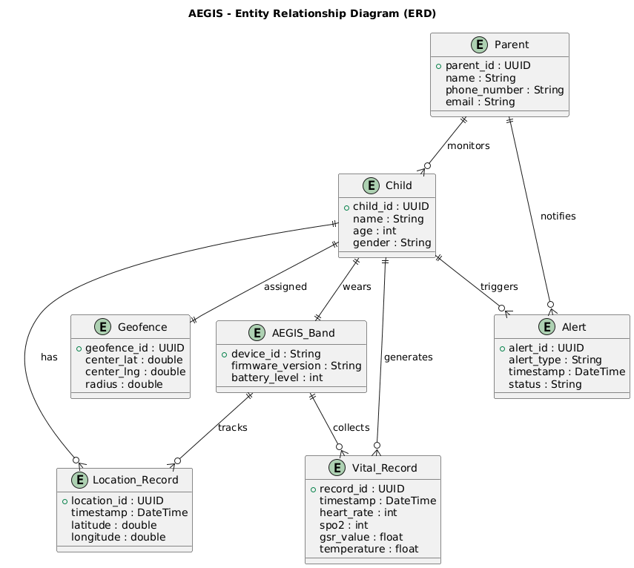
Figure 3 Entity Realtionship Diagram

Activity Diagram
Decision diamonds, swimlane-free flow, and notes highlight conditional power-aware actions (e.g., internet-optional upload). This models continuous monitoring with fusion to reduce false positives, akin to ESP32 loops using FreeRTOS tasks for sensors/ML, ensuring <1s alert latency.

Key Decisions and Flows
The while loop and nested ifs capture resilience, with exceptions like low battery implicitly handled via power manager.

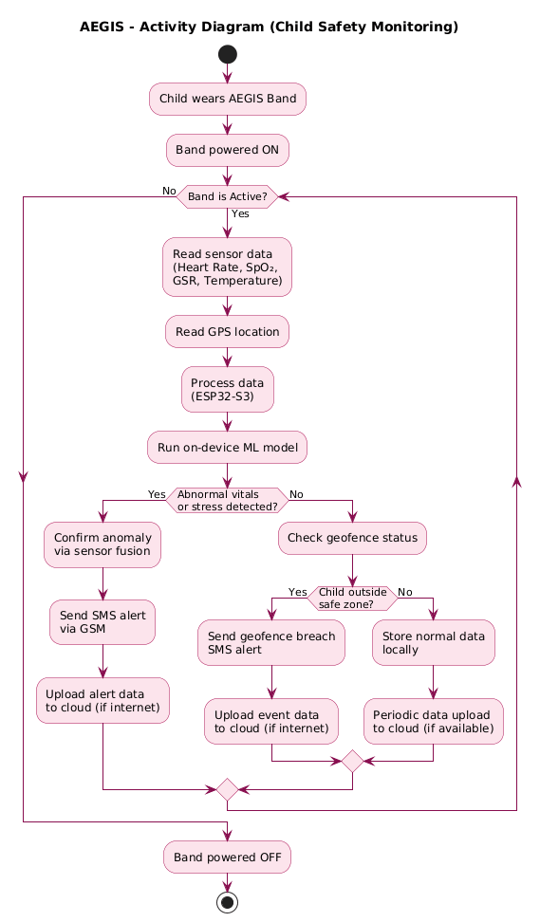
Figure 4 Activity Diagram

Sequence Diagram
To keep each diagram readable, the AEGIS sequence behaviour is split into four views, one per major actor or subsystem: the ESP32 Wearable's edge-processing pipeline, the Firebase Backend's sync-and-notify flow, the GSM module's SMS fallback, and the Parent/Guardian app's ten user-facing use cases (shown across two parts). Together they trace how the system moves from a raw sensor reading to a classified event, a backend record, and finally a notification or SMS delivered to the parent.

ESP32 Wearable: Edge Processing Sequence
This sequence diagram traces the seven use cases that run entirely on the ESP32 Wearable's edge-processing pipeline: baseline calibration, sensor collection (heart rate, EDA, temperature, accelerometer), Z-score normalization, sliding-window filtering, on-device Random Forest stress classification, geofence-breach detection, and the periodic sync of results to the Firebase Backend. Internal steps (normalization, the activity filter that discards high-motion noise, and the classifier itself) are shown as self-calls on the Edge Device lifeline; the only outward call in this flow is the Firestore sync that hands processed vitals, location, and classification results to the backend.
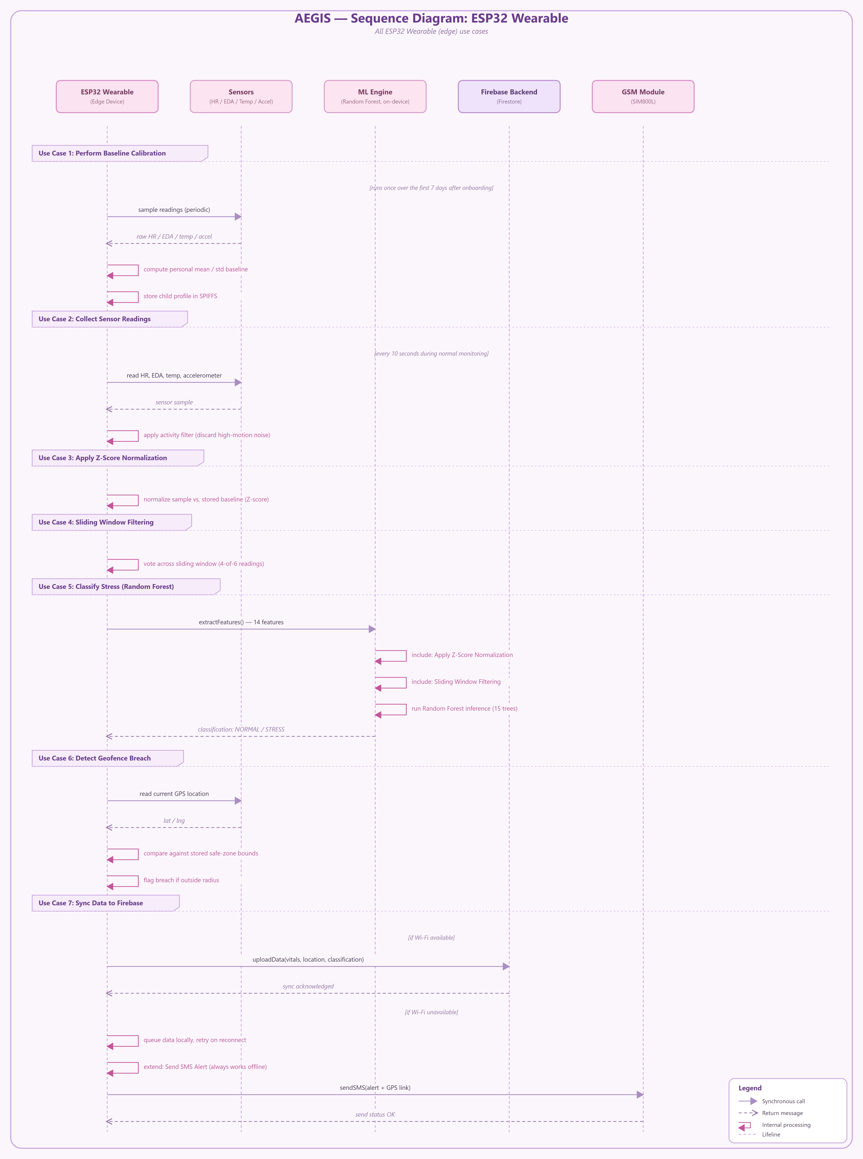
Figure 5 ESP32 Wearable (Edge Processing)

Firebase Backend Sequence
This diagram shows how the Firebase Backend turns an edge-processed reading into a notification. The ESP32 Wearable uploads vitals, location, and classification via uploadData(); the backend validates the payload and writes it to the child's Firestore document. If the write is flagged as an alert, the backend immediately calls sendPushNotification() to deliver the alert to the Flutter App through FCM, independently of the routine sync acknowledgement returned to the wearable.
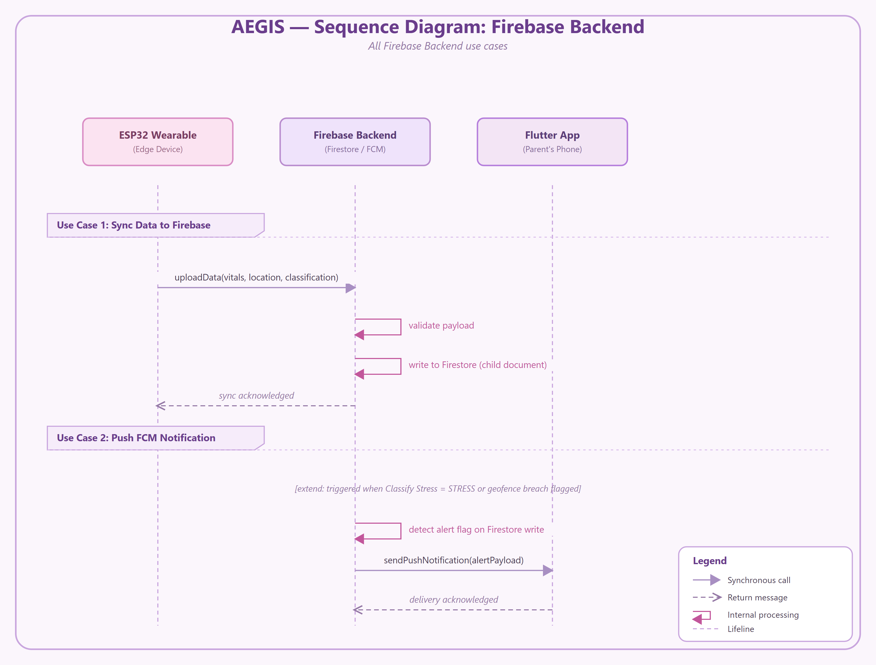
Figure 6 Firebase Backend

GSM Module: SMS Alert Sequence
This diagram covers the one use case reserved for the SIM800L GSM module: Send SMS Alert, the fallback path used when the WiFi/Firebase route is unavailable. The ESP32 Wearable establishes a GSM network session over the AT command interface, sends the alert directly to the parent's phone number as an SMS, and receives an OK/ERROR status back from the module before the outcome is reported on the Parent/Guardian side.
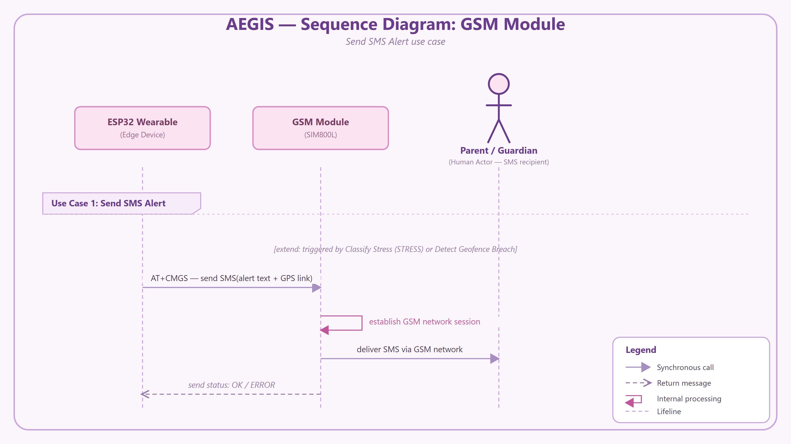
Figure 7 GSM Module (SMS Alert)

Parent/Guardian App Sequence (Part 1 of 2)
This diagram traces the Parent/Guardian's interactions with the Flutter App across Use Cases 1–5: registering or logging in, onboarding a child profile (which includes triggering baseline calibration on the wearable), viewing the child's real-time location, defining or editing safe zones, and reviewing vitals analytics and history. Each block shows the call from the parent through the mobile UI to the Firebase Backend, and on to the ESP32 Wearable where relevant, together with the return message that updates the screen.
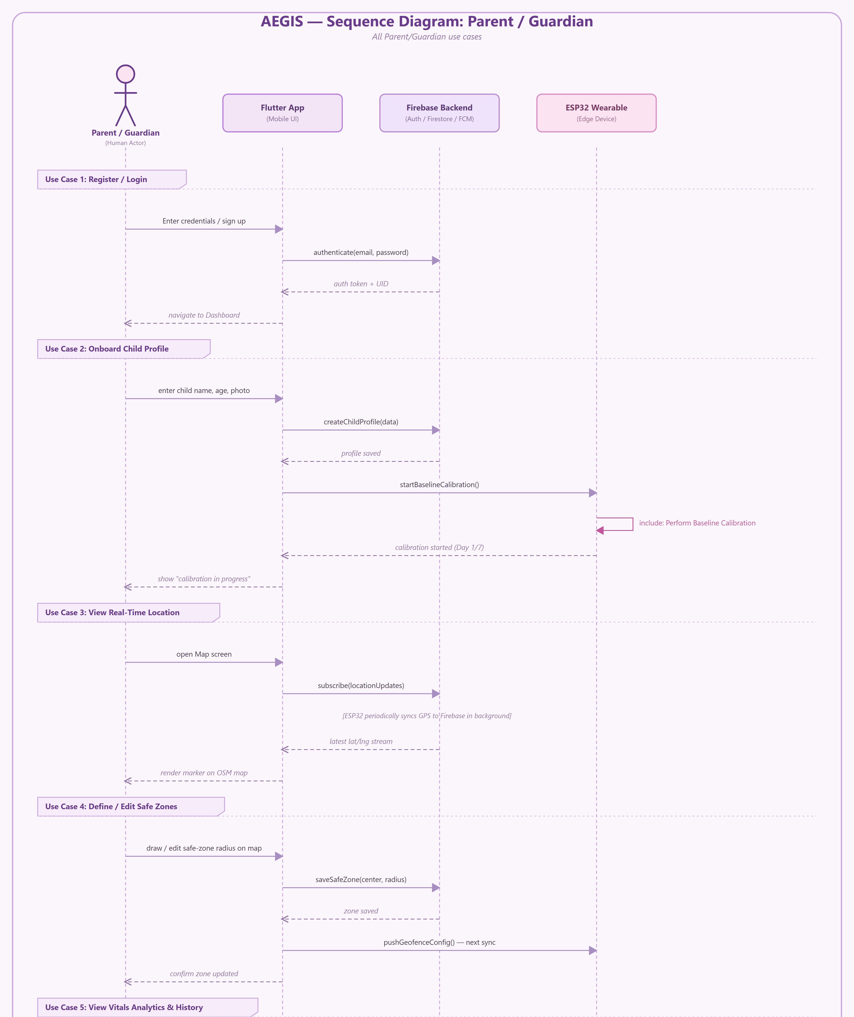
Figure 8 Parent/Guardian App (Part 1 of 2)

Parent/Guardian App Sequence (Part 2 of 2)
Continuing from Part 1, this diagram covers Use Cases 6–10: configuring alert sensitivity thresholds, viewing calibration progress, managing app settings such as units and theme, viewing the bundled privacy/data policy, and viewing alerts in the app. The final use case shows an FCM push notification arriving asynchronously and the parent drilling into an alert's details, illustrating how the alert dispatch layer surfaces inside the mobile app.

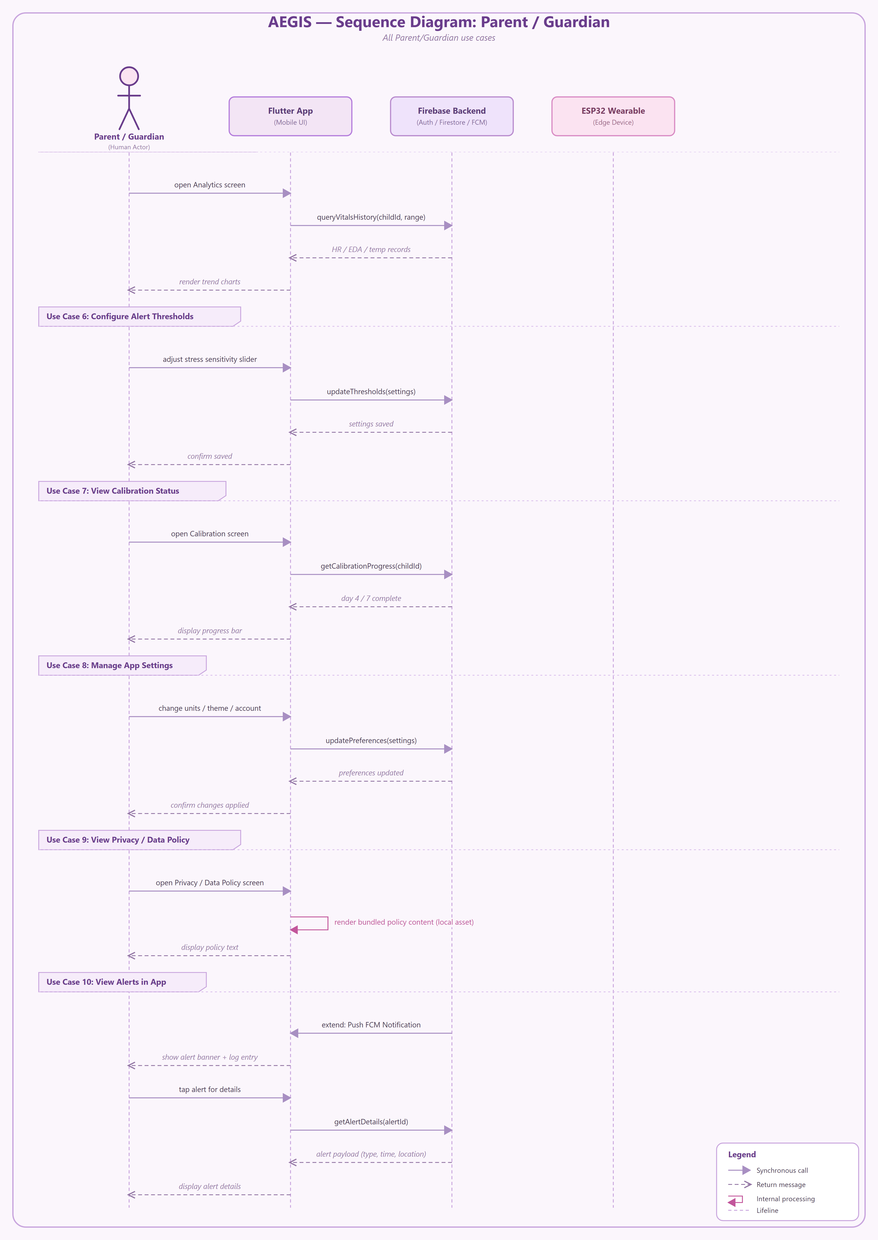
Figure 9 Parent/Guardian App (Part 2 of 2)

Class Diagram
This design promotes polymorphism (sensor subclasses), encapsulation (private attrs), and loose coupling, ideal for firmware updates in ESP32 IoT devices handling ML inference for stress/HR anomalies
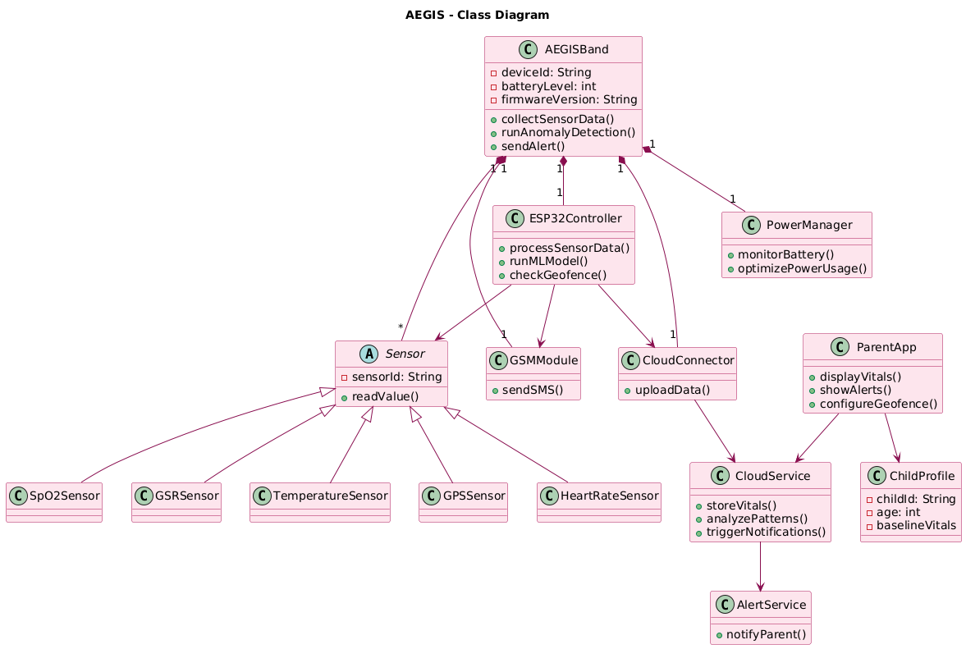
Figure 10 Class Diagram

CHAPTER 6
IMPLEMENTATION

Implementation

Implementation Overview
The previous two chapters set out what AEGIS is supposed to do and how its pieces are meant to fit together; this chapter describes how those pieces were actually built. The work splits into four layers that mirror the architecture from Chapter 4: firmware running on the wearable band, the network logic that moves data off the band, the Firebase backend that stores and forwards it, and the Flutter app a parent actually uses. Each layer was implemented and tested largely on its own before being wired into the next, which kept problems contained to one layer at a time instead of surfacing as a single tangled debugging session across the whole system.
This chapter follows that same order: firmware first, then network, then backend, then app, because that is the order data actually travels through AEGIS, from a sensor reading on a child's wrist to a notification on a parent's phone.

Development Tools and Technologies
AEGIS combines an embedded codebase, a cloud backend, and a mobile app, so the toolchain spans three different environments. Table 1 lists the tools used for each layer.
Table 7: Development Tools and Technologies by Layer
Layer | Tool / Technology | Purpose
Wearable Firmware | Arduino-ESP32 core (C++) | Firmware development on the ESP32-S3
Wearable Firmware | FreeRTOS | Task scheduling for sensors, anomaly detection, and communication
Wearable Firmware | Wire (I2C) library | Communication with the MAX30102 and MLX90614
Wearable Firmware | TinyGPS++ | Parsing NMEA sentences from the NEO-6M GPS module
Wearable Firmware | SIM800L AT command handler | GSM/SMS fallback communication
Backend | Firebase Realtime Database | Storage of vitals, location, and alert data
Backend | Firebase Authentication | Parent account creation and sign-in
Backend | Firebase Cloud Messaging | Push notification delivery to the parent app
Mobile App | Flutter / Dart | Cross-platform parent application
Development | VS Code / PlatformIO | Firmware editing, building, and flashing
Development | Git | Version control
The firmware was written in C++ against the Arduino-ESP32 core rather than raw ESP-IDF, trading a small amount of low-level control for faster iteration, a reasonable trade for a project where the sensor and communication logic needed more attention than the operating system internals. The backend and app share Firebase as a common point of integration: the same project, the same API keys, and the same free-tier limits, which kept the cloud side of the system within the zero-cost constraint set out in Chapter 1.

Wearable Firmware Implementation
The firmware is the part of AEGIS that has to work correctly with no one watching it. It runs unattended on a child's wrist, and every decision it makes, when to trust a sensor reading, when to escalate to an alert, when to save power instead of transmitting, has to be made without a parent or a server in the loop. The three subsections below cover how that responsibility is split across the firmware's structure.

Sensor Acquisition and Task Scheduling
The ESP32-S3 firmware is organized as a small set of FreeRTOS tasks rather than a single loop that polls everything in sequence. A dedicated task wakes on its own timer to read the MAX30102 over I2C and extract heart rate and SpO₂; a second task reads the MLX90614, also over I2C, for body temperature; a third samples the GSR sensor through the ESP32's ADC; and a fourth listens to the NEO-6M GPS module over UART, parsing NMEA sentences as they arrive. Running these as separate tasks means a slow sensor read does not block the others; the GPS module can take noticeably longer to produce a fix than the other sensors take to return a reading, and a single-loop design would have made every other sensor wait on it.
Once a task has a fresh reading, it writes the value into a shared snapshot structure rather than sending it anywhere directly. A separate aggregation task collects the most recent value from each sensor on a fixed cycle and treats that snapshot as the unit of work for everything downstream; anomaly detection, logging, and transmission all operate on one complete snapshot rather than four independent streams. Table 2 summarizes how each sensor connects to the controller.
Table 8: Sensor Interfaces and Driver Libraries
Sensor | Measurement | Interface | Library / Driver
MAX30102 | Heart rate, SpO₂ | I2C | MAX3010x driver library
MLX90614 | Body temperature | I2C | MLX90614 driver library
GSR Sensor | Skin conductance (stress) | Analog (ADC) | ESP32 analogRead()
NEO-6M | GPS location | UART (NMEA) | TinyGPS++
SIM800L | GSM / SMS | UART (AT commands) | Custom AT command handler

Edge Anomaly Detection
Each snapshot is checked two ways before it is allowed to leave the aggregation stage as a confirmed reading. The first check is a straightforward threshold comparison against limits calibrated to the child's profile; a heart rate, temperature, or GSR value outside its expected band is flagged immediately, and this check alone catches most obvious emergencies without needing anything more sophisticated. The second check runs a small on-device model intended to catch patterns a fixed threshold would miss, such as a stress response that builds gradually across several cycles rather than spiking on a single reading.
A reading is only escalated to an alert once both checks agree that something is wrong, which is the detail that keeps an isolated sensor glitch, a loose contact on the GSR pads, a stray reflection on the MAX30102, from generating a false alarm on its own. The geofence check works the same way conceptually: a position outside the configured boundary from a single GPS fix is treated as provisional until the next fix confirms it, since GPS noise near a boundary edge is common enough to be worth a second look before alerting a parent.

Power Management and Alert Triggering
Continuous sensing at full rate would drain the battery in hours, not days, so the firmware duty-cycles its sensors rather than sampling continuously. Between cycles, the ESP32-S3 drops into a light-sleep mode that keeps the real-time clock and wake timer running while suspending everything else, and the cycle length itself is tunable so it can be shortened temporarily after a flagged reading and lengthened again once things look normal.
When the anomaly-detection logic confirms a reading needs to go out as an alert, the firmware does not wait for the next scheduled transmission cycle. It interrupts the normal duty cycle, wakes the communication task immediately, and hands off to the network layer described in the next section, the one place in the firmware where responsiveness is explicitly prioritized over battery life.

Network and Communication Implementation
The communication logic implements the WiFi-first, GSM-fallback design from Chapter 4 as a single function that the rest of the firmware calls without needing to know which path actually gets used. That function first attempts an HTTPS request to the Firebase Realtime Database over WiFi and waits for an acknowledgment within a short, fixed timeout. If the request succeeds, the data is marked as delivered and the function returns; if it fails, no WiFi in range, a connection error, or no acknowledgment inside the timeout window, the function falls through to the SIM800L.
The GSM path is built around the SIM800L's AT command interface over UART. The firmware issues a short, fixed sequence of AT commands to confirm network registration, then sends the alert as an SMS to a preconfigured parent number. Because GSM is reserved for alerts rather than routine data, this path is exercised far less often than the WiFi path, but it is tested independently and on its own schedule precisely because it is the one piece of the system that has to work the moment everything else has already failed. Table 3 summarizes how the firmware chooses between the two paths.
Table 9: Communication Path Selection Logic
Condition | Path Taken | Protocol
WiFi available, request acknowledged within timeout | Edge-to-cloud (primary) | HTTPS to Firebase Realtime Database
WiFi unavailable or request times out | GSM fallback | SMS via SIM800L AT commands
Routine vitals fail to upload | Local queue, retried on reconnect | Queued (no GSM escalation)

Backend Implementation
Firebase functions as both the storage layer and the notification layer for AEGIS, in line with the zero-paid-services constraint from Chapter 1. The free tier of Firebase Realtime Database, Firebase Authentication, and Firebase Cloud Messaging covers everything the backend needs to do at the scale of a single deployed prototype, with no separate server to provision or maintain.

Firebase Database Structure
The data model from Chapter 4 is implemented as a tree of nodes in the Firebase Realtime Database rather than as relational tables, which changes how the entities relate to each other in practice even though the underlying information is the same. Table 4 shows how each entity maps onto a database path.

Table 10: Firebase Realtime Database Structure
Entity (Chapter 4) | Firebase Path | Key Fields
Parent | /parents/{parent_id} | name, phone_number, email
Child | /children/{child_id} | name, age, gender, parent_id
AEGIS_Band | /bands/{device_id} | child_id, firmware_version, battery_level
Vital_Record | /vitals/{child_id}/{record_id} | timestamp, heart_rate, spo2, gsr_value, temperature
Location_Record | /locations/{child_id}/{location_id} | timestamp, latitude, longitude
Geofence | /geofences/{child_id} | center_lat, center_lng, radius
Alert | /alerts/{child_id}/{alert_id} | alert_type, timestamp, status
Vital and location records are written as new child nodes under the relevant child's path rather than overwriting a single value, which is what lets the app reconstruct a history instead of only ever seeing the latest reading. Alerts are written to their own node specifically so the app can listen to that one path for push-worthy events without needing to filter through routine vitals traffic.

Authentication and Push Notifications
Parent accounts are created and signed in through Firebase Authentication using email and password, which avoids building and securing a custom login system for a feature Firebase already provides reliably at no cost. Once signed in, a parent's access is scoped to the children linked to their account through Firebase's security rules, so one parent's app instance cannot read another family's data even though all records live in the same database.
Push delivery runs through Firebase Cloud Messaging. When an alert is written to the database, a notification is sent to the device token associated with the relevant parent, and the Flutter app displays it as a system notification even if the app itself is not open. This path complements, rather than replaces, the GSM fallback from Section 6.4: Firebase Cloud Messaging handles the common case where the parent's phone has internet access, and SMS covers the case where it does not.

Mobile Application Implementation
The Flutter app is the only part of AEGIS a parent interacts with directly, and its structure reflects that: each screen maps to one of the things a parent actually wants to do, rather than to the underlying data model. Table 5 summarizes the main screens and what each one does.
Table 11: Mobile Application Screens and Firebase Interactions
Screen | Purpose | Firebase Interaction
Login / Signup | Parent account creation and sign-in | Firebase Authentication
Vitals Dashboard | Real-time heart rate, SpO₂, temperature, and stress display | Live read from /vitals/{child_id}
Location Map | Current location and movement history | Live read from /locations/{child_id}
Geofence Editor | Define and edit safe-zone boundaries | Write to /geofences/{child_id}
Alerts Screen | View pending and acknowledged alerts | Live read/write to /alerts/{child_id}
Child Profile Settings | Manage child details and thresholds | Write to /children/{child_id}
Screens that display live data, the vitals dashboard and the location map, subscribe to their corresponding Firebase paths rather than polling on a timer, so a new reading appears within moments of the band reporting it instead of waiting for the next refresh cycle. Configuration screens, such as the geofence editor, work in the opposite direction: a parent's input is validated locally and then written back to the same Firebase paths the band reads from on its next check-in, which closes the loop described in Chapter 4 between what a parent sets and what the band enforces.
State that does not need to survive a restart, which screen is currently open, whether a dialog is showing, is kept in memory using Flutter's standard state management rather than persisted anywhere. This keeps the app's own logic simple and leaves Firebase as the single source of truth for anything that actually matters across sessions.

Summary
Across firmware, network, backend, and app, the implementation work in this chapter turns the architecture from Chapter 4 into something that runs end to end: a sensor reading taken on a child's wrist passes through edge anomaly detection, leaves the band over WiFi or GSM, lands in Firebase, and reaches a parent's phone as either a live dashboard update or a push notification. Building each layer against the interfaces defined in the earlier design chapters meant the four pieces could be developed and tested somewhat independently, and integrating them mostly amounted to wiring already-working pieces together rather than discovering that two layers disagreed about what they expected from each other.
The next chapter covers how this implementation was tested, including the cases where it did not yet behave as Chapter 4 intended and what was done about it.
CHAPTER 7
TESTING

Testing

Overview
This chapter sets out how AEGIS is being tested, and at the time of writing, what has already been exercised against that plan. AEGIS is currently an MVP: the firmware design, the Flutter application, and the Firebase integration are implemented and runnable, but the wearable has not yet been packaged into a finished band, and the mobile app currently sources vitals and location data from a dummy data service rather than a live device while hardware integration is completed. Testing is scoped accordingly. Software components, the firmware's processing logic and the Flutter/Firebase application, are tested in the conventional sense: unit tests, integration tests, and manual black-box test cases. Hardware components are planned to be tested at the bench/prototype level, on a development board with sensors wired in, rather than through field wear-testing on a finished device. Both halves matter equally to AEGIS's central design claim, that meaningful health and safety decisions can be made on the edge, so this chapter treats software correctness and sensor accuracy as two sides of the same testing effort rather than as separate concerns.
Section 7.8 documents a representative set of test cases in a consistent, traceable format. These are the cases that will be executed, and logged with actual results, as hardware integration and field testing proceed; the working tracker used for that execution is maintained alongside the project's source files rather than in this document, and is referenced in Section 7.10.

Verification and Validation
Verification and validation answer two different questions about AEGIS, and the distinction shapes how this chapter is organized. Verification asks whether each component does what its specification says it should: does the normalization function return the correct Z-score, does the Flutter widget render the expected state, does the firmware send the AT command sequence the SIM800L datasheet calls for. Validation asks the harder question of whether the system, once all of those correct components are wired together, actually achieves what AEGIS is for, detecting a child's elevated stress or a geofence breach in a way a parent can act on, without flooding them with false alarms.
Unit testing (Sections 7.4 and 7.5) and integration testing (Section 7.7) are primarily verification activities. Sensor accuracy testing (Section 7.4.3), hardware prototype testing (Section 7.6), and the end-to-end test cases in Section 7.8 lean toward validation, since they measure AEGIS against real-world conditions rather than against a written specification. Both are necessary: a system can be fully verified, every function doing exactly what it was coded to do, and still fail validation if, for example, the classifier's false-positive rate makes the alerts useless in practice.

Testing Strategy and Tools
Testing follows a bottom-up strategy: individual functions and components are tested in isolation before being combined, so that a failure during integration testing can be traced to a specific interaction between components rather than re-opening every unit test at once. Firmware logic that does not depend on real sensor hardware, the normalization, filtering, and classification functions, is tested with white-box unit tests using known inputs and hand-calculated expected outputs. The mobile application and its interaction with Firebase are tested with a mix of white-box unit tests for model and service classes and black-box manual test cases for user-facing flows. Hardware that cannot be meaningfully tested off a physical board, the sensors themselves and the GSM fallback path, is tested manually on the bench against reference instruments. Table 12 summarizes the tools and frameworks used at each layer.
Table 12: Testing Tools and Frameworks by Layer
Layer | Tool / Framework | Purpose
Firmware (pure logic) | PlatformIO native unit-test environment (Unity) | Unit-test normalization, filtering, and classifier wrapper functions without flashing the board
Firmware (on-device) | Serial monitor and manual AT-command inspection | Verify sensor polling and GSM command sequences on real hardware
Mobile App | flutter_test (unit and widget tests) | Test model and service classes and screen behaviour
Backend | Firebase Local Emulator Suite | Test Authentication, Cloud Firestore, and Cloud Messaging without touching production data
Hardware Bench | Reference instruments (clinical oximeter, calibrated thermometer, secondary GPS receiver) | Validate sensor accuracy against known-good readings
Manual / System | Scripted manual test cases (Section 7.8) | End-to-end and exploratory testing across layers

Unit Testing the Firmware
The firmware's processing pipeline, baseline calibration, Z-score normalization, sliding-window filtering, and Random Forest classification, is designed as a set of pure functions wherever possible, specifically so it can be unit-tested without needing a live sensor or network connection. This section describes the harness used for that testing and the resulting coverage.

Test Harness
Because ESP32-S3 firmware mixes hardware-dependent code (sensor polling, WiFi, GSM AT commands) with hardware-independent computation, the two are deliberately kept separate so the latter can be tested without flashing a physical board. The computational functions are compiled and run under PlatformIO's native unit-test environment using the Unity test framework, which executes directly on the development machine rather than on the ESP32 target. Each test feeds a function a known input, mocked sensor readings, a stored baseline, a feature vector, and asserts that the returned value matches a value computed independently (by hand or in a spreadsheet) rather than by the function under test, to avoid the test simply re-deriving the same formula as a tautology.

Coverage
Table 13 summarizes which firmware modules are covered by this off-device unit-testing approach and which require the physical board, and are instead covered under hardware prototype testing in Section 7.6.
Table 13: Firmware Unit Test Coverage Summary
Module / Function | Test Type | Covered Off-Device | Notes
Z-score normalization | Unit | Yes | Pure function, fully testable off-device
Sliding-window filter | Unit | Yes | Pure function, fully testable off-device
Random Forest classifier wrapper | Unit | Yes | Tested against labelled feature vectors
Geofence breach check | Unit | Yes | Pure distance-versus-radius comparison
Sensor I2C drivers (MAX30102, MLX90614) | Hardware | Partial | Requires the physical board; see 7.6.1
GSM AT command sequencing | Hardware | Partial | Timing-dependent; see 7.6.2
Power manager / duty-cycle logic | Integration | Planned | Requires extended-run hardware testing; see 7.6.3

Sensor Calibration and Accuracy Testing
The previous two subsections test the math the firmware performs on a reading; they cannot verify that the reading itself is accurate. That question can only be answered by comparing the physical sensor against a trusted reference under controlled conditions. Table 14 defines the bench test plan for each sensor on the AEGIS prototype board: the condition under which it is tested, the reference instrument used for comparison, and the tolerance considered acceptable given the sensor's datasheet and AEGIS's intended use as a screening, not diagnostic, device. As the MVP has not yet undergone a dedicated hardware test session at the time of writing, the Status column reflects test cases that are defined and ready to execute rather than already-completed results; Section 7.10 discusses this limitation further.
Table 14: Hardware Sensor Accuracy Test Plan
Sensor | Test Condition | Reference Instrument | Acceptable Tolerance | Status
MAX30102 (HR / SpO2) | Resting subject, paired 5-minute sampling | Clinical pulse oximeter | +/- 5 bpm, +/- 2% SpO2 | Pending hardware session
MLX90614 (Temperature) | Known-temperature reference object | Calibrated digital thermometer | +/- 0.5 degC | Pending hardware session
GSR electrodes | Stimulus-response relative change | None (relative-change test only) | Detectable rise during stimulus | Pending hardware session
Accelerometer | Static versus known motion | Visual/manual motion log | Correct high-motion flag | Pending hardware session
NEO-6M GPS | Outdoor, open-sky fix | Smartphone GPS | Within approx. 5 m | Pending hardware session
SIM800L GSM | SMS send/receive | Parent test phone | Delivery within fallback window | Pending hardware session

Unit Testing the Mobile Application and Backend Integration
AEGIS deliberately uses Firebase Authentication, Cloud Firestore, and Cloud Messaging directly rather than building and securing a bespoke REST API, so unit testing this layer means testing the app's own model and service classes and its integration with Firebase, rather than testing server-side endpoints. Model classes such as ChildModel and the calculation logic in vitals_analytics.dart are tested with Flutter's flutter_test package using plain unit tests: known inputs in, known outputs checked against assertions. Widgets and screens that depend on state, the dashboard, the alerts list, the calibration progress indicator, are tested with widget tests that pump a widget tree with mock data and verify the correct text, icons, or navigation appear.
Rather than testing against the live production Firebase project, integration-style tests for the prefs, storage, and notification services are run against the Firebase Local Emulator Suite, which provides local, disposable instances of Authentication, Firestore, and Cloud Messaging. This keeps test runs repeatable and avoids polluting production data with test parent accounts and test alerts.

Hardware Prototype Testing
The sections above test code; this section tests the physical prototype board itself, the ESP32-S3 with the MAX30102, MLX90614, GSR electrodes, accelerometer, SIM800L, and NEO-6M wired together as described in Chapter 6. Because AEGIS does not yet exist as a packaged wearable, this testing happens on the bench rather than on a wrist, and is scoped to confirming the hardware behaves correctly rather than to confirming it is comfortable, durable, or child-safe to wear, which would require a finished enclosure and is out of scope for this MVP.

Sensor Integration Testing
Individual sensor accuracy is covered in Section 7.4.3; this subsection instead checks that the sensors behave correctly when polled together in the firmware's actual sequence rather than one at a time. The MAX30102 and MLX90614 share the ESP32-S3's I2C bus, so the test plan includes polling both in immediate succession, as the firmware does each sensing cycle, and confirming neither reading is corrupted or delayed by bus contention. The GSR electrodes and accelerometer sit on separate analog/digital lines and are checked for cross-talk when sampled in the same cycle as the I2C sensors.

Communication and Fallback Testing
This subsection tests the two paths data can take off the wearable, described in Chapter 6's fallback table, under conditions that force each path to be exercised. WiFi upload is tested at typical home or classroom distances from a router to confirm reliable delivery to Cloud Firestore. The GSM fallback is tested by deliberately disabling WiFi and confirming the SIM800L registers on the network, sends the SMS, and reports an OK status back to the firmware (this is the basis for TC-HW-002 in Section 7.8). GPS fix time and accuracy from the NEO-6M are tested outdoors under open sky, with indoor/under-cover behaviour recorded as a known limitation rather than a pass/fail condition, since GPS is not expected to function reliably indoors regardless of implementation.

Power and Battery Testing
Because continuous full-rate sensing would drain the battery in hours rather than days (Chapter 6), this subsection verifies that duty-cycled sampling actually extends runtime as intended, by measuring battery voltage over a full discharge cycle under normal duty-cycled operation, and confirms the power manager's low-battery handling activates at the expected threshold rather than letting the board die without warning.

Integration and System Testing
Where Sections 7.4 through 7.6 test layers individually, this section tests them wired together, since AEGIS's core value proposition only exists at the seams between layers: a correct classifier is useless if its output never reaches Firebase, and a correct Firebase write is useless if it never reaches the parent's phone. Three pipelines are planned to be exercised end to end: a stress classification on the wearable resulting in a Firestore write and a Cloud Messaging push to the app (TC-INT-002); a geofence breach detected from a GPS coordinate resulting in the same alert pipeline (TC-INT-001); and the GSM fallback pipeline exercised when the primary WiFi path is unavailable (TC-HW-002). Each is run as a black-box test, mock or real sensor input in, observed behaviour in the app or on the parent's phone out, without assuming knowledge of which internal function produced the result.

Representative Test Cases
The following test cases document representative scenarios across the firmware, mobile application, hardware, and integration layers discussed above, each in the same structured format so they can be tracked through to execution and result. They are a representative sample rather than the complete test suite; the working test-case tracker used to run and log these (and additional) cases during the hardware testing phase is maintained separately and described in Section 7.10.

Detailed Test Cases

TC-FW-001: Baseline Z-Score Normalization
Test Case id : TC-FW-001 | Test Item : Z-Score Normalization Function
Author : AEGIS Development Team | Documentation Date : 28-06-2026
Test Type : Unit -- White Box | Test Case Name : Baseline Z-Score Normalization
Component : Firmware - Sensor Processing | Release / Version # : v0.1 (MVP)
Test case Description: Verifies that the firmware's Z-score normalization function correctly standardizes a raw sensor reading against a child's stored calibration baseline.
Operation Procedure:
In the firmware test harness:
Load a mock Calibration Profile with a known BaselineMean and BaselineStdDev.
Call normalize(reading, baselineMean, baselineStdDev) with a known reading.
Compare the returned value against the manually computed expected Z-score.
The test case ends.
Pre-conditions : | Post-conditions :
A calibration profile with a non-zero BaselineStdDev is available to the function. | The function returns a float Z-score without modifying the input baseline values.
Input Data/Events : | Expected output Data/Events :
reading = 80, baselineMean = 70, baselineStdDev = 5 | Returns 2.0

TC-FW-002: Stress Classification on Known Feature Vector
Test Case id : TC-FW-002 | Test Item : Random Forest Stress Classifier
Author : AEGIS Development Team | Documentation Date : 28-06-2026
Test Type : Unit -- White Box | Test Case Name : Stress Classification on Known Feature Vector
Component : Firmware - Edge ML | Release / Version # : v0.1 (MVP)
Test case Description: Verifies that the on-device Random Forest classifier returns the expected label when given a feature vector that matches a known labelled example.
Operation Procedure:
In the firmware test harness:
Feed a 14-feature vector corresponding to a labelled STRESS sample into the classifier.
Capture the returned label.
Repeat using a labelled NORMAL sample.
The test case ends.
Pre-conditions : | Post-conditions :
The trained Random Forest model has been flashed to the test harness build. | The classifier returns one label per call without altering state needed for the next call.
Input Data/Events : | Expected output Data/Events :
A STRESS-labelled feature vector, then a NORMAL-labelled feature vector | Returns "STRESS" for the first input and "NORMAL" for the second.

TC-FW-003: 7-Day Calibration Window Completion
Test Case id : TC-FW-003 | Test Item : Baseline Calibration Completion
Author : AEGIS Development Team | Documentation Date : 28-06-2026
Test Type : Integration -- White Box | Test Case Name : 7-Day Calibration Window Completion
Component : Firmware - Calibration | Release / Version # : v0.1 (MVP)
Test case Description: Verifies that the firmware marks a child's Calibration Profile complete only after seven days of valid baseline readings, and that normalization is not applied before completion.
Operation Procedure:
Onboard a mock child profile and start calibration.
Feed six days of valid mock sensor readings via the test harness.
Confirm CalibrationProgress reports "day 6 of 7" and that classification is suppressed.
Feed the seventh day of readings.
Confirm CalibrationProgress reports complete and subsequent readings are classified.
The test case ends.
Pre-conditions : | Post-conditions :
Child profile exists with no prior calibration data. | The calibration profile holds finalized BaselineMean / BaselineStdDev values.
Input Data/Events : | Expected output Data/Events :
7 days of mock HR / EDA / temperature readings | Classification is enabled only from day 8 onward.

TC-HW-001: Heart Rate Reading Accuracy vs Reference Oximeter
Test Case id : TC-HW-001 | Test Item : MAX30102 Heart Rate Accuracy
Author : AEGIS Development Team | Documentation Date : 28-06-2026
Test Type : Manual -- Hardware Bench | Test Case Name : Heart Rate Reading Accuracy vs Reference Oximeter
Component : Hardware - Sensors | Release / Version # : Prototype Rev. A
Test case Description: Determines whether the MAX30102 PPG sensor reports heart rate within acceptable tolerance of a clinical-grade reference pulse oximeter at rest.
Operation Procedure:
Attach the AEGIS sensor and a reference pulse oximeter to the same subject.
Record both readings every 30 seconds for 5 minutes at rest.
Compute the average absolute difference between the two devices.
The test case ends.
Pre-conditions : | Post-conditions :
Subject is at rest; sensor is correctly seated against skin. | A logged set of paired readings is available for Table 14.
Input Data/Events : | Expected output Data/Events :
10 paired heart-rate samples | Average deviation within +/- 5 bpm of the reference device.

TC-HW-002: SMS Alert Delivery When WiFi Is Unavailable
Test Case id : TC-HW-002 | Test Item : GSM SMS Fallback Delivery
Author : AEGIS Development Team | Documentation Date : 28-06-2026
Test Type : Manual -- Black Box | Test Case Name : SMS Alert Delivery When WiFi Is Unavailable
Component : Hardware/Network - GSM Fallback | Release / Version # : Prototype Rev. A
Test case Description: Confirms that when the WiFi upload path fails, the firmware falls back to the SIM800L GSM module and successfully delivers an SMS alert to the registered parent number.
Operation Procedure:
Disable WiFi connectivity on the test board.
Trigger a stress or geofence event so the firmware attempts to send an alert.
Observe the AT command sequence on the serial monitor.
Confirm SMS receipt on the parent's registered phone.
The test case ends.
Pre-conditions : | Post-conditions :
SIM800L has an active SIM with credit and network coverage; parent number is configured. | Firmware logs an "SMS sent: OK" status.
Input Data/Events : | Expected output Data/Events :
A simulated stress alert with WiFi disabled | SMS received on the parent's phone within the fallback's expected delivery window.

TC-APP-001: Parent Account Registration
Test Case id : TC-APP-001 | Test Item : Parent Registration Form
Author : AEGIS Development Team | Documentation Date : 28-06-2026
Test Type : Manual -- Black Box | Test Case Name : Parent Account Registration
Component : Mobile App - Authentication | Release / Version # : v0.1 (MVP)
Test case Description: Determines the functionality of new parent account registration through Firebase Authentication.
Operation Procedure:
In the AEGIS app's onboarding screen:
Enter full name, email address, and password.
Tap the Register button.
The test case ends.
Pre-conditions : | Post-conditions :
The app has loaded the onboarding screen and the device has network connectivity. | A new parent account exists in Firebase Authentication; user is navigated onward.
Input Data/Events : | Expected output Data/Events :
Valid name, unique email, password meeting complexity rules; tap Register. | Parent is registered and redirected to the Onboard Child Profile screen.

TC-APP-002: Define and Persist a Safe Zone
Test Case id : TC-APP-002 | Test Item : Safe Zone Definition
Author : AEGIS Development Team | Documentation Date : 28-06-2026
Test Type : Manual -- Black Box | Test Case Name : Define and Persist a Safe Zone
Component : Mobile App - Geofencing | Release / Version # : v0.1 (MVP)
Test case Description: Verifies that a parent can draw a safe zone on the map and that the zone persists correctly after the app is closed and reopened.
Operation Procedure:
Open the Safe Zone Picker screen.
Draw a zone radius around a chosen centre point and name it.
Save the zone.
Close and relaunch the app, then reopen the Safe Zone screen.
The test case ends.
Pre-conditions : | Post-conditions :
Parent is logged in and a child profile exists. | The safe zone record exists in Firestore under the child's path.
Input Data/Events : | Expected output Data/Events :
Zone name, centre coordinate, radius | The saved zone reappears identically after the app restart.

TC-APP-003: Invalid Login Credential Rejection
Test Case id : TC-APP-003 | Test Item : Login Form Validation
Author : AEGIS Development Team | Documentation Date : 28-06-2026
Test Type : Manual -- Black Box | Test Case Name : Invalid Login Credential Rejection
Component : Mobile App - Authentication | Release / Version # : v0.1 (MVP)
Test case Description: Confirms that the login screen rejects incorrect credentials with a clear error message rather than failing silently or crashing.
Operation Procedure:
Open the login screen.
Enter a registered email with an incorrect password.
Tap Login.
The test case ends.
Pre-conditions : | Post-conditions :
At least one parent account already exists. | User remains on the login screen; no session token is issued.
Input Data/Events : | Expected output Data/Events :
Valid email, wrong password | An on-screen error message indicating invalid credentials; no navigation occurs.

TC-INT-001: End-to-End Geofence Breach Notification
Test Case id : TC-INT-001 | Test Item : Geofence Breach Alert Pipeline
Author : AEGIS Development Team | Documentation Date : 28-06-2026
Test Type : Integration -- Black Box | Test Case Name : End-to-End Geofence Breach Notification
Component : Cross-Layer - Firmware to App | Release / Version # : v0.1 (MVP)
Test case Description: Verifies that a simulated geofence breach travels correctly through the full pipeline: detection on the firmware, write to Firestore, and push notification to the parent's app.
Operation Procedure:
Configure a safe zone in the app for a test child.
Feed the firmware a mock GPS coordinate outside the configured zone.
Observe the firmware's geofence check and resulting alert write.
Observe Cloud Messaging dispatch and the alert's arrival in the Flutter app.
The test case ends.
Pre-conditions : | Post-conditions :
Safe zone is configured; parent app is signed in with notifications enabled. | An Alert record exists in Firestore with DeliveryChannel including push.
Input Data/Events : | Expected output Data/Events :
Mock GPS coordinate outside the safe zone radius | Push notification appears in the app within the expected sync interval.

TC-INT-002: Alert Flag Triggers FCM Push
Test Case id : TC-INT-002 | Test Item : Alert Write Triggers Push Notification
Author : AEGIS Development Team | Documentation Date : 28-06-2026
Test Type : Integration -- Black Box | Test Case Name : Alert Flag Triggers FCM Push
Component : Backend - Firebase Cloud Messaging | Release / Version # : v0.1 (MVP)
Test case Description: Confirms that writing an alert-flagged vitals record to Cloud Firestore results in a Firebase Cloud Messaging push to the correct parent device token, independent of the routine sync acknowledgement.
Operation Procedure:
Manually write a vitals record with an alert flag set to the test child's document.
Observe whether a push notification is dispatched to the registered parent device token.
Confirm the routine sync acknowledgement still returns normally.
The test case ends.
Pre-conditions : | Post-conditions :
Parent device token is registered; child document exists in Firestore. | Notification delivery log shows a dispatched message.
Input Data/Events : | Expected output Data/Events :
A manually inserted vitals record with alert = true | Push notification received on parent device; sync acknowledgement unaffected.

A Sample Testing Cycle
To illustrate how a defect found during testing is expected to move from discovery to resolution, consider the following hypothetical walkthrough based on TC-FW-002 (Random Forest Stress Classification). Suppose unit testing the classifier wrapper with a feature vector drawn from a borderline calibration sample, one close to the boundary between the NORMAL and STRESS clusters in the training data, occasionally returned a label inconsistent with its training annotation. Tracing the discrepancy back through the feature-extraction code would be the next step: if the sliding-window filter were including one extra reading at the window boundary, it would slightly shift the averaged feature values fed to the classifier. The fix would be to correct the window-indexing logic, re-run the affected unit test to confirm it now passes, and re-classify the full calibration dataset to confirm the change does not alter the result for samples that were not near the decision boundary.
This cycle, discover during a unit or integration test, trace to a root cause, fix, re-run the original test, and re-check nearby cases for regressions, is the process intended for any defects surfaced during the hardware prototype and integration testing described in Sections 7.6 and 7.7, once that testing phase is executed. Each defect found during execution is logged against the test case that found it, using the same test case ID referenced in Section 7.8, so that the fix can be traced back to a specific, reproducible scenario rather than a vague bug report.

Scope and Limitations of Testing
Several limitations follow directly from AEGIS's current MVP stage and should be read alongside the test cases above. The hardware exists as a development-board prototype rather than a packaged wearable, so testing covers sensor accuracy and firmware behaviour on the bench rather than comfort, durability, or wear-testing on a child over time; the latter is deferred to future work once an enclosure exists. The mobile application currently displays vitals and location data from a dummy data service for screens not yet wired to live hardware, so end-to-end testing of those screens is, for now, limited to the data the dummy service can produce rather than genuine sensor variability. GSR has no practical ground-truth reference instrument, so it can only be validated as a relative-change signal, not an absolute one. GPS accuracy is only meaningfully testable outdoors under open sky, and indoor performance is expected to be poor regardless of implementation. The Random Forest classifier's accuracy claims are bounded by the size and diversity of the calibration dataset available at test time, a small or non-diverse sample will not generalize to the wider population AEGIS is ultimately intended to serve. Finally, the detailed test cases in Section 7.8 are a representative sample chosen to cover each architectural layer, not an exhaustive test suite; the full set of cases used during actual execution is tracked separately, as described below.

Summary
This chapter set out AEGIS's testing strategy across four layers, firmware, mobile application, backend integration, and hardware, and the tools used at each: PlatformIO/Unity for off-device firmware logic, flutter_test and the Firebase Local Emulator Suite for the app and backend, and bench testing against reference instruments for the sensors and GSM fallback path. Ten representative test cases were documented in a consistent, traceable format spanning unit, integration, hardware, and system-level scenarios, along with the sensor accuracy test plan and firmware coverage summary that support them. Because AEGIS is currently at MVP stage without a packaged wearable, several of these test cases are defined and ready to execute rather than already-completed results; Section 7.10 makes that scope explicit so the testing claims made here are not overstated. The next chapter concludes the report by summarizing what AEGIS achieves against its original objectives and what remains as future work.
CHAPTER 8
CONCLUSION AND FUTURE WORK

Conclusion and Future Work

Summary of the Work
This report has documented the design, implementation, and testing plan for AEGIS, a child safety wearable system built around three ideas argued for in Chapter 1: that meaningful safety decisions need to happen on the device rather than depend entirely on connectivity, that a single communication path is a single point of failure, and that a system aimed at families in Pakistan has to work within a zero-paid-services budget rather than assume premium hardware or paid cloud tiers. Chapter 2 and Chapter 3 grounded those ideas in the underlying technology, MEMS sensors, embedded machine learning, GSM and GPS, and in the gap left by existing commercial and academic solutions, none of which combine proactive health monitoring, offline-capable alerting, and child-appropriate affordability in one device.
Chapter 4 and Chapter 5 turned that gap analysis into a concrete architecture: four subsystems, the wearable, the network layer, the Firebase backend, and the Flutter app, connected through use case, sequence, and entity-relationship models that fixed what each piece is responsible for before any code was written. Chapter 6 carried that architecture into an actual implementation, an ESP32-S3 firmware design that polls the MAX30102, MLX90614, GSR, and accelerometer sensors, classifies stress on-device with a Random Forest model, falls back to SIM800L SMS when WiFi is unavailable, and a Flutter application that gives a parent a single place to see vitals, location, and alerts. Chapter 7 set out how each of those pieces is being verified, from firmware unit tests through to the bench-level hardware test plan, and was explicit about the fact that AEGIS is currently an MVP rather than a finished, field-tested wearable.

Key Contributions
Several aspects of this work go beyond simply assembling existing sensors and cloud services into a wearable, and are worth stating explicitly as contributions of this project.
• Edge-first anomaly detection: rather than streaming raw vitals to the cloud for classification, stress detection runs on the ESP32-S3 itself using a Random Forest model trained on normalized, filtered features, so the system keeps working, and keeps a child's raw physiological data off the network, even when connectivity is poor.
• A genuinely dual-path alert architecture: most of the commercial and academic systems reviewed in Chapter 3 either depend entirely on a data connection or treat SMS as an afterthought. AEGIS instead designs the GSM fallback as a first-class path from the outset, specifically so an alert can still reach a parent when WiFi cannot.
• A personalized rather than population baseline: the seven-day calibration period and per-child Z-score normalization mean AEGIS judges a child against their own resting physiology instead of a fixed adult-derived threshold, which is the detail that makes on-device stress classification plausible for a pediatric population at all.
• A zero-paid-services design constraint that was actually followed through: the backend relies entirely on Firebase's free tier, and the architecture, data model, and alert volume were all evaluated in Chapter 4 against that tier's limits rather than treated as an afterthought, which matters directly to whether a device like this could realistically reach lower-income families in Pakistan.
• A documented, traceable testing plan at every layer: Chapter 7 leaves behind a structured set of test cases, a firmware coverage summary, and a hardware sensor accuracy plan that the project can execute against directly, rather than treating testing as an afterthought to be improvised once hardware exists.

Limitations
An honest account of this project's limitations matters as much as its contributions, and most of them follow directly from its current MVP stage.
• No packaged wearable yet: the firmware design exists on paper and the sensors have been selected and specified, but AEGIS has not yet been assembled into a finished, wearable band and validated on a child's wrist. Everything in Chapter 6 and Chapter 7 describing hardware behaviour is a design and a test plan, not a field result.
• Mobile application currently runs on simulated data: several app screens display data from a dummy data service rather than a live sensor feed, so the end-to-end user experience has not yet been validated against real physiological variability.
• No clinical validation of the stress classifier: the Random Forest model's accuracy is bounded by the size and diversity of whatever calibration data is available at training time. A small or non-diverse dataset will not generalize to the broader population AEGIS is ultimately meant to serve, and nothing here substitutes for review by someone with pediatric physiology expertise.
• GSR has no practical ground-truth reference: unlike heart rate or temperature, there is no simple instrument to validate absolute GSR accuracy against, so stress detection from electrodermal activity can only be evaluated as a relative-change signal, not an absolute one.
• Single-guardian data model: the current entity design (Chapter 4) ties one child to one parent account, which does not yet support households where multiple guardians or co-parents need independent access to the same child's data.
• Free-tier ceiling: relying entirely on Firebase's free tier keeps AEGIS affordable, but it also means the system has a hard ceiling on read/write volume and storage that has not been stress-tested at a scale beyond a handful of test devices.

Future Work
The limitations above point fairly directly at what would need to happen next, roughly in the order a continuation of this project would need to tackle them.
• Hardware integration and enclosure design: assembling the specified sensors onto a single PCB, designing a child-appropriate enclosure and strap, and executing the hardware test plan from Section 7.6 against the resulting prototype.
• Field and wear testing: once a packaged prototype exists, running the kind of longitudinal, real-world wear testing that was explicitly out of scope for this MVP, ideally with multiple children to capture physiological diversity the current calibration dataset cannot.
• Expanding and validating the calibration dataset: collecting labelled physiological data across a wider range of children, and evaluating whether techniques such as transfer learning from existing adult stress datasets can responsibly reduce how much child-specific data the classifier needs before it can be trusted.
• Multi-guardian support: extending the entity-relationship model so a child can be associated with more than one parent or guardian account, with appropriate access control.
• Battery and power optimization: extended-run testing of the duty-cycled sensing approach described in Chapter 6, with the aim of quantifying actual battery life on real hardware rather than the design-time estimate.
• Independent clinical and security review: once a working prototype exists, seeking review from someone with pediatric health expertise on the classification approach, and a security review of the Firebase rules and authentication flow before any deployment beyond controlled testing.

Closing Remarks
AEGIS started from a fairly specific observation: that the child safety wearables already on the market in Pakistan are either imported smartwatches priced well beyond most families' reach, or GPS trackers that say nothing about a child's physical state and require a parent to already suspect something is wrong before they will check the app. Closing that gap meant a device that senses continuously, makes a first decision about that data on the wearable itself, and has more than one way to get a parent's attention when something looks wrong. That is what this report has designed, implemented in software, and set out a concrete plan to test.
What remains, principally turning the current MVP into an assembled, field-tested wearable, is real and should not be understated. But the harder design decisions, what to sense, how to decide on the edge versus the cloud, how to fail gracefully when WiFi disappears, and how to do all of this within a Firebase free tier rather than assuming a funded backend, have been made and are documented in enough detail to be carried forward, tested against, and built on by whoever continues this work.

References
[1] M. A. Khan, M. U. Aftab, A. Iqbal, M. M. Khalid, and I. Mehmood, “IoT-based child health monitoring system using wearable sensors,” IEEE Access, vol. 9, pp. 112045–112059, 2021.
[2] A. Kos, V. Milutinovic, and A. Umek, “Challenges in wireless communication for connected sensors and wearable devices used in sport biofeedback applications,” Future Generation Computer Systems, vol. 92, pp. 582–592, Mar. 2019.
[3] S. Pirbhulal, H. Zhang, W. Wu, S. C. Mukhopadhyay, and Y. T. Zhang, “A novel secure IoT-based smart home automation system using a wireless sensor network,” Sensors, vol. 17, no. 1, p. 69, Jan. 2017.
[4] N. Dinh-Thi-Lieu, N. T. Lam, N. T. Thu, and B. T. Thanh, “Real-time GPS-based child tracking system using GSM network,” International Journal of Advanced Computer Science and Applications, vol. 11, no. 4, pp. 201–207, 2020.
[5] R. Gravina, P. Alinia, H. Ghasemzadeh, and G. Fortino, “Multi-sensor fusion in body sensor networks: State-of-the-art and research challenges,” Information Fusion, vol. 35, pp. 68–80, May 2017.
[6] Y. LeCun, Y. Bengio, and G. Hinton, “Deep learning,” Nature, vol. 521, pp. 436–444, May 2015.
[7] P. Warden and D. Situnayake, TinyML: Machine Learning with TensorFlow Lite on Arduino and Ultra-Low-Power Microcontrollers. Sebastopol, CA, USA: O’Reilly Media, 2020.
[8] S. Nazir, Y. Ali, N. Umer, and S. Bhatti, “Mobile health applications for the most prevalent conditions by the World Health Organization: Review and analysis,” JMIR mHealth and uHealth, vol. 7, no. 7, p. e13675, Jul. 2019.
[9] J. Pan and W. J. Tompkins, “A real-time QRS detection algorithm,” IEEE Transactions on Biomedical Engineering, vol. BME-32, no. 3, pp. 230–236, Mar. 1985.
[10] A. Reiss and D. Stricker, “Introducing a new benchmarked dataset for activity monitoring,” in Proc. 16th Int. Symp. Wearable Computers (ISWC), Newcastle, UK, Jun. 2012, pp. 108–109.
[11] P. Schmidt, A. Reiss, R. Duerichen, C. Marberger, and K. Van Laerhoven, “Introducing WESAD, a multimodal dataset for wearable stress and affect detection,” in Proc. 20th ACM Int. Conf. Multimodal Interaction (ICMI), Boulder, CO, USA, Oct. 2018, pp. 400–408.
[12] Espressif Systems, “ESP32-S3 Technical Reference Manual,” Espressif Systems, Shanghai, China, Tech. Rep. v1.3, 2023. [Online]. Available: https://www.espressif.com/sites/default/files/documentation/esp32-s3_technical_reference_manual_en.pdf

