**RDKDC Lab 2 report**  Nathan van Damme

* gac = gacreal:

The frames should be the same. Frame_C coincides with the origin. Moving it gbc with Frame_B as origin moves it to the position seen in the pictures. It can now be observed that, in Frame_A, moving from A to B and then B to C is equivalent to the transformation from A directly to C.

The error between the frames is in the order of 10^(-15) which is essentially 0. This small error originates from small rounding errors in matlab and reading the actual position of Frame_C in RViz which has an (although small) error on it as well.

* Frames A, B and C visualization:

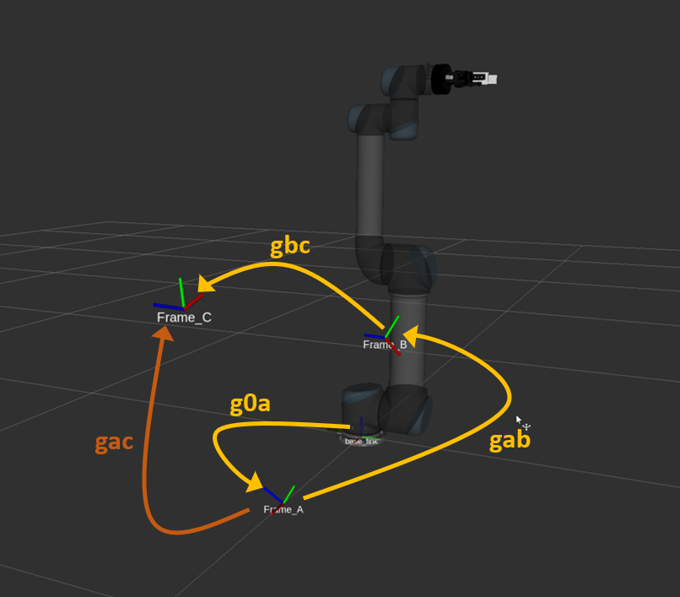

* Frames A2, B2 and C2 visualization:

