VPN connection:

Ping 10.20.1.1

IPsec status:

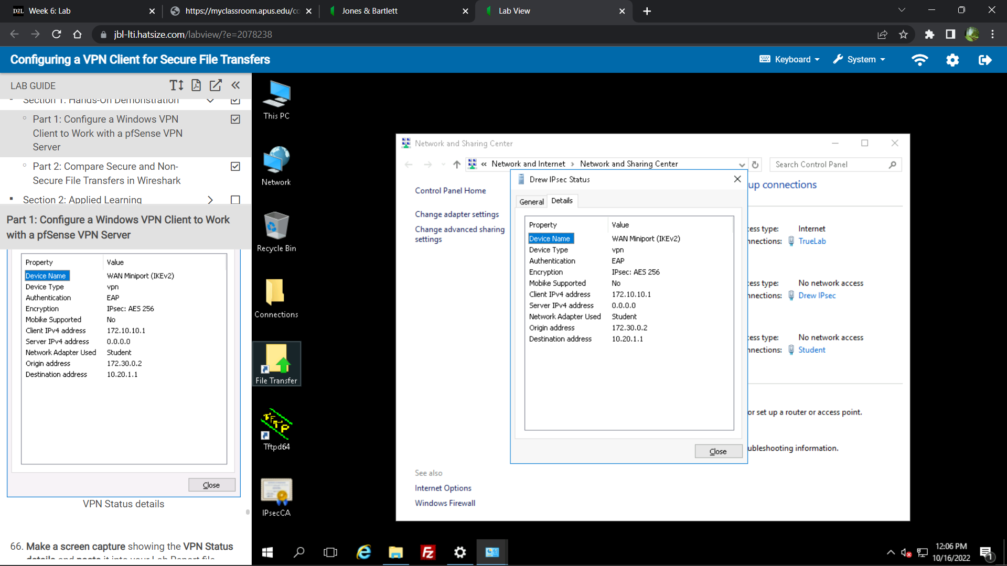

Correct Pass:

