This lab shows a virtual machine hosted computer with vulnerabilities.

The task was to scan the network for open ports to search for threat vectors.

Once the threat vectors were found, attacking them with any of the CVE on the CVSS could be implemented.

Attack vector chosen was with a rootkit installation.

Section one open ports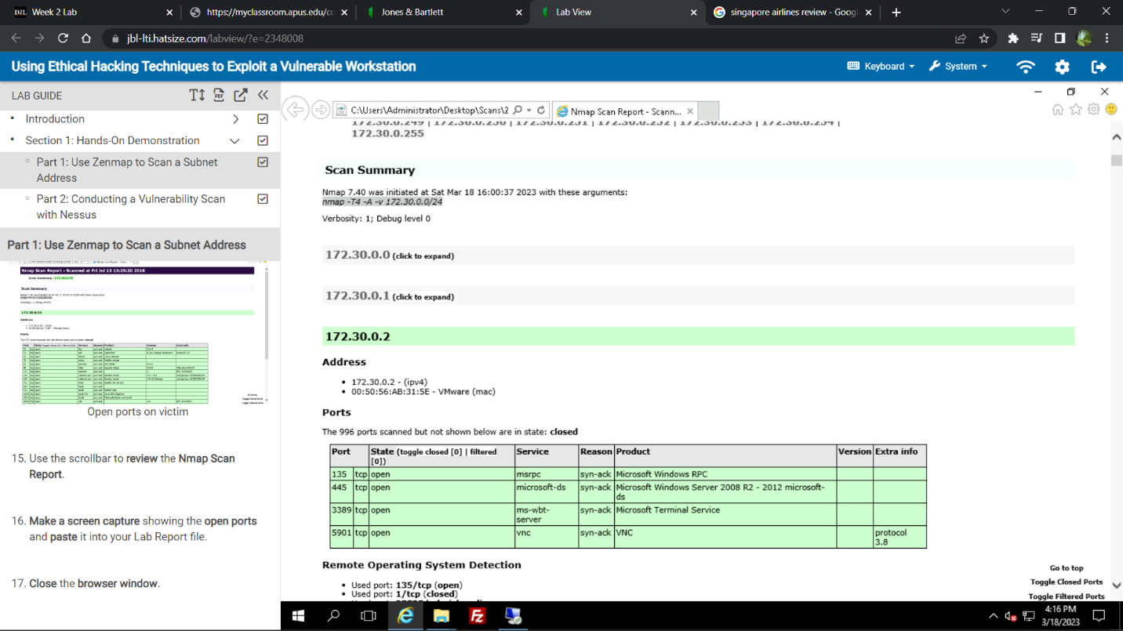

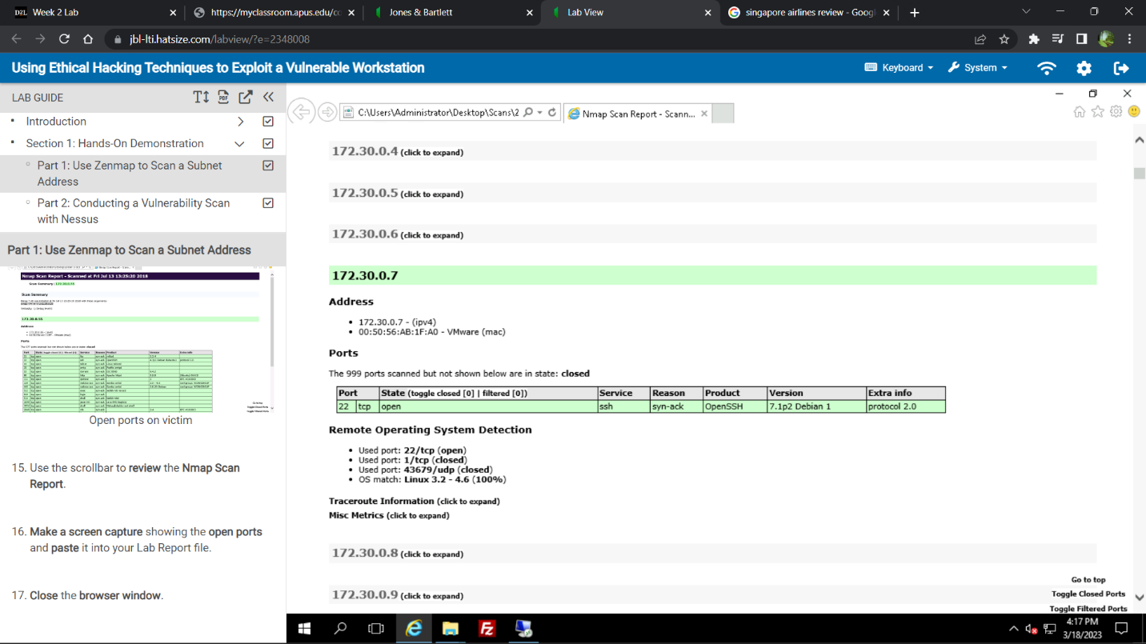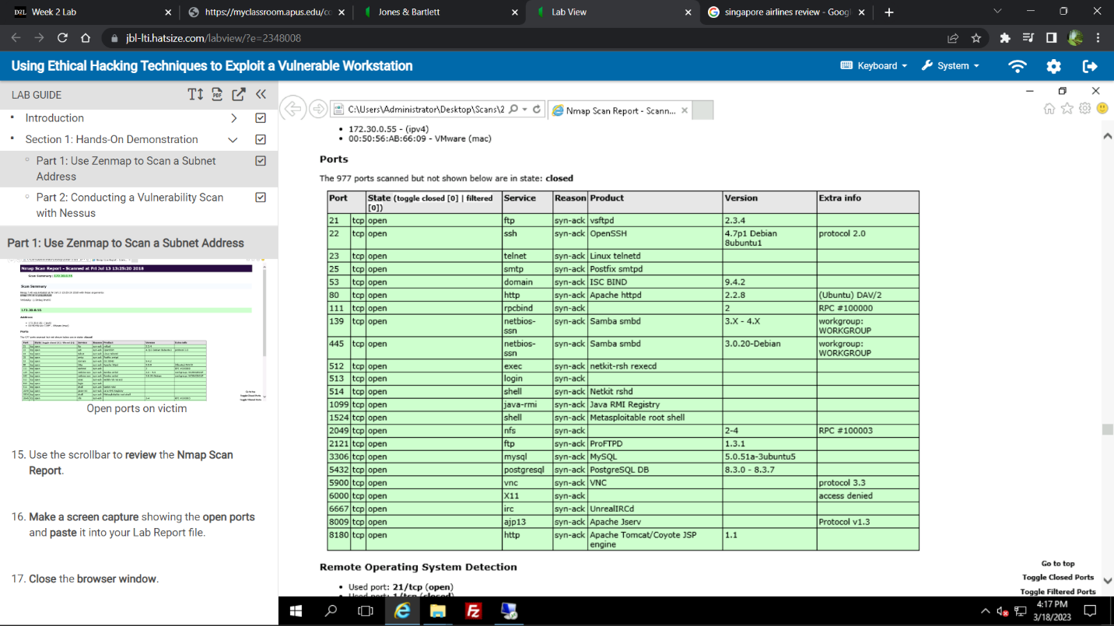

Section 2 open ports:

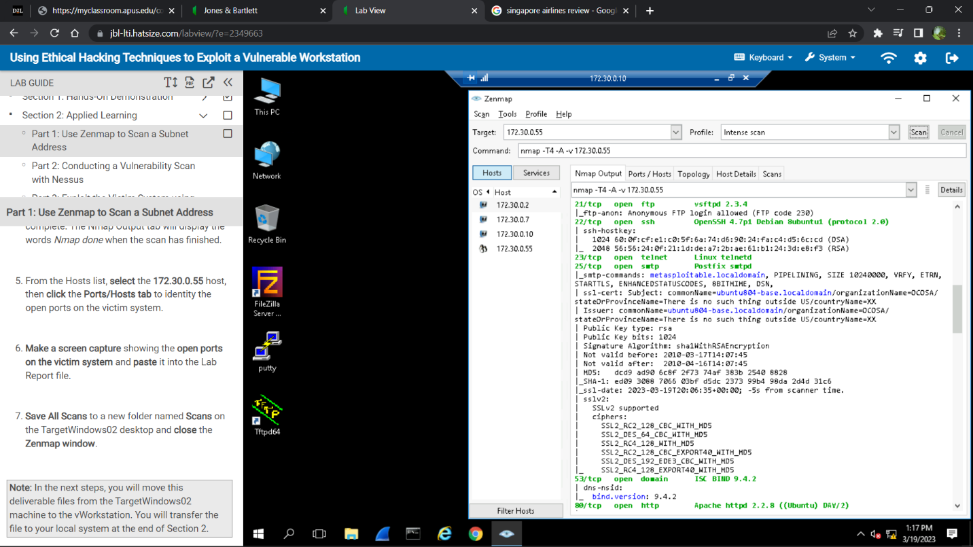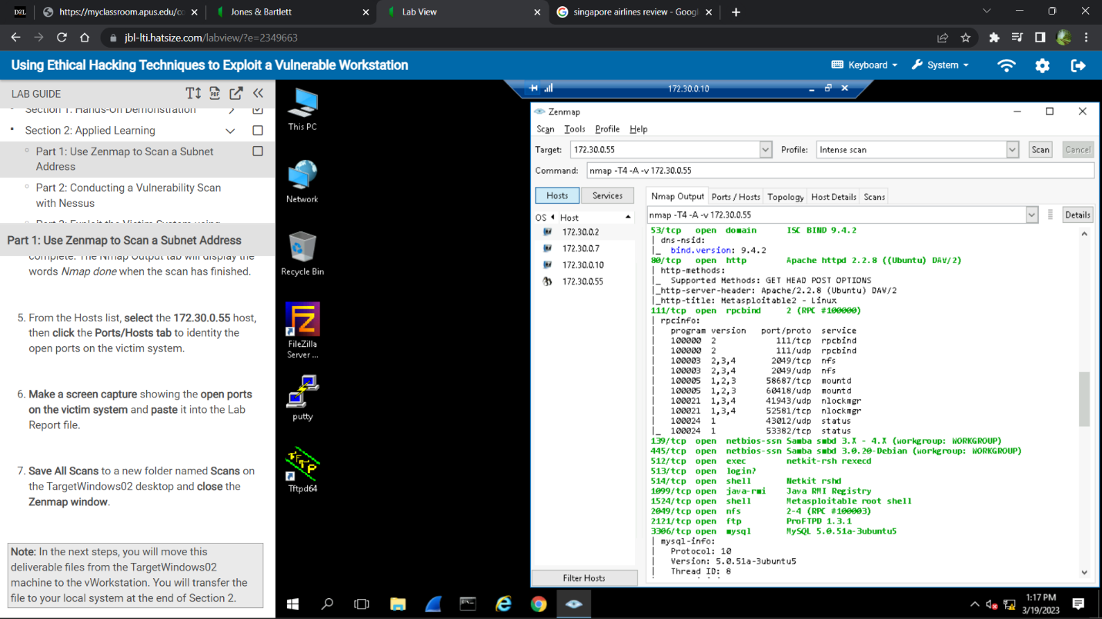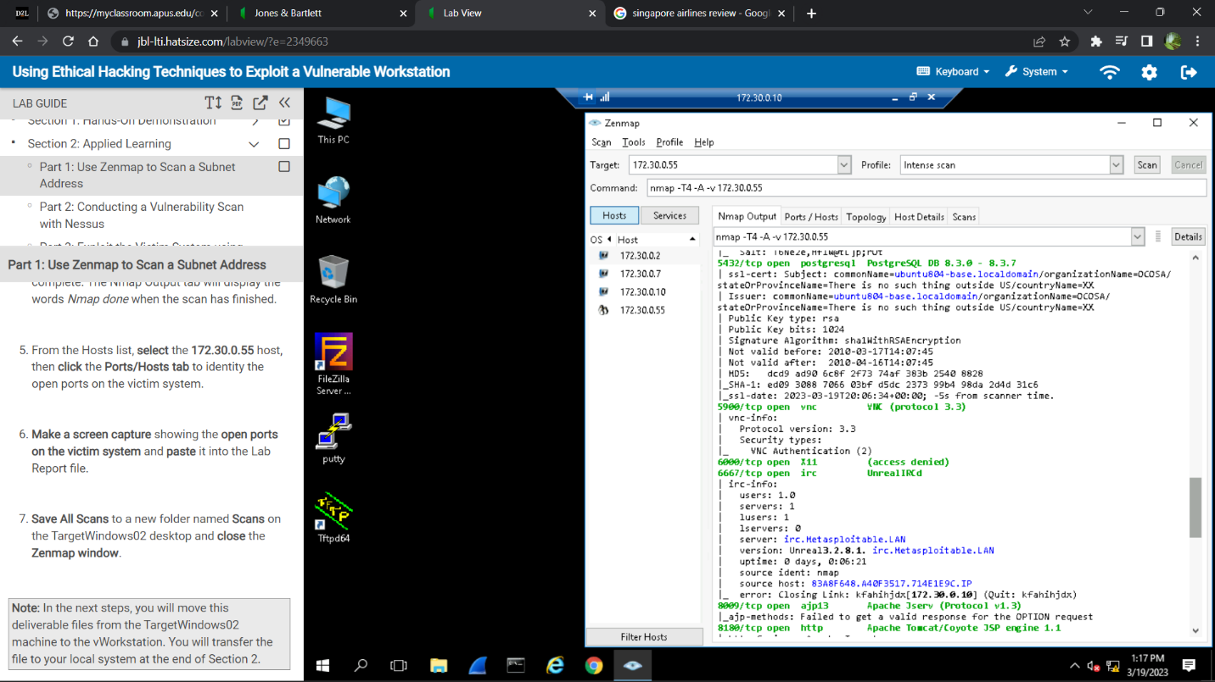

Section 2 Critical Vulnerabilities

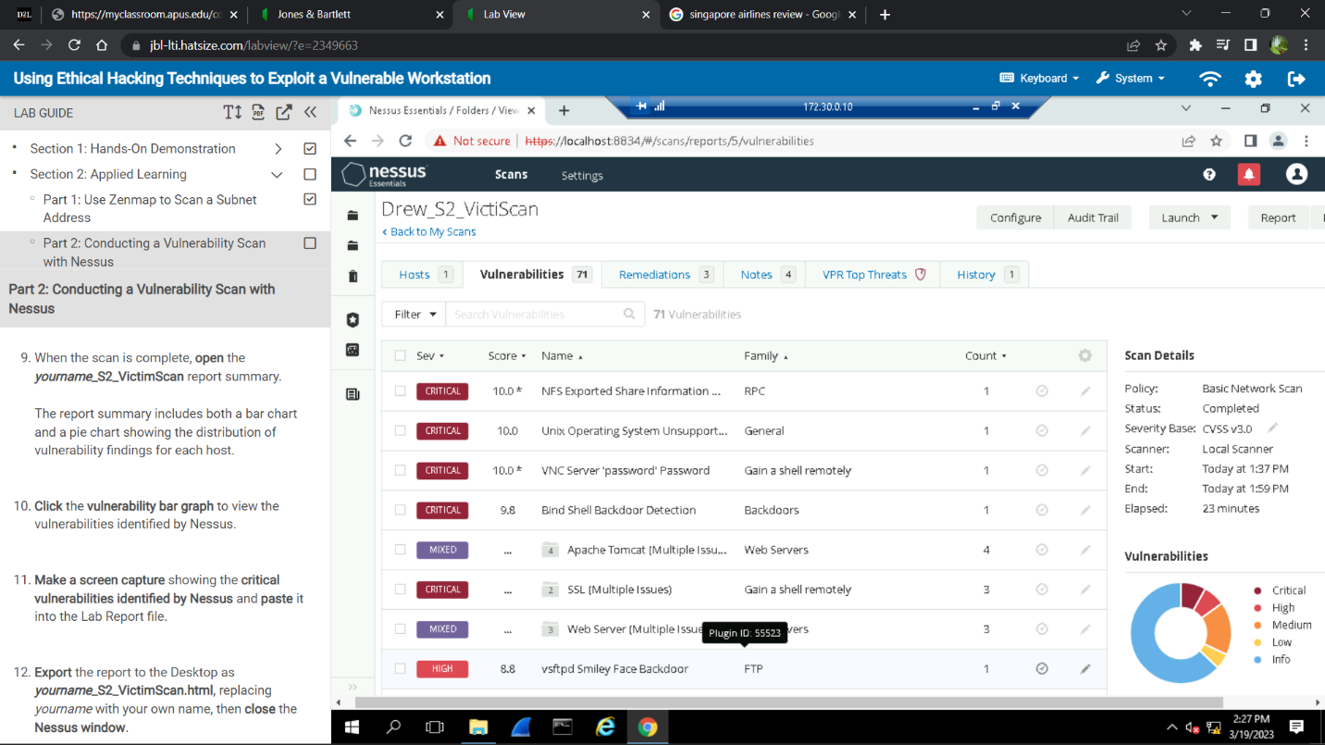

Section 2 Severity Vulnerabilities

Section 2 Evil Skippy

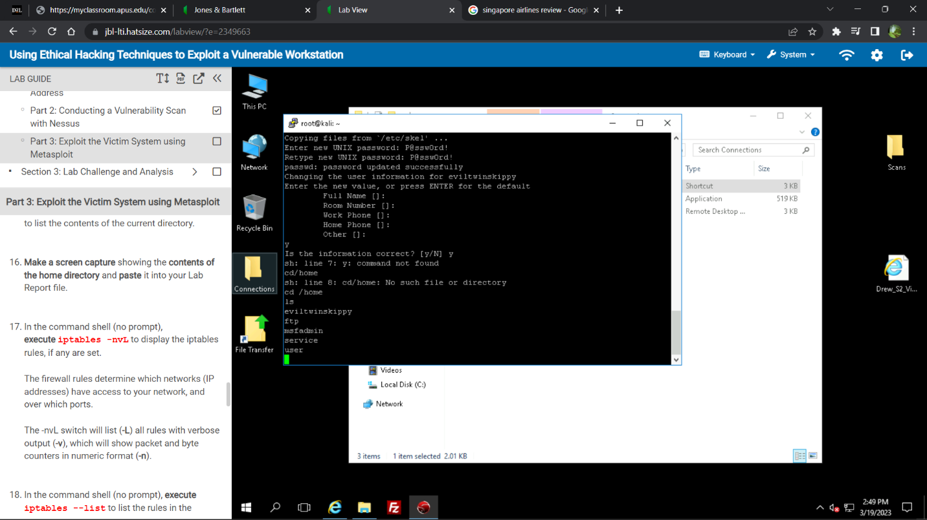

Section 2 --list

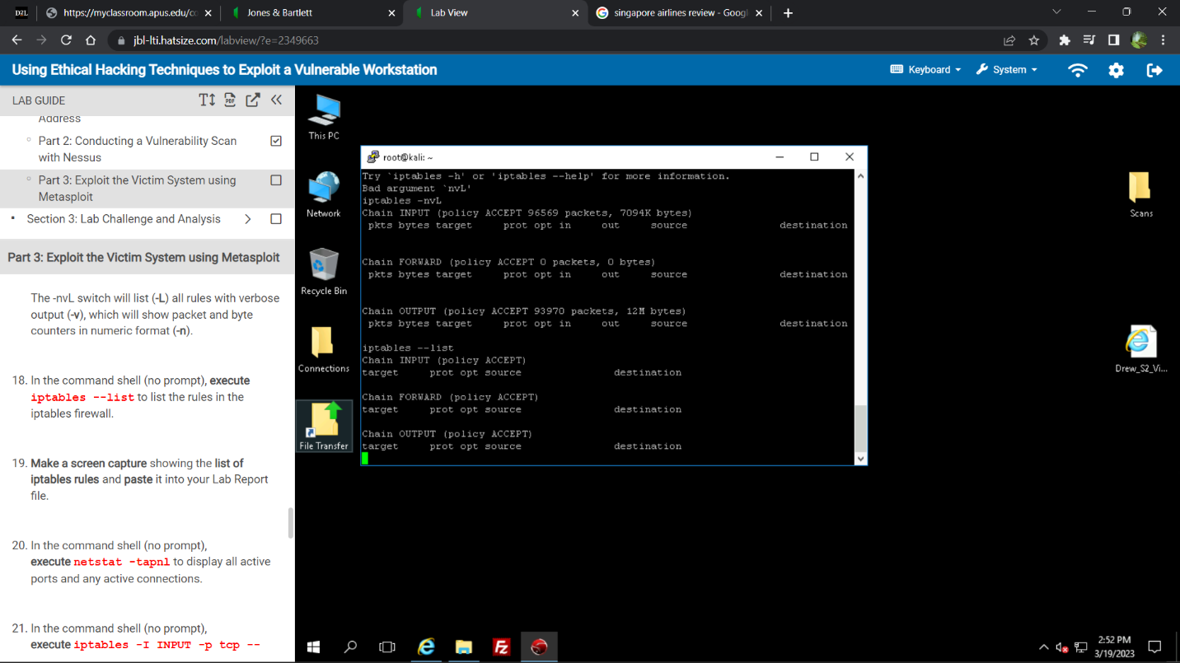

Section 2 Remote Hack

Section 2 Solution

Validate and recompile a legitimate copy of the source code.

