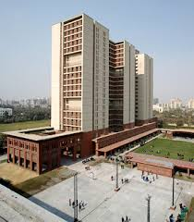

|  |
| --- |
| PROJECT REPORT  2019 |
|  |
| APRIL 24,2019  RAILWAY RESERVATION SYSTEM  MADE BY: AGRAJ GARG  ANANAY SRIVASTAVA  SHIVANG CHATURVEDI |

# Introduction

|  |
| --- |
| This whole system is based on a concept to reserve train tickets of various destinations. Here, as the program is executed, there’s a login system then the user has to choose between reserving a ticket, viewing all the available trains and cancel the reservation. By choosing reservation of ticket, user has to enter the name, number of tickets and then choose by which train to travel according to their destination. Then the system will ask for ticket confirmations. User can also view full list of all the trains available. After reserving a ticket you call also cancel your reservation. This whole project is designed in ‘C’ Programming language & different variables and strings have been used for the development. It is easy to operate and understand by the users.  Features: |
| 1. Login System with validations 2. Easy ticket reservations 3. View the arrival time and departure time of trains and ticket fare 4. Systematic presentation of train’s information 5. Searching your ticket 6. Viewing all the bookings 7. Ticket cancellation   CERTIFICATE |
| This is to certify that the group comprising  • Ananay Srivastava (18103033)  • Agraj Garg (18103031)  • Shivang Chaturvedi (18103056)  have completed their SDF-2 Lab project as per the standards and within the submission dates. Their dedicated efforts are greatly appreciated and their project has been evaluated as per the given criteria.  Date :- Signature :- |

BASIC DATA STRUCTURES USED

STRUCTURES:

The program uses two structures namely, “Train” and

“Passenger”. “Train” stores the information about the train which includes train number, train name, source, destination ,arrival time , departure time , class-wise fare.

. “Passenger” stores passenger detail such as his/her name, gender, train no ,class, age , mobile number , address .

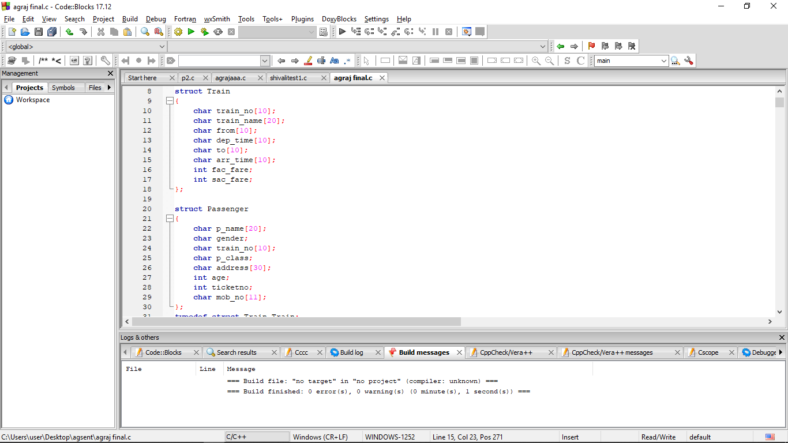

ARRAY:

The program uses arrays at various places, such as, at the time of login, user’s username and password is stored in an array(username[20] and pwd[20]) and if both username and password are correct, the specified functions are called. Further during the whole execution of program and the conduction of the motive of the project array is used as the primary data structure to perform required tasks.

IMPORTANT FUNCTIONS:

* view_trains( ) : This function displays the list of the trains stored in the database of the program in the file. It delivers the information about the trains, their respective boarding and destination stations, timings, and train numbers.
* get_passenger_details( ) : This function accepts the detail of passenger while booking a ticket and stores it into the database of the file – bookings.
* book_ticket( ) : This function confirms booking of a seat in the particular train, accepting various required details from the user.
* view_ticket( ) : This function accepts ticket number to display the details of the particular ticket.
* view_all_bookings( ) : This function shows all the active bookings

bookings made by the user.

* view_bookings( ) : This function accepts the train number to display all the active reservations made for the train.
* cancel_ticket ( ) : This function is called to cancel the reservation made against the entered ticket number.

DIVISION OF WORK AMONG GROUP MEMBERS :

FILE DATABASE :

* AGRAJ GARG
* ANANAY SRIVASTAVA

USER INTERFACE :

* SHIVANG CHATURVEDI

PROGRAM’S ALGORITHMS :

* AGRAJ GARG
* ANANAY SRIVASTAVA
* SHIVANG CHATURVEDI