LOGIN PAGE:

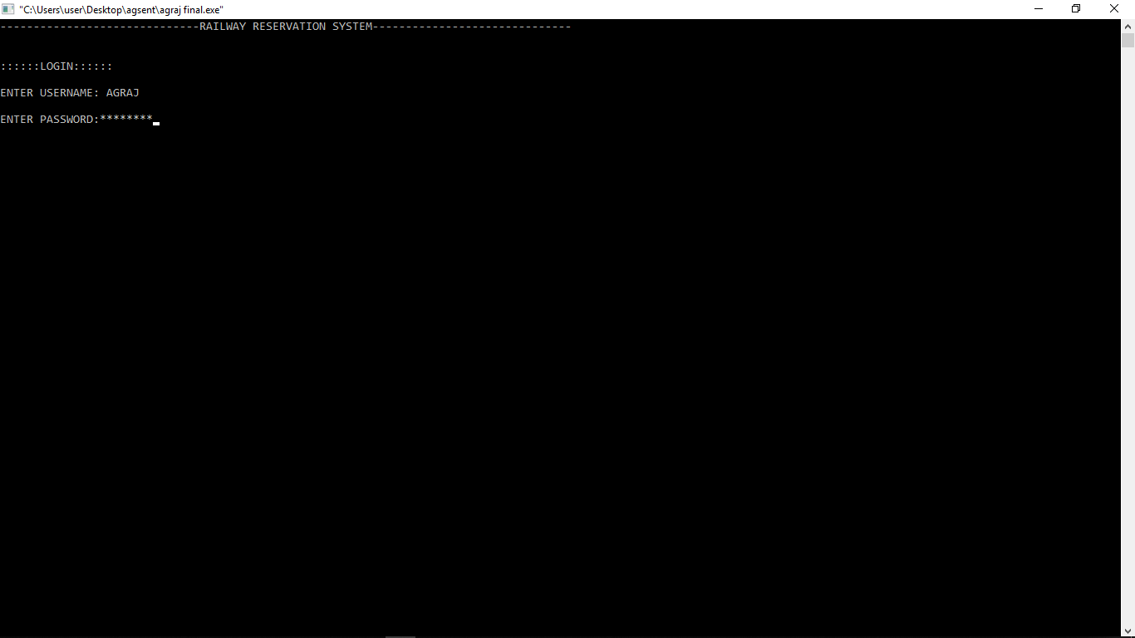

MAIN WINDOW :

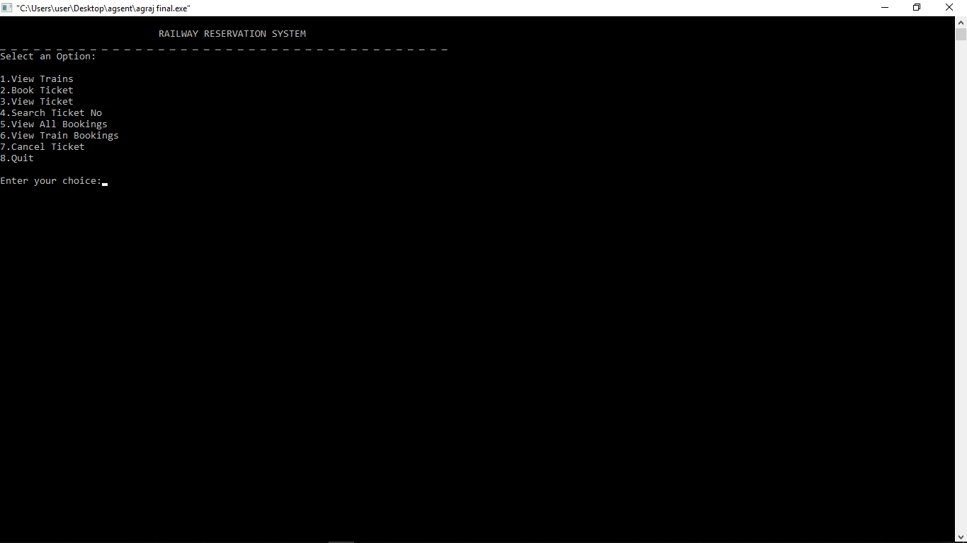

VIEW TRAIN FUNCTION :

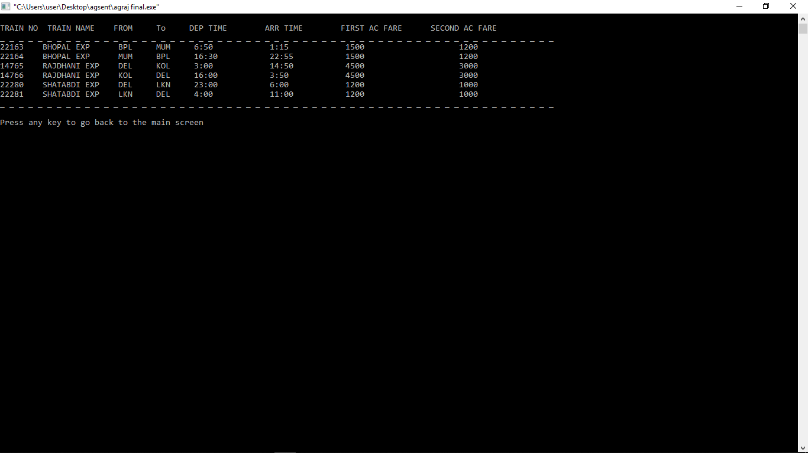

BOOKING A TICKET :

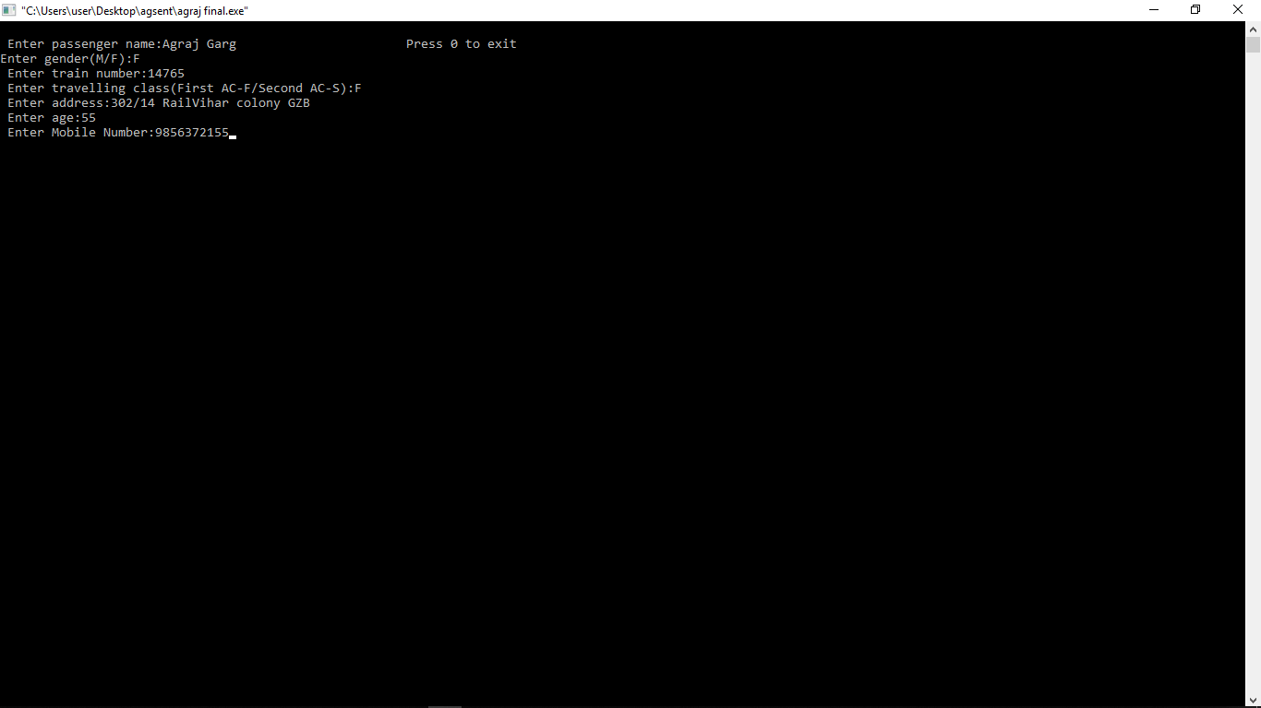

VIEW TICKET FUNCTION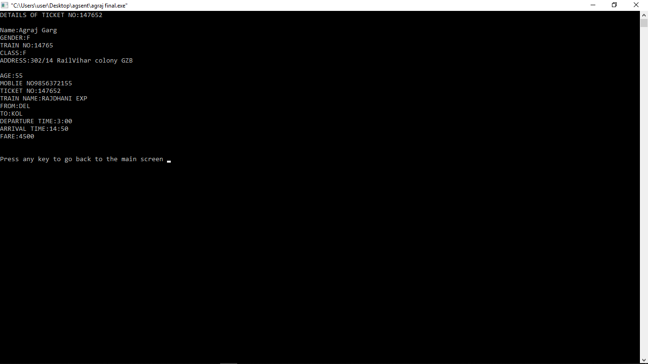

SEARCH TICKET NO. FUNCTION :

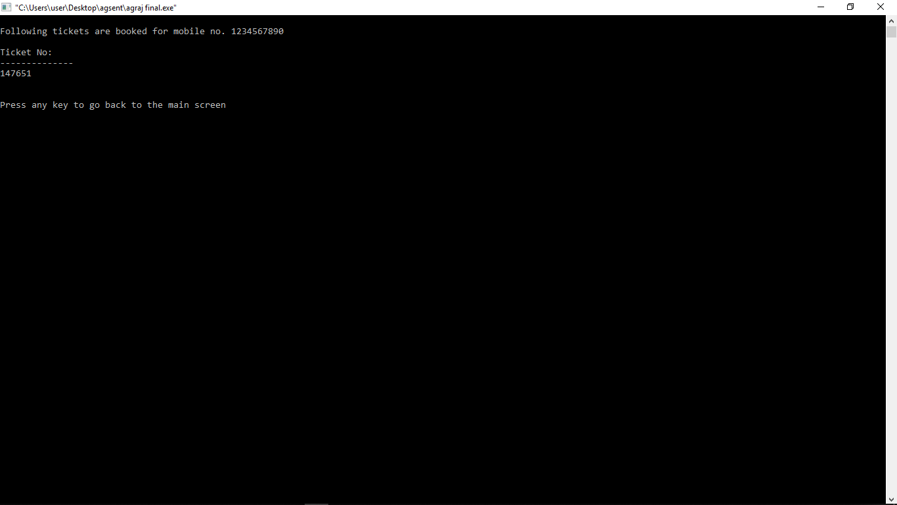

VIEW ALL BOOKINGS FUNCTION :

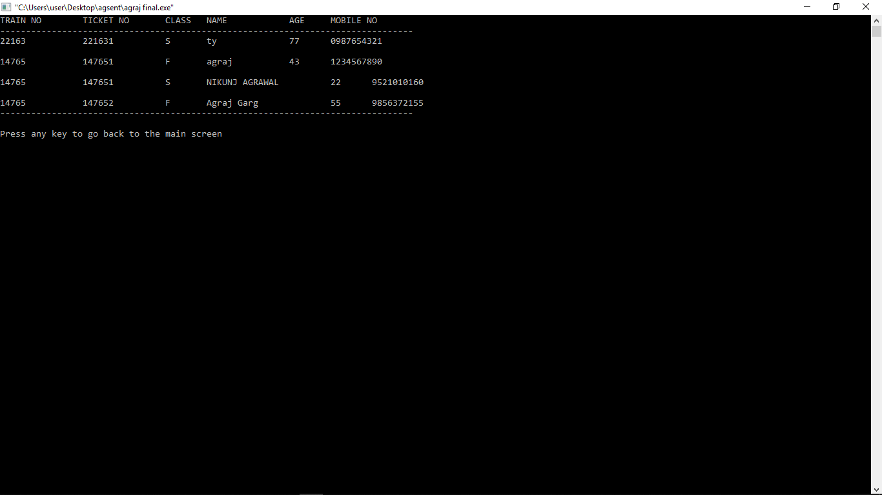

TICKET CANCELLATION :

