**Automotive UI**

Cedric Wambe, Asmaa Alzoubi, Akeem Abrahams

|

Computer Engineering Technology April 9, 2020

|  |
| --- |
|  |

# Declaration of Joint Authorship

We, Asmaa Alzoubi, Akeem Abrahams, and Cedric Wambe, confirm that this work submitted is the joint work of our group and is expressed our own words. Any uses made within it of the works of any other author, in any form (ideas, equations, figures, texts, tables, programs), are properly acknowledged at the point of use. A list of the references used is included. The work breakdown is as follows: Each of us provided functioning, documented hardware for a sensor. Asmaa Alzoubi provided VMA340 Heart/Pulse Rate Sensor. Akeem Abrahams provided MAX30100 Pulse Oximetry Sensor. Cedric Wambe provided AMG8833 Thermal Camera. In the integration effort Akeem Abrahams is the lead for further development of our mobile application, Cedric Wambe is the lead for the Hardware, and Asmaa Alzoubi is the lead for connecting the two via the Database.

# Proposal

We have created a mobile application, worked with databases, completed a software engineering course, and prototyped a small embedded system with a custom PCB as well as an enclosure (3D printed/laser cut). Our internet of things (IoT) capstone project uses a distributed computing model of a smart phone application, a database accessible via the internet, an enterprise wireless (capable of storing certificates) connected embedded system prototype with a custom PCB as well as an enclosure (3D printed/ laser cut).

Intended project key component descriptions and part numbers

Development platform:

Sensor/Effector 1: MAX30100 Pulse Oximetry Sensor

Sensor/Effector 2: VMA340 Heart/Pulse Rate Sensor

Sensor/Effector 3: AMG8833 Thermal Camera

The objective for the User Interface of our mobile application was to build a platform that could be useful to paramedics. This user interface should contain features that are capable of assisting a paramedic in completing tasks during an emergency scenario, thus, should reduce the amount of work that a paramedic has to perform when going towards the scene.

To facilitate this, we included features in the mobile application that will allow a paramedic to, communicate with a patient through video chat, retrieve vital readings of a patient in real-time, and track a patient’s whereabouts automatically with the use of GPS tracking.

The design specifications that we decided on, is as follows:

The User Interface must:

• be easy to use and understand

• allow patient->paramedic communication

• able to automatically track the location of patient

• able to provide some vital information about the patient’s physical and internal state to the paramedic, before arriving at the scene

Paramedic must be able to:

• View patient history

• Access vital information about the patient

• Retrieve client location in real time

Patient must be able to:

• Call and connect with a paramedic through the UI

• View the progress of paramedic as they head towards the scene

• Rate a paramedic

We will continue to develop skills to configure operating systems, networks, and embedded systems, using these key components to create a system capable of determining results for human vital readings in real-time, which includes: heart rate, temperature, and blood oxygen rate readings. This data will be sent to a database platform known as firebase, over the network, where it will then be retrieved for display on our mobile application.

Our project description/specifications will be reviewed by, Dennis Kappen, ideally an employer in a position to potentially hire once we graduate. They will also ideally attend the ICT Capstone Expo to see the outcome and be eligible to apply for NSERC funded extension projects. This typically means that they are from a Canadian company that has revenue generating for a minimum of two years, and have a minimum of two full time employees.

The small physical prototypes that we build are to be small and safe enough to be brought to class every week as well as be worked on at home. In alignment with the space below the tray in the Humber North Campus Electronics Parts kit the overall project maximum dimensions are 12 13/16" x 6" x 2 7/8" = 32.5cm x 15.25cm x 7.25cm.

Keeping safety and Z462 in mind, the highest AC voltage that will be used is 16Vrms from a wall adapter from which +/- 15V or as high as 45 VDC can be obtained. Maximum power consumption will not exceed 20 Watts. We are working with prototypes and that prototypes are not to be left powered unattended despite the connectivity that we develop.

# Executive Summary

Throughout the development of the project, the main goal was to create a simple, compact, user-friendly system which serves to reduce the work-load of a paramedic while heading towards an emergency scenario. With this in mind, we designed a system which is capable of providing some helpful information about the patient, that will make life just that much easier for a paramedic, and in some cases, the patient as well.

This system consists of three sensors, an embedded system, a database over the network, and an android application, implemented/developed by the team. The role of the three sensors are to provide vital information about the patient, and save this information automatically in the database by taking advantage of a network. These sensors function by outputting data about a patient who comes in contact with these sensors. This data provided by each sensor can be processed to, determine the temperature, heart rate, and the oxygen concentration in the blood, of a patient. In order to get this data, a patient must be in contact with the sensors, that is, all they need to do is place one of their fingers on each sensor, and the rest will be handled by the sensor and embedded system. For the user interface, our android application was designed to have these following capabilities:

• Video chat capability

• Retrieve patient information for display

• GPS tracking capability

• Update/Modify patient information as needed

Our goal for this user interface with regards to the paramedic, is to create a platform where paramedics can, easily and efficiently access the location of the patient by automatically tracking the location of the patient, provide visual communication that allows a paramedic to observe the state/condition of a patient, enable accessibility of a paramedic to vital information about the patient by displaying this information in a comprehensive format. With these functionalities, a paramedic will be better prepared for the emergency situation, since they won’t be required to ask a patient for their current location, and they will have some information about the state of the patient before arriving at the scene. This way, they can focus on the patient and be better prepared for their treatment upon arrival at the emergency scene.

Our goal for this user interface with regards to the patient, is to create a platform where patients can, visually communicate with a paramedic, track a paramedics progress when travelling towards the scene, and provide options that allows a patient to type in his/her home address if emergency location is not their home location. These functionalities will serve to lessen the stress on a patient while communicating with the paramedic, since they won’t be burdened with a requirement to provide their current location, or to possibly provide a description of their current state. The GPS tracking and the visual capability of the video chat app will remove these unimportant roles that a patient has to perform. By giving a patient the capability to track the progress of the paramedic when heading towards their location, this will also help to reduce stress on the patient since they will be relieved knowing that a paramedic is that much closer to providing them with the treatment they deserve.

We believe that this system will contribute greatly to the medical field, since this will have a positive impact on the responsiveness of paramedics towards an emergency scenario. Thus, investing in this product should have good prospects for success given time and effort.

Contents

Declaration of Joint Authorship 3

Proposal 5

Executive Summary 9

List of Figures 15

1.0 Introduction 17

1.1 Scope and Requirements 18

2.0 Background 21

2.1 MAX30100 Pulse Oximetry Sensor 22

2.2 AMG8833 IR Grid Eye Thermal Camera 22

2.3 VMA340 Heart/Pulse Rate Sensor 24

3.0 Methodology 25

3.1 Required Resources 25

3.1.1 Parts, Components, Materials 25

3.1.2 Manufacturing 25

3.1.3 Tools and Facilities 25

3.1.4 Shipping, duty, taxes 25

3.1.5 Time expenditure 25

3.2 Development Platform 25

3.2.1 Mobile Application 25

3.2.2 Image/firmware 27

3.2.3 Breadboard/Independent PCBs 27

3.2.4 Printed Circuit Board 29

3.2.5 Enclosure 30

3.3 Integration 31

3.3.1 Enterprise Wireless Connectivity 32

3.3.2 Database Configuration 32

3.3.3 Security 32

3.3.4 Testing 32

4.0 Results and Discussions 33

5.0 Conclusions 35

7.0 Appendix 39

7.1 Firmware code 39

7.2 Application code 39

# List of Figures

Figure 1. By Android Studio - https://developer.android.com/studio/, CC BY-SA 4.0, https://commons.wikimedia.org/w/index.php?curid=74094999 26

Figure 2. Initial schematic. This work is a derivative of "http://fritzing.org/parts/" by Fritzing, used under CC:BY-SA 3.0. 28

Figure 3. This work is a derivative of "http://fritzing.org/parts/" by Fritzing, used under CC:BY-SA 3.0. 28

Figure 4. Breadboard prototype. 29

Figure 5. PCB design This work is a derivative of "http://fritzing.org/parts/" by Fritzing, used under CC:BY-SA 3.0. 30

Figure 6. Humber Sense Hat Prototype PCB. 30

Figure 7. Example enclosure. 31

# 1.0 Introduction

We plan to build a platform specifically for the use of paramedics. The main goal of this system is to reduce the number of roles that are required by a paramedic during an emergency event. We will accomplish this by, building a User Interface through the implementation of an android application to, enable video-chat communication in order to help a paramedic have an idea of the current well-being of the patient, enable GPS tracking so that the paramedic may be able to quickly retrieve the current location of the patient, create a means of display for a paramedic to conveniently observe a patients vital readings so that they may be able to have an idea about the internal state of the patient, and how to proceed. These functions will allow a paramedic to execute their roles more quickly and easily, and they will be able to gather accurate information regarding the condition of the patient, before arriving at the emergency scene. For the hardware side, we will be implementing the use of three sensors, namely, the MAX30100 Pulse Oximetry Sensor, AMG8833 IR Grid Eye Thermal Camera, VMA340 Heart/Pulse Rate Sensor. These sensors will be implemented as follows: MAX30100 Pulse Oximetry will be used to detect blood oxygen levels in a patient, VMA340 Heart/Pulse Rate will be used to detect the heart rate in the body in Beats per Minute, the Thermal camera sensor will be use to measure temperature by scanning the patient’s affected body area and visually represent it on the screen. This data will be sent to firebase, a database over the network, and will be retrieved in the android application for the use of the paramedic.

## 1.1 Scope and Requirements

Throughout the first half of the development of the project, there were both hardware and software guidelines necessary for the successful completion of the project.

The hardware requirements were as follows: configure a raspberry Pi by installing an operating system, establishing a stable connection to the internet, enabling required functions such as I2C, SPI and VNC to retrieve data from the I2C and SPI interface, and enable remote access to the RPI via VNC. Additionally, we are required to, design and test PCB sensors, test connections of PCB with Raspberry Pi and sensor, design an enclosure for the Raspberry with integrated embedded system, and finally, test the functionality of the sensors through programming.

The software requirements for the android application were as follows: User interface should be designed in a simple format to reduce confusion as much as possible for a paramedic and especially for the patient. Paramedic should be able to track patient automatically. Paramedic should be able to view vital information about the patient on the app. Paramedic should be able to search his/her history of completed emergency scenarios. Patient must be able to connect through video chat with a paramedic. Patient should be able to view the progress of a paramedic as they head towards the scene.

Throughout the planning and development stage, there were milestones set in order to ensure the completion of required tasks before the second half of development. We were tasked to, build a Gantt chart to set out all the milestones and due dates for completion of these milestones, create test plans for the app which is an evaluation sheet for app functionality, conduct presentations and attend interviews to advertise our app.

For the second half of development, we will be required to, integrate our PCB’s into one PCB, testing connection of PCB with Raspberry Pi, testing Sensor connection with Raspberry Pi, testing sensor functionality through programming, writing program to send data to firebase, and finally build a new enclosure for the RPI and PCB with al three sensors integrated.

Report

/1 Hardware present?

/1 Introduction (500 words)

/1 Scope and Requirements

/1 Background (500 words)

/1 References

# 2.0 Background

We would like to thank Haki Sharifi, professor of humber college and mentor for android application development or, and Dennis Kappen, the collaborator for our project, for their support and feedback throughout the course of software and hardware development. Professor Haki Sharifi was especially helpful in providing us with innovative ideas and practices to improve how we approach aspects of software development. Due to this, we were able to efficiently design a User Interface that meets all the specified requirements.

Throughout the development of our project, we used various platforms/third party software to execute main tasks, working towards the completion of the project. Android Studio, an android application development platform, was used to design, program and simulate the functionality of our android app. Fritzing, a hardware design platform, was used to design the PCB, schematic, and bread board layout for the sensors selected by each member of the team. Inkscape, a software tool useful for creating custom hardware designs and tools, was used to design the enclosure for the microcontroller with embedded system attached.

With regards to the sensors chosen, each sensor was chosen specifically to accomplish a task that would be useful to a paramedic in an emergency setting. After some research about sensors currently used in the medical field, we were able to select three sensors that would meet this criterion.

## 2.1 MAX30100 Pulse Oximetry Sensor

The MAX30100 Pulse Oximetry Sensor, selected by team member: Akeem Abrahams, is a device used for measurement of heart pulse rate and oxygen concentration in the blood. The sensor consists of two LEDs, modifiable optics, low noise signal processor which detects heart pulse rate signal (Strogonvs, 2017). This sensor communicates with the Raspberry Pi 3 B+ Microcontroller using I2C. For this project, only the blood oxygen detection function of the MAX30100 will be used. This sensor detects the blood oxygen concentration level in the body by measuring the amount of red light and infrared light that is absorbed by the tissue of a finger that has been placed on it (Strogonvs, 2017). Depending on the quantity of oxygen in a human body, the ratio of absorbed red light and infrared light will be different (Strogonvs, 2017). This ratio, multiplied by a 100, represents the blood oxygen level in the blood hemoglobin of a human (Strogonvs, 2017). The blood oxygen rate can be represented as a formula: Blood Oxygen Rate % = red light / infrared light * 100. This sensor can be used for wearable devices, fitness assistant devices, and medical monitoring devices (SPO2 Sensor MAX30100 Pulse Oximeter heart Rate Sensor Module, n.d.).

## 2.2 AMG8833 IR Grid Eye Thermal Camera

This sensor, selected by team member: Cedric Wambe, is an 8x8 array of IR thermal sensors from Panasonic. It measures temperatures with a range from 0oC to 80oC or 32oF to 176oF having an accuracy of +-2.5oC which is 4.5oF (Miller, n.d.). The SciPy python library provided help to process the image. Also, the library helps in getting some nice image result.

When connected to the raspberry pi, the sensor will return an array of 64 individual infrared temperature which will be read through the I2C interface. This sensor is a great add on to project which requires visually detecting heat instead of just getting the values. Like is the case with this current project, the sensor will be used to scan the body of the patient and report which part of the body is more affected and how hot it is. Also, this sensor can be use as a human detector as it has the capacity to detect humans from a distance of up to 7 meters (Miller, n.d.) which is up to 23 feet. Doing this at a rate of up to 10Hz. In addition, the sensor has an interrupt pin than can be invoked when a certain level of pixel is reached. This level could be below or above depending on pre set value. The sensor can be connected to the raspberry pi through 3V or 5V; the 3.3V regulator level that comes with the sensor will be able to adjust the voltage accordingly.

The following pins are used to connect the sensor to the raspberry pi.

Vin: power pin which will take the input voltage and convert it using the voltage regulator to 3.3V used by the sensor.

3Vo: the output voltage from the regulator which is 3.3V.

GND: is the common ground

INT: the interrupt pin which can be use to detect motion or change.

SDA: I2C data pin that connects to the data pin 3 of the raspberry pi.

SCL: I2C clock pin that connects to the clock pin 5 on the raspberry pi.

## 2.3 VMA340 Heart/Pulse Rate Sensor

The VMA340 Heart/Pulse Rate Sensor, selected by team member: Asmaa Alzoubi, is a device used for measurement of heart pulse rate in the blood. It is a pulse/heart rate sensor which easily measures your own pulse and thus monitor permanently your health condition, using Raspberry Pi (Raspberry Pi Heartbeat / Pulse measuring, n.d.). It measures the number of times the heart beats per minute (BPM). This sensor can also be used in mobile Raspberry Pi applications. The Raspberry Pi pulse sensor can not be read out digitally, thus we need an analog-to-digital converter. Such an ADC makes it possible to read out analog signals on the Raspberry Pi, communicates with microcontroller using SPI interface. It uses an infrared light to measure the pulses Heartbeat can be measured based on optical power variation as light is scattered or absorbed during its path through the blood. It uses 3.3 V from the Raspberry Pi (Raspberry Pi Heartbeat / Pulse measuring, n.d.).

# 3.0 Methodology

## 3.1 Required Resources

Report

/1 Parts/components/materials (500 words)

/1 PCB, case (500 words)

/1 Tools, facilities (500 words)

/1 Shipping, duty, taxes (250 words)

/1 Working time versus lead time (250 words)

### 3.1.1 Parts, Components, Materials

The main parts required for the blood oxygen rate functionality of the system includes: SD card ranging between 16Gigabytes and 32 Gigabytes, Raspberry PI 3 B+ microcontroller, MAX30100 Pulse Oximetry Sensor and Light Emitting Diodes, a transistor, soldering lead metal, electrical wires. Throughout the development stage, other parts needed to complete an up-coming task were purchased. These include, wire cutter and headers. Over time, some issues came up with some of the major parts which required purchasing. These parts became defective due to carelessness when handling parts during the configuration and testing stage. The parts that had to be re-purchased were, Raspberry Pi 3 B+, three SD cards with 32 Gigabyte capacity, and another MAX30100 Sensor. The MAX30100 Pulse Oximetry Sensor consists of seven pins. They are placed in order from VIN, SCL, SDA, INT, IRD, RD, GND respectively. VIN accepts source voltage ranging from 1.8V to 3.3V, SCL and SDA are used to enable I2C communication, IRD and RD not applicable since not needed for functionality, GND for ground. Parts should be handled with utmost care as damage of parts will more often than not result in replacement, which is very expensive and takes time to get shipped. Some tips for success with regards to the testing stage of the hardware are as follows: do not, at any point, bring your microcontroller or sensor in contact with loose metal as this might possibly cause the sensor or the microcontroller to become defective, and maintain an organized environment when testing as this reduces the occurrence of possible accidents that could delay the completion of a dated task.

**__Cedric write about parts that you bought for hardware production technology project, the components: like pinouts of your sensor. Talk about the extra stuff you bought. Talk about some of the issues you faced with hardware, for example, hardware stopped working etc…..**

**__Asmaa write about parts that you bought for hardware production technology project, the components: like pinouts of your sensor. Talk about the extra stuff you bought. Talk about some of the issues you faced with hardware, for example, hardware stopped working etc…..**

### 3.1.2 Manufacturing

The production of the PCBs and case was done at Humber College Institute of Technology and Advanced Learning, using laser-cut technology from the prototype lab. Soldering of the PCB for each sensor was done by the respective members of the team to which each sensor was assigned.

### 3.1.3 Tools and Facilities

Throughout each milestone for the half of the development, various tools and facilities were used to achieve a working model by end of December 2019. The software tools used were, Inkscape, fritzing, Gantt, SD Card Formatter, and Android Studio. Inkscape was used to design the case for the embedded system. Fritzing was used to build a schematic design, bread board design, and PCB design for the circuit. A significant amount of time was spent on Inkscape and fritzing, since there were some minor errors in the design figured out at a later time, which needed to be fixed by revisiting these software tools. Gantt was used to set out the timeline for all the tasks required to be completed over the course of four months. It was encouraged, when building the chart, to follow Agile methods in order to increase productivity. This schedule, designed using Gantt, was then used to follow up on deadlines to ensure we complete tasks on time. SD card formatter is a utility that was used in the first stage of stage of configuration and installation of raspberry Pi operating System on the Microcontroller. SD card must be formatted so as to prevent the possibility of sensitive files getting corrupted during the installation phase. Android studio, is a software tool used to build the User Interface for the system. Android Studio was used to build an android application, and contains all the features needed to accomplish the User Interface requirements. For minor tools needed, such as safety glasses, extra soldering lead metal, electrical wires, extra transistors, and so on, were all borrowed from the parts crib at Humber College. In order to configure Operating System on microcontroller, some peripheral devices were needed. These were, a mouse and a keyboard, directly connected to the microcontroller via the USB bus. After enabling VNC to allow the system to allow a remote connection over the network, it was then possible to use the VNC viewer software tool to interact with the microcontroller wirelessly.

### 3.1.4 Shipping, duty, taxes

For shipping of parts for MAX30100 Pulse Oximetry sensor, the maximum shipping time was three weeks, however, parts came one week earlier. The planned budget for shipping cost including taxes, were $94.25 in total. However, due to unexpected defects that occurred over the development period, more parts had to be purchased. Since time was limited during this time, even more money was spent to ensure the quick shipment of the parts so that they could be quickly integrated before the deadline. By the end of December 2019, a total of $262.91 was spent in total.

**__Asmaa write about your shipping duties and taxes, and stuff.__**

**__Cedric write about your shipping duties and taxes, and stuff.__**

### 3.1.5 Time expenditure

With regards to the lead time. All milestones were planned at and set in order so that every week there was something to do. For the first week, we were tasked to select our team members, choose the project we plan to take part in, and schedule a meeting with the collaborator for the project. For the second week, we did some research on the project, selected our sensor, submitted milestone for the proposal. In the third week, we were expected to have already ordered the parts, and should have already started planning the design of the User interface for the android application. For the fourth week, should have received our shipment, and begin configuration of equipment, and breadboard, schematic and PCB design. After reading week and mid-term, working on beta release for android application, should have all functionalities up and running before the due date. At this point, should have a working design for PCB, and send off to the prototype lab for production. In the 8th week, the testing phase of PCB, soldering, and testing connection with microcontroller. In the ninth week, beta release of android application should be completed and submitted before the deadline. For weeks of 10 to 13, designing case for raspberry Pi and embedded system, and sending it to prototype lab for laser or 3D print. Perform final touches to User Interface of android application, present working hardware, and working android application.

For the working time, most of the tasks set out for each week of the lead time was followed. However, there were periods where some tasks were submitted late due to unexpected situations occurring during development. Work load was also a major factor in development, since there were various other tasks given during this period so much so that it was difficult to keep on track.

Working time versus lead time

## 3.2 Development Platform

### 3.2.1 Mobile Application

Status

/1 Hardware present?

/1 Memo by student A + How did you make your Mobile Application? (500 words)

/1 Login activity

/1 Data visualization activity

/1 Action control activity

Include screenshots such as Figure 1. Testing. Progress.

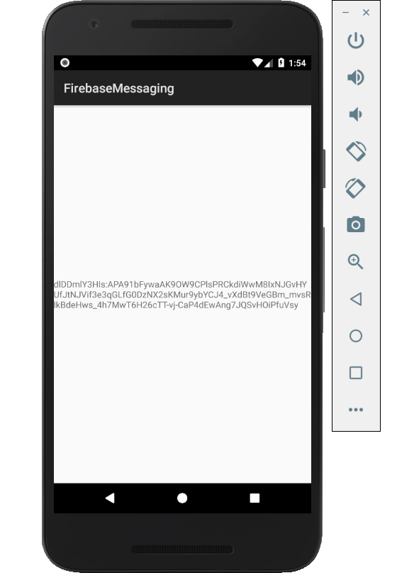

Figure 1. By Android Studio - https://developer.android.com/studio/, CC BY-SA 4.0, https://commons.wikimedia.org/w/index.php?curid=74094999

### 3.2.2 Image/firmware

Status

/1 Hardware present?

/1 Memo by student B + How did you make your Image/firmware? (500 words)

/1 Code can be run via serial or remote desktop

/1 Wireless connectivity

/1 Sensor/effector code on repository

### 3.2.3 Breadboard/Independent PCBs

Status

/1 Hardware present?

/1 Memo by student C + How did you make your hardware? (500 words)

/1 Sensor/effector 1 functional

/1 Sensor/effector 2 functional

/1 Sensor/effector 3 functional

The initial schematic design, Figure 2, based on datasheets (Bosch Sensortec, 2019) led to a breadboard layout Figure 3 that was realized Figure 4.

How did you build your Prototype: Breadboard?

Then a PCB was designed, Figure 5, and populated (Figure 6). Bill of Materials, Case, Time commitment. Testing. Progress.

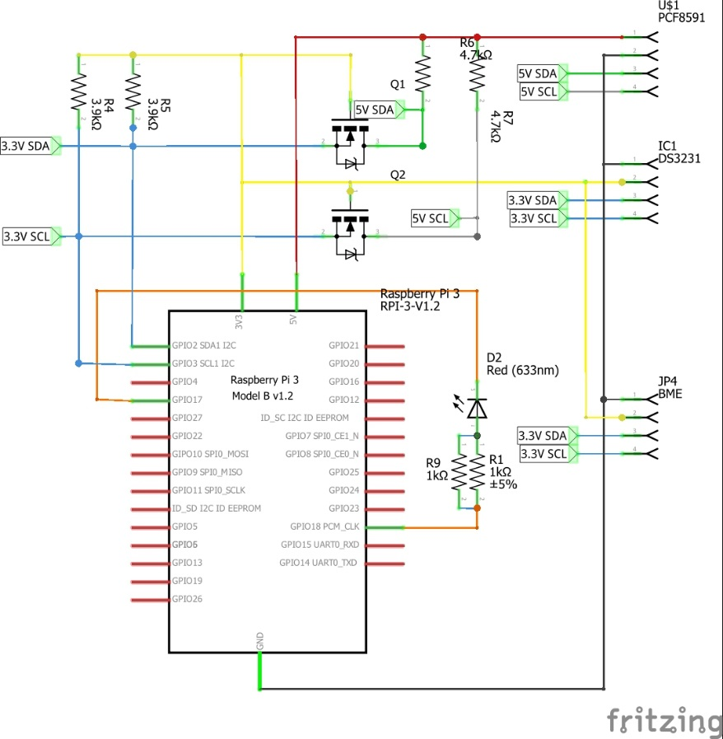

Figure 2. Initial schematic. This work is a derivative of "http://fritzing.org/parts/" by Fritzing, used under CC:BY-SA 3.0.

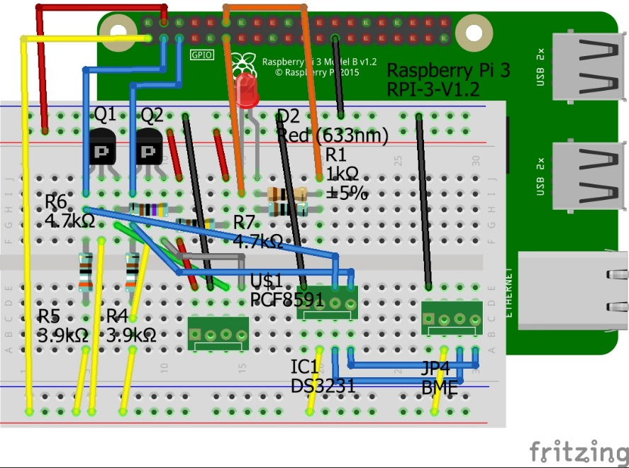

Figure 3. This work is a derivative of "http://fritzing.org/parts/" by Fritzing, used under CC:BY-SA 3.0.

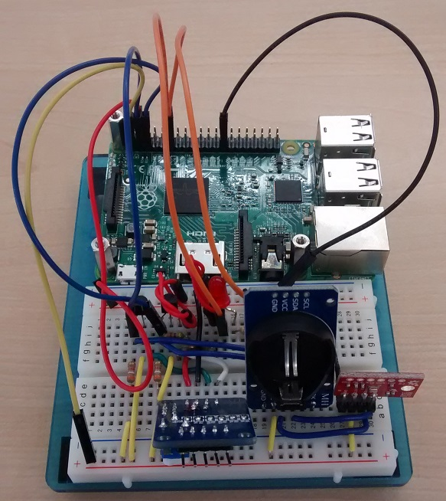

Figure 4. Breadboard prototype.

### 3.2.4 Printed Circuit Board

Demo

/1 Hardware present?

/1 PCB Complete and correct

/1 PCB Soldered wire visible but trim, no holes or vacancies

/1 PCB Tested with multimeter

/1 PCB Powered up

How did you build your Prototype: PCB?

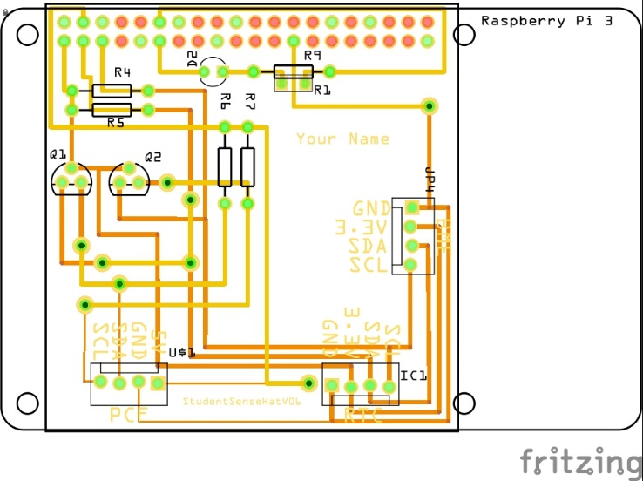

Figure 5. PCB design This work is a derivative of "http://fritzing.org/parts/" by Fritzing, used under CC:BY-SA 3.0.

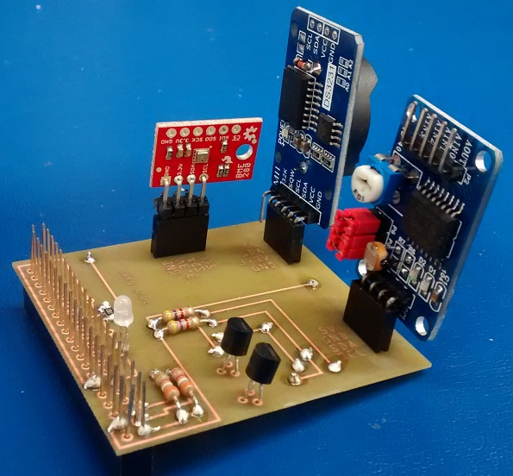

Figure 6. Humber Sense Hat Prototype PCB.

### 3.2.5 Enclosure

Demo

/1 Hardware present?

/1 Case encloses development platform and custom PCB.

/1 Appropriate parts securely attached.

/1 Appropriate parts accessible.

/1 Design file in repository, photo in report.

How did you build your Prototype: Case?

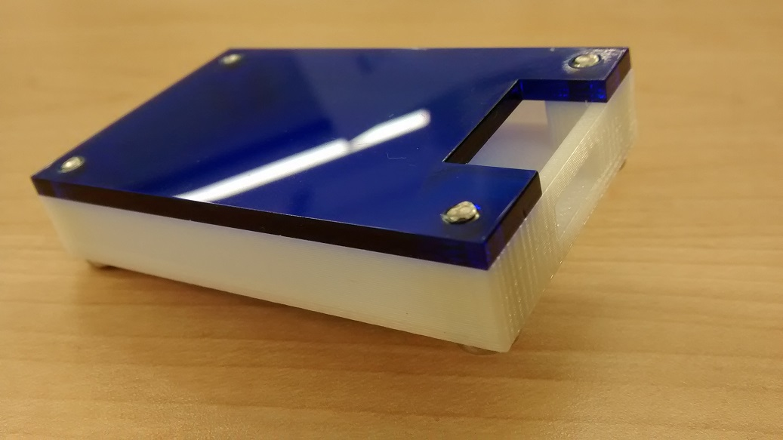

Figure . Example enclosure.

## 3.3 Integration

Demo

/1 Hardware present?

/1 Data sent by hardware

/1 Data retrieved by mobile application

/1 Action initiated by mobile application

/1 Action recieved by hardware

Report

/1 Enterprise wireless connectivity (250)

/1 Database configuration (250 words)

/1 Security considerations (500 words)

/1 Unit testing (900 words)

/1 Production testing (100 words)

### 3.3.1 Enterprise Wireless Connectivity

How did you make a Database accessible by both your Prototype and Mobile Application?

### 3.3.2 Database Configuration

### 3.3.3 Security

### 3.3.4 Testing

Unit testing and Production testing.

# 4.0 Results and Discussions

Is your prototype perfect? What did you learn?

# 5.0 Conclusions

If you were making 1000 of these.

Report

/1 Hardware present?

/1 Checklist truthful

/1 Valid Comments

/1 Results and Discussion (500 words)

/1 Conclusion

Miller, D. (n.d.). *Adafruit AMG8833 8x8 Thermal Camera Sensor*. Retrieved from Adafruit: https://learn.adafruit.com/adafruit-amg8833-8x8-thermal-camera-sensor/overview

*Raspberry Pi Heartbeat / Pulse measuring*. (n.d.). Retrieved from Raspberry Pi Tutorials: https://tutorials-raspberrypi.com/raspberry-pi-heartbeat-pulse-measuring/

*SPO2 Sensor MAX30100 Pulse Oximeter heart Rate Sensor Module*. (n.d.). Retrieved from Hallroad.org: https://hallroad.org/max30100-pulse-oximeter-heart-rate-sensor-module-in-pakistan.html

Strogonvs, R. (2017, 3 8). *Implementing pulse oximeter using MAX30100*. Retrieved from Morf Coding & Engineering: https://morf.lv/implementing-pulse-oximeter-using-max30100

# 7.0 Appendix

## 7.1 Firmware code

Demo

/1 Hardware present?

/3 Code runs concurrently for all sensors/effectors

/1 Project repository contains integrated code

Status

/1 Memo including updates

/1 Financial update

/1 Progress update

/1 Modified Code Files in Appendix

/1 Link to Complete Code in Repository

## 7.2 Application code

Demo

/1 Hardware present?

/1 Memo by student A

/1 Login activity

/1 Data visualization activity

/1 Action control activity

Report

/1 Login activity

/1 Data visualization activity

/1 Action control activity

/1 Modified Code Files in Appendix

/1 Link to Complete Code in Repository