Hui Li

Embedded Linux Class

***the Picture of Set up***

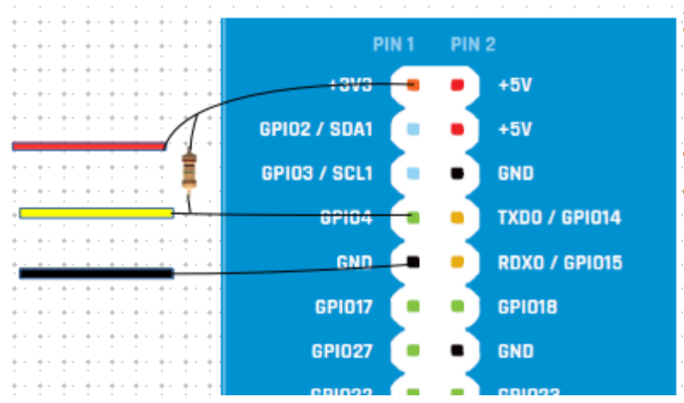

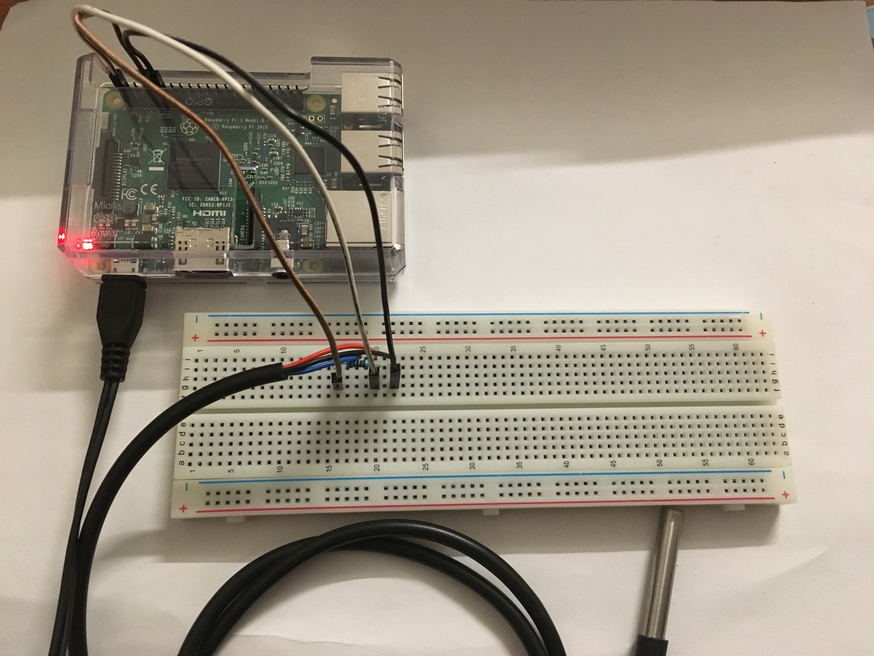

***Source code of log temperature data into database***

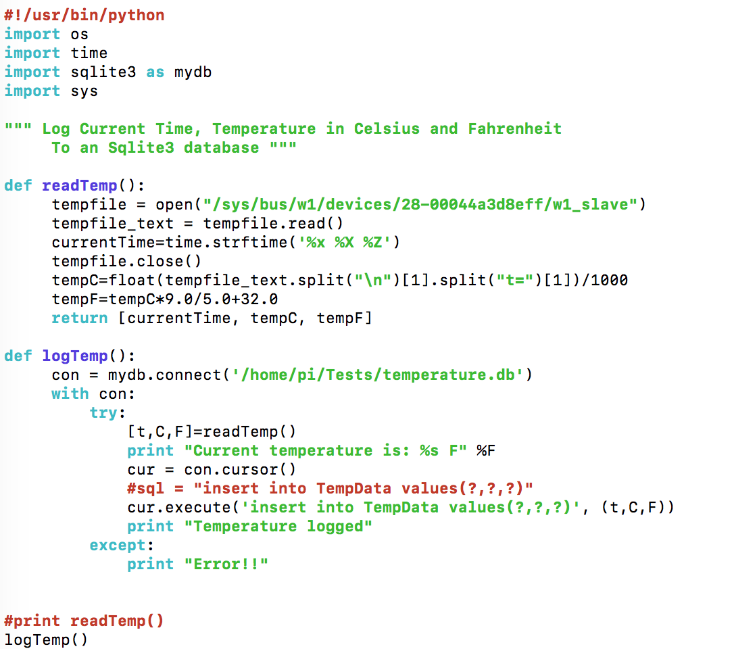

**run the following code in the terminal and waits for 10 minutes to use CTRL + C to exit**

**while true ; do sudo python logTemperature.py & sleep 30; done**

***Source code of output data from database***

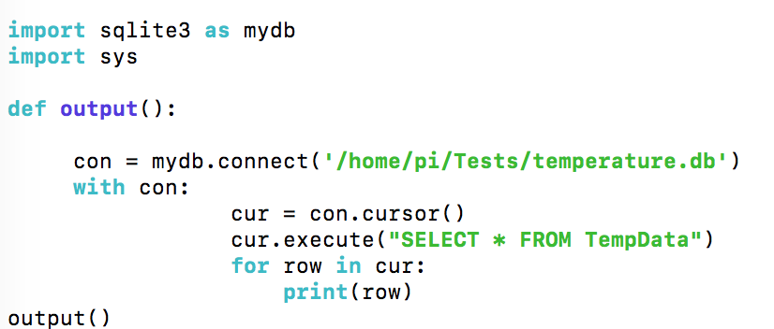

***Table of Temperature Data***

