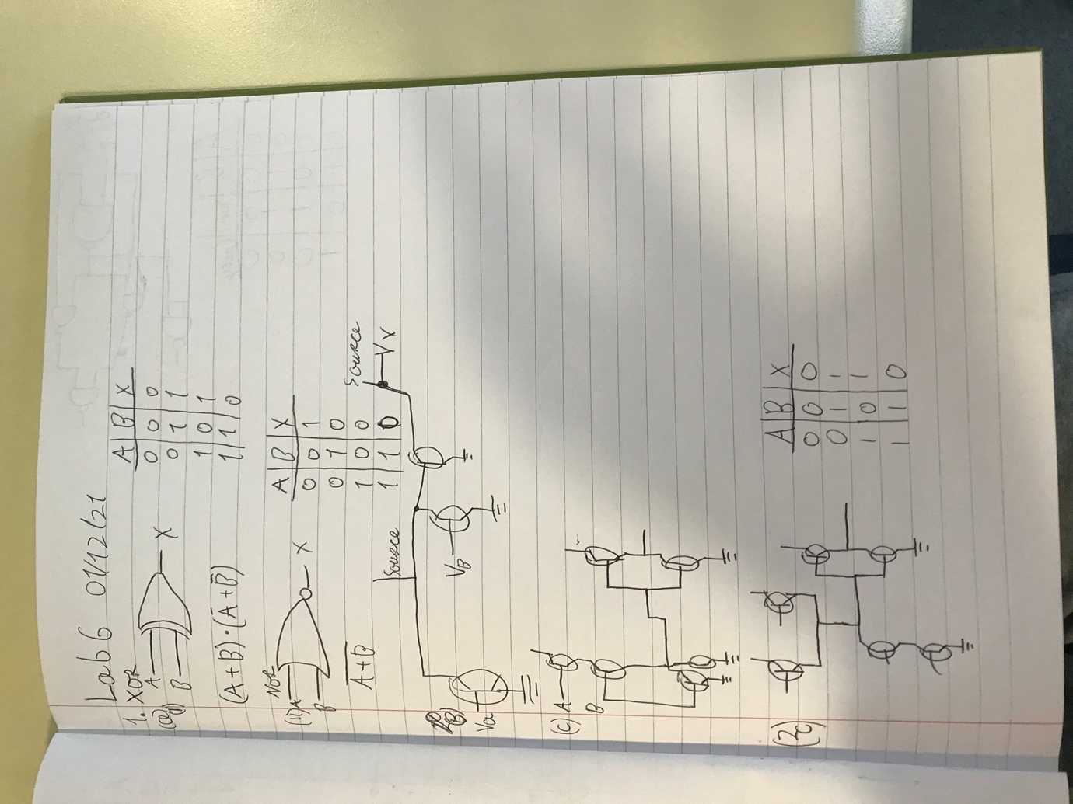
Objective
Understand various logic gates
- Complete questions below a, b, c below
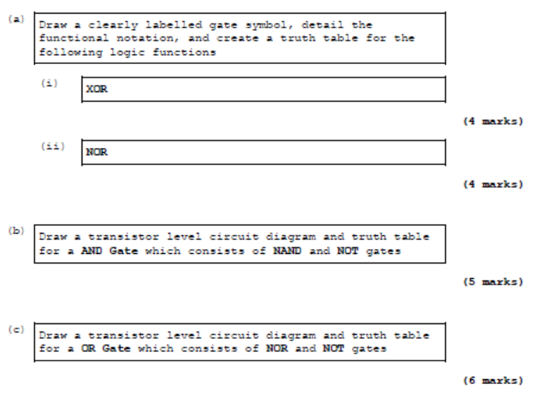

- Complete questions below
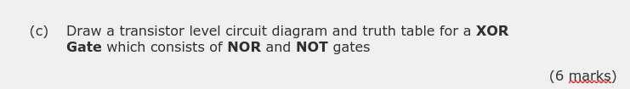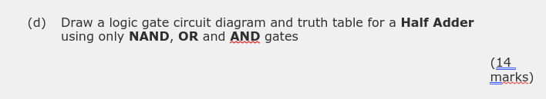
- Complete questions below
Construct the following Circuit using NAND and NOT Gates and complete Truth Tables

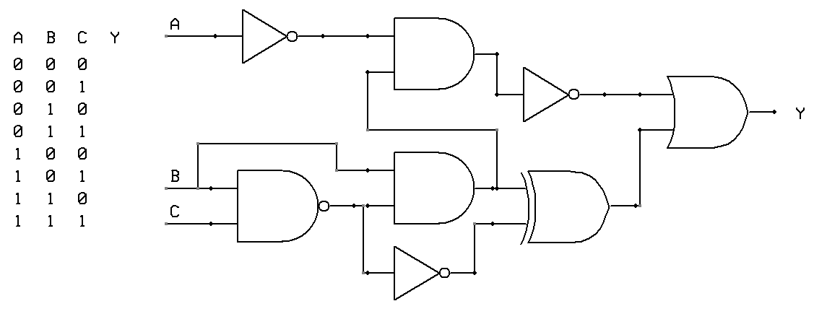

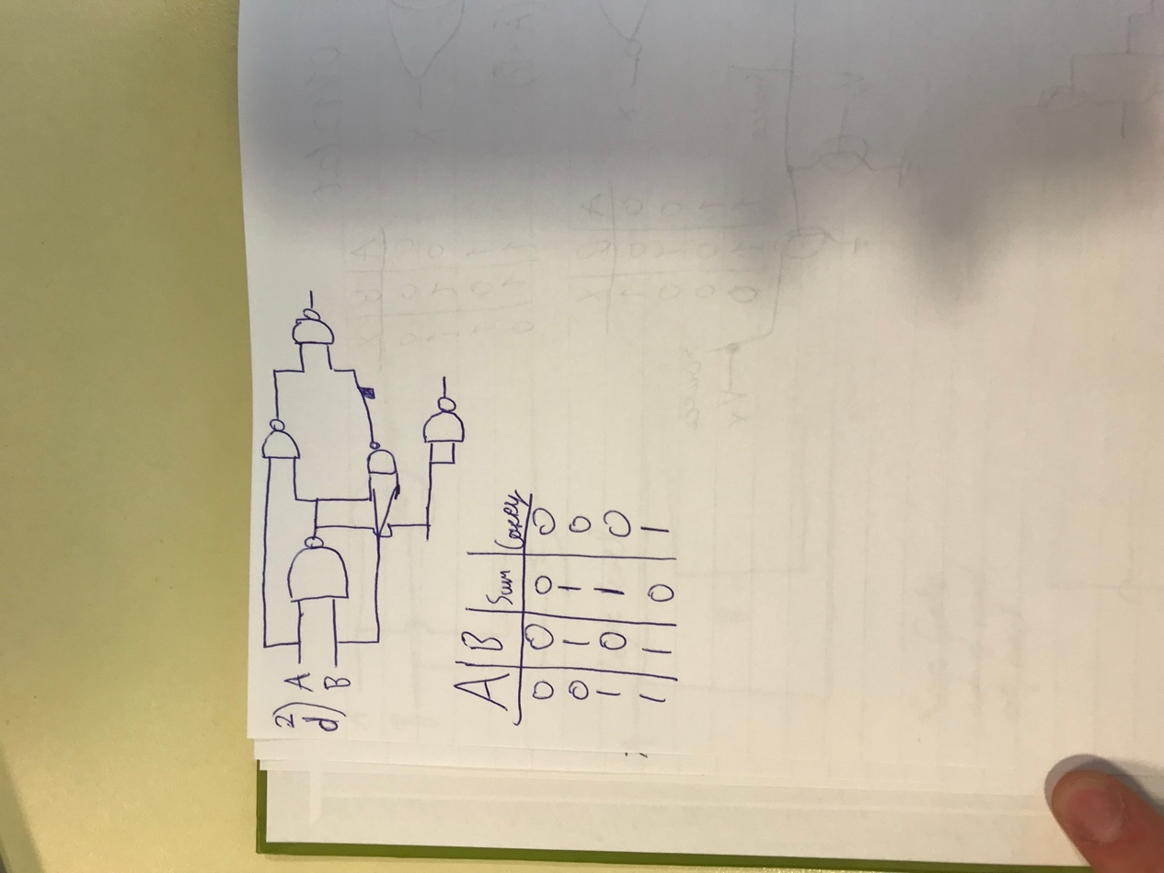
Complete Questions in Logbook
Student Name | Nojus satikauskas | Student Number | C00261186
Date | 01/12/21
Group | A

