NOTE: Use of internet is permitted only to access software website, calculators are permitted and your answers must include worked solutions. If you require extra sheet(s) please write your name and student number at the top of each additional sheet.
https://logic.ly/
Part A
Objective
Understand various logic gates
- Using Logic.ly create a circuit file and label Gate Symbols, Functional Notation and truth table for the gates listed in the table below:

Inputs |  | Output(s) Truth Table
A | B | AND | OR | XOR | NAND | NOR
0 | 0 | 0 | 0 | 0 | 1 | 1
0 | 1 | 0 | 1 | 1 | 1 | 0
1 | 0 | 0 | 1 | 1 | 1 | 0
1 | 1 | 1 | 1 | 0 | 0 | 0
Gate  Symbol |  | 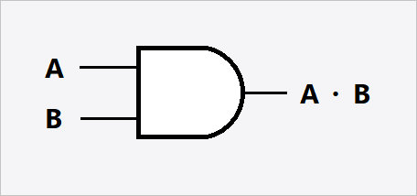 | 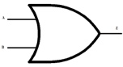 | 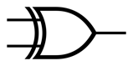 | 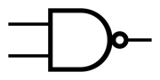 | 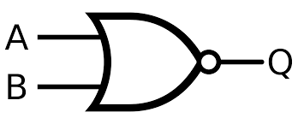
Functional
Notation
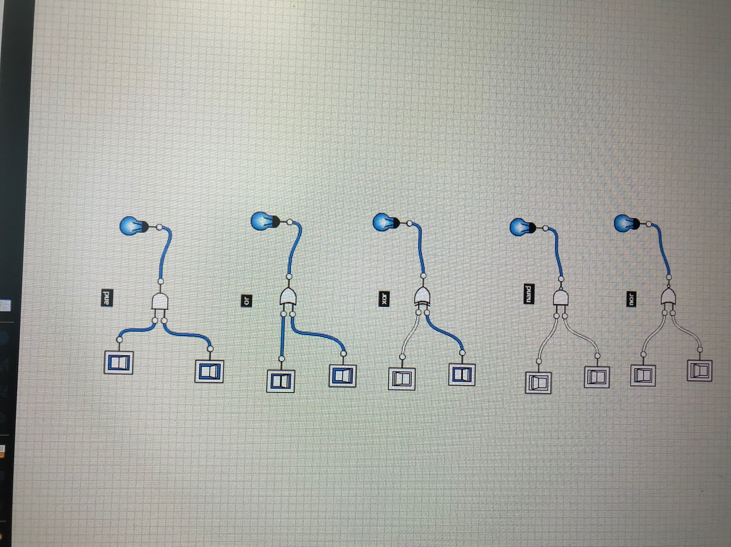

- Construct the logic circuit below using Lab Logic and detail the functional notation and truth table for a two input AND gate.

 | Switches | AND Gate | LED Output
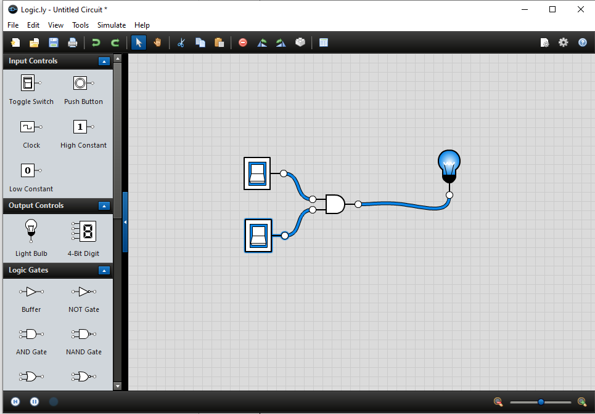

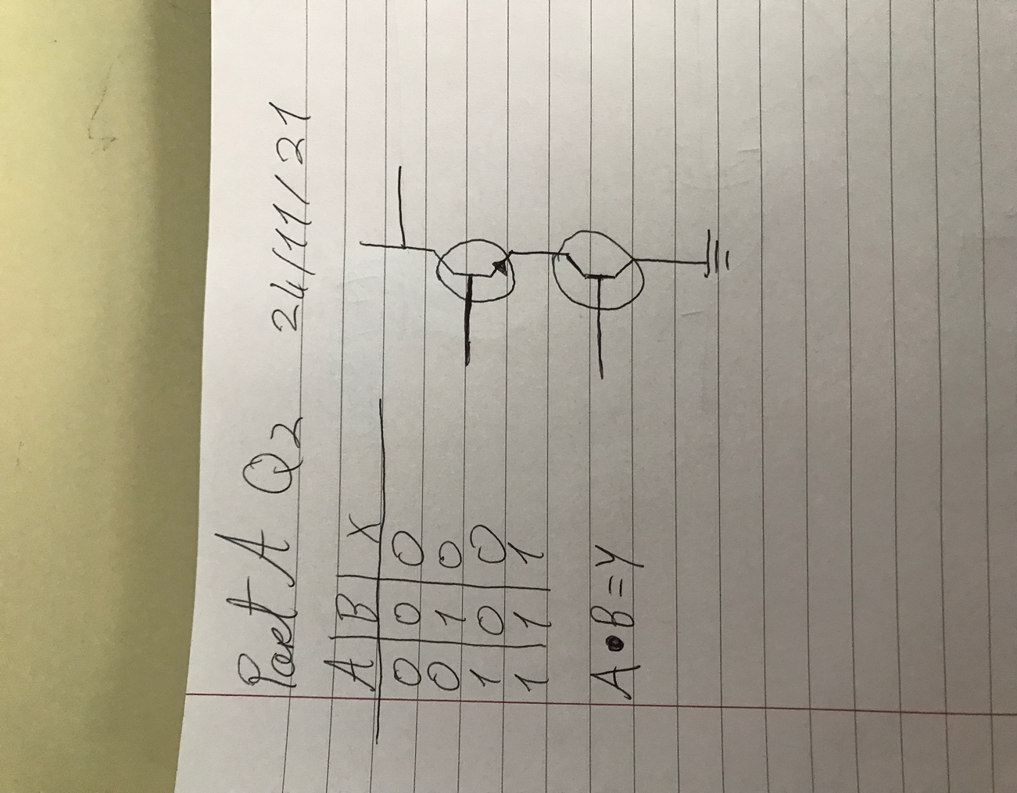

Part B
Objective
Understand the construction of Logic Gates from various combinations of logic gates
- Using Lab Software prove that combining and AND and a NOT constructs a NAND Gate
NOTE: solution must be demonstrated to Lecturer prior to leaving laboratory
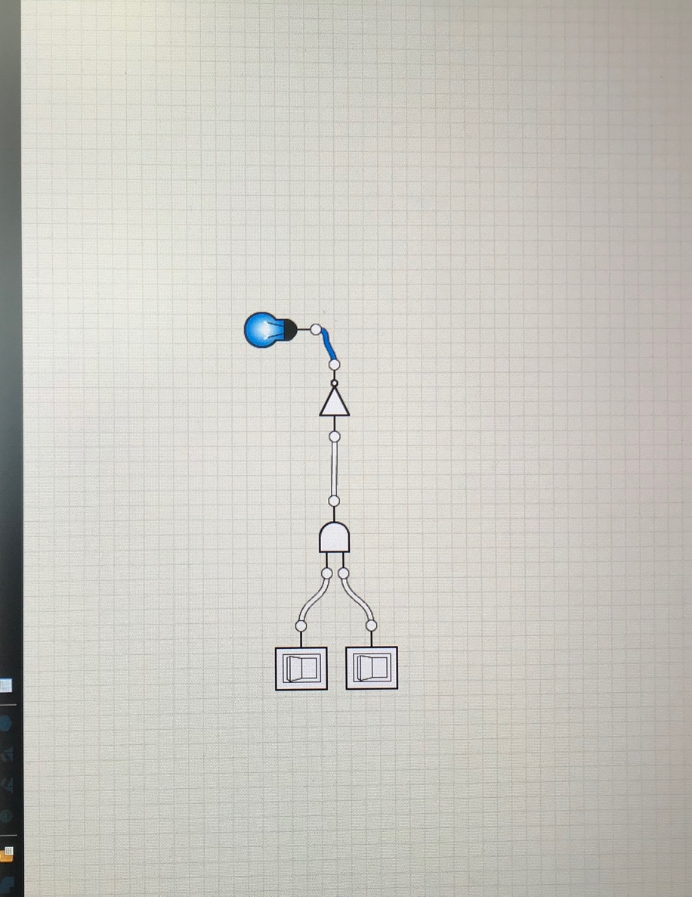

Demonstrated to lecturer
  Yes | No

- Prove using Lab Software and a truth table that the circuit below is a XOR Gate. Place an LED on the output of the constructed circuit.
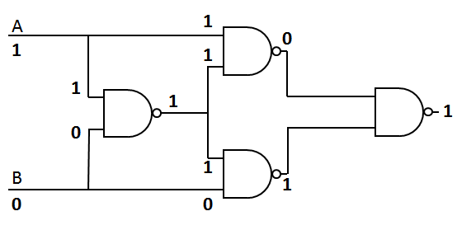

NOTE: solution must be demonstrated to Lecturer prior to leaving laboratory
Inputs
A | B | XOR
0 | 0 | 0
0 | 1 | 1
1 | 0 | 1
1 | 1 | 0

Demonstrated to lecturer
  Yes | No

- Prove DeMorgan’s Law ¬(A ∧ B) = ¬A ∨ ¬B using Lab Software
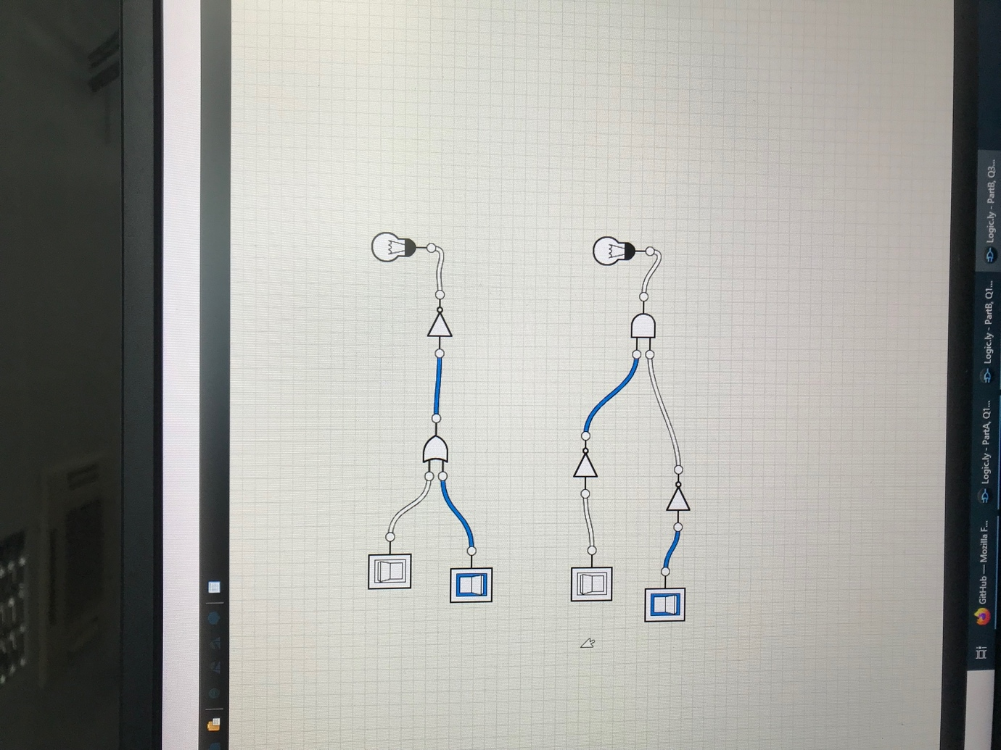

Demonstrated to lecturer
  Yes | No

Hand up this practical report at the end of session and ensure it has been checked
Student Name | Nojus Satikauskas | Student Number | C00261186
Date | 24/11/21 | Checked
Group | A

