1) Зарегистрироваться на GitHub (<https://github.com/>);

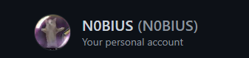

2) Создать свой публичный репозиторий и получить ссылку на него;

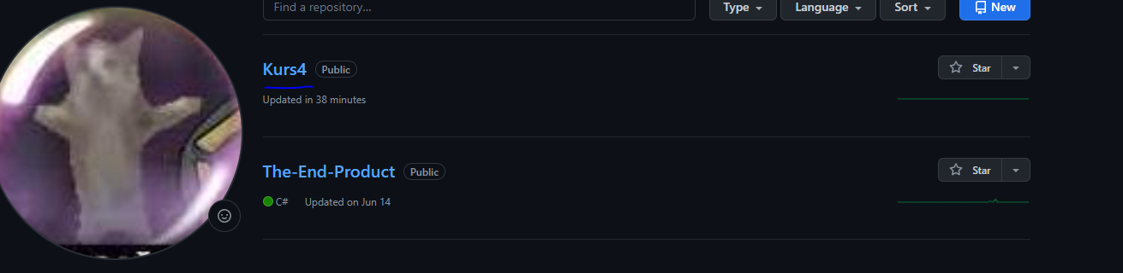

https://github.com/N0BIUS/Kurs4.git

429196-1@A403PWS22 MINGW64 /h/kurs4

$ echo "# Kurs4" >> README.md

429196-1@A403PWS22 MINGW64 /h/kurs4

$ git init

Initialized empty Git repository in //fs-ispo/uvc/stud/429196/429196_1/kurs4/.git/

429196-1@A403PWS22 MINGW64 /h/kurs4 (master)

$ git add README.md

warning: LF will be replaced by CRLF in README.md.

The file will have its original line endings in your working directory

429196-1@A403PWS22 MINGW64 /h/kurs4 (master)

$ git commit -m "first commit"

[master (root-commit) 09b8f36] first commit

Committer: unknown <429196-1>

Your name and email address were configured automatically based

on your username and hostname. Please check that they are accurate.

You can suppress this message by setting them explicitly. Run the

following command and follow the instructions in your editor to edit

your configuration file:

git config --global --edit

After doing this, you may fix the identity used for this commit with:

git commit --amend --reset-author

1 file changed, 1 insertion(+)

create mode 100644 README.md

429196-1@A403PWS22 MINGW64 /h/kurs4 (master)

$ git branch -M main

429196-1@A403PWS22 MINGW64 /h/kurs4 (main)

$ git remote add origin https://github.com/N0BIUS/Kurs4.git

429196-1@A403PWS22 MINGW64 /h/kurs4 (main)

$ git push -u origin main

Enumerating objects: 3, done.

Counting objects: 100% (3/3), done.

Writing objects: 100% (3/3), 207 bytes | 0 bytes/s, done.

Total 3 (delta 0), reused 0 (delta 0), pack-reused 0

To https://github.com/N0BIUS/Kurs4.git

* [new branch] main -> main

branch 'main' set up to track 'origin/main'.

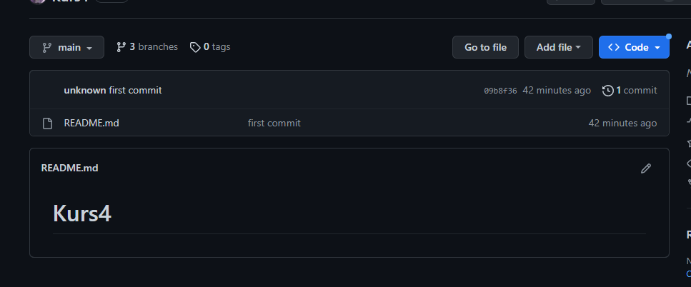

Создать файл .gitignore и добавить туда все временные файлы проекта.

