GENERAL CONFEDERATION OF LABOR OF VIETNAM

**TON DUC THANG UNIVERSITY**

**FACULTY OF INFORMATION TECHNOLOGY**



**PERSONAL ASSIGNMENT REPORT ENTERPRISE RESOURCE PLANNING SYSTEMS**

**ENTERPRISE RESOURCE PLANNING SYSTEMS FOR FITTER SNACKER**

*Supervisor:* **MSc. PHAM THAI KY TRUNG**

*Author*: **NGUYEN LUU TRI – 519H0048**

Class**: 19H50204**

Course **:23**

**HO CHI MINH CITY, 2021**

GENERAL CONFEDERATION OF LABOR OF VIETNAM

**TON DUC THANG UNIVERSITY**

**FACULTY OF INFORMATION TECHNOLOGY**



**PERSONAL ASSIGNMENT REPORT ENTERPRISE RESOURCE PLANNING SYSTEMS**

**ENTERPRISE RESOURCE PLANNING SYSTEMS FOR FITTER SNACKER**

*Supervisor:* **MSc. PHAM THAI KY TRUNG**

*Author*: **NGUYEN LUU TRI – 519H0048**

Class**: 19H50204**

Course **:23**

**HO CHI MINH CITY, 2021**

# APPRECIATION LETTER

First of all, I highly appreciate all the support from Mr.Pham Thai Ky Trung. Thank you for all your help to nurture my will to research and study.

Thank you so much for all knowledges that Ton Duc Thang University provides for me in the last two years so that I am able to finish this assignment completely.

Cannot deny that there are still some mistakes in my assignment but I will never stop improving myself to achieve more and more. I hope that my work will be appreciated in the right way and receiving optimistic comments and a right score as it should have.

I sincerely thank you!

# THE ESSAY HAS BEEN CONDUCTED IN TON DUC THANG UNIVERSITY

I assure that this is my own product and has been guided by Mr.Pham Thai Ky Trung. The research contents, results in this topic are all about honesty and this is the first time my essay published as an academic essay. The data in the tables for analysis, comments and evaluation are collected by the me from various sources in the reference section.

In addition, comments and assessments as well as data from other authors or organizations are also used in the essay but with references and annotations.

**If there is any fraud is detected, I ensure my complete responsibility for the contents of my work.** Ton Duc Thang University is not related to violations of authority and copyright caused by me during my work process (if any).

*Ho Chi Minh city, Monday, 29th April. 2022*

*Author*

*(Sign and provide full name)*

*Nguyen Luu Tri*

# VERIFICATION AND EVALUATION FROM LECTURER

**Supervisor’s evaluation**

_______________________________________________________________________________________________________________________________________________________________________________________________________________________________________________________________________________________________________________________________________________________________________________________________________________

Ho Chi Minh city, , . 2022

(Sign and provide full name)

**The assessment of the teacher marked**

_______________________________________________________________________________________________________________________________________________________________________________________________________________________________________________________________________________________________________________________________________________________________________________________________________________

Ho Chi Minh city, , . 2022

(Sign and provide full name)

# SUMMARY

At present, life is growing strongly, leading to the need for science and technology and information technology to meet the needs of people and society. For this reason, our team has applied the knowledge learned through the ENTERPRISE RESOURCE PLANNING SYSTEMS course to manage the Fitter Snacker's production supply chain on the OpenERP/Odoo platform.

# TABLE OF CONTENT

APPRECIATION LETTER 3

THE ESSAY HAS BEEN CONDUCTED IN TON DUC THANG UNIVERSITY 4

VERIFICATION AND EVALUATION FROM LECTURER 5

SUMMARY 6

TABLE OF CONTENT 7

PREFACE 9

CHAPTER 1. OVERVIEW 10

1. Introduction 10

2. Fitter Snacker's Business Process Introduction 10

2.1. Sale Order Process 10

2.2. E-commerce 12

CHAPTER 2. ANALYSIS AND DESIGN 12

1. List of use cases for Fitter Snacker online system 12

2.Use case description: 15

CHAPTER 3. APPLY ON ODOO 17

1. Mapping Fitter Sneaker's production chain process into Odoo 17

2. Create Ecommerce Website 18

CONCLUSION 24

**LIST OF TABLES**

*Table 1: Use case description for Add product* 15

*Table 2: Use case description for Add to Cart* 16

*Table 3: Use case description for Checkout* 16

*Table 4: Use case description for Receive receipt* 17

**LIST OF FIGURES**

*Figure 1 : Sale Order Process swimlane diagram* 12

*Figure 2 : Sale Order Process swimlane diagram* 13

*Figure 3 :Fitter Snacker online shopping use case diagram* 14

*Figure 4: Mapping Fitter Sneaker's production chain process into Odoo* 18

*Figure 5: Log in and create an account.* 18

*Figure 6: Home page design.* 19

*Figure 7: Business introduction page design.* 20

*Figure 8: Contact company page design* 21

*Figure 9: Bodybuilding Protein Snack page design* 21

*Figure 10: Advanced Energy Snack* 22

*Figure 11: Order management page design* 22

*Figure 12: Shipping info page design* 23

*Figure 13: Checkout page design.* 23

*Figure 14: Order management page design* 24

# PREFACE

In today's life, there are many types of snacks on the market and most of them contain a lot of oil, salt and colorants that easily make users gain weight and suffer from diseases related to obesity and heart disease. That's why we invented the Fitter Snacker - a healthy, no-frills, no-color, low-salt snack. To be able to manage the production supply chain, our team has applied Odoo software to bring better efficiency.

# CHAPTER 1. OVERVIEW

## 1. Introduction

Fitter Snacker manufacturing company that makes healthy snack bars under the Fitter Snacker brand name, and packages the bars in store-brand wrappers for some chain stores. There are two types of nutritious snack bars: NRG-A: “advanced energy” and NRG-B: “body building proteins”. Marketing and Sales (M/S) is the focal point of many of Fitter Snacker’s activities. However, Fitter Snacker’s M/S information systems are not well integrated with company’s other information systems and the company-wide use of transaction data is inefficient. Fitter Snacker has organized its sales force into two groups, known as divisions: wholesale division and direct sales division. The two sales divisions differ in terms of quantities of orders and pricing terms. At the same time many of Fitter Snacker’s sales orders have problems, such as: Incorrect pricing, excessive calls to the customer for information, delays in processing orders, missed delivery dates. And here are the reasons for problems: Fitter Snacker has separate information systems throughout the company for three functional areas (Sales order system, Warehouse system, Accounting system), high number of transactions that are handled manually, information stored in the three systems is not available in real time. To be able to manage the production supply chain, our team has applied Odoo software to bring better efficiency.

## 2. Fitter Snacker's Business Process Introduction

## 2.1. Sale Order Process

Giving a customer a price quotation and then taking the customer’s order at Fitter Snacker

– Sales call: salesperson either telephone the customer or visits in person

– At the end of the sales call, the salesperson prepares a handwritten quotation on a form that generates two copies

• Original sheet goes to the customer

• Middle copy is first faxed and then mailed to the sales office

• Salesperson keeps the bottom copy for his or her records

– Quotation form has an 800 number that the customer can call to place an order

– Determining the delivery date

– Checking customer’s credit status

– Entering the customer’s order into the current order entry system

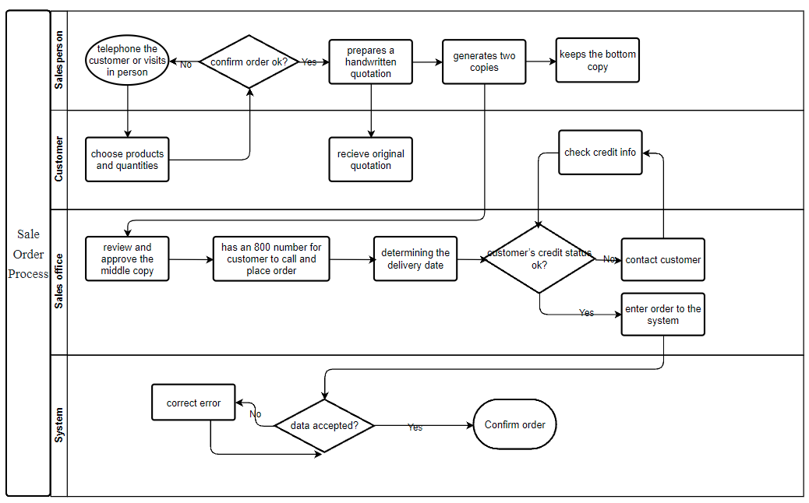

*Figure 1 : Sale Order Process swimlane diagram*

## 2.2. E-commerce

First, the customer will visit the website, if there is no account, create a new account with the name and password, the system will check and save the new user, then it will go to the login page. After successful login, you will be redirected to the homepage. Here, the user can select the product and quantity. The system will check the quantity on the database, if it runs out, it will notify the user, if it is still available, it will be added to the cart. The customer then accesses the payment page, fills in shipping and credit information. The system will check the credit information, if there is an error, it will notify the user and ask to re-enter. If successful, it will save the data to the database and display the successful order screen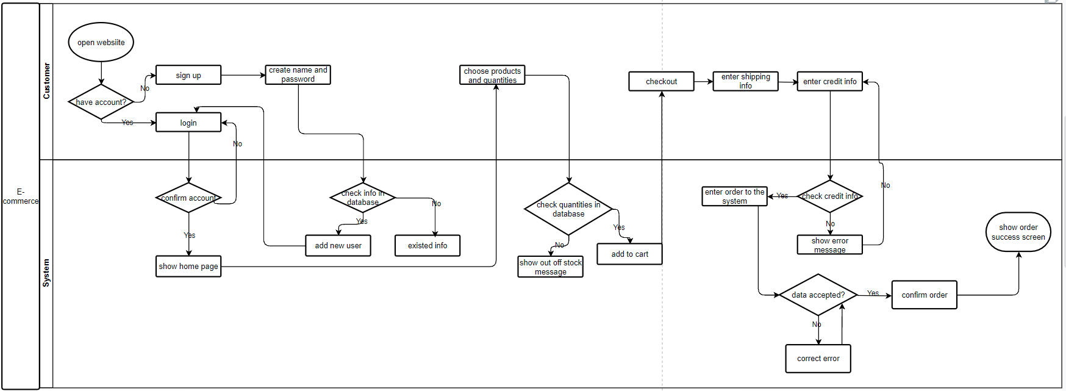

*Figure 2 : Sale Order Process swimlane diagram*

# CHAPTER 2. ANALYSIS AND DESIGN

## 1. List of use cases for Fitter Snacker online system

UC-1: sign up

UC-2: login

UC-3: change password

UC-4: add product

UC-5: delete product

UC-6: edit product

UC-7: search product

UC-8: choose product

UC-9: add seller

UC-10: edit seller

UC-11: deleter seller

UC-12: search seller

UC-13: add to cart

UC-14: delete from cart

UC-15: create invoice

UC-16: edit invoice

UC-17: search invoice

UC-18: delete invoice

UC-19: checkout

UC-20: add credit info

UC-21: confirm shipping info

UC-22: receive receipt

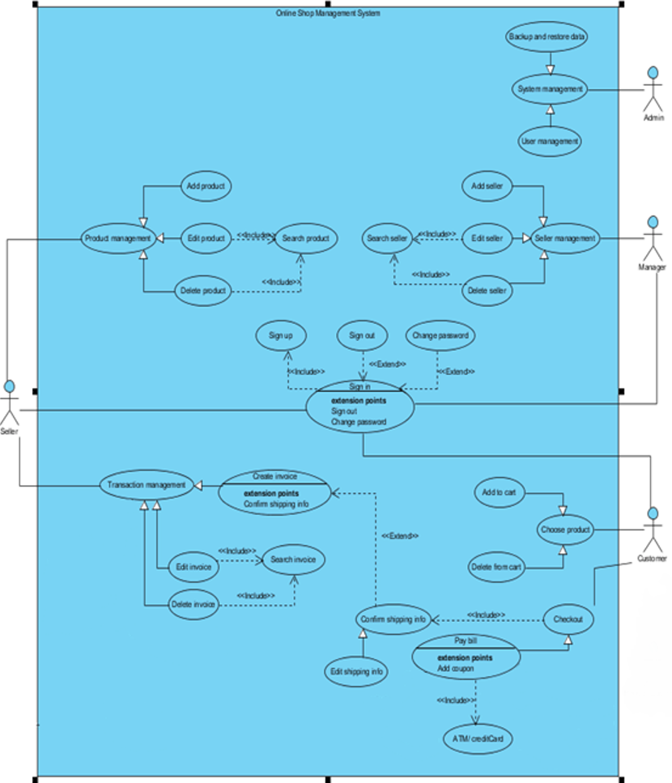

*Figure 3 :Fitter Snacker online shopping use case diagram*

## 2.Use case description:

|  |  |  |
| --- | --- | --- |
| **Use Case ID** | UC-4 | |
| **Use Case Name** | Add product | |
| **Scenario** | Seller adds new products to the system | |
| **Actor(s)** | Seller, System | |
| **Priority** | Must have | |
| **Trigger** | Seller clicks on the "add product" button | |
| **Pre-Condition(s)** | 1. Seller wants to add new products | |
| **Post-Condition(s)** | * The product is successfully added on the system | |
| **Flow of activities** | Actor | System |
| 1. Seller clicks on the "add product" button  2. Seller enters the product’s information | 1.1 System show the product information screen  2.1 System saves the new product on the database and show "successfully added" message |
| **Non-Functional Requirement** | * The system must run quickly, without errors * System response to user must be quick | |

*Table 1: Use case description for Add product*

|  |  |  |
| --- | --- | --- |
| **Use Case ID** | UC-13 | |
| **Use Case Name** | Add to Cart | |
| **Scenario** | Customers add new products to their cart | |
| **Actor(s)** | Customer, System | |
| **Priority** | Must have | |
| **Trigger** | Customer clicks on the "add product to cart" button | |
| **Pre-Condition(s)** | 1. Customer wants to add new products to their cart | |
| **Post-Condition(s)** | * The product is successfully added to their cart | |
| **Flow of activities** | Actor | System |
| 1. Customer clicks on the " add product to cart " button | 1.1 System check the product's quantities on the database  1.2 System add the product to cart if the product is available  1.2 System show message out of stock if the product isn't available |
| **Non-Functional Requirement** | * The system must run quickly, without errors * System response to user must be quick | |

*Table 2: Use case description for Add to Cart*

|  |  |  |
| --- | --- | --- |
| **Use Case ID** | UC-19 | |
| **Use Case Name** | Checkout | |
| **Scenario** | The customer wants to checkout for the chosen product | |
| **Actor(s)** | Customer, System | |
| **Priority** | Must have | |
| **Trigger** | Customer clicks on the "checkout" button | |
| **Pre-Condition(s)** | 1. Customer wants to checkout for the chosen product | |
| **Post-Condition(s)** | * Show checkout screen where customer can add shipping info and credit info | |
| **Flow of activities** | Actor | System |
| 1. Customer clicks on the " checkout " button | 1.1 System check the products in the cart  1.2 System create a provisional invoice with total price (product price + shipping price) |
| **Non-Functional Requirement** | * The system must run quickly, without errors * System response to user must be quick | |

*Table 3: Use case description for Checkout*

|  |  |  |
| --- | --- | --- |
| **Use Case ID** | UC-22 | |
| **Use Case Name** | Receive receipt | |
| **Scenario** | The customer wants to receive the receipt | |
| **Actor(s)** | Customer, System | |
| **Priority** | Must have | |
| **Trigger** | Customer clicks on the "confirm checkout" button | |
| **Pre-Condition(s)** | 1. Customer wants to paid and receive the receipt | |
| **Post-Condition(s)** | * Show the final receipt after checkout | |
| **Flow of activities** | Actor | System |
| 1. Customer clicks on the " confirm checkout " button | 1.1 System check the credit info  1.2 If correct show the checkout complete message and the final receipt  1.3 If not correct show wrong credit info message  1.4 Send a second receipt via customer's email in shipping info |
| **Non-Functional Requirement** | * The system must run quickly, without errors * System response to user must be quick | |

*Table 4: Use case description for Receive receipt*

# CHAPTER 3. APPLY ON ODOO

## 1. Mapping Fitter Sneaker's production chain process into Odoo

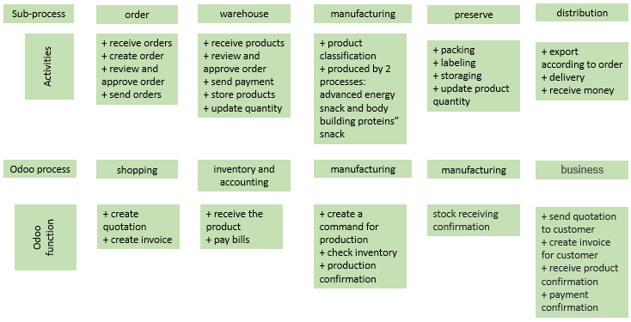

*Figure 4: Mapping Fitter Sneaker's production chain process into Odoo*

The supply chain system of Fitter Snackers include the following subprocess: Ordering from suppliers => Importing raw materials => Production => Storing and storing finished products => Stocking, Invoicing and track the debt of distributors.

The above activities will be manipulated on Odoo step by step to create a supply chain system of Fitter Snackers as follows:

First, you must download the Odoo software version 11.0 and install it on your computer or laptop.

After installation, you start connecting your account, log in to Odoo on the website and create a new Database.

After creating the database, you will download the necessary applications for the company's revenue cycle, specifically here are the applications: Customer Relationship Management, Warehouse Management, Production, Sales Management , Invoice management, Website builder, E-commerce, Purchase management, Contacts directory.

## 2. Create Ecommerce Website

The first thing that is indispensable for businesses is an e-commerce website to sell the company's products. Therefore, designing a website so that customers can choose and shop online is extremely important.

After downloading the "E-commerce" application in Odoo, log in to your existing Odoo account or create a new one depending on your needs. One account is equivalent to one customer of the e-commerce site.

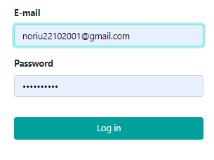

*Figure 5: Log in and create an account.*

After successful login, the first thing is to design the homepage. Click on the word "Edit" to design the website, the procedure is very simple, just drag and drop. The homepage can be viewed as a web or as a Mobile by pressing and the phone icon in the upper right corner of the screen.

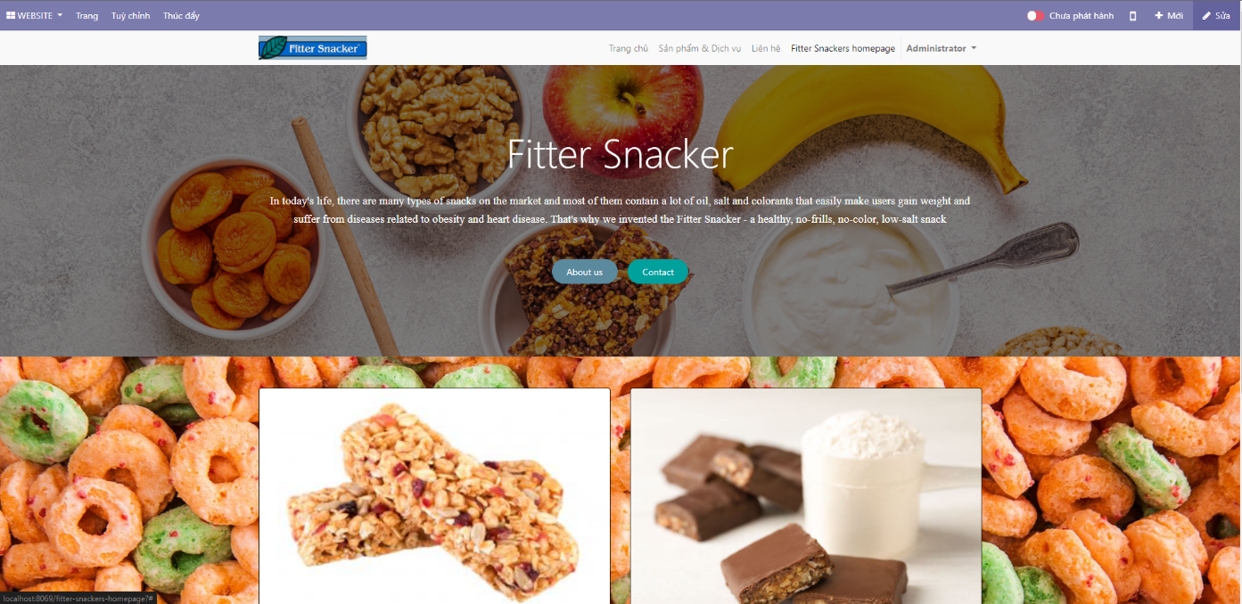

*Figure 6: Home page design.*

Continue to design the business introduction page - About us with drag and drop similar to the homepage design. In addition, you can add an arbitrary new website when you press new “+New” next to the word “Edit”.

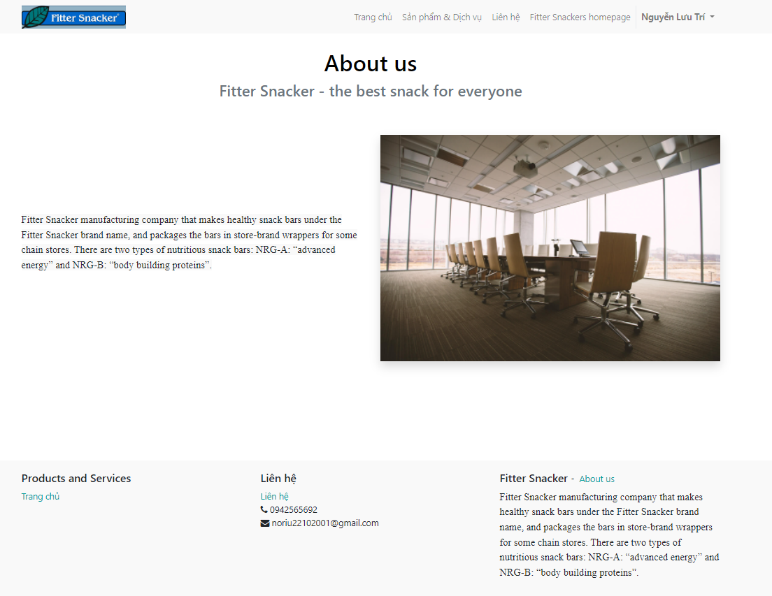

*Figure 7: Business introduction page design.*

Continue to design the contact information page with simple drag and drop procedures when clicking on the word “Edit”.

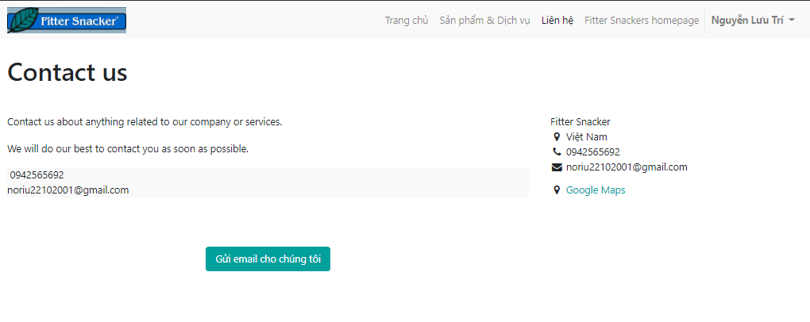

*Figure 8: Contact company page design*

Continue to design the Products and Services page with product information such as price. The design and editing is the same as above.

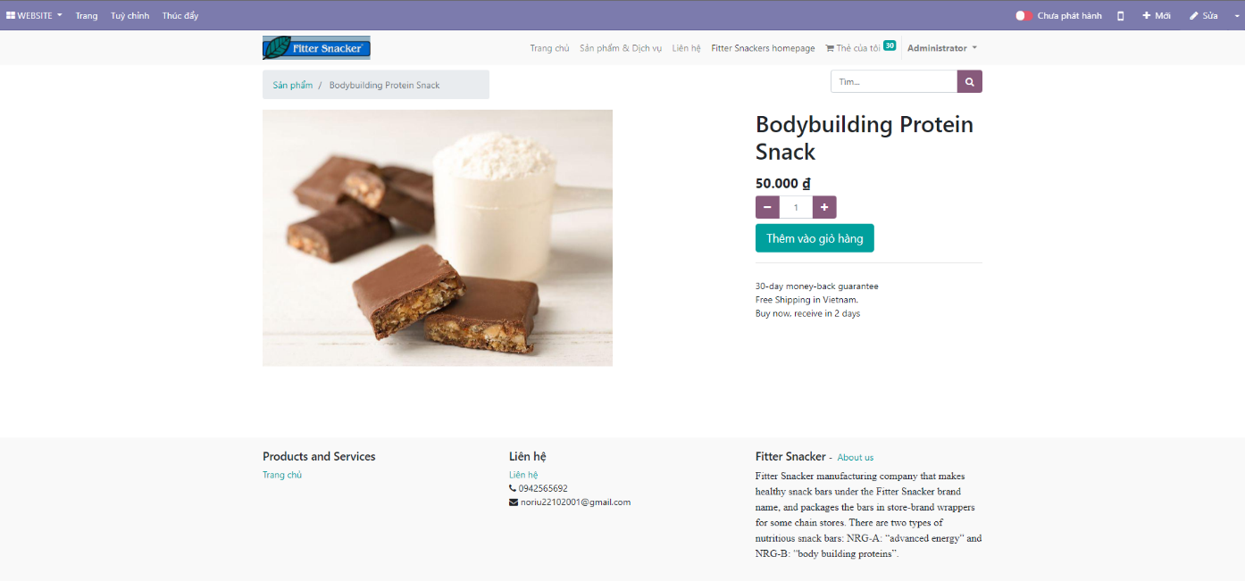

*Figure 9: Bodybuilding Protein Snack page design*

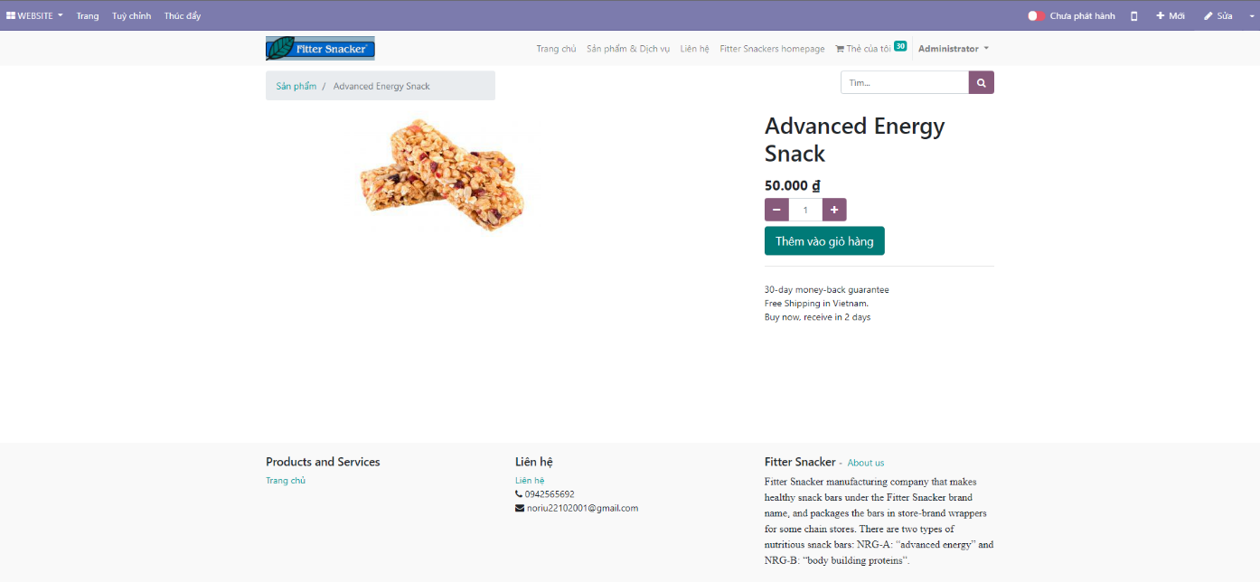

*Figure 10: Advanced Energy Snack*

Continue to design the order management page to continue the purchase process. Here, customers can view their shopping cart, see what stage their checkout process is in, and can add or reduce items by clicking the “+” “-” button. Click “Continue Shopping” to add new products, click “Checkout” to continue with the purchase process.

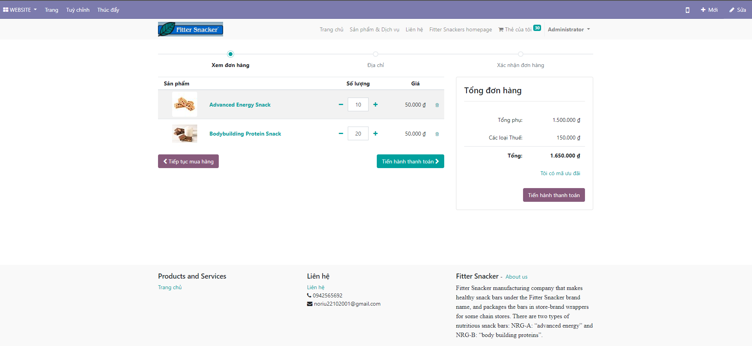

*Figure 11: Order management page design*

The next step is to edit the checkout page. Here, customers can check that the order is correct and optionally a payment method, a shipping method. The design of payment and delivery methods is in the “Edit” button and the settings. However, the payment methods section has a link to another Odoo app.

Click checkout to finish the purchase.

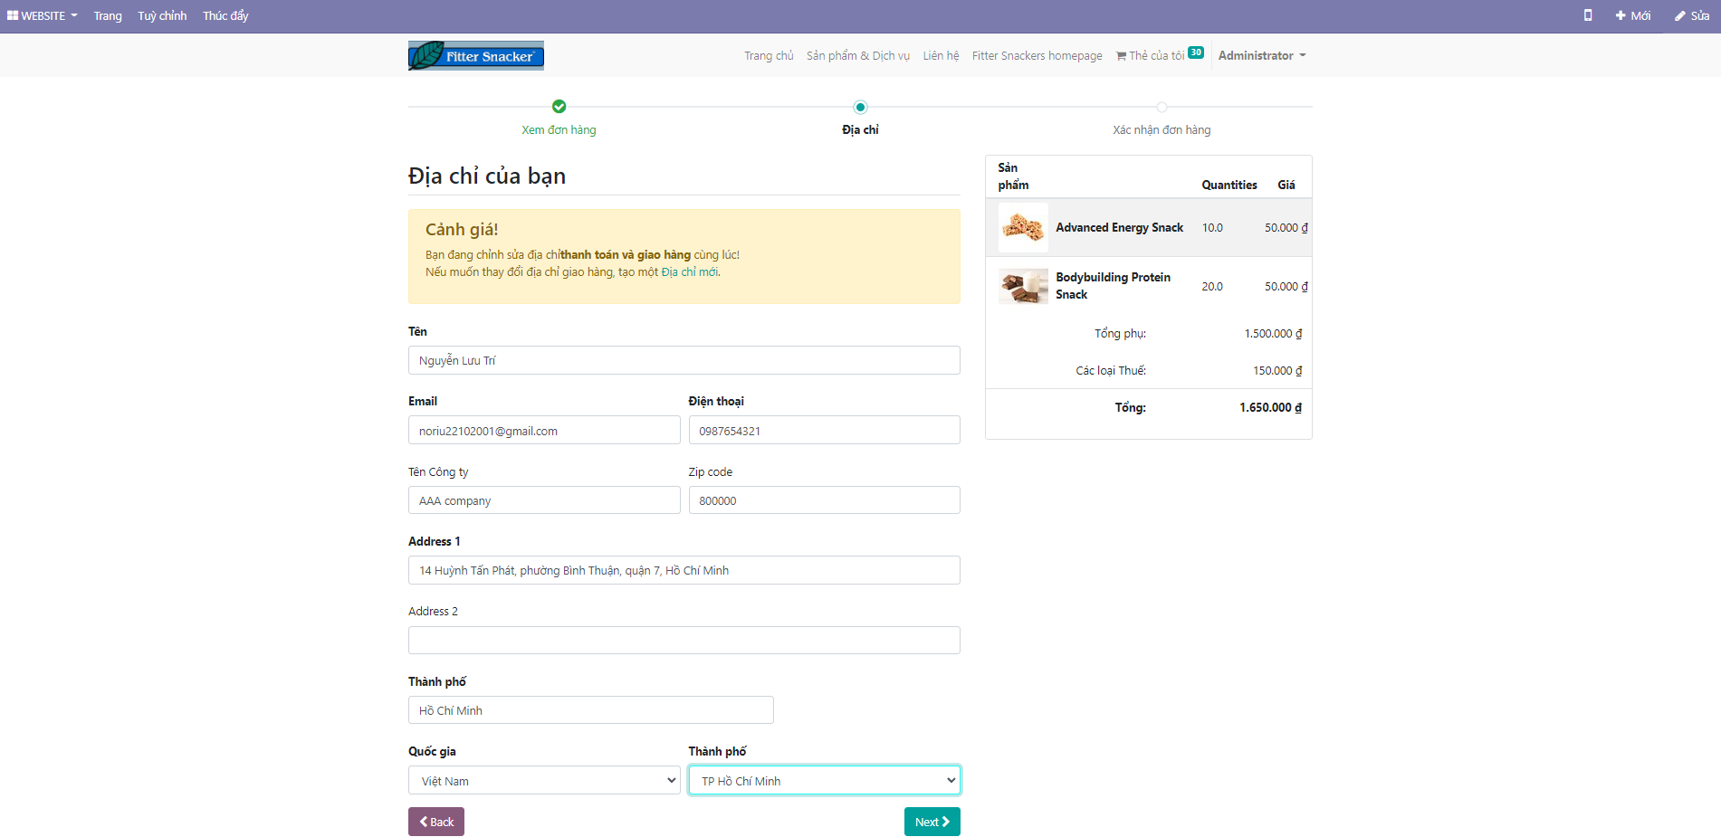

*Figure 12: Shipping info page design*

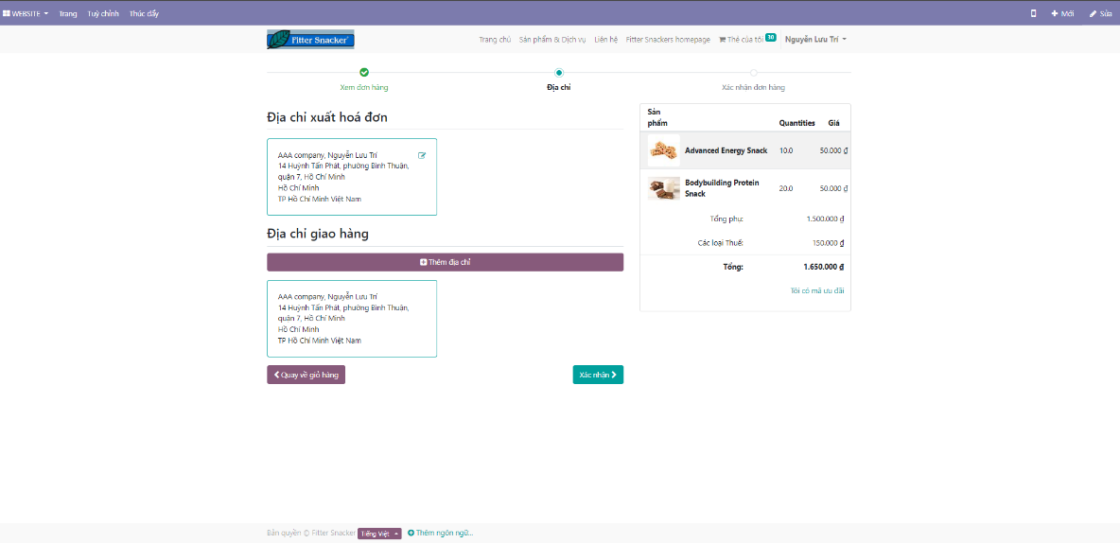

*Figure 13: Checkout page design.*

After the customer makes a purchase, the company's staff will make a delivery note, specifically through the order management page. This page includes all the information about the product as well as the customer, which is compiled from the purchasing process. Here, the status of the order is pending and needs to be verified, the appraisal will be handled by the customer relationship management department. The order management website is the end point of the customer's purchase process.

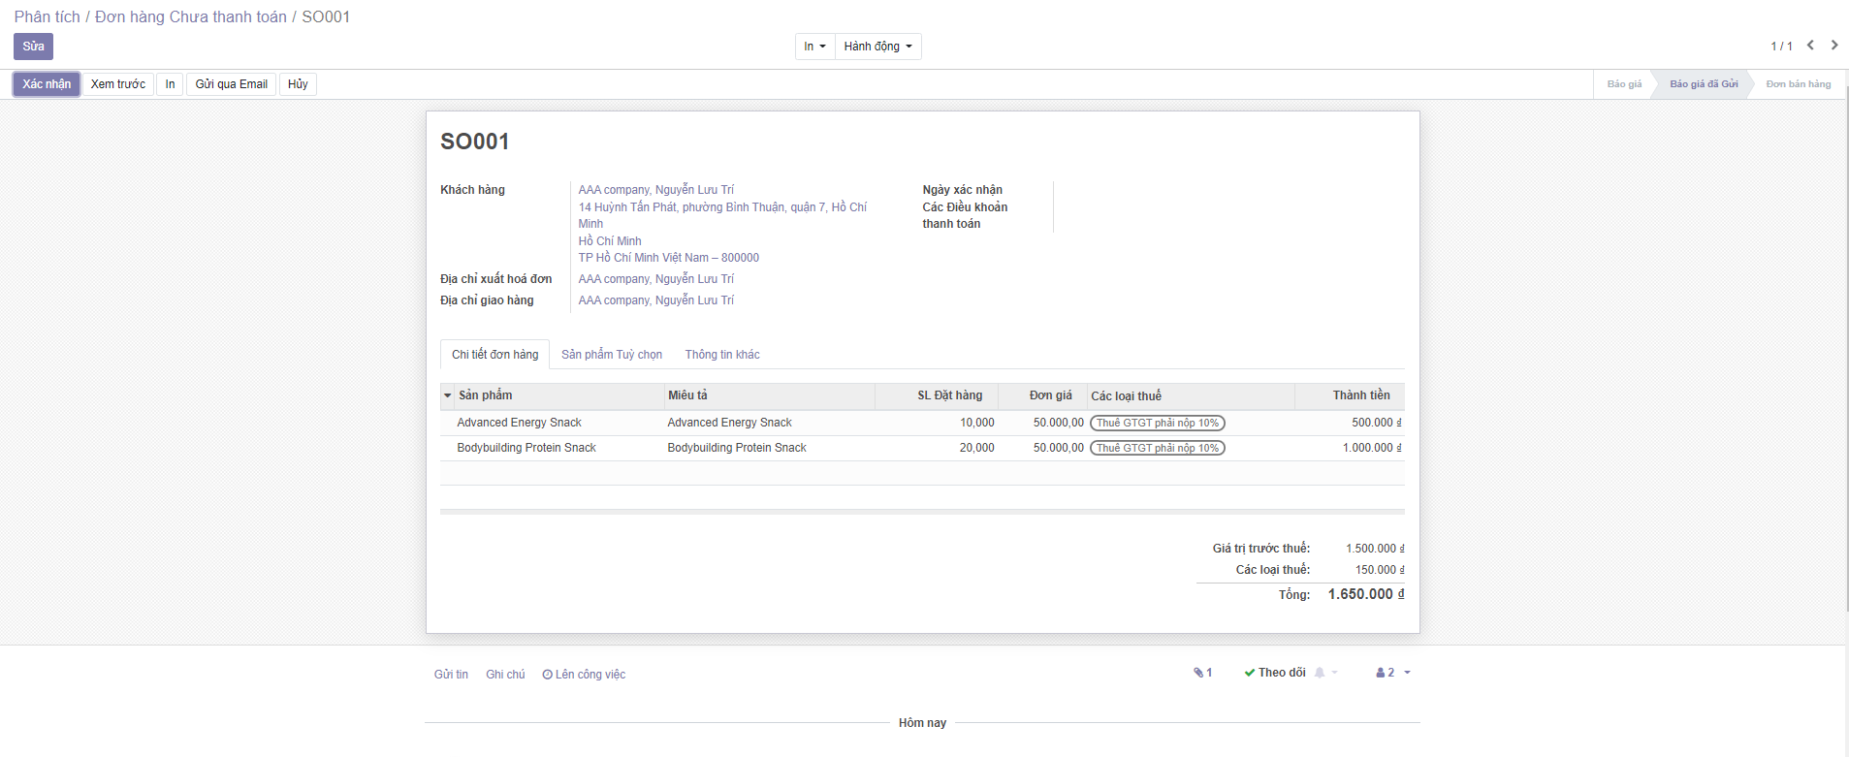

*Figure 14: Order management page design*

# CONCLUSION

Any business activity is directed towards the highest goal of profit. To get the most profit, every business needs to have existing measures to reduce costs and increase revenue. In today's market economy, especially for commercial enterprises, well-organizing the process of buying - selling - circulating goods is an important condition to help businesses develop. In particular, the supply chain system plays an extremely important role for businesses, it will determine the success or failure of an entire business, so we must design and create a supply chain system. strong response, helping the business grow more and more in the future. To do these things, businesses not only need knowledgeable human resources, they also need software and applications to help them easily manage and review their business. Each type of business of the business, thereby giving the right strategies to bring the highest profit for the business. Small and medium businesses can now use Odoo or Access software to help them manage business operations instead of spending unnecessary human resources.