Reference-Conditioned Closed-Loop Prediction for Dynamic Obstacle Avoidance of an Autonomous Sailboat
Authors and affiliations to be confirmed

Abstract—A position reference can induce an unsafe sailing trajectory even when its geometric chord is clear. We study a supervisor that predicts the execution of candidate reference-and-hold protocols for a fixed recurrent sailboat controller. Separate policy and dynamics instances reconstruct causal history, fit a local wind vector from motion and evaluate synchronized obstacle clearance before next-step reference delivery. A nominal-first guard selects among finite alternatives without a safety certificate. Under ideal computation, historical tests show recovered buffer-incursion failures and unnecessary intervention costs. In a newly frozen 24-task comparison, reactive navigation, a calibrated low-order candidate predictor and detailed prediction safely complete 19, 23 and 24 tasks. Detailed prediction gains one completion over the low-order comparator, but adds 7 s on average across their 23 common-safe tasks and substantially more computation. Fixed-protocol checks support a local fidelity advantage while retaining a 106 m adverse prediction error. Guard sensitivity and integrator-substep checks clarify the margin–cost tradeoff and numerical evidence. The results support conditional value of execution-conditioned prediction, not general efficiency dominance or real-time safety.
Keywords: autonomous sailing; reference-conditioned prediction; dynamic avoidance; recurrent control; closed-loop simulation

I. Introduction and Related Work
A waypoint specifies where a sailing controller should go, not the trajectory that it will execute. Wind-dependent propulsion, finite turning response, actuator dynamics and recurrent state can produce motion that differs from the waypoint chord. During a moving-vessel encounter, a geometrically clear reference can therefore induce a safety-buffer incursion. The supervisory problem is to compare references together with their holding and feedback-restoration rules.
High-level sailing planners can exploit environmental information; Silva Junior et al. use Q-learning for sailboat path planning [1]. We address the execution interface below planning, with a known static map, no direct wind measurement and observations of one low-speed target. Generalized velocity obstacles (GVO) evaluate control-induced motion rather than assuming that a desired velocity is immediately achievable [2]. Reference governors similarly modify commands supplied to an existing closed loop [3]. Branching-course model predictive control evaluates maritime maneuvers before executing their initial portion [6]. Feedback motion prediction provides controller-specific motion envelopes for unicycle reference regulation [7]. These works motivate the interface studied here; their controller assumptions and safety guarantees are not transferred to a recurrent sailing policy.
We adapt the GVO principle to finite position-reference protocols. A separate instance of the inherited policy and dynamics predicts each protocol under a motion-based local wind fit. MoWe [4] motivates obtaining wind information from vessel motion, but our bounded inverse-dynamics fit is neither its reproduction nor a new estimator. The contribution is a concrete execution-prediction interface and a qualified empirical assessment. We compare detailed prediction with a calibrated low-order candidate predictor, examine a finite guard range, and distinguish actual short-prefix agreement from fixed-protocol prediction quality. Planning computation pauses the physical clock. Actual motion still follows sailboat dynamics and feedback; neither perfect heading tracking nor future environmental information is supplied.

II. System and Evaluation Conditions

A. Inherited dynamics and local policy
The local controller is an inherited 18-input recurrent SAC policy with temporal attention, a frozen normalizer and deterministic tanh evaluation actions. Reference [5] describes SAC, not the specific inherited checkpoint. The Actor has hidden layers (256,256) and persistent recurrent state; its ten-slot attention history is not a periodic memory reset. No network is trained in this study. The physical simulator and detailed predictor use separate instances of the same inherited dynamics. This isolates state and hidden information, not model-identification error.
The implemented four-degree motion state includes position, roll, heading, body surge/sway velocities and roll/yaw rates, plus actual sail and rudder angles. Implemented parameters include mass 25,900 kg and sail, rudder and keel areas 170, 1.17 and 8.7 m². The reproducibility supplement lists the full parameter dictionary, exact code and weight hashes. Sailing-yacht models are discussed in [8]; code-level equivalence to that publication is not asserted. The supplied artifact identifies the local source files and checkpoint by hash, but a verified original publication/training record and redistribution license have not been supplied. This is a provenance and public-reproducibility gap, not merely missing author metadata. Results characterize this inherited system, not a verified reproduction of [8].
An active reference g defines a rigid frame with angle θ equal to the boat-to-reference bearing at application and origin g − 500[cos θ,sin θ]. It places the reference at (500,0) m without rescaling. The first 14 policy inputs are local position, roll/local heading, body velocities, angular rates, actual sail/rudder angles, two progress differences and reference coordinates. Progress differences are previous minus current goal distance and previous minus current |500 − x_local|, initially zero. Body velocities remain in body coordinates. Two additional obstacle distance/bearing pairs use max(0,d−R+40 m), where R is exclusion radius; pairs within 150 m in that encoding are sorted by distance/bearing, with missing entries zero-filled.
Reference changes reconstruct recurrent state by reencoding the real history and replaying issued commands. Each historical moving-obstacle input uses that time's observations. Predicted histories never enter the real history. Commands are scaled by 10 degrees, signed-floor quantized to one-degree increments and accumulated into setpoints, clipped to ±90 degrees for sail and ±30 degrees for rudder. Actual angles move at most 10 degrees per second. The custom adaptive Dormand–Prince integrator advances one-second control intervals; these actuation rules are shared by all physically executed comparators.

B. Information, timing and safety
At boundary t, the supervisor receives observed physical state, causal history, issued commands, a complete static circular map, current reference/manager state and target observations with identity, timestamp, position, ground velocity and validity. Targets are observed within 1000 m. There is no added sensor noise. The predictor does not receive the real wind field, environment RNG, scenario seed or future target schedule. Actual evaluation uses the full target truth.
The local policy first computes an action at t using the active reference. Planning follows. That already computed action advances t to t+1; a changed reference is then applied and memory reencoded. The earliest affected physical interval is t+1 to t+2. The physical simulation clock pauses during planning. This is an ideal-compute evaluation, not a real-time implementation claim.
Dynamic exclusion distance is 85 m: a combined 25 m entity proxy (10 m own vessel and 15 m target) plus 60 m buffer. Static exclusion radius is entity radius plus 60 m. For relative displacement r₀=pₜ−qₜ and d=(pₜ₊₁−qₜ₊₁)−r₀, synchronized segment clearance is
$c_{j,t}=‖r_{0}+α^{*}d‖−D_{j}$
$α^{*}={clip}_{\text{[0,1]}}(−\frac{{r_{0}}^{T}d}{{‖d‖}^{2}})\text{for d≠0.}$ (1)
For d=0, α*=0; code uses squared displacement ≤10⁻¹² as the numerical degeneracy threshold. Here Dⱼ=85 m for a dynamic target; for a static obstacle Dⱼ is its entity radius plus 60 m, and q is its fixed center. The actual task minimum m_real is the minimum of cⱼ,ₜ over all true obstacles and all executed intervals, including failed tasks. This is exact for synchronized one-second linear segments, not for swept hulls. Safe completion requires arrival within 10 m of G, strictly positive margins throughout, and completion within 1800/5400/9000 s for 1/3/5 km. A buffer incursion remains a failure even if the vessel later arrives. NoRouteError is an exit reason, not the safety measurement.

III. Reference-Conditioned Prediction

A. State reconstruction and reference protocols
The nominal geometric relay uses 120 m planning allowance, 500 m lookahead, 100 m handoff distance and an 80 m geometric-clearance trigger. Its shared temporary-endpoint manager retains a clear incumbent beyond 100 m when the goal is occupied, or considers eight points on a 305 m goal-centered ring. Candidates must be at least 200 m from the boat, have a clear segment and at least 120 m endpoint clearance; distance plus 80 times absolute heading turn ranks them. Goal availability clears the incumbent and reconnects to the mission. No admissible temporary reference causes NoRouteError. This mechanism is shared by all comparators.
Prediction eligibility starts at 10 s, requires a valid target strictly within 600 m, and requires the review timer to be due. A non-nominal hold takes precedence while t<until. The representative configuration uses horizon H=60 s, period P=15 s and guard ρ=30 m. A branch needs physical state, accumulated actuator setpoints, recurrent/attention state, reference frame, manager state, actual history and the already computed action. The implementation reconstructs setpoints from the complete command history starting from the zero initial setpoints and reconstructs policy state by historical replay. It asserts equality of the reproduced current action. That is a consistency check, not a future-accuracy proof.
The real nominal relay is called before prediction. Each candidate receives a clone of its resulting manager state. During a real hold, that manager is not updated; release clears the incumbent. These details matter when restoring a branch. The independent predictor clock starts at zero, while nominal management uses absolute task time. The execution snapshot is thus a specification of required information, not a claim to clone all hidden environmental state.
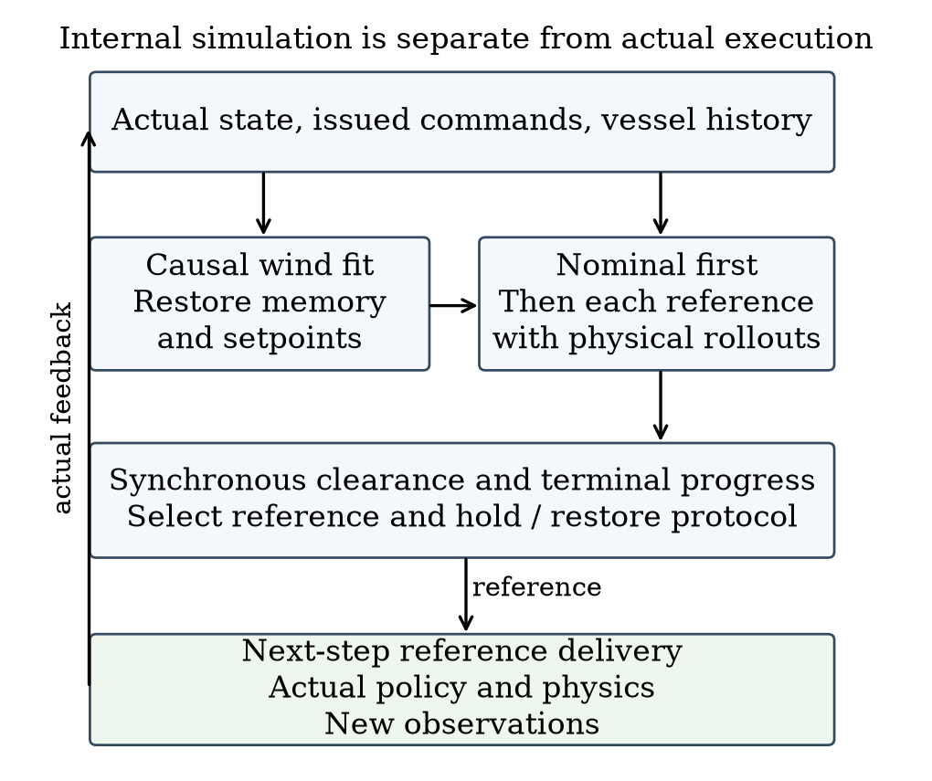
Fig. 1. Prediction branches and actual execution. Candidate histories remain separate; only actual observations and commands update the real history.

B. Local wind fit and candidate rollout
Let z=(u,v,ωφ,ωψ) and f_z be its derivative from inherited dynamics. Three transitions start at Iₜ={t−6,t−4,t−2}; the most recent ends at t−1. The fitted vector minimizes the residual objective approximately:
$ℒ_{t}(w)=\sum_{i∈I_{t}}{}{‖D(e_{i}(w))‖}^{2}$
$e_{i}=f_{z}({\overline{s}}_{i},w)−\frac{z_{i+1}−z_{i}}{Δt}$ (2)
The midpoint s̄ uses endpoint averages, except shortest-angle heading interpolation. Sail/rudder inputs are averages of observed endpoint angles, with zero within-step increments for this derivative evaluation. D=diag(1,1,5,5) is empirical scaling in stored units, not an estimated noise covariance. A bounded local least-squares solver searches componentwise w∈[−16,16]² m/s. The initial prior (0,8) and six magnitude-8 initializations separated by 60 degrees are tried on the first fit; subsequent fits warm-start from the preceding estimate. Each start has max_nfev=35 and finite-difference step 10⁻³. Insufficient history retains the current estimate. Neither a global minimum nor wind identifiability is guaranteed.
The ordered candidates are nominal feedback, current-reference continuation if available, and four points 350 m from the present position at −90, −45, +45 and +90 degrees relative to the nominal bearing. Nominal follows ordinary relay updates. Other candidates hold their reference for P seconds from selection, then restore ordinary feedback with incumbent cleared. Identical initial reference coordinates can therefore induce different trajectories. Future online searches are not simulated in that tail.
Each candidate uses the same pending old-reference action in its first interval. The fitted wind remains constant within a branch; target position is extrapolated from its current observed velocity. Forecast policy/relay observations retain the 1000 m sensing cutoff, but clearance scoring retains every initially valid observed target throughout the horizon. No unobserved future target is introduced. A branch stops at H, predicted arrival, route failure or integration failure. Early predicted arrival is valid; route/integration failure is not.

C. Nominal-first selection and guard interpretation
For a candidate protocol γ, let Kγ be its number of completed one-second predicted intervals and O_t the union of the full static map and targets valid in the current observed list. Define
$\overset{ˆ}{m}(γ)=\min_{j∈O_{t}}\min_{0≤k<K_{γ}}{\overset{ˆ}{c}}_{j,k}(γ)$ (3)
Each ĉ uses the synchronized segment expression with the same obstacle-specific D_j. H=60 s bounds the rollout; Kγ≤60 ends at predicted arrival or failure, so Kγ seconds is its effective horizon. A valid early arrival includes the arrival interval; it does not certify later occupancy. Empty obstacle sets give +∞ for a nonempty rollout. A zero-step rollout uses the implementation sentinel −10⁹ m and does not pass the guard. Failed route or integration predictions are excluded regardless of recorded margin. P=15 s is the hold/review period; ρ=30 m is an extra predicted margin above the unchanged true exclusion boundary. Let V contain valid integration-successful candidates, F(ρ)={γ∈V:m̂(γ)≥ρ}, n denote nominal, and ι denote enumeration order. The original terminal preference is
$J(γ)=d_{G}(γ)+201_{γ≠n}+101_{γ∈\text{side}}$
$d_{G}(γ)=‖{\overset{ˆ}{p}}^{γ}(K_{γ})−G‖\text{[m].}$ (4)
Nominal feasible returns immediately. Otherwise a nonempty F is ranked by (J,ι). If F is empty but V is nonempty, ranking is lexicographic (−m̂,J,ι): maximum margin, then lower original cost. If V is empty, continuation is retained when available, otherwise nominal. Base-planner failure before candidate construction can still terminate execution. There is no separate side-reference geometric prefilter or certified backup.
The 20 m offset is common to all feasible alternatives after nominal rejection and does not price whether intervention is worthwhile in that branch. It can affect tied-margin fallback comparisons that include nominal. We preserve it in code. Search eligibility and nominal guard determine whether alternatives are considered; terminal preference ranks those alternatives.
Algorithm 1 Selection at a one-second control boundary
1 If t < until, return the held reference.
2 Call nominal management, clearing incumbent after an expired hold.
3 If review is not due or no target is strictly within 600 m,
release an expired hold and return nominal. Initial review is 10 s.
4 Set next review to t+P; fit wind and reconstruct branch state.
5 Predict nominal. If it is valid, integrates and meets ρ, select it.
6 Otherwise predict continuation and the four side protocols.
7 Select by guarded cost, margin fallback or incumbent fallback.
8 A non-nominal choice sets until=t+P; nominal releases the hold.
9 Apply a changed reference after the already computed real action.
At equality t=until, review is allowed. A release selected then applies one step later. Increasing ρ shrinks F only for the same frozen predictions; closed-loop safety or time need not change monotonically. For the same protocol, obstacle identities/radii and common time domain T, the triangle inequality gives
$|m^{\text{real}}−\overset{ˆ}{m}|≤E,m^{\text{real}}≥\overset{ˆ}{m}−E$ (5)
Here E is the supremum of own-position error plus target-position error over T and the compared obstacles. Static centers have zero position error. A known E<ρ would imply positive clearance for a prediction meeting ρ, but no such uniform bound is available. Empirical maxima and the 30 m guard do not establish one. Derivations and a fallback counterexample are in the supplement.

IV. Matched Comparators and Experimental Design

A. Historical evidence and targeted revision
Within each task, physical policy, normalizer, dynamics, initial conditions, map, external wind parameters, target motion, execution timing and evaluation are shared. Different paths may encounter different local wind. Reactive relay R uses nominal feedback without future candidate rollout. Search15 S15 is the detailed predictor with P=15; Search60 S60 retains the same candidates/H but uses P=60. Nominal-prediction hold NH predicts nominal and, if invalid, integration-failed or below guard, holds the current reference when available without evaluating alternatives. NH is not a no-prediction baseline; S60 is not a no-search method.
Historical R8 evidence comprises 30 short instances (six each of pressure crossing, ordinary crossing, overtaking, endpoint occupation and non-conflict) and four long tasks (crossing/overtaking at 3/5 km). The 13 R10 mechanism instances overlap the historical short set. R10 separately froze 12 new instances. R12 uses old tasks for calibration/sensitivity and one newly frozen 24-instance confirmation (8 pressure, 4 each of the other four families), comparing R, S15 and the simplified predictor. All generated tasks and failures are retained. These designed strata are not natural traffic frequencies, and the evidence groups are not pooled.
All targets in these main tests have constant world-frame velocity and no scheduled turn. The observed target-motion model is therefore matched; maneuver robustness is untested. The wind field has base speed 8 m/s. Historical short profiles are 18 stable/6 slow/6 fast; R10 has 6 stable/6 fast; R12 has 12 stable/12 fast. Slow/fast profiles add spatial/temporal direction waves of 25/45 degrees, perturbations up to 3/6 degrees and 12/20 percent speed modulation. Exact scene manifests accompany the results. Common-safe time/path differences exclude pairs where either method fails, and task—not prediction window—is the sampling unit.

B. Matched low-order candidate predictor
The new comparator L retains the same supervisor, candidates, H/P/ρ, cost, fallback, endpoint manager and real execution. Only the predictor is replaced. Its low-order state is position, course χ and course rate r, initialized from causal recent position differences. The last observed ground speed v stays fixed over the horizon. For bearing error e to the currently active reference, it uses
$\overline{r_{k}}=clip(κe_{k},−r_{\text{max}},r_{\text{max}})$
$r_{k+1}=r_{k}+(1−e^{−\frac{Δt}{τ}})(\overline{r_{k}}−r_{k})$
$χ_{k+1}=χ_{k}+Δtr_{k+1}$ (6)
Here r and r̄ are actual modeled and desired course rates (rad/s), χ is course in radians, κ has units s⁻¹, and τ is a response time in seconds. Δt=1 s, eₖ=wrap(bearing(g−pₖ)−χₖ), and position advances with v at course χₖ+Δt rₖ₊₁/2. Current heading minus course is retained as a fixed offset for the cloned relay's heading input; its ten-step velocity window is recomputed from predicted positions. New references affect the following interval, and the initial interval is candidate-independent. Unlike detailed prediction, that first interval extrapolates observed motion rather than evaluating the pending action. L omits recurrent policy, actuator, wind and speed dynamics together; it is a full predictor replacement, not an isolated change of ODE order.
Parameters were selected from a fixed 48-point grid using seven previously seen tasks and validated on five other seen tasks. The objective equally weights each task's mean position error over unchanged-reference 15-second windows. The selected τ=8 s, κ=0.1 s⁻¹ and r_max=0.16 rad/s give train/validation errors 2.749/2.694 m over 136/87 windows. The rate cap is the upper tested value, not an identified physical limit. This calibration does not establish 60-second or newly proposed side-reference accuracy. Parameters and 24 new instances were frozen before observing their outcomes.

C. Guard, prediction and numerical checks
Twelve preselected old tasks cover 3 pressure, 3 endpoint and 2 each of ordinary crossing/overtaking/non-conflict. We compare ρ∈{0,15,30,60} m without changing true safety. Original 30 m results are reused after a bitwise 444-step S15 reproduction, with other values run as complete tasks. This is sensitivity analysis; no new guard is selected.
Existing detailed-prediction logs provide actual selected-protocol prefixes until the next review or earlier prediction/real termination. Complete 15-second windows and truncated windows are reported separately; post-replanning tails are excluded. Six development snapshots additionally execute two fixed protocols each, to 60 seconds or actual termination. Full physical prefixes and selected first 15 seconds must reproduce the original trajectory before their branch comparisons are accepted. Predictors use only causal inputs; offline real branches alone advance the actual external field.
For two decisive meter-scale incursions and their safe S15 pairs, fixed issued commands are replayed with the original integrator while logging its accepted internal substeps. Endpoint parity must remain exact. Synchronized substep-segment clearance supplements, and does not replace, the original one-second metric. Hardware is an AMD EPYC 7V12 host with at most four one-thread CPU experiment workers and no GPU. Pure planning calls and complete-episode CPU are distinguished; no online deadline is claimed.

V. Results

A. Matched 24-task comparison
Table I is the primary comparison: all 24 prespecified R12 confirmation tasks, with no outcome filtering. At the time of R12 evaluation, these were new and all methods were frozen; this revision reuses their outcomes and does not relabel post-hoc analyses as new confirmation. Gains/losses denote paired changes in safe completion. Time differences condition on both methods succeeding and are not an overall efficiency measure that assigns an artificial time to failures.
Table I. Matched 24-task results. Δt is relative to R on common-safe pairs; CPU is cumulative episode CPU, not navigation time.
Metric | R | L | S15
Safe /24 | 19 | 23 | 24
Gain/loss vs R | — | 4/0 | 5/0
Common-safe n | — | 19 | 19
Mean Δt (s) | — | +6.63 | +25.16
Median Δt (s) | — | 0 | 0
Maximum Δt (s) | — | +69 | +308
Episode CPU (s) | 270.68 | 378.44 | 2133.23

Against L, S15 gains one safe completion and loses none. Their 23 common-safe pairs have mean S15−L time +7 s, median 0 and maximum +308 s. These are descriptive paired results, not population superiority or a statistically established safety advantage. All five R failures and the one L failure are pressure-crossing buffer incursions. L reaches the goal on its failed task, which remains unsafe. S15 and L each activate on 11 tasks. The designed pressure-enriched mix does not estimate natural traffic frequency.
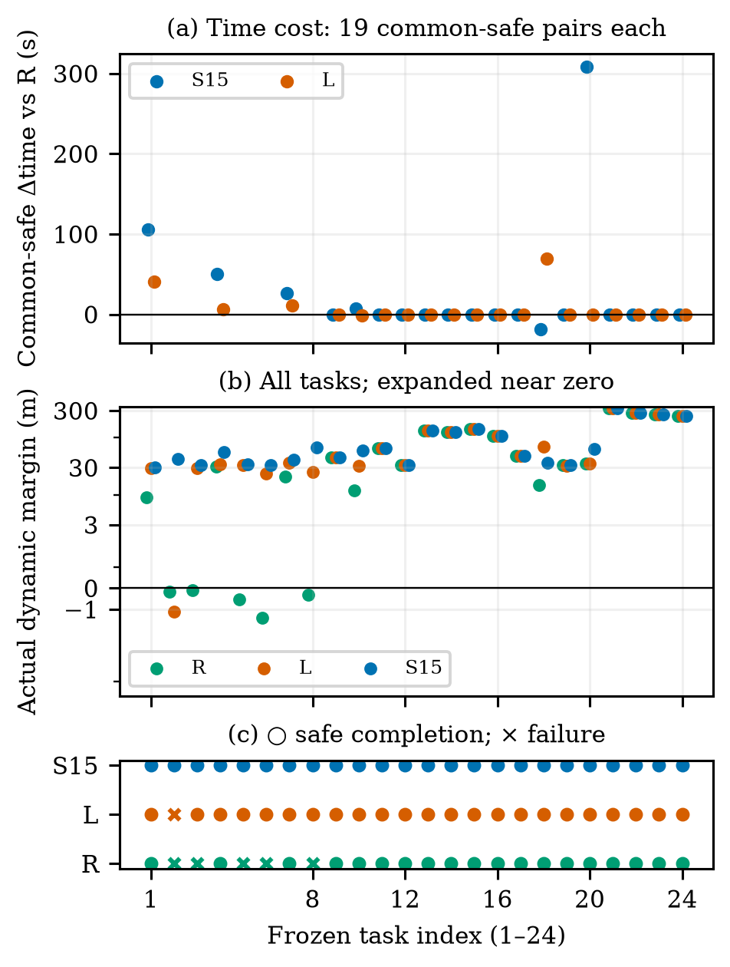
Fig. 2. All 24 matched tasks: common-safe time differences, every actual dynamic margin with an expanded near-zero scale, and a separate safety-status strip. Missing time points are failed pairs, not zero cost. Indices 1–8: pressure; 9–12: crossing; 13–16: overtaking; 17–20: endpoint; 21–24: non-conflict.

B. A decision difference and an adverse case
The unique L-unsafe/S15-safe task is r12new_mixed_pressure_1. The two methods have exactly equal recorded physical states, reference histories and issued commands through t=260 s. At that state, detailed nominal prediction gives 11.893 m minimum margin, below ρ=30 m, whereas L gives 59.832 m and returns nominal. Detailed prediction selects +90 degrees with predicted margin 36.546 m and cost 509.528 m; the feasible −90-degree alternative has margin 70.147 m and cost 513.228 m. The selected target is (627.068,163.231) m, versus nominal (575,−200) m. Selection occurs at 260 s, delivery at 261 s, and its first possible physical effect is the 261–262 s interval. This is a verified same-input decision difference; L does not evaluate alternatives after nominal passes.
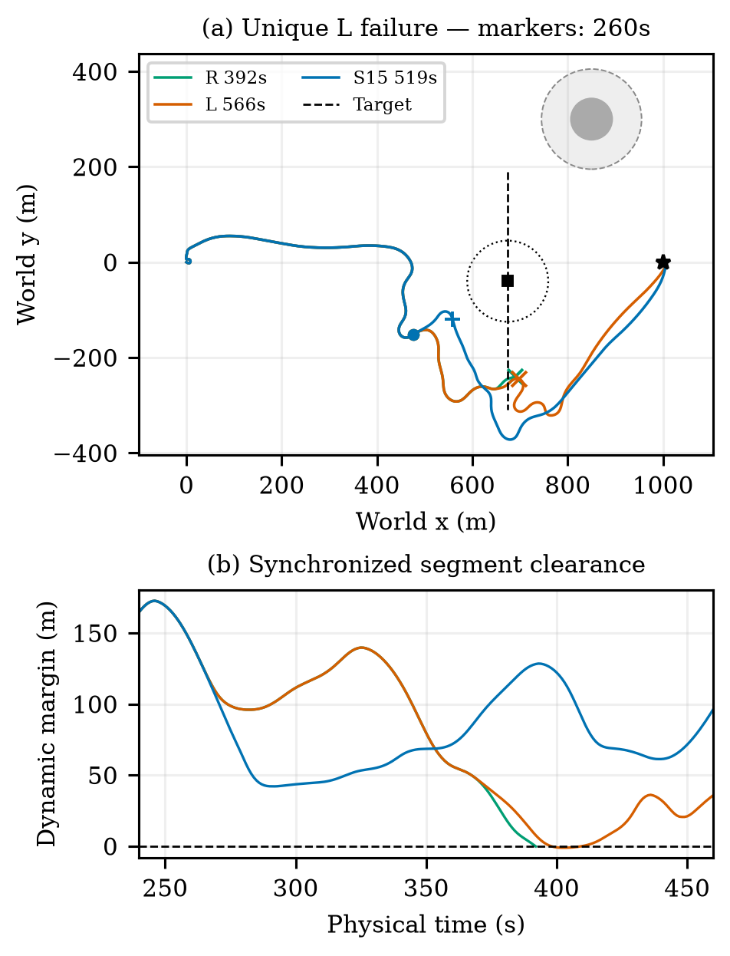
Fig. 3. Unique new-confirmation L incursion with complete R/L/S15 and target tracks. Circles and square mark synchronized positions at 260 s; the dotted circle is the target’s 85 m exclusion boundary then. Plus/cross marks identify each run’s minimum-margin endpoint. Lower panel shows the encounter interval, not separate-time closest points.
Over the complete voyage, L reaches at 566 s with minimum −1.115 m at 402 s; S15 arrives at 519 s with minimum 42.096 m at 291 s. R exits at 392 s with margin −0.162 m. Later states, subsequent interventions and encountered wind differ. We therefore do not attribute the full-voyage outcome solely to the first target change or infer its counterfactual 60-second effect from a later replanned trajectory. The full candidate table and exact log locations are supplied in the supplement.
The strongest new time-cost counterexample is r12new_endpoint_3: R and L safely arrive in 279 s, while S15 takes 587 s. That +308 s penalty remains in the primary table and Fig. 4. Useful risk intervention and unnecessary intervention must both be evaluated.
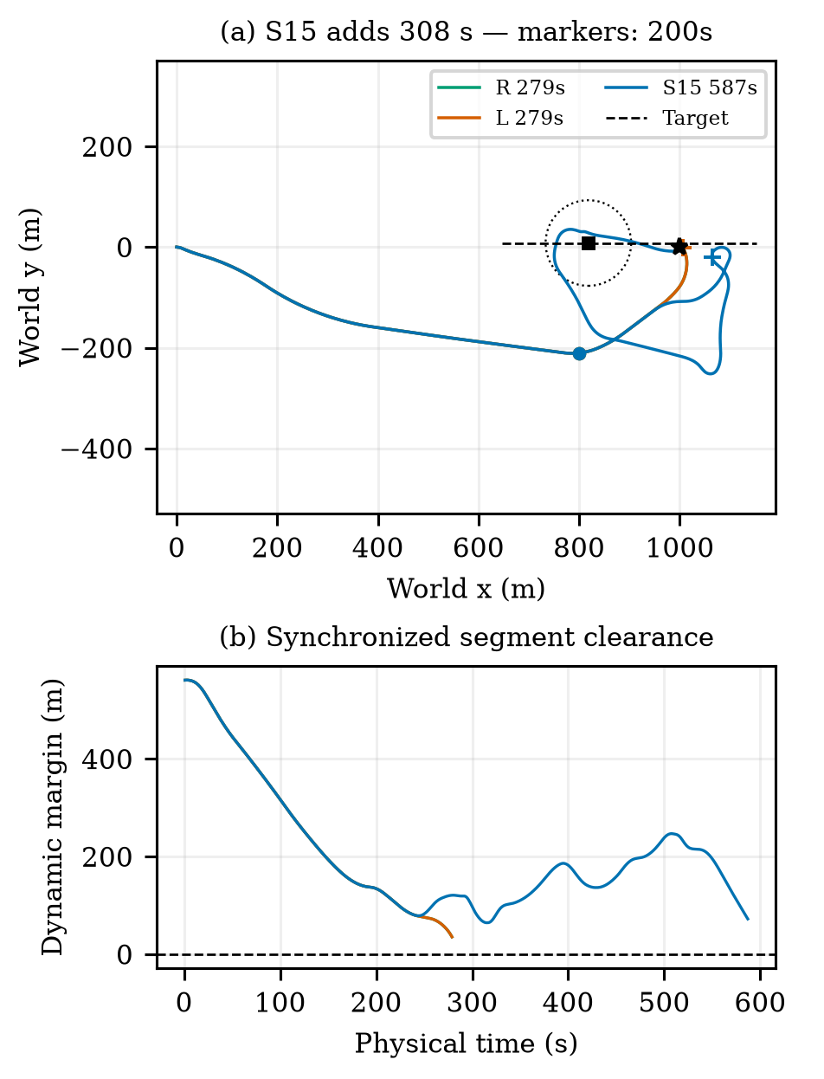
Fig. 4. Adverse endpoint task: S15 adds 308 s over safe R and L. All complete actual tracks and synchronized target motion are shown. Circles/square mark 200 s; the dotted circle is the exclusion boundary at that time. The lower panel reports synchronized clearance throughout each run.
Historical R8 evidence rescues two of 30 short and one of four long reactive failures. R10’s twelve separate new tasks show no extra completion over R and include a +271 s endpoint detour. Its 13 seen mechanism tasks overlap R8. These groups remain separate in Supplement S6; they are supporting context, not additional independent trials for Table I. S60 still searches candidates and NH still predicts nominal. Neither is described as a no-prediction baseline.

C. Guard sensitivity
Table II shows all four guards on the same twelve old tasks; 30 m reuses exact original results after parity verification. Reactive succeeds on 10/12. The guard changes complete closed-loop decisions, not the true exclusion boundary. Non-nominal selection totals for 0/15/30/60 m are 7, 13, 20, 32; no-guard-feasible fallback totals are 0, 1, 0, 2. Figure 5 shows the cost tail and worst actual margin. The experiment does not identify an optimal guard or a monotone safety guarantee. The original 30 m configuration retains its identity.
Table II. Guard sensitivity; common-safe Δt is relative to R. True safety is unchanged.
ρ (m) | Safe /12 | Worst dynamic (m) | Δt median/max (s)
0 | 12 | 3.35 | 0.00/28.00
15 | 12 | 24.88 | 0.00/334.00
30 | 12 | 31.78 | 0.00/267.00
60 | 12 | 61.77 | 0.00/321.00

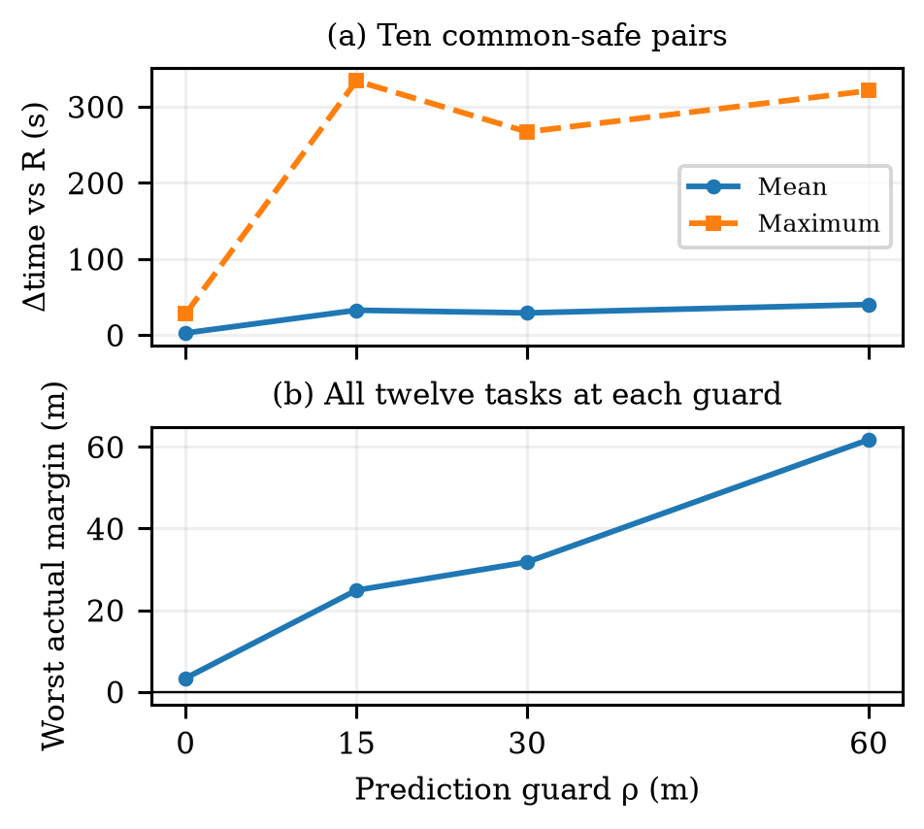
Fig. 5. Guard sensitivity on twelve prespecified development tasks. Original 30 m results are reused. Common-safe time differences and worst actual margin are different outcomes; larger guard need not improve both.

D. Prediction agreement, numerical safety and cost
From 46 distinct historical source tasks, 1083 selected-protocol windows yield 1048 complete 15 s prefixes and 35 truncated prefixes. These are clustered windows, not 1083 independent tasks. Maximum position errors for entering, ordinary feedback, reevaluation and release are 1.039, 30.506, 2.090 and 0.626 m. No compared prefix has a predicted positive margin followed by a nonpositive actual margin; nor does a predicted 30 m guard become an actual guard shortfall on these short prefixes. This limited observation does not validate unexecuted candidates or later replanned tails.
All twelve fixed real branches from six snapshots reproduce their full physical prefixes and the selected first 15 s exactly. Detailed predictions and real branches share the full 60 s in all twelve. Three-way comparisons with L share 60 s in ten branches and 58 s in two because L predicts arrival earlier while the real branch continues. The median branch-maximum position error on those common intervals is 1.104 m for detailed prediction and 53.818 m for L. Three L nominal predictions meet 30 m while actual margins are 17.868, 23.384 and 16.430 m. These are guard shortfalls, not buffer incursions. Conversely, detailed prediction reaches 106.064 m position error at one endpoint snapshot; its nominal and continuation paths coincide and are not independent failures. Its predicted/actual minimum margins remain 140.990/146.171 m. Figure 6 makes both the local accuracy advantage and the adverse error explicit.
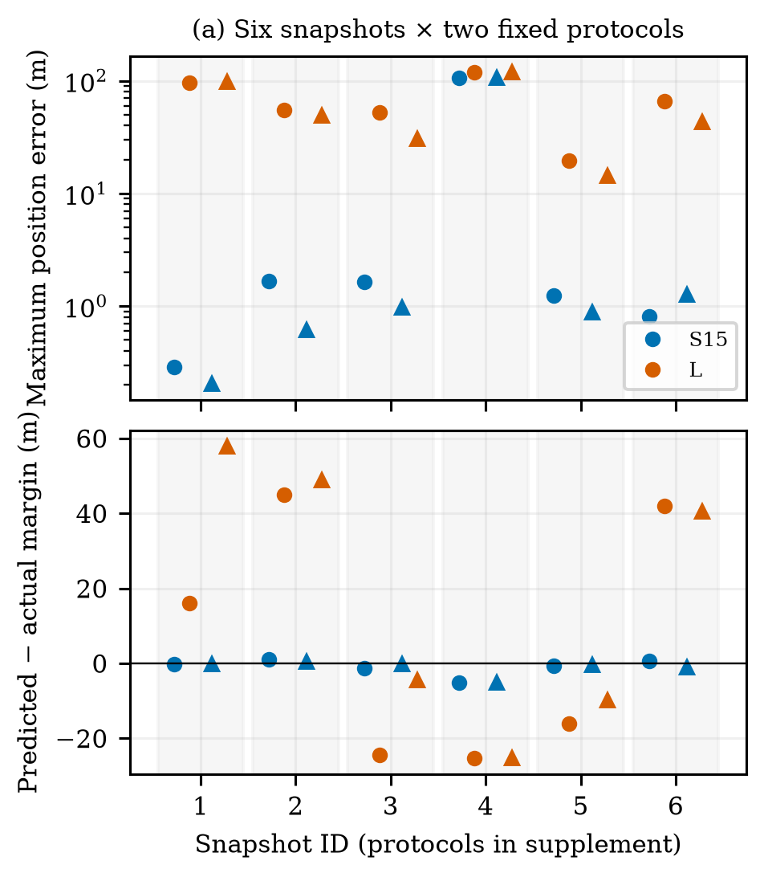
Fig. 6. Predictions versus actual fixed-protocol execution. Grouped by six source snapshots, with two protocols per group (circle/triangle; identities in Supplement S7). Errors and margin residuals share ten 60 s and two 58 s intervals. Duplicate nominal/continuation at snapshot 4 is one source state, not independent evidence.
At the historical pressure snapshot t=149 s, detailed nominal predicts 17.706 m and rejects the 30 m guard; the selected −90-degree side protocol predicts 94.815 m. Fixed execution gives 17.868/95.098 m for the two protocols. The low-order predictor instead accepts nominal at 75.748 m in this same state. This isolates a decision-relevant prediction difference without attributing an entire later voyage to a single branch. This development snapshot illustrates fidelity on a fixed protocol; it is distinct from the new-confirmation complete-task comparison in Figs. 3–4.
Accepted-integrator-substep checks preserve every one-second endpoint exactly. The two historical reactive incursions remain −1.225 and −0.872 m. Their S15 minimum margins change from 43.589/38.455 m under one-second segments to 43.597/38.425 m under accepted-substep segments (maximum substep 0.1 s). Thus these particular gain labels do not arise solely from a one-second chord sign error. This is still a numerical circular-proxy check, not swept-hull or formal continuous safety.
Nine measurements of the estimation/rollout/selection core per model at three fixed states give detailed median/p95/maximum wall times 17.009/17.662/17.685 s, compared with 0.067/0.136/0.136 s for L. The states include two risk decisions and ordinary feedback, each repeated three times. The timer excludes initial nominal/candidate setup and model loading. Nominal early return can evaluate different candidate counts, so this is not an equal-work per-candidate speed ratio. Complete new-confirmation episode CPU totals are 270.68, 2133.23 and 378.44 s for R, S15 and L. These measures include different work and are not interchangeable. Detailed calls can exceed the 15 s review period; physical time remains paused here. Separate R9 delayed-execution failures are boundary evidence, not pooled main-method outcomes.

VI. Discussion and Conclusion
The study adapts control-induced prediction to a recurrent sailboat controller through explicit reference, holding and feedback-restoration protocols. Causal reconstruction makes candidate predictions correspond to the actual control interface. The main selection mechanism is nominal-first guard testing followed by finite alternative evaluation; the 20 m term is not a general intervention-cost tradeoff.
The targeted revision supports three bounded findings. First, detailed prediction is more faithful on the selected fixed protocols and provides one additional safe completion over the calibrated low-order comparator on 24 frozen tasks. Second, that benefit carries computation and navigation costs, including a 308 s unnecessary endpoint detour. A simpler predictor remains a serious alternative. Third, the four-guard experiment changes achieved margins and cost tails without identifying an optimal value. The retained large prediction error and finite best-effort fallback prevent interpreting the guard as a safety guarantee.
The evaluation assumes the inherited dynamics, noiseless current motion observations, a known static map and one non-cooperative low-speed vessel with constant velocity. Target extrapolation is matched in these tests; maneuvering-target robustness, broader model mismatch, multi-vessel encounters and complete COLREGs behavior are not established. Prediction windows and development branches are diagnostic, not independent task trials. The physical clock pauses during planning; a measured call can exceed the review period. Real-time deployment would require a separate moving-while-computing delivery evaluation. Within these limits, the paper provides a reproducible reference-execution interface and evidence of both useful avoidance and conservative intervention, rather than a universal improvement claim.

Acknowledgment and Author Actions
Author names, affiliations, funding and formal attribution/release permission for inherited assets remain to be confirmed. AI tools assisted drafting, implementation and internal evidence review. Human authors remain responsible for verification and disclosure. The experiments are simulation comparisons and offline checks; this revision reorganizes their evidence without policy training or a physical experiment.

References
[1] A. G. da Silva Junior, D. H. dos Santos, A. P. F. de Negreiros, J. M. V. B. de Souza Silva, and L. M. G. Gonçalves, “High-level path planning for an autonomous sailboat robot using Q-learning,” Sensors, vol. 20, no. 6, Art. 1550, 2020, doi: 10.3390/s20061550.
[2] D. Wilkie, J. van den Berg, and D. Manocha, “Generalized velocity obstacles,” in Proc. IEEE/RSJ International Conference on Intelligent Robots and Systems, 2009, doi: 10.1109/IROS.2009.5354175.
[3] E. Garone, S. Di Cairano, and I. Kolmanovsky, “Reference and command governors for systems with constraints: A survey on theory and applications,” Automatica, vol. 75, pp. 306–328, 2017, doi: 10.1016/j.automatica.2016.08.013.
[4] Q. Sun, W. Qi, and H. Qian, “MoWe: Motion observation for wind estimation of sailing robots,” Journal of Field Robotics, vol. 42, no. 5, pp. 2355–2374, 2025, doi: 10.1002/rob.22512.
[5] T. Haarnoja, A. Zhou, P. Abbeel, and S. Levine, “Soft actor-critic: Off-policy maximum entropy deep reinforcement learning with a stochastic actor,” in Proc. 35th International Conference on Machine Learning, vol. 80, pp. 1861–1870, 2018.
[6] B.-O. H. Eriksen, M. Breivik, E. F. Wilthil, A. L. Flåten, and E. F. Brekke, “The branching-course model predictive control algorithm for maritime collision avoidance,” Journal of Field Robotics, vol. 36, no. 7, pp. 1222–1249, 2019, doi: 10.1002/rob.21900.
[7] A. İşleyen, N. van de Wouw, and Ö. Arslan, “Feedback motion prediction for safe unicycle robot navigation,” in Proc. IEEE/RSJ International Conference on Intelligent Robots and Systems, 2023, pp. 10511–10518, doi: 10.1109/IROS55552.2023.10341787.
[8] L. Xiao and J. Jouffroy, “Modeling and nonlinear heading control of sailing yachts,” IEEE Journal of Oceanic Engineering, vol. 39, no. 2, pp. 256–268, 2014, doi: 10.1109/JOE.2013.2247276.

