[ASSESSMENT TASK #2 - Vending Machine](https://app.newee.io/courses/2/assignments/48) – MLG Vending Machine

**Group Consisting of Ryan Dowman and Stanley McLaughlin**

Table of Contents

**This report will outline all sections specified within the assignment requirements and will have mention to external documents. All the work below was completed by Ryan Dowman and Stanley McLaughlin. The following documents will be located outside of this report in the “docs” folder: Gantt chart, log book, and the webpages themselves, these webpages come with their images included.**

IPO Chart

|  |  |  |
| --- | --- | --- |
| **Input** | **Process** | **Output** |
| Item Code (Keypad Interaction) | When the code is submitted through the pressing of the pay button the code is checked to see if it aligns with any items under than code and if so passes forward the name of the item, cost of the item and stock of the item. | The out put is the details of the items which can be used to make sure whether the purchase can be confirmed. It also allows for the image of the item to be produced if the purchase is successful. |
| Money Dragging and Dropping | When a particular image of money is dragged a function is run which passes through 1 parameter which is the value of the money itself, when said money is dropped in the slot the value of the last moved money is added to the money inside and subtracted from the wallet. | The display for money in the machine changes to suit the new amount as well as any currency you can no longer afford disappears from your wallet. |
| Admin Button Pressed | When pressed a prompt is opened where the value you insert is compared to the current password and if they are the same it will then toggle a class which expands the admin menu. | The admin menu will slide out if the correct password has been pressed and will show the admin buttons along with the X to close the menu. |
| Admin Stock Button (+ or -) | When pressed the currently selected item’s stock will either be decreased or increased based on the button clicked and will in turn change the value for that stock and will also display the new value next to the buttons. | When interacted with the value for the stock will change and display the new current number. |
| Admin Close Button | When pressed the X will toggle the same class as the admin lock and will slide the menu off screen. | The sliding menu will slide out of view. |
| Wallet Pressed | When the wallet is pressed a class is toggled on and off with JS that will scale the wallet and the items in it. | The wallet will grow and shrink as you press it. |

MLG Vending Machine – Interface Design Changes

To make our **MLG Vending Machine** the best we could we have had many changes in the style, functionality and user friendliness in order to provide a smooth and easy to use UI with also a strong focus on UX. Many of these changes have been made to make it easier for users to navigate the vending machine but also provide them with a more engaging and unique experience.

**ORGINAL DESIGN:**

*Figure 1: Original Main interface layout of the* ***MLG Vending Machine****.*

As seen in Figure 1 our original layout is like our final product with the same image used for the base of the vending machine as well as having the same use of images for currency. This layout was primarily going to be a strong guideline for our general layout and although there are similarities there are many issues with this base design.

**MAJOR CHANGE 1:**

One of the primary issues with this layout includes that of the currency, since one of our first issues with styling the currency was the size and positioning of the money as the needed to be visible and easy to use but were becoming too much of a focus if they were enlarged. To solve this issue we decided to initially remove the some of the money in order to make a more compact and easy to use range of currency, along with positioning them out in a straight-line in order to not take up unnecessary room, finally was the issue with the money still being too small; as this issue required more work as to fix this issue we decided on making a feature in which the user could make the wallet and money inside grow larger and allow the user themselves to decide on the sizing of the currency in order to satisfy both usability and appearance.

*Figure 2: Final design for wallet and currency.*

Another major change to our machine was also our change in how money worked within our machine, as at first, we utilized onclick functions to simply change the amount of money there was inside the machine. We both found this to lack much interest and decided to change how users interacted with money by making each item of currency draggable into a black slot above the wallet. Although this was an improvement to the to the previous system it required much more work and research to make it work in a way which was simply yet usable. Through this process another smaller feature was added such as an amount of money within the wallet was made which when the wallet could not support a type of currency due to lack of funds it would remove that currency as an option. Overall, we decided to make changes to the way money works in order to make our machine more engaging but also more visually appealing with a stronger resemblance to how a real vending machine would work.

**MAJOR CHANGE 2:**

With our machine not just, the frontend changed as we along the way made various changes to the backend of our machine and how that information was being displayed.

*Figure 3: Original layout for admin menu.*

As seen in figure 3 our original design for our admin consisted of a bulky table and many confusing buttons and other inputs, we decided that this lacked good visual hierarchy and lack much form of whitespace surrounding the elements themselves. Another issue with tis was how we planned on displaying the admin as a whole as it was planned to make the admin appear and disappear under the machine, which we soon found to be too much information on screen and made the machine itself look cluttered and confusing. To fix this we completely reshaped our backend in which we were not reliant on so many inputs and allowed for stock numbers to be changed individually by simply selecting his code with the keypad. On top of this we also fixed our issue with cluttering by making the admin appear on a slide out menu which would smoothly appear in the right side of the screen; this combination of changes made our admin not only easier to use but drastically reduced the amount of information on screen at any point in time giving the appearance of a clean and organized layout. And finally, we added in a password system into the admin which means no interactions could be made unless the password was correct which controlled who could and couldn’t use the admin.

*Figure 4: Final layout for admin menu.*

**MAJOR CHANGE 3:**

One of our most UI focused changes was our overall better use of color and implementing a strong color scheme as originally our buttons and tables look bland and didn’t fit the bright and vibrant colors that they sat in front of and thought that without good use of color the machine looked more confusing and lacked the ability to give the user clear and easy navigation, and simply made the machine hard to understand. To fix this we decided on sticking with the MLG color scheme or red white and blue and utilizes good practices of visual hierarchy mainly through contrast and positioning to make the machine easy to look at and understand. Primarily we aimed to remove colors that lacked contrast with either red or blue and only used colors such as black when given a more suitable background. Overall, our aim was to make our website look better as a whole with a clean matching color scheme that makes the machine easier to view and in turn use.

*Figure 2: Final color scheme for frontend.*

**Conclusion:**

Overall, our machine has undergone many changes in order to make our webpage look simple, easy to use, visually appealing and functional as we wanted to provide our users with only the best experience when using the **MLG Vending Machine**. Thanks to these changes we have been able to produce a more refined and useful product and hope you will enjoy using our machine!

MLG Vending Machine – User Manual

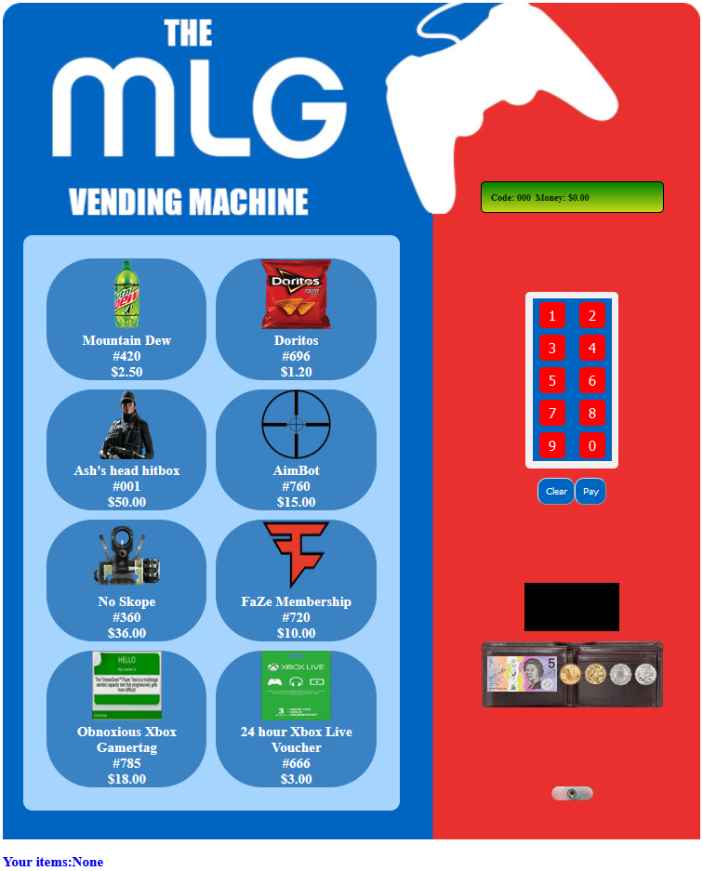Thank you for choosing the **MLG Vending Machine**. This user manual will provide an introduction to using the **MLG Vending Machine**, and also how to use the administration menu to restock the machine, return money, and give the user extra money. At MLG Services International, we pride ourselves in offering the best of the best products. In the rare event that you have any issues with the operation of this machine, please visit <https://github.com/N0bodyparticular/mlgVendingMachine/issues/new> to create an issue.

Figure 1: Main interface of the **MLG Vending Machine.**

# Section 1: Basic Operation

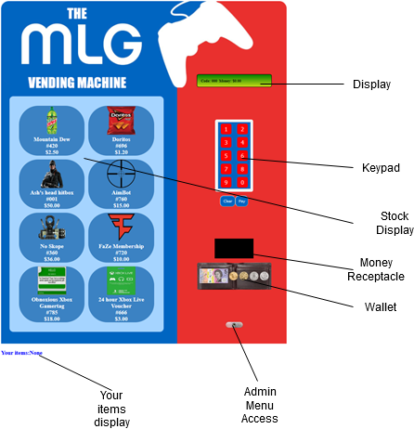The **MLG Vending Machine** has a comprehensible and fluid user interface. The diagram to the right outlines the basic functionality that the user has access to.

# Buying Items

The process for buying items is very straightforward:

1. Decide what item you want.
2. Enter the code using the keypad.
3. Drag enough money from the wallet into the receptacle.
4. Press pay.
5. You will now have bought the selected item. Press the clear button to return your change and clear the code.

Figure 2: Functionality of the **MLG Vending Machine.**

# Section 2: Administration Menu

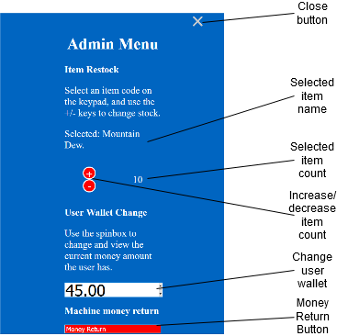In addition to the user interface for customers, the **MLG Vending Machine** also has a multipurpose administration menu for the system owner to perform maintenance.

## Accessing the Menu

Accessing the administration menu is very simple.

1. Click on the lock button to open the password entry.
2. Enter the password **“very strong password”** without quotes.

## Changing stock numbers

Once inside the menu you can change the amount of a product that is in the machine.

1. Type in the code for the item you wish to change in the keypad, e.g. 420 for Mountain Dew.
2. Use the + and – buttons to change the number of items.

## Changing user wallet amount

To change the amount of money that the user has available to spend, simply type the new amount into the “Change user wallet” section and press Enter.

## Returning money

By pressing the “Money Return” button, all the money that has been added to the machine will be refunded to the operator.

# Conclusion

Again, thank you for choosing the **MLG Vending Machine**. MLG Services International would like to remind you that if you suffer from any issues with the **MLG Vending Machine**, to report them on <https://github.com/N0bodyparticular/mlgVendingMachine/issues/new>.

BIBLIGRAPHY

MLG Cover IMAGE: <https://esportsobserver.com/mlg-sells-substantially-all-assets-to-activision-blizzard-for-46-million/>