## 

*Website Design****2***

Introduction 2

Wireframes 2

Hierarchy 2

Purpose 2

Target audience 2

Requirements 2

Client requirements 2

Website requirements 2

*Evaluation Report****2***

Introduction 2

Source code used 2

Reflection 2

Improvements 2

Conclusion 2

References 2

# Website Design

## Introduction

The website the developer is going to create is a website providing intel to anyone who considers building their own PC or just providing general information to anyone who is curious about what each PC component does.

## Wireframes

Initial:

**Index/Main Page:**

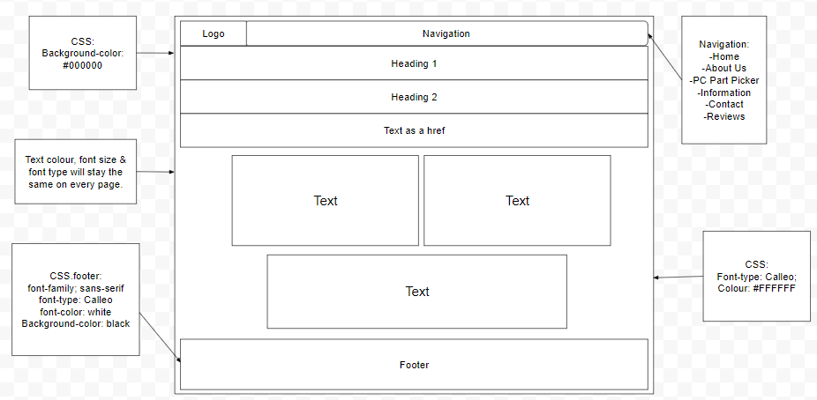

**About Us Page:**

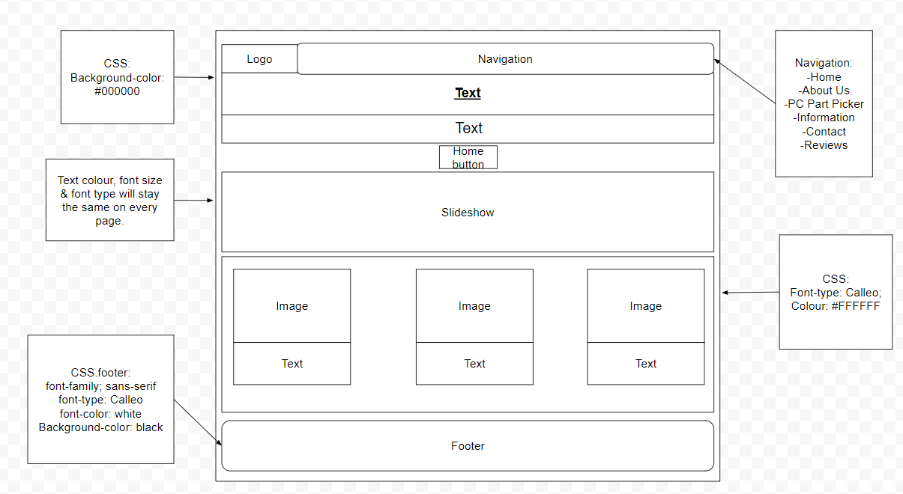

**Bottleneck Calculator:**

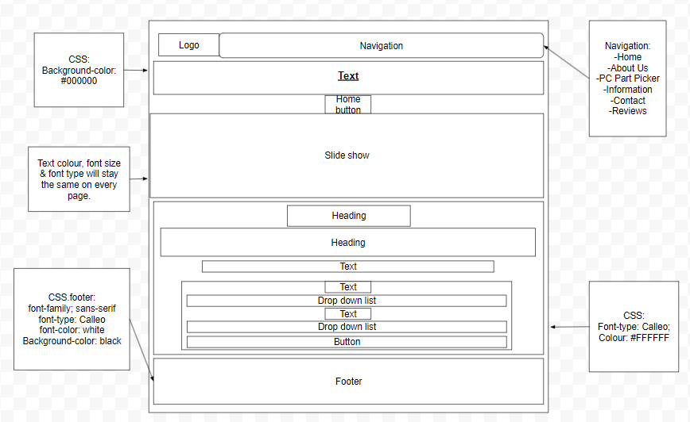

**Information Page:**

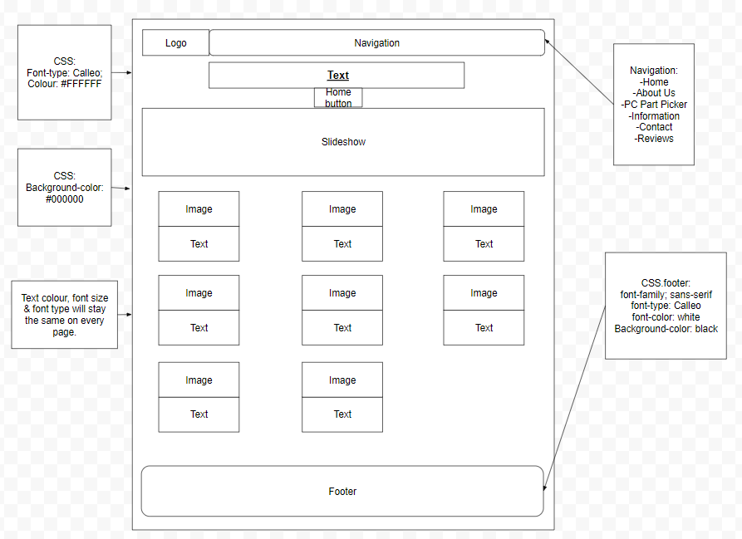

**Contact Page:**

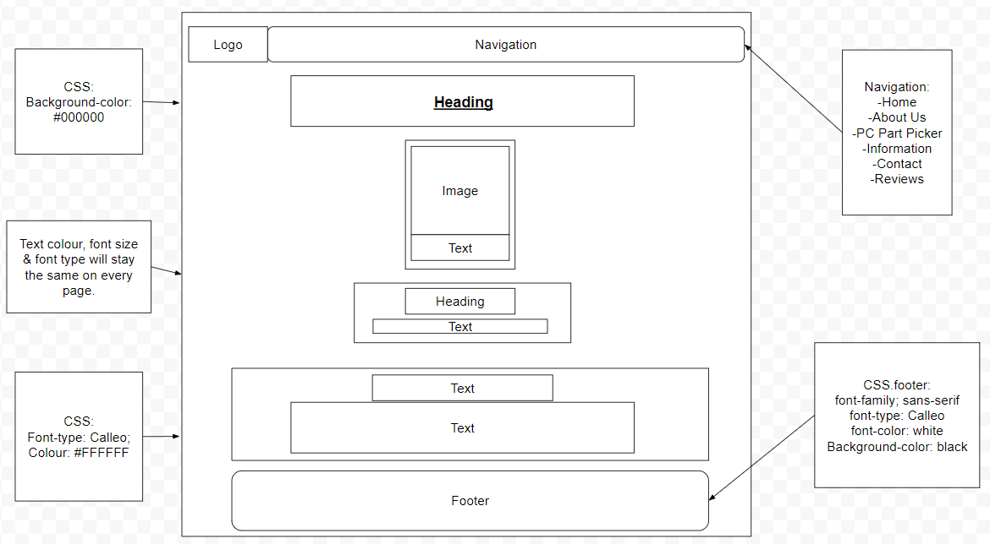

**Reviews:**

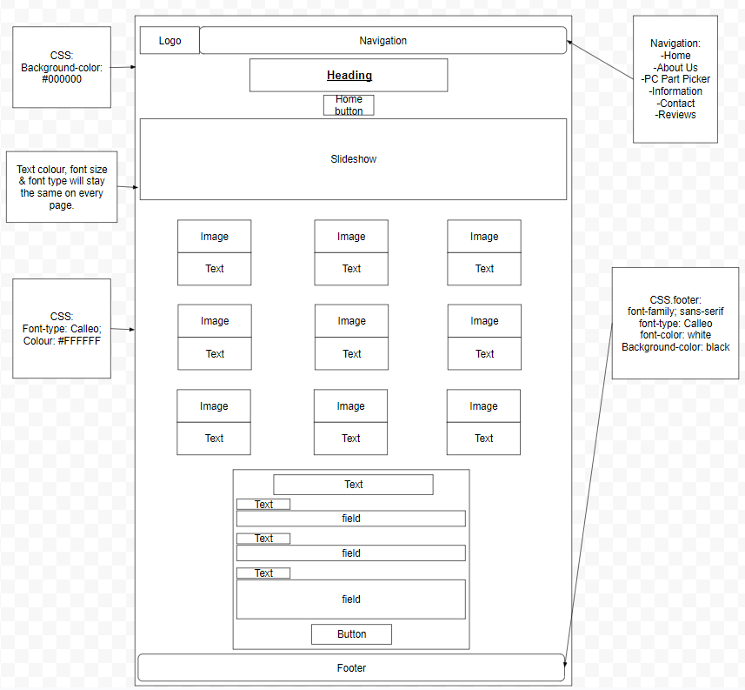

Alternative:

**Index/Main Page:**

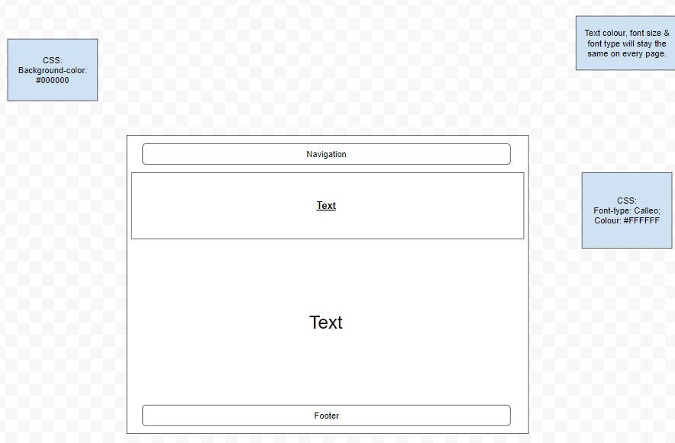

**About Us Page:**

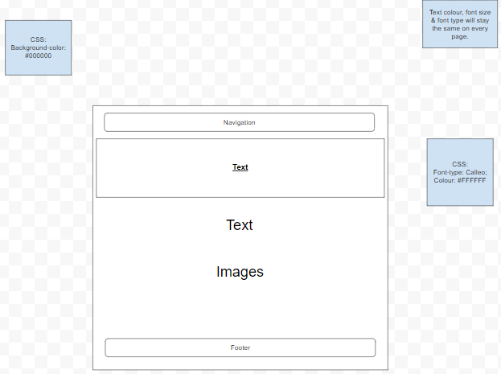

**PC Part Picker:**

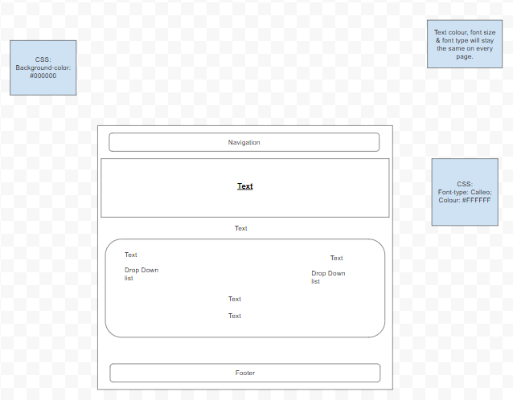

**Information Page:**

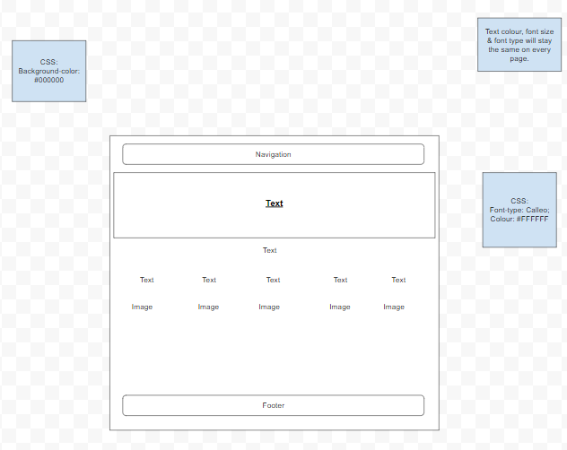

**What you need vs What you want Page:**

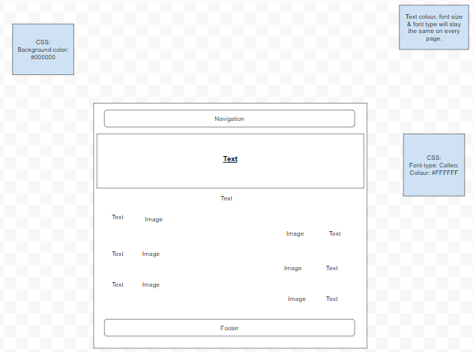

**Contact Page:**

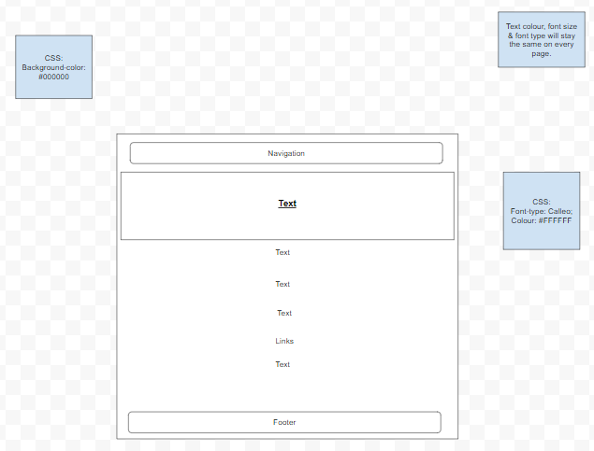

## Hierarchy/Site Map:

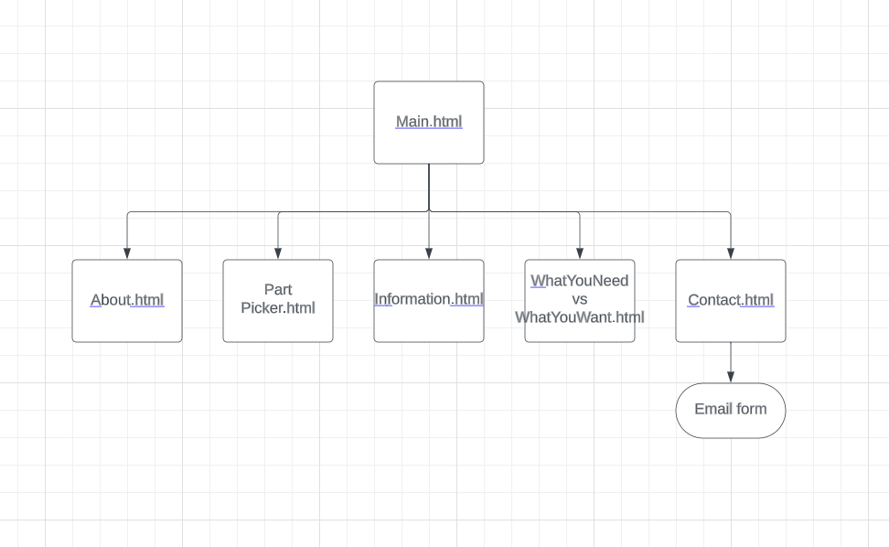

## Purpose

The purpose of this website is to let people use it to determine what parts they would like to implement in their new PC & to configure the best efficiency (creating the smallest bottleneck possible). Additionally, It can also be used as a general information website to inform someone.

## Target audience

The website is specifically designed for people who are interested in computers and want to know more about what is inside a PC and what each part of a PC does. Furthermore, People or even companies who built their own PCs can use it.

## Requirements

### Client requirements

The requirements given by the client are that the Website is supposed to be coded in 3 different coding languages. HTML, CSS and JavaScript.

### Website requirements

The requirements for the website is as follows: The website needs to have at least 6 webpages, needs to be functional and contain a contact form as well (included in the 6 pages). Additionally, it should have different features like accessibility features.

# Evaluation Report

## Introduction

The purpose of this evaluation is to assess and review as well as provide detail to the reader about the assignment. The assignment was set as a task. The task is based on the client requirements to develop a 6 page website including, HTML, CSS and JavaScript. I have started by analysing what the client requirements are as well as the purpose of this task. After that, the target audience for the website was determined. This is because every website should have a target audience in order to have a direction where the website should be going. Then The Hierarchy of the website has been decided which goes like this: the index page/homepage is the main web page. From the index page, all the other web pages can be accessed. The 6 pages (including the index page) are called: “index”, “About Us”, “Bottleneck Calculator”, “Contact Us”, “Information” & “Reviews”.

## 

## Source code used

**index page:**

|  |
| --- |
| <!DOCTYPE html>  <html>  <head>  <title>ITUPC</title>  <!-- Bootstrap CSS -->  <link rel="stylesheet" href="https://cdnjs.cloudflare.com/ajax/libs/font-awesome/5.15.4/css/all.min.css">  <link href="https://stackpath.bootstrapcdn.com/bootstrap/4.5.2/css/bootstrap.min.css" rel="stylesheet">  <style>  body {  background-color: #000;  font-family: Calleo, sans-serif;  color: #fff;  }  body {  background-image: url('Gaming PC Bunter Hund.jpg');  background-size: cover;  background-repeat: no-repeat;  font-family: Calleo, sans-serif;  color: #fff;  margin: 0;  padding: 0;  }  h1, h2, h3, h4 {  color: white;  margin-top: 20px;  font-weight: bold;  }    /*seperate h1 CSS line because the heading 1 needs to be seperated from the navbar.*/  h1 {  color: white;  margin-top: 80px; /* adjust margin top here */  font-weight: bold;  }  th, td {  padding: 10px;  text-align: left;  border-bottom: 1px solid #ddd;  }  th {  background-color: white;  color: white;  }  a {  color: white;  text-decoration: none;  font-size: 20px;  }  .navbar {  background-color: white;  overflow: hidden;  position: fixed;  top: 0;  width: 100%;  }    .navbar-logo {  max-height: 50px; /*maximum height*/  margin-right: 10px;  }  /* Moving left part of navbar more to the left */  .navbar-brand {  padding-left: 20px;  font-weight: bold; /* add bold font weight */  font-size: 1.5rem;  }  /* Moving right part of navbar more to the right */  .navbar-nav {  margin-right: 20px;  }    /*Footer lines start here*/    .footer {  background-color: #333;  padding: 20px 0;  color: white;  text-align: center;  }  .footer a {  color: white;  text-decoration: none;  margin: 0 20px;  }  .footer a:hover {  text-decoration: underline;  }  </style>  </head>  <body>  <!-- Navigation Bar HTML -->  <nav class="navbar navbar-expand-lg navbar-light bg-light fixed-top">  <img src="Predator.png" class="navbar-logo" alt="Logo">  <a class="navbar-brand" href="#">ITUPC</a>  <button class="navbar-toggler" type="button" data-toggle="collapse" data-target="#navbarNav" aria-controls="navbarNav" aria-expanded="false" aria-label="Toggle navigation">  <span class="navbar-toggler-icon"></span>  </button>  <div class="collapse navbar-collapse" id="navbarNav">  <ul class="navbar-nav ml-auto">  <li class="nav-item active"><a class="nav-link" href="index.html">Home</a></li>  <li class="nav-item"><a class="nav-link" href="About Us.html">About Us</a></li>  <li class="nav-item"><a class="nav-link" href="Bottleneck Calculator.html">Bottleneck Calculator</a></li>  <li class="nav-item"><a class="nav-link" href="Information.html">PC Parts Information</a></li>  <li class="nav-item"><a class="nav-link" href="Contact.html">Contact Us</a></li>  <li class="nav-item"><a class="nav-link" href="Reviews.html">Reviews</a></li>  </ul>  </div>  </nav>  <div class="container mt-5">  <div class="text-center">  <h1>Power up your knowledge with International Talent of Ultimate PC!</h1>  <h2>The latest PC part information you will need can be found on International Talent of Ultimate PC</h2>  <a href="information.html" class="h4">Click here to go straight to the latest information!</a>  </div>  <div class="row justify-content-center mt-5">  <div class="col-md-4 border border-white bg-dark text-white p-3">  <h3>Our Team</h3>  <img src="Team.jpg" alt="Image 1" class="img-fluid mb-3">  <p>Our passionate team is eager to provide the best service to customers.</p>  </div>  <div class="col-md-4 border border-white bg-dark text-white p-3">  <h3>The Office</h3>  <img src="PC Company.jpg" alt="Image 2" class="img-fluid mb-3">  <p>The office has the facilities to provide quick and the best services.</p>  </div>  </div>  <div class="text-center mt-5">  <div class="col-md-6 border border-white bg-dark text-white p-3 mx-auto">  <h3>Let Us Hear You!</h3>  <p>If you have any questions to us, please contact us and if you have any feedback, review us!</p>  </div>  </div>  </div>  <!-- Footer -->  <footer class="footer mt-5">  <div class="container">  <div class="row">  <div class="col-md-12">  <h4>Follow Us!</h4>  <a href="https://www.facebook.com"><i class="fab fa-facebook fa-2x"></i></a>  <a href="https://twitter.com/?lang=en"><i class="fab fa-twitter fa-2x"></i></a>  <a href="https://www.instagram.com"><i class="fab fa-instagram fa-2x"></i></a>  <h6 style="margin-top: 15px;">All rights reserved - Copyright © 2023</h6>  </div>  </div>  </div>  </footer>  <!-- Bootstrap JS and jQuery (for Bootstrap functionality) -->  <script src="https://cdnjs.cloudflare.com/ajax/libs/jquery/3.5.1/jquery.min.js"></script>  <script src="https://stackpath.bootstrapcdn.com/bootstrap/4.5.2/js/bootstrap.min.js"></script>  </body>  </html> |

**About Us:**

|  |
| --- |
| <!DOCTYPE html>  <html lang="en">  <head>  <meta charset="UTF-8">  <meta name="viewport" content="width=device-width, initial-scale=1.0">  <title>About Us - ITUPC</title>  <!-- Bootstrap CSS -->  <link rel="stylesheet" href="https://stackpath.bootstrapcdn.com/bootstrap/4.5.2/css/bootstrap.min.css">  <!-- Font Awesome -->  <link rel="stylesheet" href="https://cdnjs.cloudflare.com/ajax/libs/font-awesome/5.15.2/css/all.min.css">  <style>  body {  background-color: #000;  color: #fff;  font-family: Calleo, sans-serif;  font-size: 1.2rem;  }    /*the next few lines are for the navbar*/  .navbar {  background-color: white;  overflow: hidden;  position: fixed;  top: 0;  width: 100%;  }  .navbar-logo {  max-height: 50px;  margin-right: 10px;  }  .navbar-brand {  color: #000;  font-weight: bold;  font-size: 1.5rem;  padding-left: 20px; /* Adjust padding-left */  }  .navbar-nav {  margin-right: 20px;  }  .navbar-nav .nav-link {  margin-right: 0px;  color: #333;  font-size: 20px;  }    /*Jumbotron creates a big box if you want to give some sepcial content on page extra attention*/  .jumbotron {  background-color: #212121;  color: #fff;  padding: 60px 30px;  margin-top: 80px;  text-align: center;  }  h1, h2, h3, h4 {  color: #fff;  font-weight: bold;  }    /*The next few lines are for the image carousel/slideshow*/  .card {  background-color: #212121;  color: #fff;  border: none;  margin: 30px;  }  .card-img-top {  max-height: 200px;  }    .carousel-item img {  max-height: 400px;    }  .card-text {  font-size: 1.1rem;  }    /*Footer lines start here*/  .footer {  background-color: #333;  color: #fff;  padding: 20px 0;  text-align: center;  }  .footer a {  color: #fff;  text-decoration: none;  margin: 0 10px;  }  .footer a:hover {  text-decoration: underline;  }  </style>  </head>  <body>  <!-- Navigation Bar HTML -->  <nav class="navbar navbar-expand-lg navbar-light bg-light fixed-top">  <img src="Predator.png" class="navbar-logo" alt="Logo">  <a class="navbar-brand" href="#">ITUPC</a>  <button class="navbar-toggler" type="button" data-toggle="collapse" data-target="#navbarNav" aria-controls="navbarNav" aria-expanded="false" aria-label="Toggle navigation">  <span class="navbar-toggler-icon"></span>  </button>  <div class="collapse navbar-collapse" id="navbarNav">  <ul class="navbar-nav ml-auto">  <li class="nav-item active"><a class="nav-link" href="index.html">Home</a></li>  <li class="nav-item"><a class="nav-link" href="About Us.html">About Us</a></li>  <li class="nav-item"><a class="nav-link" href="Bottleneck Calculator.html">Bottleneck Calculator</a></li>  <li class="nav-item"><a class="nav-link" href="Information.html">PC Parts Information</a></li>  <li class="nav-item"><a class="nav-link" href="Contact.html">Contact Us</a></li>  <li class="nav-item"><a class="nav-link" href="Reviews.html">Reviews</a></li>  </ul>  </div>  </nav>  <!-- Jumbotron -->  <div class="jumbotron">  <div class="container">  <h1 class="display-4">About Us</h1>  <h2 class="mb-5">Information about our Company can you find here.</h2>  <a href="index.html" class="btn btn-outline-light btn-lg">Home</a>  </div>  <!-- Slideshow -->  <div id="carouselExampleIndicators" class="carousel slide pt-5" data-ride="carousel">  <ol class="carousel-indicators">  <li data-target="#carouselExampleIndicators" data-slide-to="0" class="active"></li>  <li data-target="#carouselExampleIndicators" data-slide-to="1"></li>  <li data-target="#carouselExampleIndicators" data-slide-to="2"></li>  <!-- Add more indicators as needed -->  </ol>  <div class="carousel-inner">  <div class="carousel-item active">  <img src="HardwareDealzSticker.png" class="d-block w-100" alt="Slide 1">  </div>  <div class="carousel-item">  <img src="PC Company.jpg" class="d-block w-100" alt="Our Office">  </div>  <div class="carousel-item">  <img src="HardwareDealzLilaPC.png" class="d-block w-100" alt="Slide 3">  </div>  <!-- Add more carousel items with images -->  </div>  <a class="carousel-control-prev" href="#carouselExampleIndicators" role="button" data-slide="prev">  <span class="carousel-control-prev-icon" aria-hidden="true"></span>  <span class="sr-only">Previous</span>  </a>  <a class="carousel-control-next" href="#carouselExampleIndicators" role="button" data-slide="next">  <span class="carousel-control-next-icon" aria-hidden="true"></span>  <span class="sr-only">Next</span>  </a>  </div>  </div>  <!-- Text boxes -->  <div class="container mt-5">  <div class="row">  <div class="col-md-4">  <div class="card">  <img src="PC Company.jpg" alt="Image 1" class="card-img-top">  <div class="card-body">  <h3 class="card-title">Our facilities</h3>  <p class="card-text">Our facilities and office are capable of providing the best service possible.</p>  </div>  </div>  </div>  <div class="col-md-4">  <div class="card">  <img src="Team.jpg" alt="Image 2" class="card-img-top">  <div class="card-body">  <h3 class="card-title">Our Team</h3>  <p class="card-text">Our Team is made up of highly skilled and trained professionals making them a perfect match when working together in order to provide the customer with the best service.</p>  </div>  </div>  </div>  <div class="col-md-4">  <div class="card">  <img src="Building PC.jpg" alt="Image 3" class="card-img-top">  <div class="card-body">  <h3 class="card-title">Our Services</h3>  <p class="card-text">We are providing a service in which we recommend different PC parts solution to best fit our customer or solutions to a problem the user might come across with his PC.</p>  </div>  </div>  </div>  </div>  </div>  <!-- Footer -->  <footer class="footer mt-5">  <div class="container">  <div class="row">  <div class="col-md-12">  <h4>Follow Us!</h4>  <a href="https://www.facebook.com"><i class="fab fa-facebook fa-2x"></i></a>  <a href="https://twitter.com/?lang=en"><i class="fab fa-twitter fa-2x"></i></a>  <a href="https://www.instagram.com"><i class="fab fa-instagram fa-2x"></i></a>  <h6 style="margin-top: 15px;">All rights reserved - Copyright © 2023</h6>  </div>  </div>  </div>  </footer>  <!-- Bootstrap JS and jQuery (for Bootstrap functionality) -->  <script src="https://code.jquery.com/jquery-3.5.1.slim.min.js"></script>  <script src="https://cdn.jsdelivr.net/npm/@popperjs/core@2.9.3/dist/umd/popper.min.js"></script>  <script src="https://stackpath.bootstrapcdn.com/bootstrap/4.5.2/js/bootstrap.min.js"></script>  </body>  </html> |

**Bottleneck Calculator:**

|  |
| --- |
| <!DOCTYPE html>  <html lang="en">  <head>  <meta charset="UTF-8">  <meta name="viewport" content="width=device-width, initial-scale=1.0">  <title>Bottleneck Calculator - ITUPC</title>  <!-- Bootstrap CSS -->  <link rel="stylesheet" href="https://stackpath.bootstrapcdn.com/bootstrap/4.5.2/css/bootstrap.min.css">  <!-- Font Awesome -->  <link rel="stylesheet" href="https://cdnjs.cloudflare.com/ajax/libs/font-awesome/5.15.2/css/all.min.css">  <style>  body {  background-color: #000;  color: #fff;  font-family: Calleo, sans-serif;  font-size: 1.2rem;  }    /*The next few lines are for the navbar*/  .navbar {  background-color: white;  overflow: hidden;  position: fixed;  top: 0;  width: 100%;  }  .navbar-logo {  max-height: 50px;  margin-right: 10px;  }  .navbar-brand {  color: #000;  font-weight: bold;  font-size: 1.5rem;  padding-left: 20px; /* Adjust padding-left */  }  .navbar-nav {  margin-right: 20px;  }  .navbar-nav .nav-link {  margin-right: 0px;  color: #333;  font-size: 20px;  }    /*Jumbotron creates a big box if you want to give some sepcial content on page extra attention*/  .jumbotron {  background-color: #212121;  color: #fff;  padding: 60px 30px;  margin-top: 80px;  text-align: center;  }  h1, h2, h3, h4 {  color: #fff;  font-weight: bold;  }    /*The next few lines are for the image carousel/slideshow*/  .card {  background-color: #212121;  color: #fff;  border: none;  margin: 30px;  }  .card-img-top {  max-height: 200px;  }    .carousel-item img {  max-height: 500px;    }  .card-text {  font-size: 1.1rem;  }    /*Footer starts here*/  .footer {  background-color: #333;  color: #fff;  padding: 20px 0;  text-align: center;  }  .footer a {  color: #fff;  text-decoration: none;  margin: 0 10px;  }  .footer a:hover {  text-decoration: underline;  }  </style>  </head>  <body>  <!-- Navigation Bar HTML -->  <nav class="navbar navbar-expand-lg navbar-light bg-light fixed-top">  <img src="Predator.png" class="navbar-logo" alt="Logo">  <a class="navbar-brand" href="#">ITUPC</a>  <button class="navbar-toggler" type="button" data-toggle="collapse" data-target="#navbarNav" aria-controls="navbarNav" aria-expanded="false" aria-label="Toggle navigation">  <span class="navbar-toggler-icon"></span>  </button>  <div class="collapse navbar-collapse" id="navbarNav">  <ul class="navbar-nav ml-auto">  <li class="nav-item active"><a class="nav-link" href="index.html">Home</a></li>  <li class="nav-item"><a class="nav-link" href="About Us.html">About Us</a></li>  <li class="nav-item"><a class="nav-link" href="Bottleneck Calculator.html">Bottleneck Calculator</a></li>  <li class="nav-item"><a class="nav-link" href="Information.html">PC Parts Information</a></li>  <li class="nav-item"><a class="nav-link" href="Contact.html">Contact Us</a></li>  <li class="nav-item"><a class="nav-link" href="Reviews.html">Reviews</a></li>  </ul>  </div>  </nav>  <!-- Jumbotron -->  <div class="jumbotron">  <div class="container">  <h1 class="display-4">Bottleneck Calculator</h1>  <a href="index.html" class="btn btn-outline-light btn-lg">Home</a>  </div>  <!-- Slideshow -->  <div id="carouselExampleIndicators" class="carousel slide pt-5" data-ride="carousel">  <ol class="carousel-indicators">  <li data-target="#carouselExampleIndicators" data-slide-to="0" class="active"></li>  <li data-target="#carouselExampleIndicators" data-slide-to="1"></li>  <li data-target="#carouselExampleIndicators" data-slide-to="2"></li>  <!-- Add more indicators as needed -->  </ol>  <div class="carousel-inner">  <div class="carousel-item active">  <img src="Office herrunterblickend.jpg" class="d-block w-100" alt="Slide 1">  </div>  <div class="carousel-item">  <img src="PC Company.jpg" class="d-block w-100" alt="Our Office">  </div>  <div class="carousel-item">  <img src="Windows 7.jpg" class="d-block w-100" alt="Slide 3">  </div>  <!-- possibility to add more carousel items with images -->  </div>  <a class="carousel-control-prev" href="#carouselExampleIndicators" role="button" data-slide="prev">  <span class="carousel-control-prev-icon" aria-hidden="true"></span>  <span class="sr-only">Previous</span>  </a>  <a class="carousel-control-next" href="#carouselExampleIndicators" role="button" data-slide="next">  <span class="carousel-control-next-icon" aria-hidden="true"></span>  <span class="sr-only">Next</span>  </a>  </div>  </div>  <center>  <h1>Compatibility Calculator</h1>  <h2>This calculator can be used to calculate the compatibility of your chosen CPU</h2>  <h2>with your chosen GPU and see how well they suit together. (Bottleneck Calculator)</h2>  <h5 style="background-color:DodgerBlue;">Note!: The information received from the caluclator can be used to choose a CPU & GPU for your new PC built!</h5>  <center>  <!-- Form -->  <div class="container mt-5">  <form class="border border-white p-4">  <div class="form-group">  <label for="cpuDropdown" style="color: white;">CPU</label>  <select class="form-control" id="cpuDropdown">  <option>Select CPU</option>  <option>Intel Core i3-12100</option>  <option>Intel Core i3-12100F</option>  <option>Intel Core i3-13100F</option>  <option>Intel Core i3-13100</option>  <option>Intel Core i5-12500</option>  <option>Intel Core i5-12400F</option>  <option>Intel Core i5-13400F</option>  <option>Intel Core i5-13400</option>  <option>Intel Core i5-13500</option>  <option>Intel Core i5-13600</option>  <option>Intel Core i7-12700</option>  <option>Intel Core i7-12700F</option>  <option>Intel Core i7-13600F</option>  <option>Intel Core i7-13700</option>  <option>Intel Core i9-12900</option>  <option>Intel Core i9-12900F</option>  <option>Intel Core i9-13900F</option>  <option>Intel Core i9-13900</option>  <option>Intel Core i9-13900KS</option>  <option>AMD Ryzen 3 1200</option>  <option>AMD Ryzen 3 1300X</option>  <option>AMD Ryzen 3 2300X</option>  <option>AMD Ryzen 3 3100</option>  <option>AMD Ryzen 3 3300X</option>  <option>AMD Ryzen 3 1200</option>  <option>AMD Ryzen 5 1400</option>  <option>AMD Ryzen 5 1600</option>  <option>AMD Ryzen 5 2600</option>  <option>AMD Ryzen 5 3500</option>  <option>AMD Ryzen 5 3600</option>  <option>AMD Ryzen 5 5600</option>  <option>AMD Ryzen 5 5600X3D</option>  <option>AMD Ryzen 5 7600</option>  <option>AMD Ryzen 7 1700</option>  <option>AMD Ryzen 7 2700</option>  <option>AMD Ryzen 7 3700X</option>  <option>AMD Ryzen 7 3800X</option>  <option>AMD Ryzen 7 5800</option>  <option>AMD Ryzen 7 5800X3D</option>  <option>AMD Ryzen 7 7700</option>  <option>AMD Ryzen 9 3900</option>  <option>AMD Ryzen 9 5900</option>  <option>AMD Ryzen 9 5900X</option>  <option>AMD Ryzen 9 7900</option>  <option>AMD Ryzen 9 7900X</option>  <option>AMD Ryzen 9 7900X3D</option>  <option>AMD Ryzen 9 7950X</option>  <option>AMD Ryzen 9 7950X3D</option>  <!-- Add more CPU options as needed -->  </select>  </div>  <div class="form-group">  <label for="gpuDropdown" style="color: white;">GPU</label>  <select class="form-control" id="gpuDropdown">  <option>Select GPU</option>  <option>Nvidia GT 710</option>  <option>Nvidia GTX 960</option>  <option>Nvidia GTX 980</option>  <option>Nvidia GTX 1630</option>  <option>Nvidia GTX 1050</option>  <option>Nvidia GTX 1050 Ti</option>  <option>Nvidia GTX 1060</option>  <option>Nvidia GTX 1070</option>  <option>Nvidia GTX 1080</option>  <option>Nvidia GTX 1080 Ti</option>  <option>Nvidia GTX 1630</option>  <option>Nvidia GTX 1650</option>  <option>Nvidia GTX 1660</option>  <option>Nvidia GTX 1660 Ti</option>  <option>Nvidia RTX 2060</option>  <option>Nvidia GTX 2060 SUPER</option>  <option>Nvidia RTX 2070</option>  <option>Nvidia RTX 2080</option>  <option>Nvidia RTX 2080 SUPER</option>  <option>Nvidia RTX 2080 Ti</option>  <option>Nvidia RTX 3050</option>  <option>Nvidia RTX 3060</option>  <option>Nvidia RTX 3060 Ti</option>  <option>Nvidia RTX 3070</option>  <option>Nvidia RTX 3070 Ti</option>  <option>Nvidia RTX 3080</option>  <option>Nvidia RTX 3080 Ti</option>  <option>Nvidia RTX 3090</option>  <option>Nvidia RTX 3090 Ti</option>  <option>Nvidia RTX 4060</option>  <option>Nvidia RTX 4060 Ti</option>  <option>Nvidia RTX 4070</option>  <option>Nvidia RTX 4070 Ti</option>  <option>Nvidia RTX 4080</option>  <option>Nvidia RTX 4090</option>  <!-- Add more GPU options as needed -->  </select>  </div>  <button type="submit" class="btn btn-primary btn-block mt-3">Proceed to Calculation [!!!COMING SOON!!!]</button>  </form>  </div>  <!-- Footer -->  <footer class="footer mt-5">  <div class="container">  <div class="row">  <div class="col-md-12">  <h4>Follow Us!</h4>  <a href="https://www.facebook.com"><i class="fab fa-facebook fa-2x"></i></a>  <a href="https://twitter.com/?lang=en"><i class="fab fa-twitter fa-2x"></i></a>  <a href="https://www.instagram.com"><i class="fab fa-instagram fa-2x"></i></a>  <h6 style="margin-top: 15px;">All rights reserved - Copyright © 2023</h6>  </div>  </div>  </div>  </footer>  <!-- Bootstrap JS and jQuery (for Bootstrap functionality) -->  <script src="https://cdnjs.cloudflare.com/ajax/libs/jquery/3.5.1/jquery.min.js"></script>  <script src="https://stackpath.bootstrapcdn.com/bootstrap/4.5.2/js/bootstrap.min.js"></script>  </body>  </html> |

**Information:**

|  |
| --- |
| <!DOCTYPE html>  <html lang="en">  <head>  <meta charset="UTF-8">  <meta name="viewport" content="width=device-width, initial-scale=1.0">  <title>PC Parts Information - ITUPC</title>  <!-- Bootstrap CSS -->  <link rel="stylesheet" href="https://stackpath.bootstrapcdn.com/bootstrap/4.5.2/css/bootstrap.min.css">  <!-- Font Awesome -->  <link rel="stylesheet" href="https://cdnjs.cloudflare.com/ajax/libs/font-awesome/5.15.2/css/all.min.css">  <style>  body {  background-color: #000;  color: #fff;  font-family: Calleo, sans-serif;  font-size: 1.2rem;  }    /*The next few lines are for the navbar*/  .navbar {  background-color: white;  overflow: hidden;  position: fixed;  top: 0;  width: 100%;  }  .navbar-logo {  max-height: 50px;  margin-right: 10px;  }  .navbar-brand {  color: #000;  font-weight: bold;  font-size: 1.5rem;  padding-left: 20px; /* Adjust padding-left */  }  .navbar-nav {  margin-right: 20px;  }  .navbar-nav .nav-link {  margin-right: 0px;  color: #333;  font-size: 20px;  }    /*Jumbotron creates a big box if you want to give some sepcial content on page extra attention*/    .jumbotron {  background-color: #212121;  color: #fff;  padding: 60px 30px;  margin-top: 80px;  text-align: center;  }  h1, h2, h3, h4 {  color: #fff;  font-weight: bold;  }    /*The next few lines are for the image carousel/slideshow*/  .card {  background-color: #212121;  color: #fff;  border: none;  margin: 30px;  }  .card-img-top {  max-height: 200px;  }    .carousel-item img {  max-height: 500px;    }  .card-text {  font-size: 1.1rem;  }    /*Footer starts here*/  .footer {  background-color: #333;  color: #fff;  padding: 20px 0;  text-align: center;  }  .footer a {  color: #fff;  text-decoration: none;  margin: 0 10px;  }  .footer a:hover {  text-decoration: underline;  }  </style>  </head>  <body>  <!-- Navigation Bar HTML -->  <nav class="navbar navbar-expand-lg navbar-light bg-light fixed-top">  <img src="Predator.png" class="navbar-logo" alt="Logo">  <a class="navbar-brand" href="#">ITUPC</a>  <button class="navbar-toggler" type="button" data-toggle="collapse" data-target="#navbarNav" aria-controls="navbarNav" aria-expanded="false" aria-label="Toggle navigation">  <span class="navbar-toggler-icon"></span>  </button>  <div class="collapse navbar-collapse" id="navbarNav">  <ul class="navbar-nav ml-auto">  <li class="nav-item active"><a class="nav-link" href="index.html">Home</a></li>  <li class="nav-item"><a class="nav-link" href="About Us.html">About Us</a></li>  <li class="nav-item"><a class="nav-link" href="Bottleneck Calculator.html">Bottleneck Calculator</a></li>  <li class="nav-item"><a class="nav-link" href="Information.html">PC Parts Information</a></li>  <li class="nav-item"><a class="nav-link" href="Contact.html">Contact Us</a></li>  <li class="nav-item"><a class="nav-link" href="Reviews.html">Reviews</a></li>  </ul>  </div>  </nav>  <!-- Jumbotron -->  <div class="jumbotron">  <div class="container">  <h1 class="display-4">Information</h1>  <a href="index.html" class="btn btn-outline-light btn-lg">Home</a>  </div>  <!-- Slideshow -->  <div id="carouselExampleIndicators" class="carousel slide pt-5" data-ride="carousel">  <ol class="carousel-indicators">  <li data-target="#carouselExampleIndicators" data-slide-to="0" class="active"></li>  <li data-target="#carouselExampleIndicators" data-slide-to="1"></li>  <li data-target="#carouselExampleIndicators" data-slide-to="2"></li>  <!-- Add more indicators as needed -->  </ol>  <div class="carousel-inner">  <div class="carousel-item active">  <img src="all-parts.jpg" class="d-block w-100" alt="Slide 1">  </div>  <div class="carousel-item">  <img src="PC Rainbow Build.jpg" class="d-block w-100" alt="Our Office">  </div>  <div class="carousel-item">  <img src="EmptyGamingRoom.jpg" class="d-block w-100" alt="Slide 3">  </div>  <!-- Add more carousel items with images -->  </div>  <a class="carousel-control-prev" href="#carouselExampleIndicators" role="button" data-slide="prev">  <span class="carousel-control-prev-icon" aria-hidden="true"></span>  <span class="sr-only">Previous</span>  </a>  <a class="carousel-control-next" href="#carouselExampleIndicators" role="button" data-slide="next">  <span class="carousel-control-next-icon" aria-hidden="true"></span>  <span class="sr-only">Next</span>  </a>  </div>  </div>  <!-- Text boxes -->  <div class="container mt-5">  <div class="row">  <div class="col-md-4">  <div class="card">  <img src="AMD Ryzen 5 5600.jpeg" alt="Image 1" class="card-img-top">  <div class="card-body">  <h3 class="card-title">CPU</h3>  <p class="card-text">The CPU is the so called "Brain" of the PC from which everything is being executed. So, having a stable and efficient CPU with multiple cores and a high number of hertz is going to save you a lot of loading time.</p>  </div>  </div>  </div>  <div class="col-md-4">  <div class="card">  <img src="RTX 3060.jpeg" alt="Image 2" class="card-img-top">  <div class="card-body">  <h3 class="card-title">GPU</h3>  <p class="card-text">This lovely piece is every Gamer's most important PC component when building a PC...this is simply because without it, you would not be able to play games very good. So the more excpensive it is, usually the better it will be.</p>  </div>  </div>  </div>  <div class="col-md-4">  <div class="card">  <img src="RAM.jpeg" alt="Image 2" class="card-img-top">  <div class="card-body">  <h3 class="card-title">RAM</h3>  <p class="card-text">RAM for short, or Random Access Memory is important for any PB build as the system needs it to start up the apps and software. Furthermore, it enables you to have several applications on your PC open at the same time. In terms of gaming, 16GB is completely sufficient.</p>  </div>  </div>  </div>  <div class="col-md-4">  <div class="card">  <img src="PSU.jpeg" alt="Image 2" class="card-img-top">  <div class="card-body">  <h3 class="card-title">PSU</h3>  <p class="card-text">The PSU is not to be underestimated when bought, thisis because it needs to be a solid peace, otherwise it is not able to divide the power efficiently and especially enough, to the components and their needs.</p>  </div>  </div>  </div>  <div class="col-md-4">  <div class="card">  <img src="Motherboard.jpeg" alt="Image 2" class="card-img-top">  <div class="card-body">  <h3 class="card-title">Motherboard</h3>  <p class="card-text">The Motherboard is the "playing field" where most things from the PC are being built on.</p>  </div>  </div>  </div>  <div class="col-md-4">  <div class="card">  <img src="PC Case Fans.jpeg" alt="Image 2" class="card-img-top">  <div class="card-body">  <h3 class="card-title">Cooling System/PC Case Fans</h3>  <p class="card-text">PC Case Fans are very useful to reduce the warmth or heat inside your PC Case, especially when your PC is under a high workload a lot of times as it automatically produces a lot of heat. However, you won't need it necessarily when the PC is not built for gaming or other intensive work.</p>  </div>  </div>  </div>  <div class="col-md-4">  <div class="card">  <img src="CPU Air Fan.jpeg" alt="Image 2" class="card-img-top">  <div class="card-body">  <h3 class="card-title">Cooling System/CPU Fan</h3>  <p class="card-text">The CPU Fan is needed as without it, the CPU will most likely overheat and it does nnot take long. You will hundred percent need a CPU Fan if you at least want the PC to run a few tasks.</p>  </div>  </div>  </div>  <div class="col-md-4">  <div class="card">  <img src="AIO.jpeg" alt="Image 2" class="card-img-top">  <div class="card-body">  <h3 class="card-title">Cooling System/CPU AIO</h3>  <p class="card-text">A CPU AIO could be beneficial to someone who is more interested in looks as it most of the times glows somewhere. However, it does not end here, depending on what AIO you are using, it could be better or worse than an Air cooler. Additionally, they could improve noise or raise noise, improve the heat reduction or even increase the heat. </p>  </div>  </div>  </div>  </div>  </div>  <!-- Footer -->  <footer class="footer mt-5">  <div class="container">  <div class="row">  <div class="col-md-12">  <h4>Follow Us!</h4>  <a href="https://www.facebook.com"><i class="fab fa-facebook fa-2x"></i></a>  <a href="https://twitter.com/?lang=en"><i class="fab fa-twitter fa-2x"></i></a>  <a href="https://www.instagram.com"><i class="fab fa-instagram fa-2x"></i></a>  <h6 style="margin-top: 15px;">All rights reserved - Copyright © 2023</h6>  </div>  </div>  </div>  </footer>  <!-- Bootstrap JS and jQuery (for Bootstrap functionality) -->  <script src="https://cdnjs.cloudflare.com/ajax/libs/jquery/3.5.1/jquery.min.js"></script>  <script src="https://stackpath.bootstrapcdn.com/bootstrap/4.5.2/js/bootstrap.min.js"></script>  </body>  </html> |

**Contact Us:**

|  |
| --- |
| <!DOCTYPE html>  <html>  <head>  <title>Contact Us - ITUPC</title>  <!-- Bootstrap CSS -->  <link rel="stylesheet" href="https://cdnjs.cloudflare.com/ajax/libs/font-awesome/5.15.4/css/all.min.css">  <link href="https://stackpath.bootstrapcdn.com/bootstrap/4.5.2/css/bootstrap.min.css" rel="stylesheet">  <style>  body {  background-color: #000;  font-family: Calleo, sans-serif;  color: #fff;  }  h4, h3, h2 {  color: white;  margin-top: 20px;  }  h1 {  color: black;  margin-top: 80px; /* adjust margin top here */  font-weight: bold;  background-color: #fff; /* Background color for the box */  padding: 20px; /* Add padding to create space around the content */  display: inline-block; /* Make the box only as wide as the content */  border-radius: 10px; /* Optional: Add rounded corners to the box */  }  th, td {  padding: 10px;  text-align: left;  border-bottom: 1px solid #ddd;  }  th {  background-color: white;  color: white;  }  a {  color: white;  text-decoration: none;  font-size: 20px;  }    /*The next few lines are for the navbar*/    .navbar {  background-color: white;  overflow: hidden;  position: fixed;  top: 0;  width: 100%;  }    .navbar-logo {  max-height: 50px; /*maximum height*/  margin-right: 10px;  }  .navbar-brand {  padding-left: 20px;  font-weight: bold;  font-size: 1.5rem;  }  .navbar-nav {  margin-right: 20px;  }    /*Contact information*/      .contact-info {  background-color: #222;  color: white;  padding: 40px 20px;  text-align: center;  margin-top: 50px;  }  .contact-info h3 {  margin-bottom: 20px;  }  .contact-info p {  font-size: 18px;  }    body {  background-image: url('PC components.jpg');  background-size: cover;  background-repeat: no-repeat;  font-family: Calleo, sans-serif;  color: #fff;  margin: 0;  padding: 0;  }    /*Footer starts here*/    .footer {  background-color: #333;  padding: 20px;  color: #fff;  text-align: center;  }  .footer a {  color: #fff;  text-decoration: none;  margin: 0 10px;  }  .footer a:hover {  text-decoration: underline;  }  </style>  </head>  <body>  <!-- Navigation Bar HTML -->  <nav class="navbar navbar-expand-lg navbar-light bg-light fixed-top">  <img src="Predator.png" class="navbar-logo" alt="Logo">  <a class="navbar-brand" href="#">ITUPC</a>  <button class="navbar-toggler" type="button" data-toggle="collapse" data-target="#navbarNav" aria-controls="navbarNav" aria-expanded="false" aria-label="Toggle navigation">  <span class="navbar-toggler-icon"></span>  </button>  <div class="collapse navbar-collapse" id="navbarNav">  <ul class="navbar-nav ml-auto">  <li class="nav-item active"><a class="nav-link" href="index.html">Home</a></li>  <li class="nav-item"><a class="nav-link" href="About Us.html">About Us</a></li>  <li class="nav-item"><a class="nav-link" href="Bottleneck Calculator.html">Bottleneck Calculator</a></li>  <li class="nav-item"><a class="nav-link" href="Information.html">PC Parts Information</a></li>  <li class="nav-item"><a class="nav-link" href="Contact.html">Contact Us</a></li>  <li class="nav-item"><a class="nav-link" href="Reviews.html">Reviews</a></li>  </ul>  </div>  </nav>  <div class="container mt-5">  <div class="text-center">  <h1>On this page you can find our contact info!</h1>  </div>  <div class="row justify-content-center mt-5">  <div class="col-md-3 border border-white bg-dark text-white p-3">  <h3>Headquarters</h3>  <img src="Office.jpeg" alt="Image 1" class="img-fluid mb-3">  <p>Our headquarters are always ready to respond.</p>  </div>  </div>  <div class="text-center mt-5">  <div class="col-md-6 border border-white bg-dark text-white p-3 mx-auto">  <h3>Let Us Hear You!</h3>  <p>If you have any questions to us please contact us and if you have any feedback review us!</p>  </div>  </div>  <!-- Stylish contact information -->  <div class="contact-info">  <div class="row">  <div class="col-md-12">  <h3>Contact Information</h3>  <p>If you have any questions or feedback, please feel free to reach out to us using the following details:</p>  <p>Email: 100182533@student.burnley.ac.uk</p>  <p>Phone: +44 1282 733373</p>  <p>Address: Princess Way, Burnley BB12 0AN, United Kingdom</p>  </div>  </div>  </div>  <!-- Footer -->  <footer class="footer mt-5">  <div class="container">  <div class="row">  <div class="col-md-12">  <h4>Follow Us!</h4>  <a href="https://www.facebook.com"><i class="fab fa-facebook fa-2x"></i></a>  <a href="https://twitter.com/?lang=en"><i class="fab fa-twitter fa-2x"></i></a>  <a href="https://www.instagram.com"><i class="fab fa-instagram fa-2x"></i></a>  <h6 style="margin-top: 15px;">All rights reserved - Copyright © 2023</h6>  </div>  </div>  </div>  </footer>  <!-- Bootstrap JS and jQuery (for Bootstrap functionality) -->  <script src="https://cdnjs.cloudflare.com/ajax/libs/jquery/3.5.1/jquery.min.js"></script>  <script src="https://stackpath.bootstrapcdn.com/bootstrap/4.5.2/js/bootstrap.min.js"></script>  </body>  </html> |

**Reviews:**

|  |
| --- |
| <!DOCTYPE html>  <html lang="en">  <head>  <meta charset="UTF-8">  <meta name="viewport" content="width=device-width, initial-scale=1.0">  <title>Reviews - ITUPC</title>  <!-- Bootstrap CSS -->  <link rel="stylesheet" href="https://stackpath.bootstrapcdn.com/bootstrap/4.5.2/css/bootstrap.min.css">  <!-- Font Awesome -->  <link rel="stylesheet" href="https://cdnjs.cloudflare.com/ajax/libs/font-awesome/5.15.2/css/all.min.css">  <style>  body {  background-color: #000;  color: #fff;  font-family: Calleo, sans-serif;  font-size: 1.2rem;  }    /*The next few lines are for the navbar*/  .navbar {  background-color: white;  overflow: hidden;  position: fixed;  top: 0;  width: 100%;  }  .navbar-logo {  max-height: 50px;  margin-right: 10px;  }  .navbar-brand {  color: #000;  font-weight: bold;  font-size: 1.5rem;  padding-left: 20px; /* Adjust padding-left */  }  .navbar-nav {  margin-right: 20px;  }  .navbar-nav .nav-link {  margin-right: 0px;  color: #333;  font-size: 20px;  }    /*Jumbotron creates a big box if you want to give some sepcial content on page extra attention*/    .jumbotron {  background-color: #212121;  color: #fff;  padding: 60px 30px;  margin-top: 80px;  text-align: center;  }  h1, h2, h3, h4 {  color: #fff;  font-weight: bold;  }    /*The next few lines are for the image carousel/slideshow*/  .card {  background-color: #212121;  color: #fff;  border: none;  margin: 30px;  }  .card-img-top {  max-height: 200px;  }    .carousel-item img {  max-height: 500px;    }  .card-text {  font-size: 1.1rem;  }    /*Footer lines start here*/  .footer {  background-color: #333;  color: #fff;  padding: 20px 0;  text-align: center;  }  .footer a {  color: #fff;  text-decoration: none;  margin: 0 10px;  }  .footer a:hover {  text-decoration: underline;  }    <?php  $to = '100182533@student.burnley.ac.uk';  $subject = 'this comes from headquarters';  $name = $_POST['name'];  $email = $_POST['email'];  $topic = $_POST['topic'];  $message = $_POST['message'];  $body = <<<EMAIL  Hi! My name is $name. My topic  $message  From $name  Oh ya, my email is $email  EMAIL;  $header = "From: $email";  if($_POST){  if($name == '' || $email == '' || $message == ''){  $feedback = 'fill out all the fields';  }else{  mail($to, $subject, $body, $header);  $feedback = 'Thanks for the feedback!';  }  }  ?>  </style>  </head>  <body>  <!-- Navigation Bar HTML -->  <nav class="navbar navbar-expand-lg navbar-light bg-light fixed-top">  <img src="Predator.png" class="navbar-logo" alt="Logo">  <a class="navbar-brand" href="#">ITUPC</a>  <button class="navbar-toggler" type="button" data-toggle="collapse" data-target="#navbarNav" aria-controls="navbarNav" aria-expanded="false" aria-label="Toggle navigation">  <span class="navbar-toggler-icon"></span>  </button>  <div class="collapse navbar-collapse" id="navbarNav">  <ul class="navbar-nav ml-auto">  <li class="nav-item active"><a class="nav-link" href="index.html">Home</a></li>  <li class="nav-item"><a class="nav-link" href="About Us.html">About Us</a></li>  <li class="nav-item"><a class="nav-link" href="Bottleneck Calculator.html">Bottleneck Calculator</a></li>  <li class="nav-item"><a class="nav-link" href="Information.html">PC Parts Information</a></li>  <li class="nav-item"><a class="nav-link" href="Contact.html">Contact Us</a></li>  <li class="nav-item"><a class="nav-link" href="Reviews.html">Reviews</a></li>  </ul>  </div>  </nav>  <!-- Jumbotron -->  <div class="jumbotron">  <div class="container">  <h1 class="display-4">Reviews</h1>  <a href="index.html" class="btn btn-outline-light btn-lg">Home</a>  </div>  <!-- Slideshow -->  <div id="carouselExampleIndicators" class="carousel slide pt-5" data-ride="carousel">  <ol class="carousel-indicators">  <li data-target="#carouselExampleIndicators" data-slide-to="0" class="active"></li>  <li data-target="#carouselExampleIndicators" data-slide-to="1"></li>  <li data-target="#carouselExampleIndicators" data-slide-to="2"></li>  <!-- Add more indicators as needed -->  </ol>  <div class="carousel-inner">  <div class="carousel-item active">  <img src="Reviews.png" class="d-block w-100" alt="Slide 1">  </div>  <div class="carousel-item">  <img src="PC Rainbow Build.jpg" class="d-block w-100" alt="Our Office">  </div>  <div class="carousel-item">  <img src="EmptyGamingRoom.jpg" class="d-block w-100" alt="Slide 3">  </div>  <!-- Add more carousel items with images -->  </div>  <a class="carousel-control-prev" href="#carouselExampleIndicators" role="button" data-slide="prev">  <span class="carousel-control-prev-icon" aria-hidden="true"></span>  <span class="sr-only">Previous</span>  </a>  <a class="carousel-control-next" href="#carouselExampleIndicators" role="button" data-slide="next">  <span class="carousel-control-next-icon" aria-hidden="true"></span>  <span class="sr-only">Next</span>  </a>  </div>  </div>  <!-- Text boxes -->  <div class="container mt-5">  <div class="row">  <div class="col-md-4">  <div class="card">  <img src="5 Star.png" alt="Image 1" class="card-img-top">  <div class="card-body">  <h3 class="card-title">S Adnan</h3>  <p class="card-text">During my search I came accross this webpage which turned out to be the perfect solution to my issues regarding PC components/performance.</p>  </div>  </div>  </div>  <div class="col-md-4">  <div class="card">  <img src="5 Star.png" alt="Image 1" class="card-img-top">  <div class="card-body">  <h3 class="card-title">Ismaeel</h3>  <p class="card-text">The Website of ITUPC is amazingly user friendly!</p>  </div>  </div>  </div>  <div class="col-md-4">  <div class="card">  <img src="5 Star.png" alt="Image 2" class="card-img-top">  <div class="card-body">  <h3 class="card-title">Asim</h3>  <p class="card-text">I find the website very helpful when building my own PC.</p>  </div>  </div>  </div>  <div class="col-md-4">  <div class="card">  <img src="5 Star.png" alt="Image 2" class="card-img-top">  <div class="card-body">  <h3 class="card-title">Alan Sugar</h3>  <p class="card-text">Fortunately, finally a good website which does not want anything in exchange for providing their services.</p>  </div>  </div>  </div>  <div class="col-md-4">  <div class="card">  <img src="4 Star.png" alt="Image 2" class="card-img-top">  <div class="card-body">  <h3 class="card-title">Mathew</h3>  <p class="card-text">Good, keep it up. Like it!</p>  </div>  </div>  </div>  <div class="col-md-4">  <div class="card">  <img src="5 Star.png" alt="Image 1" class="card-img-top">  <div class="card-body">  <h3 class="card-title">Karen</h3>  <p class="card-text">I am a former PC hardware specialist so I know all about the topic "PC hardware". Therefore, I found this website very interesting.</p>  </div>  </div>  </div>  <div class="col-md-4">  <div class="card">  <img src="4 Star.png" alt="Image 2" class="card-img-top">  <div class="card-body">  <h3 class="card-title">Jerome</h3>  <p class="card-text">This is a nicely built website.</p>  </div>  </div>  </div>  <div class="col-md-4">  <div class="card">  <img src="3 Star.png" alt="Image 2" class="card-img-top">  <div class="card-body">  <h3 class="card-title">CrazyGolem</h3>  <p class="card-text">Not exactly what I searched for on the Internet but it did help.</p>  </div>  </div>  </div>  </div>  </div>  <!-- Feedback Form -->  <div class="container mt-5">  <div class="row justify-content-center">  <div class="col-md-8">  <div class="card">  <div class="card-body">  <h2 class="card-title text-center mb-4">Feedback Form</h2>  <form action="submit_feedback.php" method="post">  <div class="form-group">  <label for="name">Name:</label>  <input type="text" id="name" name="name" class="form-control" required>  </div>  <div class="form-group">  <label for="email">Email:</label>  <input type="email" id="email" name="email" class="form-control" required>  </div>  <div class="form-group">  <label for="message">Feedback:</label>  <textarea id="message" name="message" rows="4" class="form-control" required></textarea>  </div>  <div class="text-center">  <button type="submit" class="btn btn-primary btn-lg">Submit Feedback</button>  </div>  </form>  </div>  </div>  </div>  </div>  </div>  <!-- Footer -->  <footer class="footer mt-5">  <div class="container">  <div class="row">  <div class="col-md-12">  <h4>Follow Us!</h4>  <a href="https://www.facebook.com"><i class="fab fa-facebook fa-2x"></i></a>  <a href="https://twitter.com/?lang=en"><i class="fab fa-twitter fa-2x"></i></a>  <a href="https://www.instagram.com"><i class="fab fa-instagram fa-2x"></i></a>  <h6 style="margin-top: 15px;">All rights reserved - Copyright © 2023</h6>  </div>  </div>  </div>  </footer>  <!-- Bootstrap JS and jQuery (for Bootstrap functionality) -->  <script src="https://cdnjs.cloudflare.com/ajax/libs/jquery/3.5.1/jquery.min.js"></script>  <script src="https://stackpath.bootstrapcdn.com/bootstrap/4.5.2/js/bootstrap.min.js"></script>  </body>  </html> |

## Reflection

Reflecting on the work at the end is a good opportunity to look at the different aspects of the website to see what could have been improved and what I think has been done quite well.

All of the work was created by myself, however some links, templates (like bootstrap and Jquery) as well as some ideas for codes were not originally from me.

**These things go for every web page:**

I have created a header in which the website logo and navbar is. Additionally, I have created a footer in which three social media links are which link to the according social media software. Additionally, for every web page except the index page, I have created a button letting the visitor always go back to the homepage.

**Index:**

For the index page, I have decided to place a big, bold heading at the top of the page (underneath the header). underneath that a slightly smaller heading indicating that it is less important but still important. In case there are people who would just like to research about PC hardware then there is a link underneath both of these headings which takes the visitor directly to the information page (keeping in mind that the purpose of this website is to inform people about PC hardware). Next on the page is some information about the company and some encouraging words to let the reader know that they can feedback the shop website on the Reviews page. Additionally, to round the whole website up, I have decided for a decent but still slightly colourful background image which lets the website look less empty and aesthetically pleasing and befitting of the topic the website is about.

**About Us:**

For the About Us page, I have created two headings in bold stating what the website is about. Underneath the headings, the first slideshow of the website appears with 3 images befitting the web page. Underneath the slideshow, there are three different text boxes with images and texts underneath the images telling the visitor what the company/shop is about.

**Bottleneck Calculator:**

For this page, I created a slideshow with 3 images once again and underneath the slideshow is the so-called “Bottleneck Calculator”. This “machine” is there for visitors to calculate how well their chosen GPU & CPU fit together. The Visitor can select from the drop down list what GPU & CPU they want to combine.

**Information:**

For the information page I have created a slideshow with PC hardware images and underneath the slideshow places a lot of images with texts underneath them explaining what each important PC hardware component does.

**Contact Us:**

For the Contact Us page I gave it a bright background as it is supposed to be a bit different from the other webpages as it is quite empty too without the background making it similar to the index page. The first thing that looks different on this page is the big heading on top of the page which has a white box and a black font this time unlike the other webpages. However, the important stuff starts underneath the headquarters image and encouraging words. The contact information box with the contact information inside and the footer this time is more like a box with the same width as the contact information box, making it look more fitting underneath the big contact information box.

**Reviews:**

The Reviews page starts off with a slideshow with fitting images and then goes straight to reviews of the website from visitors of the website. The page does not have a background as I think it is the best if it does not. This is because the stars are best visible if there is just a plain black background. Furthermore, the text boxes and images are of different size and shape.

## 

## Improvements

Over the time that I have created this website, I came across many different things that were improved. Someone could tell by just looking at the wireframes, however that is not all. First of all, the positions of everything was adjusted several times after receiving multiple feedback from different peers. However there are also things that could still be improved like actually creating social media accounts for the company/shop or improving the bottleneck calculator so that it would actually calculate the combination and display the result. Another thing that could be considered to be an improvement for the website, is to add more features that are interactive. Furthermore, the Feedback Form at the end could be improved by saving the response and based on what entered, give a response.

## Conclusion

In conclusion, considering the criteria and client requirements for the website, it has been fulfilled and the website has been developed the whole time by keeping in mind the purpose and goal of the website as well as wireframes and a website hierarchy have been created. Overall, it was ensured that the website works totally fine and does not have something which should not be there. The website has a consistent look and feel, consistent navigation which works across all the different pages, used different elements, used external style sheets, used JavaScript, used consistent commenting in the code. Adding the Feedback Form is a good interactive feature. In the end I have ensured to create an evaluation with approximately. 1000 words which explains the website and document thoroughly and clearly.

## References

* PC Builds (no date) *Home Page*, *PC Builds*. Available at: <https://pc-builds.com/> (Accessed: 16 January 2024).
* W3schools (no date) *HTML* , *HTML input type="text"*. Available at: <https://www.w3schools.com/tags/att_input_type_text.asp> (Accessed: 16 January 2024).
* W3schools (no date a) *How to - slideshow*, *How To Create a Slideshow*. Available at: <https://www.w3schools.com/howto/howto_js_slideshow.asp> (Accessed: 16 January 2024).
* W3schools (no date b) *How to create a navbar with CSS*, *CSS navigation bar*. Available at: <https://www.w3schools.com/css/css_navbar.asp> (Accessed: 16 January 2024).
* W3schools (no date) *HTML <footer> tag</footer>*, *HTML footer Tag*. Available at: <https://www.w3schools.com/tags/tag_footer.asp> (Accessed: 16 January 2024).
* W3schools (no date b) *HTML <li> tag</li>*, *HTML li tag*. Available at: <https://www.w3schools.com/tags/tag_li.asp> (Accessed: 16 January 2024).

**Link to my Video:**

<https://drive.google.com/file/d/18AQs1QfEo3YU2J4cArg2SBkNXXlBRqL6/view?usp=sharing>

**Website File:**

<https://drive.google.com/file/d/1ZCvKjqZith4IxDmQ1Ez2LWdTdrVzNzwm/view?usp=sharing>