# OUTPUTS

### STARTING THE PROJECT



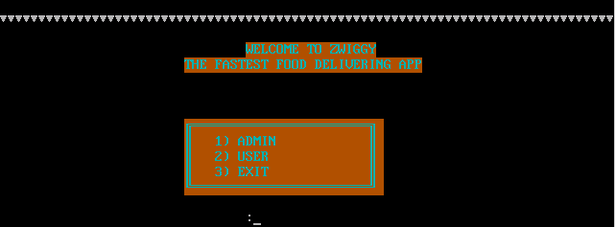

* 1. USING ADMIN MENU





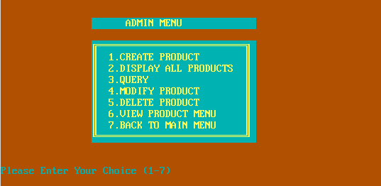

* 1. CREATING PRODUCT



* 1. DISPLAYING ALL PRODUCTS



* 1. QUERY





* 1. MODIFYING PRODUCT

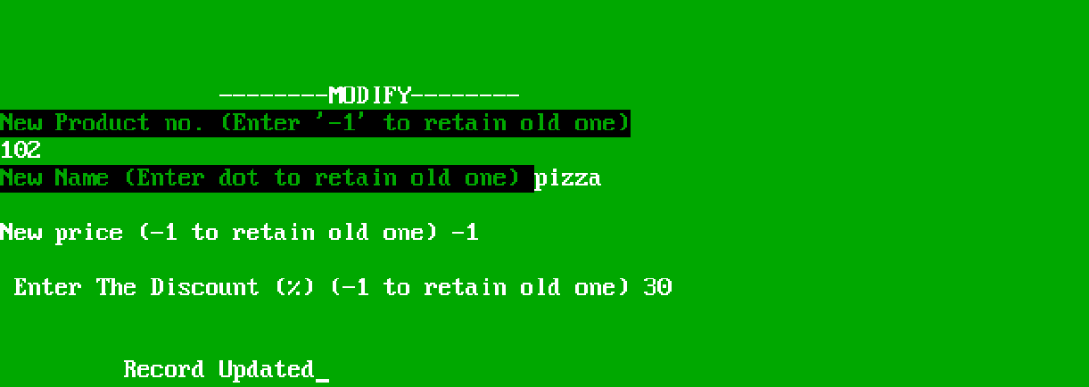

* 1. DELETING THE PRODUCT

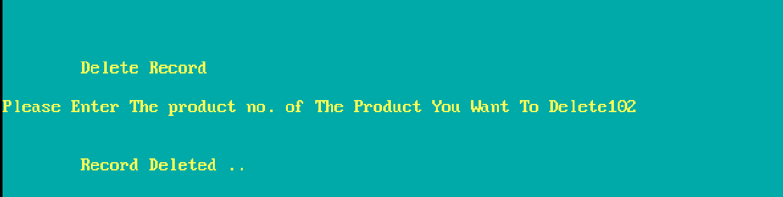

* 1. VIEWING PRODUCT MENU

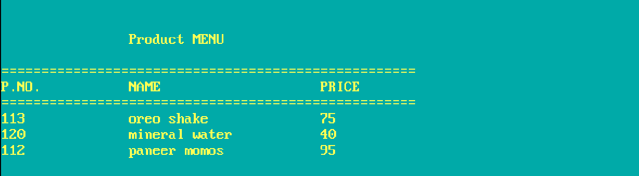

* 1. USING USER MENU

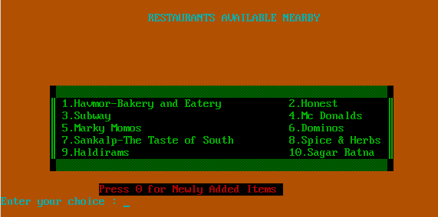

* 1. ORDERING FROM ANY RESTAURANT

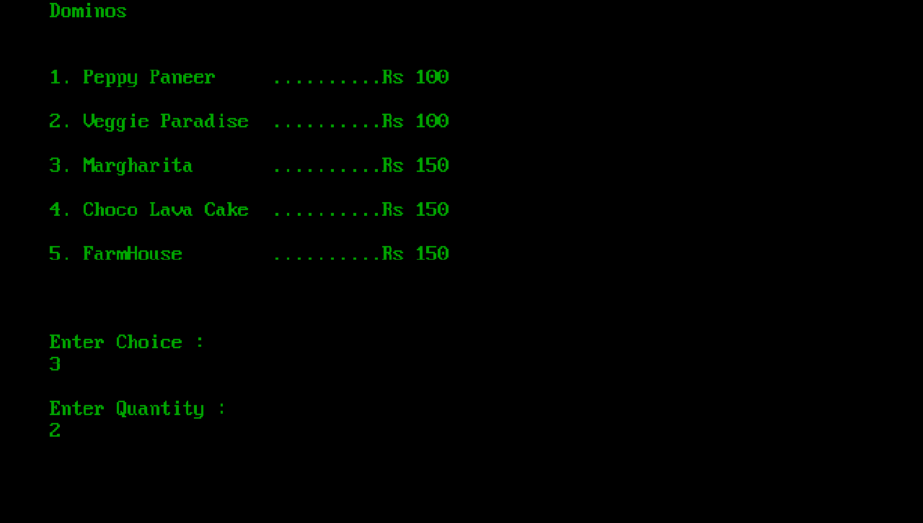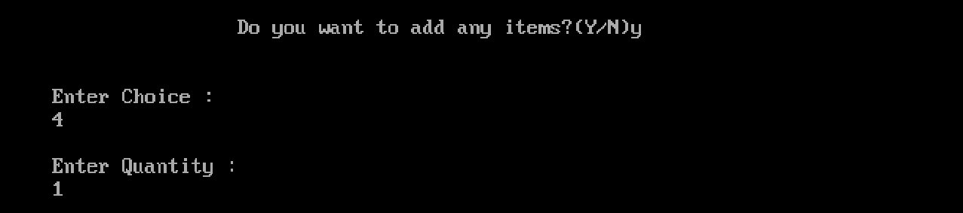

* 1. INVOICE

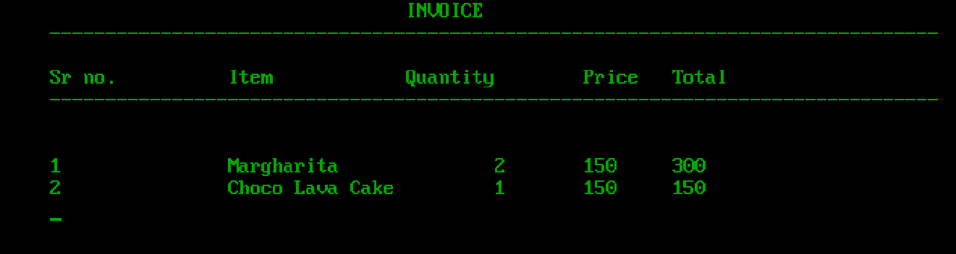

* 1. ORDERING FROM NEWLY ADDED ITEMS

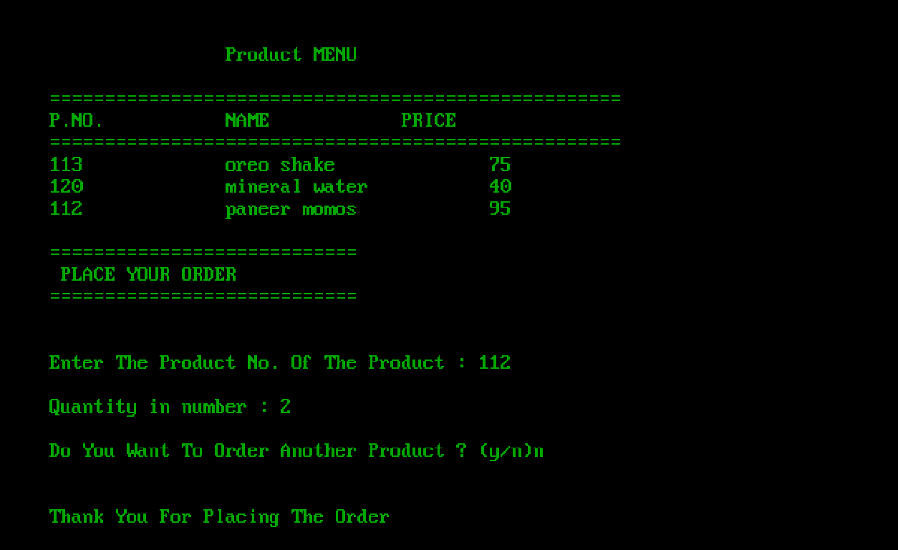

* 1. INVOICE FOR NEWLY ADDED ITEMS

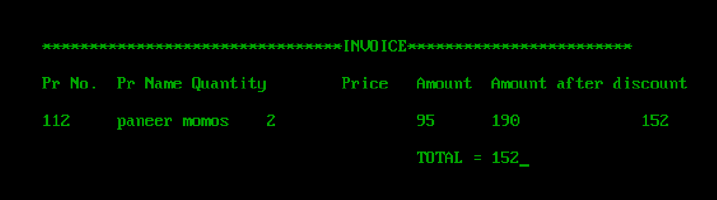

* 1. EXITING THE PROGRAM

