GDD of

Goblin Loon Who Stole the Royal Pantaloons

*Developer(s) Team [max 3]: Monika Baumgarten s31976, Anna Makowska s30729*

## Story background

You’re a small goblin with a big task of escaping from jail for stealing the King’s pantaloons. In this fantasy world the guards are dimwitted and clunky, making it easier to steal those pantaloons again from the evidence room and escape the castle with your loot.

## Brief description of the multimedia application

A lighthearted fantasy game inspired by Turnip Boy series, based on sneaking and fleeing.

* Stealth Game
* Adventure Game
* Comedy

## Art style and orientation

Description of the visual aesthetics, including inspirations, color schemes, graphical fidelity (realistic, stylized, pixel art, etc.), and mood/tone of the multimedia application.

* cartoony,
* fantasy,
* inspired by “Turnip Boy” series and “Cuphead”, “Dragon’s Lair” as in Simplified, Cartoony and full of personality.
* vivid colors, heavy black outlines

Orientation details such as 2D vs. 3D, top-down, side-scrolling, isometric, or first/third-person perspective.

* 2D,
* topdown,
* sidescrolling,
* third-person perspective

## Core gameplay loop

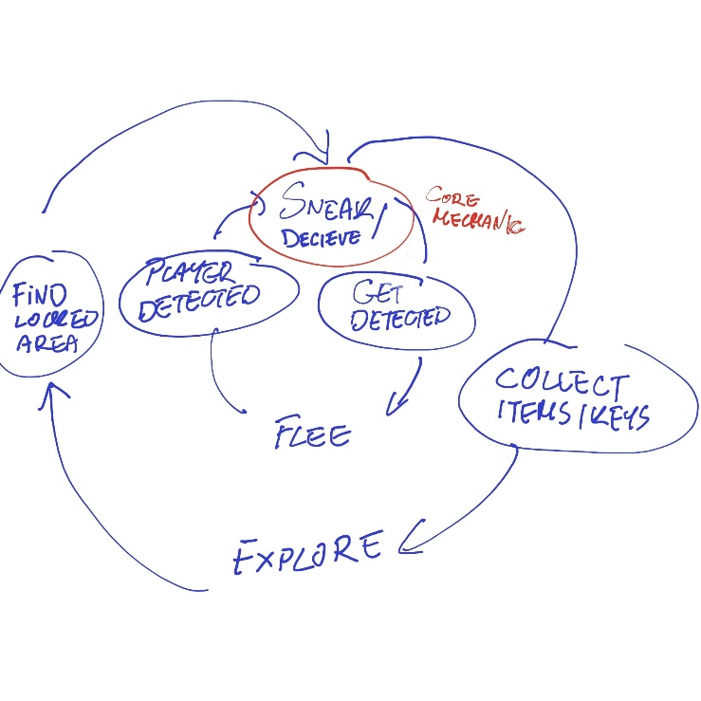

## Technologies used and why

* Unreal – preferably only
* Visual Scripting – because we suck at programming
* C++ if we need to create a custom script
* Procreate / Photoshop for sprites & maps

## Main functionalities

* Movement (WSAD)
* Sneaking (Ctrl – sneak is held until Ctrl clicked again)
* Fleeing
* Exploration – one map
* Collecting Objects to Progress, (E to collect F to use item)
* Player Detection System
* Distractions – player can use certain objects to distract the guards

## Other Functionalities

* Disguises
* Inventory
* Achievements
* Saving Room

## Graphical interfaces (GUI and menu prototype)

* Main Menu

1. Play
2. Continue/Load (Save Files)
3. Authors Button
4. Collectibles found (shows all found items)

* HUD

1. Inventory (9 slots on the bottom of the screen bound to buttons 1-9 on the keyboard to cycle through items in inventory – think Minecraft hotbar), object that is chosen is held by the character.
2. Player Detection Status: Hidden, Suspicion, Detected (upper left of the screen)

* Game Over Screen

1. Load last save
2. Main menu
3. Exit

* Success Screen/ Victory Screen

## List of assets

Comprehensive inventory of 3D models, textures, sounds, animations, and UI elements.