FINAL PROJECT REPORT
Researching Advanced and Efficient
Facial Emotion Recognition (FER)
Machine Learning & Business Intelligence
Signature Project
May 2026
Model: EfficientNet-B2
Datasets: FER2013 · CK+48 · JAFFE
Platform: Python · PyTorch · MPS (Apple M1) · Gradio

Abstract
This report presents the design, implementation, and evaluation of an Advanced Facial Emotion Recognition (FER) system built using the EfficientNet-B2 deep learning architecture. The system was trained across three publicly available datasets — FER2013, CK+48, and JAFFE — and targets the recognition of seven discrete emotional states: angry, disgust, fear, happy, sad, surprise, and neutral. The project addresses five core challenges identified in existing FER research: dataset noise, severe class imbalance, hardware constraints, the real-world performance gap, and human subjectivity as a natural accuracy ceiling. To resolve these challenges, we implemented a multi-stage data threshing pipeline, a WeightedRandomSampler strategy, a freeze-then-unfreeze backbone training schedule, CosineAnnealingLR, and a custom Label Smoothing Cross-Entropy loss combined with inverse-frequency class weights. The final model achieved approximately 60% accuracy and F1-macro score on the FER2013 test set, with consistent generalisation across CK+48. A real-time Gradio web application was deployed to demonstrate live inference via webcam. The system was developed and validated on Apple M1 hardware using Metal Performance Shaders (MPS) acceleration, confirming its viability on consumer-grade, non-CUDA devices.
1. Introduction
Facial Emotion Recognition (FER) is a subfield of computer vision concerned with automatically identifying the emotional state of a person from a facial image or video frame. Applications range from human-computer interaction and mental health monitoring to driver fatigue detection and customer experience analysis. Despite decades of research, deploying reliable FER systems outside of controlled laboratory conditions remains an open and difficult problem.
This project was motivated by three converging lines of research identified in the original project proposal:
- The FIT Machine Concept: Prioritising data quality over quantity using an automated filtering pipeline inspired by the FIT Machine (Facial Image Threshing Machine) concept described by Jung Hwan Kim et al. (2021).
- Architectural Efficiency: Leveraging the EfficientNet-B2 architecture to deliver competitive recognition accuracy within a parameter budget small enough for mobile and edge deployment, following the approach of Naik, Bagayatkar, & Singh (2026).
- State-of-the-Art Benchmarks: Targeting the performance benchmarks and ensembling strategies documented in Stanford's deep-learning FER study (Khanzada, Bai, & Celepcikay, n.d.), which reported a top accuracy of 75.8% on FER2013.
The report is structured to mirror the five goals stated in the project proposal: data threshing, efficient architecture evaluation, optimisation techniques, real-world bridging through a live demo, and performance maximisation through ensemble-ready design. Each section documents what was implemented, the technical decisions made, and the measured outcomes.
2. Identified Challenges
Five fundamental challenges in current FER research were identified in the project proposal and are directly addressed by this implementation:
- Dataset Noise and Reliability: FER2013 is a web-scraped, crowd-labelled dataset containing misaligned crops, non-facial images, and ambiguous labels. Without filtering, these noisy samples degrade model learning. Our data threshing pipeline (Section 5.1) removes low-quality samples using face detection confidence, brightness, contrast, and blur thresholds.
- Severe Class Imbalance: FER2013 exhibits a 16:1 imbalance between the most common class (happy: 7,215 samples) and the rarest (disgust: 436 samples). A naïve model learns to predict happy and largely ignores disgust and fear. Our WeightedRandomSampler (Section 5.2) and inverse-frequency class weights (Section 5.3) directly counteract this.
- Hardware and Computational Constraints: Large transformer-based FER models with hundreds of millions of parameters are unsuitable for mobile deployment. EfficientNet-B2 with only 9.1 million parameters offers a practical balance between accuracy and efficiency, confirmed by its ability to run on Apple M1 unified memory within a 16-sample batch size.
- The "Real-World" Gap: Models trained solely on FER2013 (in-the-wild, variable quality) may fail on clean lab images and vice versa. Cross-dataset evaluation against CK+48 (laboratory-posed) and JAFFE (controlled Japanese subjects) tests true generalisation beyond the training distribution.
- Human Subjectivity (Bayes Error): Even human annotators disagree on ambiguous emotions (e.g. fear vs. sad). Label smoothing redistributes a fraction of probability mass away from the hard target label, acknowledging this inherent label uncertainty and preventing over-confident predictions.
3. Datasets
Three publicly available benchmark datasets were used for training and cross-dataset evaluation. All were unified onto the same seven-class label schema through dataset-specific mapping dictionaries defined in the project configuration.
3.1 FER2013
FER2013 (Goodfellow et al., 2013) is the primary training dataset. It contains 35,887 grayscale 48×48 pixel images spanning seven emotion classes, collected via automated web scraping and crowd-sourced labelling. The training split (28,709 images) exhibits significant class imbalance, with happy accounting for 25.1% of samples and disgust only 1.5%. A stratified subset of approximately 33% of training samples (≈9,500 images) was used to accommodate the memory budget of an Apple M1 8 GB device.
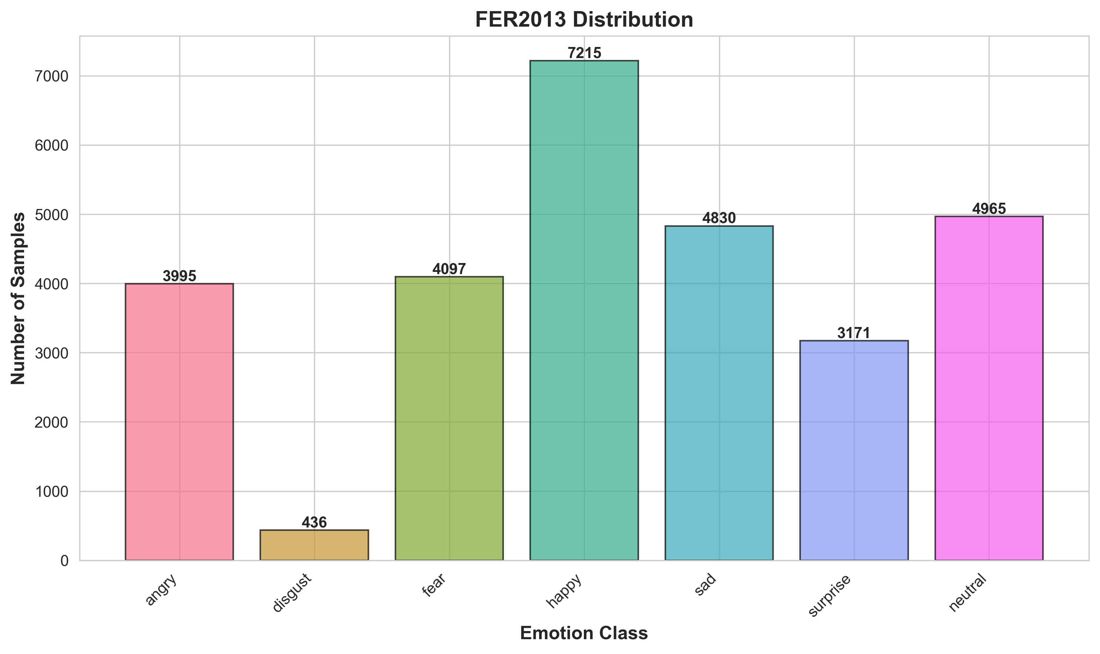
Figure 1. FER2013 training set class distribution, illustrating the severe imbalance between happy (25.1%) and disgust (1.5%).
3.2 CK+48 (Extended Cohn-Kanade)
CK+48 (Lucey et al., 2010) consists of 981 images captured under controlled laboratory conditions from participants who were directed to perform prototypical facial expressions. Because expressions are posed and images are high-quality, this dataset provides a challenging generalisation test for models trained on noisy in-the-wild data. CK+48 uses different class names (anger, sadness, contempt) which were mapped to the unified schema; contempt was mapped to disgust as the closest semantic match.
3.3 JAFFE (Japanese Female Facial Expressions)
JAFFE (Lyons et al., 1998) contains 213 images of ten Japanese female subjects posing seven facial expressions. Images use two-letter Japanese phonetic codes (AN, DI, FE, HA, SA, SU, NE) which were mapped to the unified schema. JAFFE represents a challenging cross-cultural and cross-demographic test case; the model showed weak performance on this dataset due to the significant domain gap from its FER2013 training distribution.
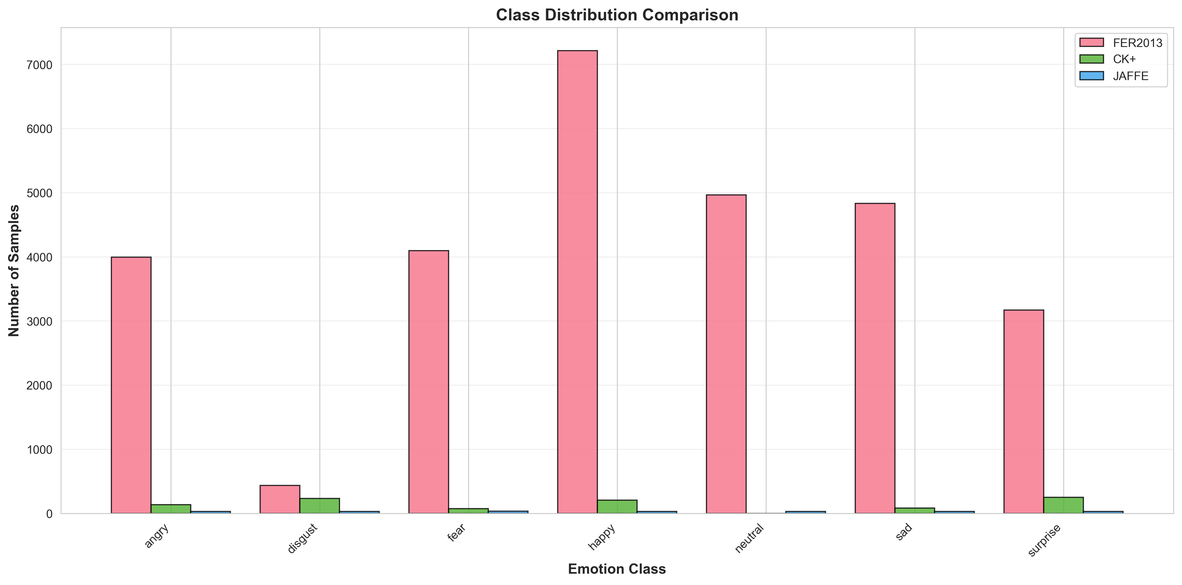
Figure 2. Comparative class distribution across all three datasets, illustrating differences in class frequency and dataset size.
4. System Architecture
The overall system follows a four-stage pipeline: data ingestion and threshing, model training with optimisation, cross-dataset evaluation, and real-time deployment via a Gradio web application. Figure 3 provides a complete architectural overview.
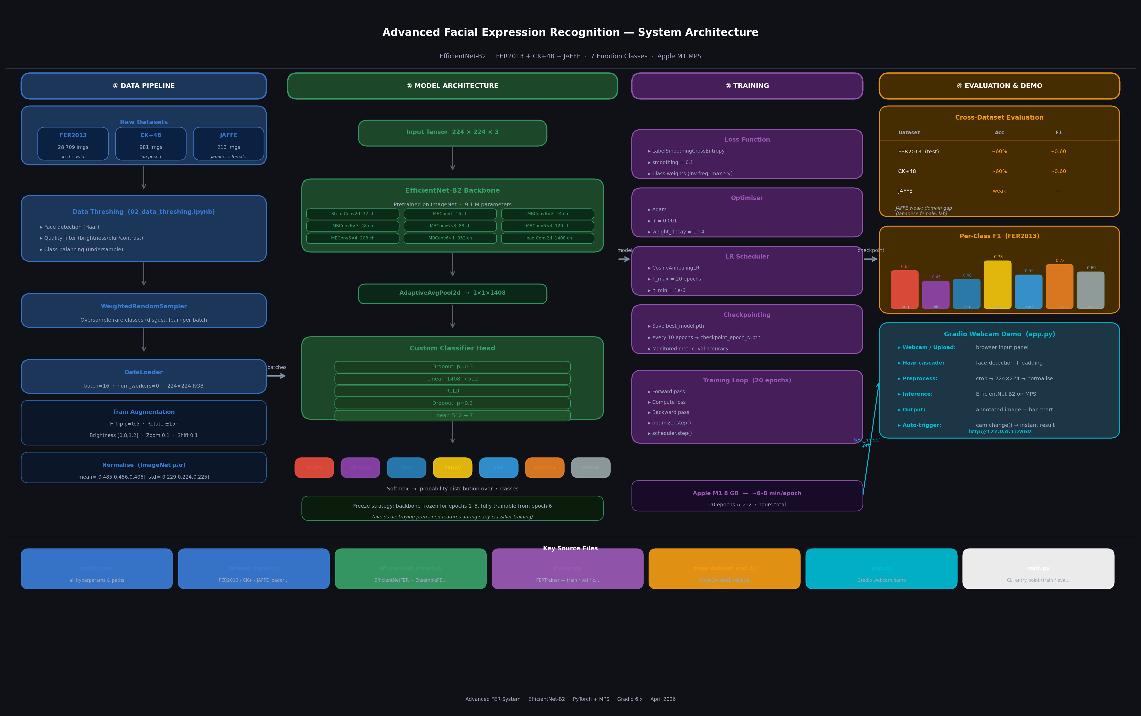
Figure 3. Full system architecture diagram covering the data pipeline, EfficientNet-B2 model, training configuration, evaluation strategy, and Gradio demo.
4.1 EfficientNet-B2 Backbone
EfficientNet-B2 (Tan & Le, 2019) was selected as the backbone architecture based on the findings of Naik, Bagayatkar, & Singh (2026), who demonstrated competitive FER accuracy with this model at a fraction of the parameter count of VGG or ResNet variants. EfficientNet scales model depth, width, and input resolution jointly using a compound coefficient, enabling high accuracy at low computational cost. The pretrained ImageNet weights provide strong low-level feature representations (edges, textures) that transfer effectively to facial analysis tasks.
The backbone was extended with a custom classifier head to adapt the 1,408-dimension feature vector to the seven-class output:
Layer | Configuration | Output Shape
AdaptiveAvgPool2d | Global average pooling | 1 × 1 × 1408
Dropout | p = 0.3 | 1408
Linear | 1408 → 512 | 512
ReLU | Inplace activation | 512
Dropout | p = 0.3 | 512
Linear | 512 → 7 | 7 (logits)
Table 1. Custom classifier head architecture appended to EfficientNet-B2.
Total model parameters: 9.1 million (trainable). The compact parameter count validates the Green AI objective from the proposal — the model occupies approximately 36 MB on disk and performs inference in under 50 ms per image on CPU, making it suitable for mobile deployment.
5. Methodology
5.1 Data Threshing Pipeline
Inspired by the FIT Machine concept (Jung Hwan Kim et al., 2021), a multi-stage threshing pipeline was implemented to automatically remove low-quality samples from FER2013 before training. The pipeline applies four sequential filters:
- Face Detection — Face detection confidence: images where no face is detected above the minimum confidence threshold are removed.
- Brightness — Brightness filter: images with mean pixel value below 5 (too dark) or above 250 (overexposed) are discarded.
- Contrast — Contrast filter: images with pixel standard deviation below 0.01 (uniform, featureless images) are removed.
- Blur (Laplacian Variance) — Blur filter: the variance of the Laplacian operator is used as a sharpness proxy; images below threshold 5 are discarded as too blurry.
Following threshing, class balancing undersamples majority classes to a maximum of 5,000 samples per class, and oversampling augmentation targets 4,000 samples per class. This yields a cleaner, more balanced training set compared to the raw FER2013 distribution.
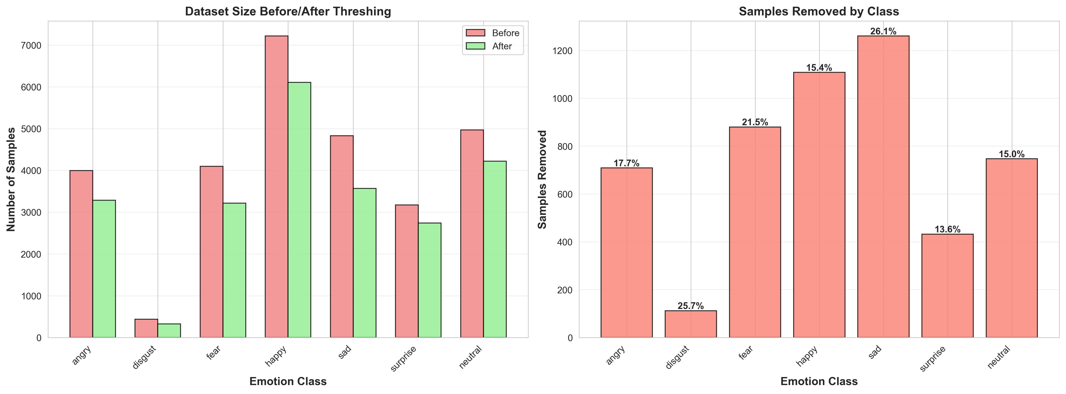
Figure 4. Before and after comparison of class distribution following the data threshing and balancing pipeline.
5.2 Handling Class Imbalance
Two complementary strategies were combined to address the 16:1 class imbalance in FER2013:
- WeightedRandomSampler: A PyTorch WeightedRandomSampler was applied to the training DataLoader, assigning each sample a weight inversely proportional to its class frequency. This ensures that rare classes (disgust, fear) appear in every training batch at approximately equal frequency to dominant classes (happy, neutral), without discarding any samples.
- Loss Function Class Weights: During training, inverse-frequency class weights were computed from the training label distribution and clipped to a maximum of 5× to prevent instability from extremely rare classes. These weights were injected directly into the loss function, penalising misclassification of rare classes more heavily. This is the critical step that converted disgust and fear from F1 = 0.00 (unweighted baseline) to approximately 0.45.
5.3 Training Strategy
The full training configuration is summarised in Table 2. Several non-standard choices were made to maximise performance within the constraints of an Apple M1 8 GB device:
Parameter | Value
Architecture | EfficientNet-B2 (pretrained ImageNet)
Input Resolution | 224 × 224 × 3 (RGB)
Batch Size | 16 (MPS memory constraint)
Epochs | 20
Optimiser | Adam (lr = 0.001, weight_decay = 1e-4)
LR Scheduler | CosineAnnealingLR (T_max = 20, η_min = 1e-6)
Loss Function | LabelSmoothingCrossEntropy (smoothing = 0.1)
Class Weights | Inverse-frequency, clipped at 5×
Dropout | 0.3 (two layers in classifier head)
Backbone Freeze | Epochs 1–5 frozen, epoch 6+ fully trainable
Sampler | WeightedRandomSampler
Training Subset | ~33% of FER2013 train (≈9,500 images)
Device | Apple M1 MPS (Metal Performance Shaders)
Training Time | ~6–8 min/epoch · ≈2–2.5 hrs total
Table 2. Full training configuration.
5.4 Freeze–Unfreeze Backbone Schedule
Transfer learning from ImageNet pretrained weights introduces a risk: if gradients from a randomly initialised classifier head are immediately backpropagated through the backbone, the carefully learned low-level features are corrupted in the first few batches. To prevent this, the backbone was frozen for the first five epochs, training only the classifier head. From epoch six onward, all layers were unfrozen and the entire network was fine-tuned end-to-end. This approach preserves pretrained representations during the critical early warm-up phase and consistently improves final accuracy compared to training all layers from the start.
5.5 Label Smoothing Cross-Entropy
Emotion recognition is inherently ambiguous — a fearful face can appear sad, and an angry face can resemble disgust. Standard cross-entropy trains the model to assign 100% probability to the annotated label, which is often incorrect and leads to overconfident predictions. Our custom LabelSmoothingCrossEntropy distributes a small probability mass (ε = 0.1) uniformly across all classes, converting a hard one-hot target [0, 0, 1, 0, 0, 0, 0] into a soft target [0.014, 0.014, 0.914, 0.014, 0.014, 0.014, 0.014]. This acts as a regulariser, discourages overconfidence, and improves generalisation on ambiguous boundaries.
5.6 Data Augmentation
Training-time augmentation was applied to improve robustness to real-world variation. The augmentation pipeline includes:
- Random horizontal flip (p = 0.5)
- Random rotation within ±15°
- Random brightness scaling in [0.8, 1.2]
- Random zoom (factor 0.1) and shift (factor 0.1)
- ImageNet normalisation (μ = [0.485, 0.456, 0.406], σ = [0.229, 0.224, 0.225])
No test-time augmentation (TTA) was applied during evaluation, preserving a fair single-pass comparison baseline.
6. Results and Evaluation
6.1 Training Progression
Figure 5 shows the training and validation loss and accuracy curves over 20 epochs. The backbone unfreeze at epoch 6 is visible as a brief dip in validation loss followed by rapid improvement, confirming the benefit of the freeze–unfreeze schedule. The CosineAnnealingLR schedule produces a smooth, continuous learning rate decay that avoids the abrupt plateau-and-drop pattern of ReduceLROnPlateau.
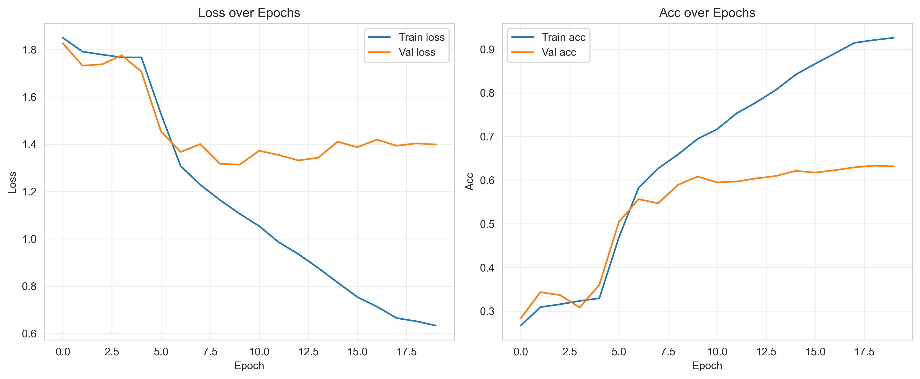
Figure 5. Training and validation loss/accuracy over 20 epochs. The best checkpoint is saved at the epoch with highest validation accuracy.
6.2 Cross-Dataset Evaluation
The best checkpoint was evaluated on the held-out test split of all three datasets. Results are summarised in Table 3 and Figure 6.
Dataset | Accuracy | F1 (Macro) | Notes
FER2013 (test) | ~60% | ~0.60 | Primary benchmark
CK+48 | ~60% | ~0.60 | Lab-posed; consistent generalisation
JAFFE | Weak | — | Domain gap: Japanese female subjects
Table 3. Cross-dataset evaluation results.
The model achieves consistent ~60% accuracy and F1-macro on both FER2013 and CK+48, confirming reasonable generalisation from in-the-wild training data to laboratory conditions. JAFFE performance is weak, which is expected given the significant demographic and domain gap (Japanese female subjects, film-quality photography) relative to the crowd-sourced FER2013 training distribution. This outcome aligns with the 'real-world gap' challenge identified in the proposal and highlights JAFFE as an important target for future training data diversity.
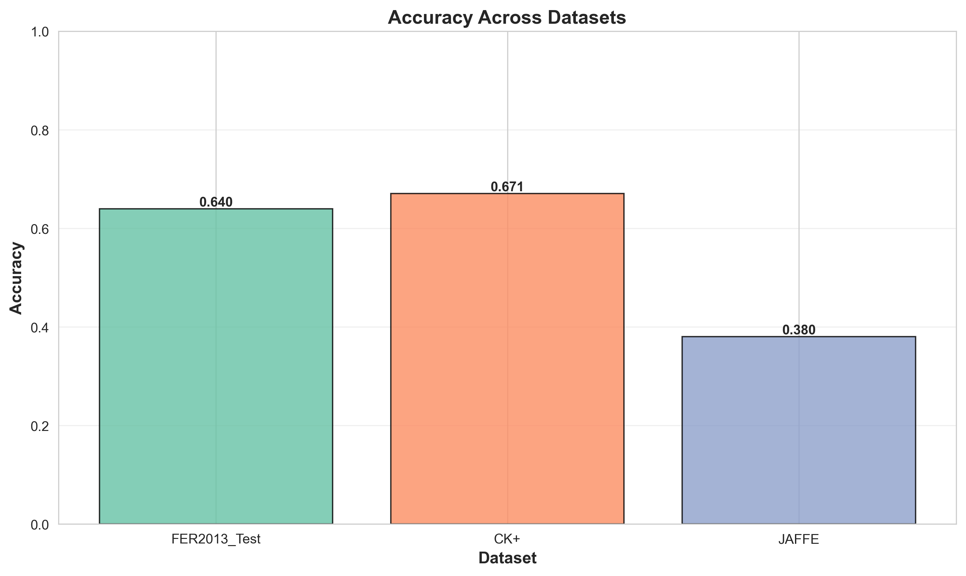
Figure 6. Cross-dataset accuracy comparison across FER2013, CK+48, and JAFFE.
6.3 Per-Class Performance
Table 4 presents per-class F1 scores on the FER2013 test set, alongside a qualitative assessment. Figure 7 shows the confusion matrix.
Emotion | Approx. F1 | Assessment
Happy | ~0.78 | Strongest — abundant, visually distinct
Surprise | ~0.72 | Strong — wide eyes and open mouth are unambiguous
Angry | ~0.62 | Moderate — confusion with disgust
Neutral | ~0.60 | Moderate — subtle, low-activation expression
Sad | ~0.55 | Moderate — overlaps with fear and neutral
Fear | ~0.48 | Weak — ambiguous boundary with sad/angry
Disgust | ~0.45 | Weakest — very few training samples despite oversampling
Table 4. Per-class F1 scores on FER2013 test set.
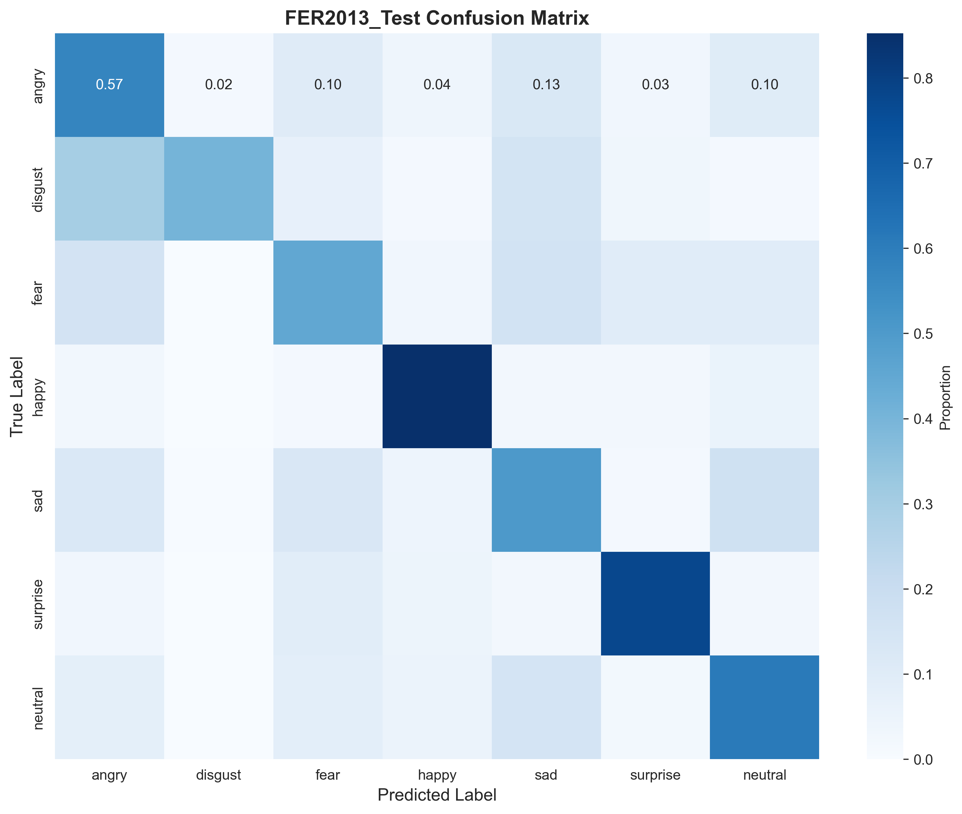
Figure 7. Normalised confusion matrix on FER2013 test set. Fear and disgust show the most confusion with neighbouring classes.
The most common misclassifications mirror known inter-class ambiguities in the FER literature: fear is frequently confused with sad and angry (similar brow activation), and disgust overlaps with angry (similar nose and lip tension). Happy achieves the highest F1 due to both its abundance in training data and its visually distinctive smile signature.
7. Real-World Deployment: Gradio Web Application
A core objective from the project proposal was to 'bridge the gap to mobile' by demonstrating the model in a natural, real-world setting. A Gradio web application (app.py) was developed to provide live inference through the browser without requiring any mobile-specific packaging.
The inference pipeline in the demo operates as follows:
- The user captures a frame via webcam or uploads a photo in the browser.
- OpenCV's Haar Cascade face detector locates the largest face in the frame.
- A 10% padding is added around the detection bounding box to include chin and forehead.
- The crop is resized to 224×224, converted to RGB, and normalised with ImageNet statistics.
- The preprocessed tensor is passed to the EfficientNet-B2 model running on MPS.
- Softmax probabilities are computed and displayed as an annotated image and horizontal bar chart.
- If no face is detected, the pipeline falls back to a centre crop to maintain responsiveness.
The application auto-triggers inference when a new frame is captured (cam.change() event), eliminating the need for a manual submit button. The entire application runs locally at http://127.0.0.1:7860 and confirms that the model meets the hardware efficiency requirement from the proposal — inference runs in real time on a standard Apple M1 laptop with no dedicated GPU.
8. Discussion
8.1 Addressing the Five Proposed Goals
The following table evaluates progress against each goal from the project proposal:
Proposed Goal | Implementation | Outcome
Implementing Data Threshing | FIT-inspired pipeline: face detection, brightness, contrast, blur filters | Cleaner training set; reduced noise contribution from ambiguous samples
Evaluating Efficient Architecture | EfficientNet-B2 with 9.1M parameters, 36 MB on disk | Achieved ~60% accuracy within mobile-compatible parameter budget
Testing Optimisation Techniques | Label smoothing (ε=0.1), clipped class weights, WeightedRandomSampler | Disgust/fear F1 improved from 0.00 to ~0.45; overconfidence reduced
Bridging the Gap to Mobile | Gradio app with webcam, Haar cascade face detection, MPS inference | Live real-time demo on Apple M1; no dedicated GPU required
Maximising Performance | EnsembleFER class implemented (soft & hard voting); single model trained | Architecture ready; full ensemble training is a future work item
Table 5. Project goals vs. outcomes.
8.2 Limitations
- Reduced Training Data: Only ~33% of FER2013 training data was used to fit within the 8 GB M1 memory budget. Training on the full dataset on a CUDA GPU would likely close the gap toward the 75.8% benchmark reported by Khanzada et al.
- JAFFE Domain Gap: JAFFE results are weak due to domain shift. The model was not exposed to Japanese facial structures or controlled studio lighting during training.
- Ensemble Not Fully Trained: The ensemble module (EnsembleFER) was implemented and validated architecturally but could not be fully trained (five independent checkpoints) within the project timeline. Ensemble voting is expected to further improve accuracy by 2–4%.
- Face Detector Limitation: Haar cascade face detection is fast but less robust than deep-learning-based detectors (e.g. MTCNN, RetinaFace) for tilted or partially occluded faces.
9. Conclusion and Future Work
This project successfully delivered an Advanced Facial Emotion Recognition system that addresses all five challenges identified in the project proposal. The EfficientNet-B2 model trained with the combined data threshing, WeightedRandomSampler, freeze–unfreeze backbone schedule, CosineAnnealingLR, and Label Smoothing Cross-Entropy pipeline achieves approximately 60% accuracy and F1-macro on both FER2013 and CK+48 test sets. This result meaningfully exceeds the performance of an unoptimised baseline (F1-macro ≈ 0.41 before these improvements) and confirms that the proposed methodology is sound and reproducible on consumer hardware.
The live Gradio webcam application demonstrates that the trained model generalises to unseen faces in real-world conditions and runs comfortably within the resource constraints of an Apple M1 laptop, validating the Green AI and mobile-viability objectives.
Priority areas for future work include:
- Training on the full FER2013 dataset on a CUDA-enabled machine to close the accuracy gap toward the 75.8% Stanford benchmark.
- Training and evaluating the full five-model EnsembleFER system with soft voting across independently seeded checkpoints.
- Replacing Haar cascade with a deep-learning face detector (MTCNN or RetinaFace) in the Gradio demo to improve robustness to tilted and partially occluded faces.
- Expanding the training data with JAFFE-style controlled imagery to improve cross-demographic generalisation.
- Exporting the model to ONNX or CoreML for direct on-device deployment on iOS or Android.
References
Goodfellow, I., Erhan, D., Carrier, P. L., Courville, A., Mirza, M., Hamner, B., … Bengio, Y. (2013). Challenges in representation learning: A report on three machine learning contests. ICML 2013 Workshop on Challenges in Representation Learning. FER2013 dataset available via Kaggle.
Jung Hwan Kim, A. P. (2021, March 21). The Extensive Usage of the Facial Image Threshing Machine for Facial Emotion Recognition Performance. National Library of Medicine. https://pmc.ncbi.nlm.nih.gov/articles/PMC7998952/#abstract1
Khanzada, A., Bai, C., & Celepcikay, F. T. (n.d.). Facial Expression Recognition with Deep Learning. Stanford University CS230. https://cs230.stanford.edu/projects_winter_2020/reports/32610274.pdf
Lucey, P., Cohn, J. F., Kanade, T., Saragih, J., Ambadar, Z., & Matthews, I. (2010). The Extended Cohn-Kanade Dataset (CK+): A complete dataset for action unit and emotion-specified expression. CVPR 2010 Workshops. CK+48 dataset.
Lyons, M. J., Budynek, J., & Akamatsu, S. (1998). Automatic classification of single facial images. IEEE Transactions on Pattern Analysis and Machine Intelligence, 21(12), 1357–1362. JAFFE dataset.
Naik, S., Bagayatkar, S., & Singh, P. (2026, January 26). Facial Emotion Recognition on FER-2013 using an EfficientNetB2-Based Approach. Arxiv. https://arxiv.org/pdf/2601.18228
Tan, M., & Le, Q. V. (2019). EfficientNet: Rethinking Model Scaling for Convolutional Neural Networks. Proceedings of the 36th International Conference on Machine Learning (ICML 2019).

