Markdown Conversion Benchmark
Use this file to benchmark Markdown -> DOCX conversion fidelity.

1. Headings

Heading 1

Heading 2

Heading 3

Heading 4

Heading 5

Heading 6

2. Paragraph And Inline Styles
This paragraph includes bold, italic, bold+italic, inline code, and a link to example.com.
This line has an escaped asterisk: *not italic* and escaped backticks: `not code`.

3. Hard Line Breaks
Line one with two trailing spaces.
Line two after hard break.
Line one with a backslash hard break.
Line two after backslash break.

4. Blockquote
This is a blockquote.It spans multiple lines and includes inline formatting.

5. Lists

Unordered
Item A
Item B
Item C

Ordered
First
Second
Third

Nested (may be simplified depending on parser)
Parent 1
Child 1.1
Child 1.2
Parent 2

Task List
[ ] Open task
[x] Completed task

6. Code Blocks
echo "hello from fenced code"
for i in 1 2 3; do
echo "$i"
done
fn main() {
println!("hello rust");
}
Indented code block line 1
Indented code block line 2

7. Table
Left | Center | Right
a | b | c
10 | 20 | 30

8. Images

Local image
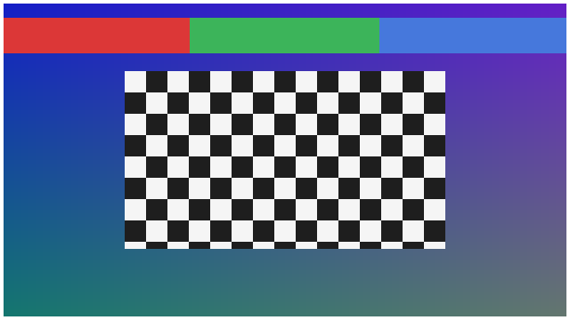

9. Horizontal Rule
---

10. Mixed Content
Paragraph before list.
Bullet with inline code
Bullet with link
Quote after list.
Final paragraph after quote.

11. Raw HTML (expected warning/fallback behavior)
<span style="color:red">Raw HTML span</span>

12. Footnote Syntax (parser support dependent)
Footnote reference[^1].
[^1]: Footnote text.

