1. In the below elements which of them are values or an expression? eg:- values can be integer or string and expressions will be mathematical operators.

**Answer: * is expression(mathematical operator), 'hello' is value(string), -87.8 is value(integer), - is expression(mathematical operator), / is expression(mathematical operator), + is expression(mathematical operator), 6 is value(interger)**

*

'hello'

-87.8

-

/

6

2. What is the difference between string and variable?

**Answer: A string is a value representing text. A variable is name that can refer to any value.**

3. Describe three different data types.

**Answer: Numeric (Integer, float, complex number) , Boolean , sequence type(string, list, tuple).**

4. What is an expression made up of? What do all expressions do?

**Answer: An expression is a combination of operators, constants and variables. An expression may consist of one or more operands, and zero or more operators to produce a value**

5. This assignment statements, like spam = 10. What is the difference between an expression and a statement?

**Answer: Expression is made of values, containers, and mathematical operators(operands)and the statement is just like a command that a python interpreter executes like print.**

6. After running the following code, what does the variable bacon contain?

**Answer :** 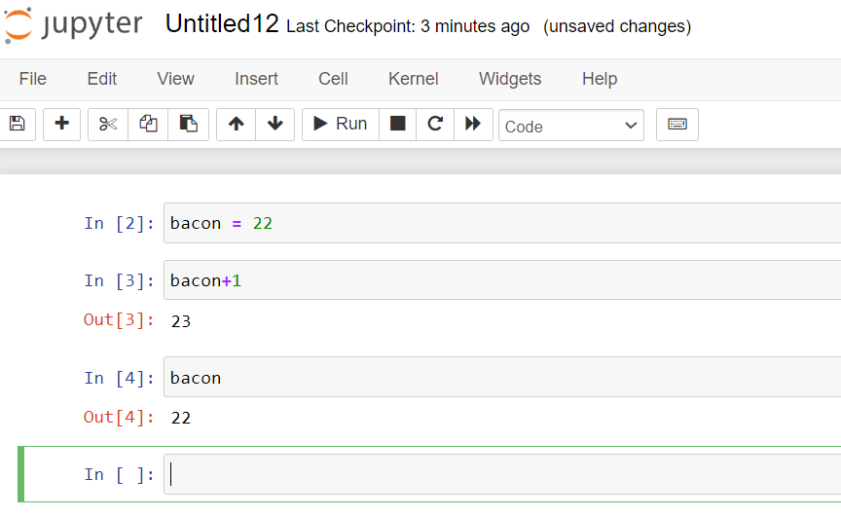

bacon = 22

bacon + 1

7. What should the values of the following two terms be?

**Answer:**

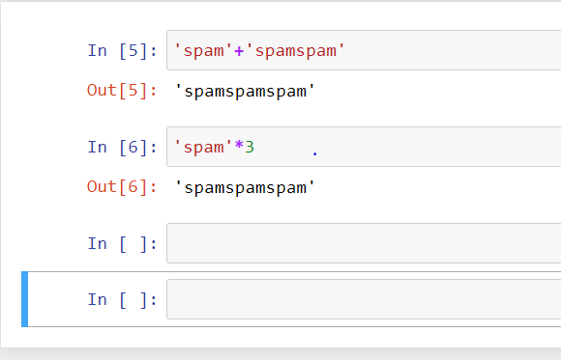

'spam' + 'spamspam'

'spam' * 3

8. Why is eggs a valid variable name while 100 is invalid?

**Answer: eggs is string it can be variable and 100 is integer, variable doesn’t start with integer. So 100 cannot be a variable.**

9. What three functions can be used to get the integer, floating-point number, or string version of a value?

**Answer: str (), int (), float ()**

10. Why does this expression cause an error? How can you fix it?

**Answer: 99 is integer we cannot add integer to string.**

'I have eaten ' + 99 + ' burritos.'