**MATLAB ASSIGNMENT**

**EXP - 6**

**(POWER METHOD)**

**Submitted by -**

**Name – Hemant Verma**

**Roll No. - 101906118**

**Batch - EC-5**

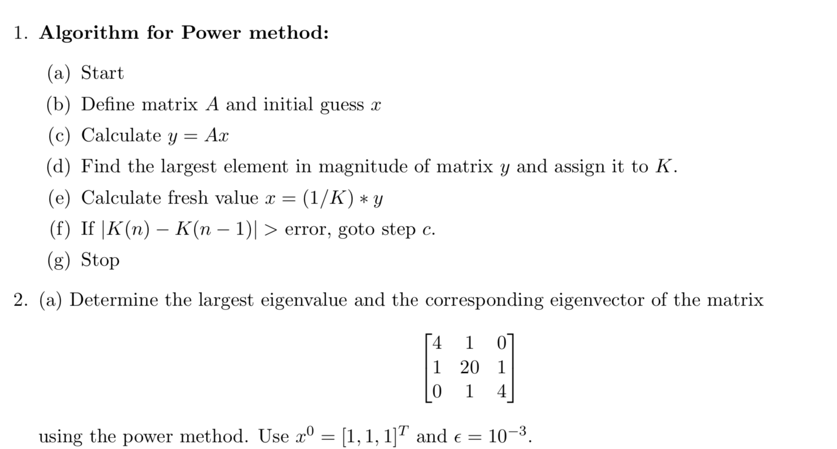

A=[4 1 0 ; 1 20 1 ; 0 1 4];

x0=[1;1;1];

y=A*x0;

k=max(y);

x1=y/k;

tol=0.001;

diff=abs(x0-x1);

while max(diff)>tol

x0=x1;

y=A*x0;

k=max(y);

x1=y/k;

diff=abs(x0-x1);

end

disp(x1);

disp(k);

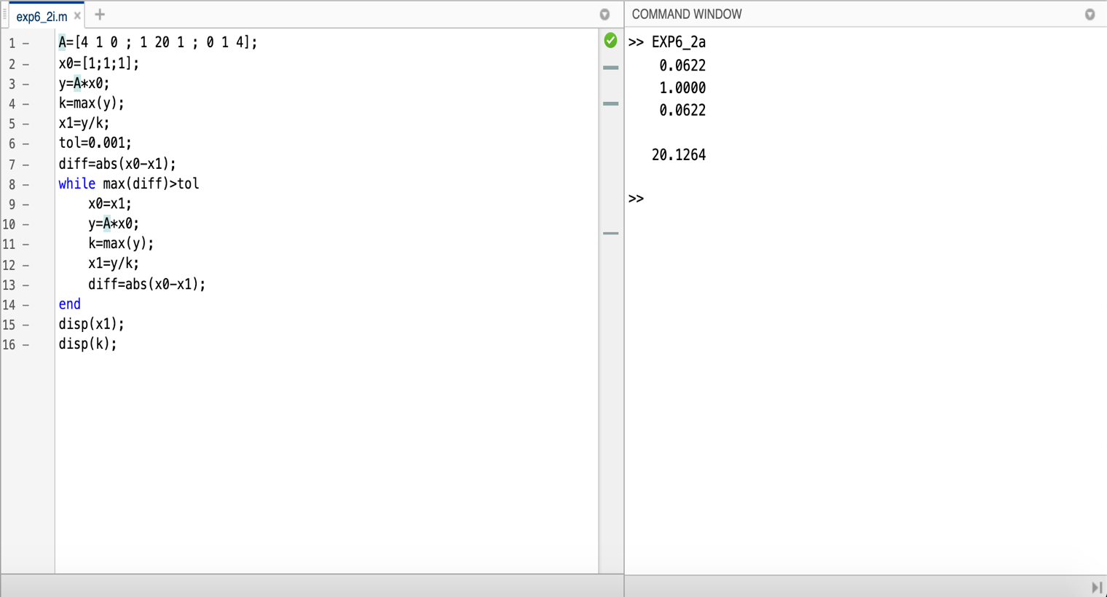

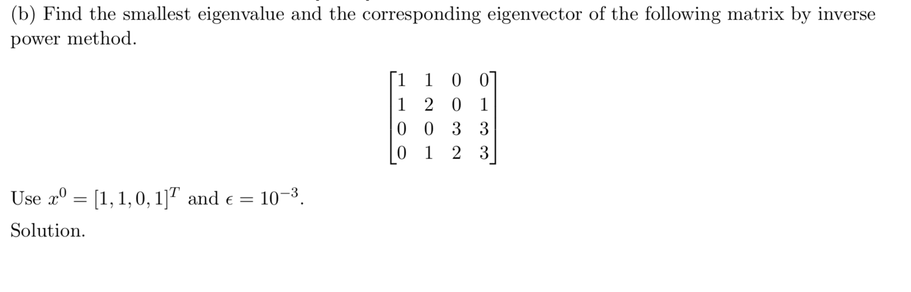

a= [1,1,0,0;1,2,0,1;0,0,3,3;0,1,2,3];

m=inv(a);

x0 = [1;1;0;1];

Y=m*x0;

k=max(Y);

x1=(Y/k);

tol=0.001;

while ((min(x1-x0))>tol)||(min(x0-x1)>tol)

x0=x1;

Y=m*x0;

k=max(Y);

x1=(Y/k);

end

disp(k);

disp(x1);

