**PIZZA SALES SQL QUERIES**

**A. KPI’s**

**1. Total Revenue:**

select round(sum(total_price),2) as Total_revenue from pizza_sales;

*output: -*

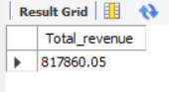

**2. Average Order Value**

select round(sum(total_price)/count(distinct order_id),2) as Average_value from pizza_sales;

*output: -*

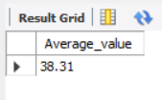

**3. Total Pizzas Sold**

select sum(quantity) as Total_Pizza_Sold from pizza_sales;

*output: -*

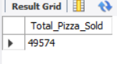

**4. Total Orders**

select count(distinct order_id) as Total_Orders from pizza_sales;

*output: -*

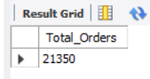

**5. Average Pizzas Per Order**

select round(sum(quantity) / count(distinct order_id),2) as Avg_pizzas_Per_Orders from pizza_sales;

*output: -*

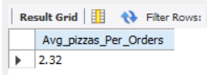

**B. Daily Trend for Total Orders**

select dayname(order_date) as order_day, count(distinct order_id) as Total_orders from pizza_sales

group by dayname(order_date);

*output: -*

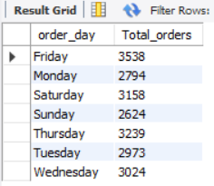

**C. Monthly Trend for Orders**

select monthname(order_date) as Month_name, count(distinct order_id) as Total_orders from pizza_sales

group by monthname(order_date)

order by Total_orders desc;

*output: -*

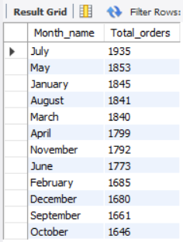

**D. % of Sales by Pizza Category**

select pizza_category,round(sum(total_price),1) as total_sales, round(sum(total_price) * 100 / (select sum(total_price) from pizza_sales /*where MONTH(order_date) = 1*/),2) as per_Total_sales

from pizza_sales

-- where MONTH(order_date) = 1

group by pizza_category;

**NOTE**: - We can see the Total_Sales and Per_of_Total_Sales for specific month by using where condition in subquery as well as main query

*output: -*

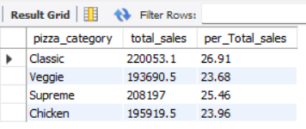

**E. % of Sales by Pizza Size**

select pizza_size, round(sum(total_price),2) as total_sales, round(sum(total_price) * 100 / (select sum(total_price) from pizza_sales ),2) as per_Total_sales

from pizza_sales

group by pizza_size

order by per_Total_sales desc;

*output: -*

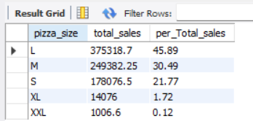

**F. Total Pizzas Sold by Pizza Category**

select pizza_category, sum(quantity) as total_pizza_sold , round(sum(total_price),2) as Total_revenue from pizza_sales

group by pizza_category;

*output: -*

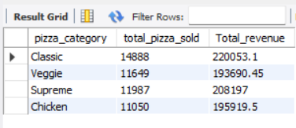

**G. Top 5 Pizzas by Revenue**

select pizza_name, sum(total_price) as Total_revenue from pizza_sales

group by pizza_name

order by Total_revenue desc limit 5;

*output: -*

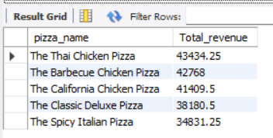

**H. Bottom 5 Pizzas by Revenue**

select pizza_name, sum(quantity) as Total_quantity from pizza_sales

group by pizza_name

order by Total_quantity limit 5;

*output: -*

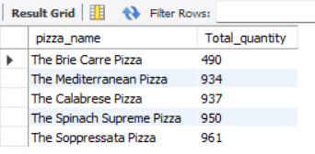

**I. Top 5 Pizzas by Quantity**

select pizza_name, SUM(quantity) as Total_Pizza_Sold

from pizza_sales

group by pizza_name

order by Total_Pizza_Sold desc limit 5;

*output: -*

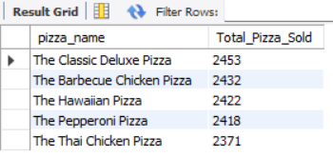

**J. Bottom 5 Pizzas by Quantity**

select pizza_name, SUM(quantity) as Total_Pizza_Sold

from pizza_sales

group by pizza_name

order by Total_Pizza_Sold asc limit 5;

*output: -*

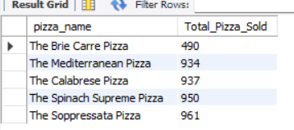

**K. Top 5 Pizzas by Total Orders**

select pizza_name, count(distinct order_id) AS Total_Orders

from pizza_sales

group by pizza_name

order by Total_Orders DESC limit 5;

*output: -*

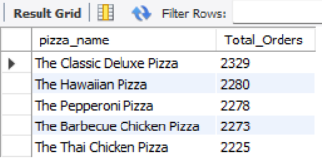

**L. Bottom 5 Pizzas by Total Orders**

select pizza_name, count(distinct order_id) AS Total_Orders

from pizza_sales

group by pizza_name

order by Total_Orders limit 5;

*output: -*

