Department of Computer Science and Engineering (Data Science)

S.Y.B.Tech. Sem: IV
Subject: Computational Methods and Pricing Models Laboratory
Experiment 5

Date: | Experiment Title: Basic and Advanced Option Strategies with Payoff Profiles.
Aim | To study, analyse, and visualize single-leg and multi-leg option strategies.
Software | Python on Google Colab
Theory | Concept of Option Strategies  An option strategy is a combination of option positions taken to achieve a specific risk–return objective based on the trader’s expectations about the market.  - Option strategies are broadly classified into:  - Single-Leg Strategies  - Multi-Leg Strategies  Single-Leg Option Strategies  Single-leg strategies involve taking a position in only one option contract (either a call or a put).  Examples include:  - Long Call  - Long Put  - Short Call  - Short Put  Key Characteristics  - Simple to understand and execute.  - Used for directional trading (bullish or bearish expectations).  - Risk and return are clearly defined.  II. Multi-Leg Option Strategies  Multi-leg strategies involve combining two or more option positions simultaneously.  Examples include:  - Covered Call  - Bull Call Spread  - Bear Put Spread  - Straddle  - Strangle  - Butterfly Spread  Key Characteristics  - Involves multiple option contracts.  - Designed to manage risk and control profit potential.  - Used for specific market conditions such as bullish, bearish, or volatile markets.  Payoff and Profit Analysis  Payoff refers to the value of an option strategy at expiration.  Profit/Loss is calculated as:  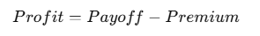
Implementation | Procedure:  - Select an underlying asset and note the current market price.  - Choose appropriate strike prices and option premiums.  - Calculate payoff values for different possible market prices at expiry.  - Compute profit/loss for each price level.  - Plot payoff diagrams using Excel / Python / graph sheet.  - Compare payoff structures for different strategies  You are tasked with evaluating and analyzing the following option strategies:  Strategies to be Analyzed  Basic (Single-Leg and Simple Multi-Leg Strategies)  - Long Call  Buy a call option with a strike price of $50.  - Long Put  Buy a put option with a strike price of $50.  Advanced Option Strategies  - Covered Call  Buy 100 shares of the stock at $50 and sell a call option with a strike price of $60.  4. Bull Call Spread  Buy a call option with a strike price of $50 and sell a call option with a strike price of $60.  5. Bear Put Spread  Buy a put option with a strike price of $60 and sell a put option with a strike price of $50.  6. Long Straddle  Buy both a call option and a put option with the same strike price of $50.  7. Long Strangle  Buy a put option with a strike price of $45 and a call option with a strike price of $55.  Market Conditions  Assume the following market parameters:  - Current Stock Price: $50  - Stock Price Range at Expiry: $40 to $80  - Cost of Call Option Premium: $5  - Cost of Put Option Premium: $5  - Risk-Free Interest Rate: 2% per annum  - Volatility: 20% per annum  - Time to Expiration: 30 days (0.0833 years)  Task 1: Plot the payoff profiles for all the strategies.  Use the formula:  1. Long call:  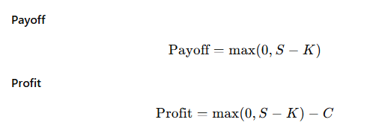  2. Long Put:  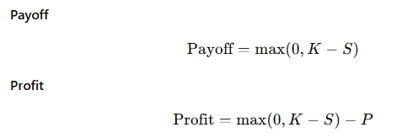  3. Covered Call  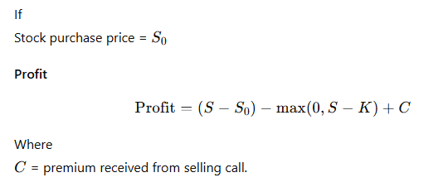  4. Bull Call Spread  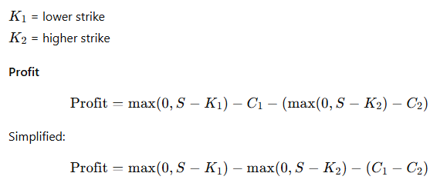  5. Bear Put Spread  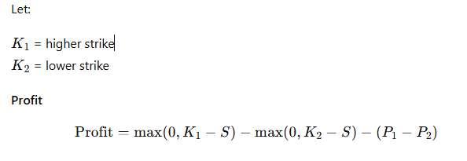  6. Long Straddle  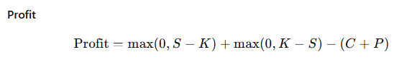  7. Long Strangle:  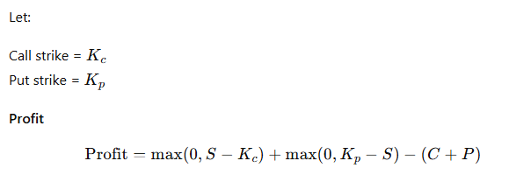  Task 2: Interpret the payoff profiles and describe how each strategy performs under different market conditions (e.g., a stock price above or below the strike price).  To interpret payoff profiles, we analyze how each strategy performs at expiration under different stock price conditions. Each strategy behaves differently based on whether the stock price is:  - Above the strike price (ITM - In The Money)  - Below the strike price (OTM - Out of The Money)  - At the strike price (ATM - At The Money)  Task 3: Determine the profit or loss after accounting for option premiums.  Task 4: Identify Break-Even Points for Each Strategy  The break-even point is the stock price at which profit = 0.  At this price, the investor neither gains nor loses money.  Task 5: Compare Risk and Reward Characteristic  Analyse the maximum profit, maximum loss, and market expectation of each strategy.  Task 6: Plot Payoff Diagrams Using Python
Conclusion | (Write your conclusions)

