Department of Computer Science and Engineering ( Data Science )
Sy.B.Tech. Sem: IV Subject: Statistics For Data Science ( DJS23DLPC403 )
Experiment 3A
Name: SAP ID:
Date: | Experiment Title: Correlation
Aim | Given a data set of 10 rows. Calculate Karl Pearson’s coefficient of correlation, Spearman’s rank correlation coefficient ( using repeated ranks) manually. Then write a python program to calculate both coefficients and match it with the manually calculated values. Solve the real world problem statements.
Software | Google Colab, Visual Studio Code, Jupyter Notebook
Theory | Correlation is a statistical measure that indicates the strength and direction of the relationship between two variables. It shows how changes in one variable are associated with changes in another and is commonly measured using the correlation coefficient, which ranges from –1 to +1. A value close to +1 indicates a strong positive correlation, –1 indicates a strong negative correlation, and 0 indicates no correlation. Correlation helps in identifying linear relationships between variables and is widely used in data analysis to understand dependencies, but it does not imply causation.
Theory To Be Handwritten | 1.Explain the concept of correlation coefficient.  What do its magnitude and sign indicate about the relationship between two variables?  2.Differentiate between positive correlation, negative correlation, and zero correlation with suitable examples.  3.Why does correlation not imply causation?  Explain this statement and discuss one limitation of using correlation in data analysis.
Implementation | Data:  X = 1, 2, 3, 4, 5, 6, 7, 8, 9, 10  Y = 5, 6, 7, 8, 7, 9, 10, 10, 11, 12  Plot a scatter plot of the above data.  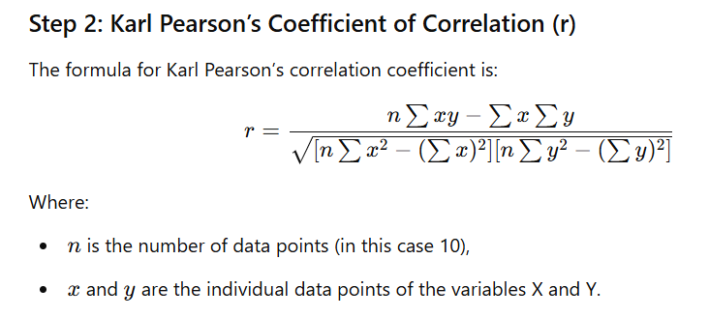  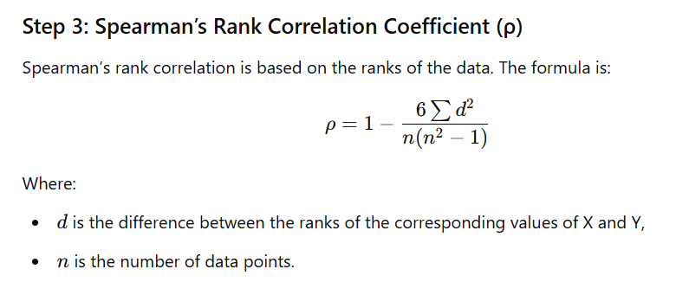  Python Code :  1, Write a function to calculate pearson_correlation(X, Y).  2. Write a function to calculate spearman_rank_correlation(X, Y).  3. Use scipy to verify Spearman's rank.  4. Print all the three results.  Real world problems.  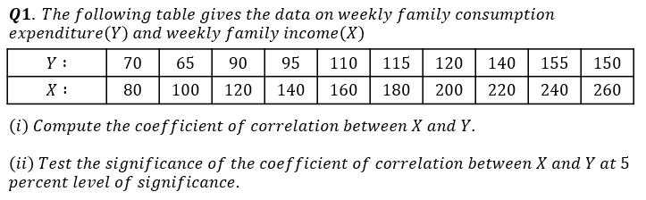  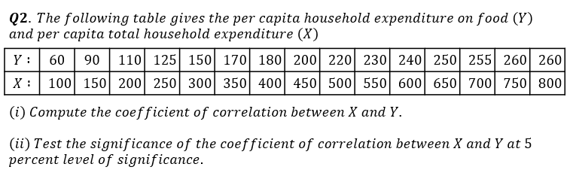
Conclusion | Hence, we have calculated Karl Pearson’s coefficient of correlation, Spearman’s rank correlation coefficient ( using repeated ranks) manually and have implemented a python program to calculate both. Both the coefficients are matching.  Conclusion of real world problem 1  Conclusion of real world problem 2

Signature of Faculty

