Department of Computer Science and Engineering ( Data Science )
Sy.B.Tech. Sem: IV Subject: Statistics For Data Science ( DJS23DLPC403 )
Experiment 3B
Name: SAP ID:
Date: | Experiment Title: Regression
Aim | To study Simple Linear Regression and Multiple Linear Regression and Solve real world problems.
Software | Google Colab, Visual Studio Code, Jupyter Notebook
Theory | Simple Linear Regression (SLR)  Simple Linear Regression models the relationship between one independent variable and one dependent variable using a straight-line equation. It is used to predict the dependent variable and to study how changes in the independent variable affect it. The model assumes a linear relationship and constant error variance.  Multiple Linear Regression (MLR)  Multiple Linear Regression models the relationship between one dependent variable and two or more independent variables. It explains how multiple factors jointly influence the dependent variable, with each variable having its own coefficient. It is widely used when outcomes depend on several inputs.
Theory to be Handwritten | 1.Define Simple Linear Regression. Explain its purpose and list the assumptions of the simple linear regression model.  2. Differentiate between Simple Linear Regression and Multiple Linear Regression.  3. Explain Multiple Linear Regression. Discuss the role of regression coefficients and the importance of independent variables in the model.
Implementation | Simple Linear Regression  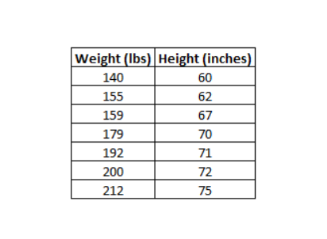  For the given data, calculate the coefficients of Simple Linear Regression and plot a regression line. ( Using Linear Regression model as well as by manual calculations. )  Calculate Coefficient of Determination (R-squared) as well in both cases.  Code:  Output:  Multiple Linear Regression  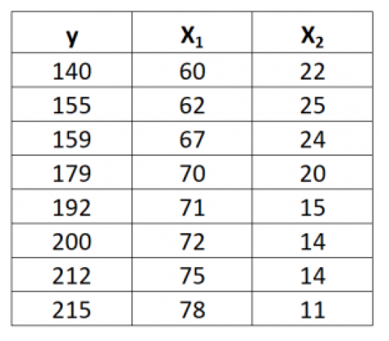  For the given data, calculate the coefficients of Multiple Linear Regression and plot a regression plane.  Code:  Output:  Real World Problems: Attach python code and the outputs.  Q1  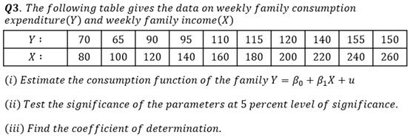  Code:  Output:  Q2  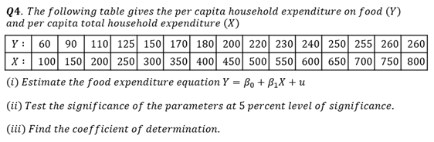  Code:  Output:
Conclusion | Hence, we have studied Simple Linear Regression and Multiple Linear Regression.  Conclusion of real world problem 1  Conclusion of real world problem 2

Signature of Faculty

