Practical No -I
HTML

Aim: Apply HTML and HTML5 semantic elements to create static and structured web pages.
1. Create a static web page using HTML.
2. Create a class timetable using HTML.
3. Create a registration form using HTML.
4. Create a web page using HTML5 tags.

Lab Assignments to complete:

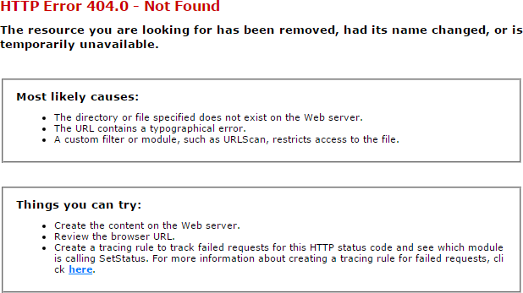
- Create a static page as the image posted below:

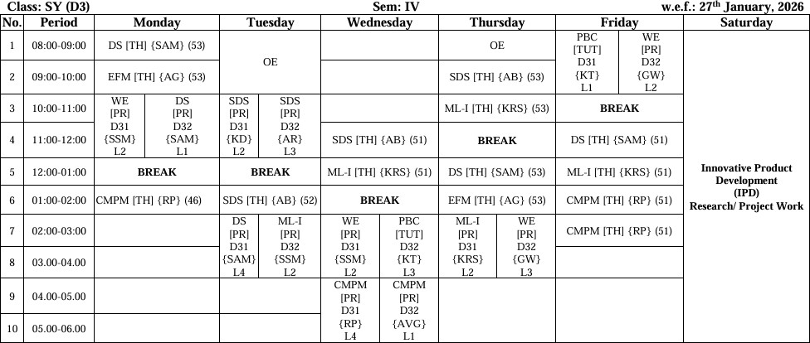
- Create the exact timetable of semester IV of your class.

- Create a registration form using HTML as per the image shown below.
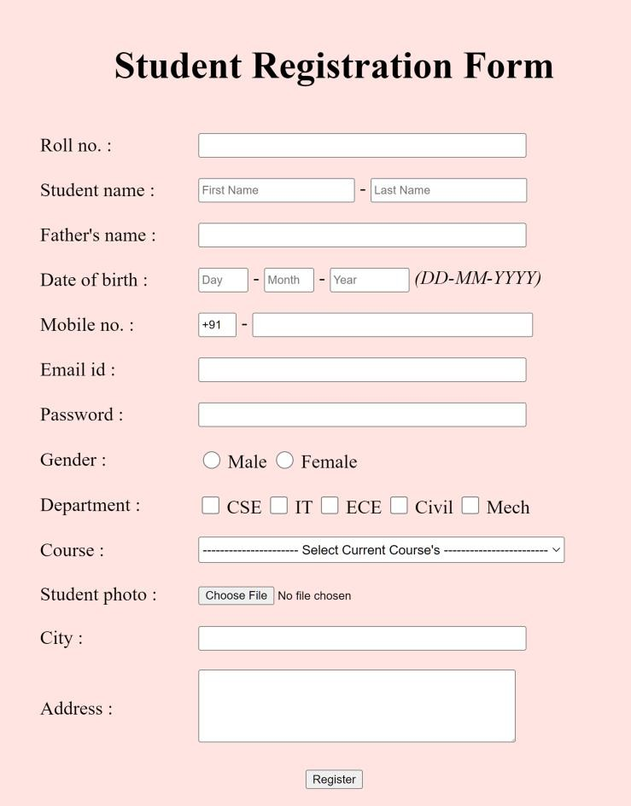

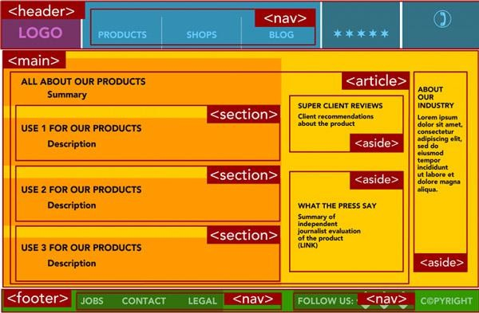
4. Create a web page using HTML5 tags.

