Department of Computer Science and Engineering (Data Science)

S.Y.B.Tech. Sem: IV
Subject: Computational Methods and Pricing Models Laboratory
Experiment 6
Name: SAP ID:
Date: | Experiment Title: Bond Pricing and Yield Curves with Sensitivity Analysis.
Aim | To determine price a bond using the yield curve and analyze how its price changes with different interest rate assumptions
Software | Python on Google Colab
Theory | A bond is a fixed-income security that represents a loan made by an investor to a borrower (typically a corporation or government). The price of a bond is determined by several factors, including interest rates, time to maturity, and the creditworthiness of the issuer.  1. Key Terms in Bond Pricing  - Face Value (Par Value): The amount paid to the bondholder at maturity (e.g., $1,000).  - Coupon Rate: The interest rate paid by the bond issuer, usually annually or semi-annually.  - Maturity Date: The date on which the bondholder receives the face value.  - Yield to Maturity (YTM): The total return an investor can expect if the bond is held until maturity.  2. Bond Price Calculation  The price of a bond is the present value of its future cash flows (coupon payments and face value) discounted at the required rate of return (market interest rate).  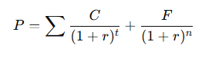  Where:  - P = Price of the bond  - C = Coupon payment per period  - r = Market interest rate (discount rate)  - F = Face value of the bond  - t = Time period  - n = Total number of periods  3. Relationship Between Bond Price & Interest Rates  When market interest rates rise → Bond prices fall.  When market interest rates fall → Bond prices rise.  This inverse relationship is due to the present value effect of discounting future cash flows at different rates.  Types of Bonds Based on Pricing  Premium Bond: Price > Face Value (Coupon Rate > Market Rate).  Discount Bond: Price < Face Value (Coupon Rate < Market Rate).  Par Bond: Price = Face Value (Coupon Rate = Market Rate).  Yield Curve  The yield curve is a powerful tool for understanding bond yields and interest rates over different maturities. It helps in evaluating bonds in terms of pricing, investment decisions, and market expectations.  How the Yield Curve Affects Bond Prices & Returns  Bond Pricing:  When the yield curve shifts upward, bond prices fall (existing bonds become less attractive).  When the yield curve shifts downward, bond prices rise (existing bonds become more attractive).  • Bond Investing Strategies:  - Riding the Yield Curve: Investors buy longer-term bonds when the curve is steep, hoping to sell them at a profit as they move toward maturity.  - Yield Curve Arbitrage: Traders exploit differences between short- and long-term yields.  • Impact on Yield to Maturity (YTM):  - YTM of a bond is determined by where it sits on the yield curve.  - A bond with a longer maturity usually has a higher yield (in normal conditions).
Implementation | Task 1: To implement a program that calculates the price of a bond using the Present Value of Cash Flows formula.  Problem Statement: (Simple Bond)  A 5-year bond has the following characteristics:  Face Value (F) = $1,000  Coupon Rate = 6%  Yield to Maturity (r) = 5%  Maturity (n) = 5 years  Using the present value formula, write a program to calculate the price of the bond.  Task 2: (bond using the yield curve)  You are tasked with pricing a bond using the yield curve and analyzing how its price changes with different interest rate assumptions. You will also perform a sensitivity analysis to see how small changes in interest rates affect the bond price.  Given the following details for a 10-year bond:  Face Value: $1,000  Coupon Rate: 5% annually  Payment Frequency: Annually  Risk-Free Rate: A yield curve with the following rates for the first three years:  1 year: 4%  2 years: 4.2%  3 years: 4.5%  From year 4 onwards: 5%  - Price the bond using the provided yield curve for each year.  - Calculate the bond price using the present value of its cash flows (coupons and face value).  - Perform sensitivity analysis to determine how bond price changes as interest rates fluctuate for different terms (e.g., from 4% to 6%).  - Plot the bond price against different interest rates.  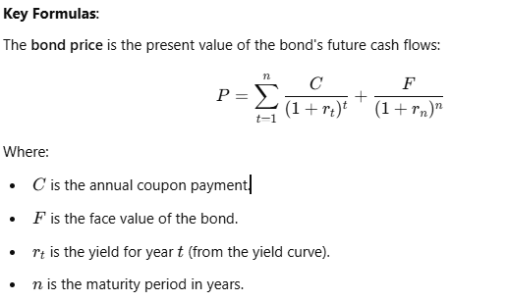  Additional Tasks:  1) Compare Bond Prices for Different Credit Ratings  - Assume different credit risks (A, B, Junk) and analyze how spreads affect bond prices.  - Face Value: $1,000  - Coupon Rate: 5% (Fixed across ratings)  - Years to Maturity: 10  - Market Yields:  - A: 4%  - B: 6%  - Junk: 9%
Conclusion | (Write your conclusions)

