Department of Computer Science and Engineering (Data Science)
S.Y. B.Tech. Sem: IV Subject: Statistics for Data Science
Experiment 9
Name: SAP ID:
Date: | Experiment Title: Chisquare Test using Python
Aim | To study test of independence of attributes and goodness of fit.
Software | Google Colab
Theory | Discuss the test of independence of attributes and test of goodness of fit.
Import numpy pandas math scipy and statistics libraries. Import chi2 from scipy.

Test of independence of attributes:

Write a function chi2_ind_att(df, alpha). It should calculate chi-square statistics and p-value. It should accept or reject null hypothesis depending on p-value and alpha.

Question 1: For a give Titanic dataset, can it be concluded that gender and survival of passengers are related to each other?

Question 2: For a give Titanic dataset, can it be concluded that class and survival of passengers are related to each other?

Question 3: A table shows the number of men and women buying different types of pets. Can it be concluded that gender and choice of pet are related to each other?

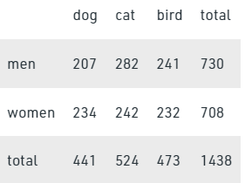

Question 4: For the given drug data, can we conclude that treatment is effective?
data = [[60, 10], [30, 25]]
df = pd.DataFrame(data, columns = ['cured', 'noncured'], index = ['treated', 'nontreated'])

Question 5: The table below is an exit poll which displays the joint responses to 2 categorical variables: people in categories from 18–29, 30–44, 45–64 and >65 years, and their political affiliation, which is “Conservative”, “Socialist” and “Other”. Create data corresponding to this information. Is there any evidence of a relationship between the age group and their political affiliation, at 5% significant level?

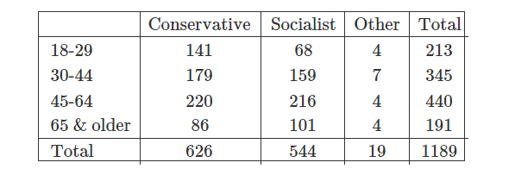
Test of Goodness of Fit:

Question 6: A researcher takes a random sample and pick 123 students about their party affiliation. Out of them 57 vote for party A, 26 vote for party B and 40 for Others. Generally, 41.5% of people vote for the party A, 25.7% for the party B and the remaining 32.8% as Others. Test the hypothesis that sample data follows given distribution.

Question 7: A bulb manufacturer wants to know whether the life of the bulbs follows the normal distribution. Forty bulbs are randomly sampled, and their life, in months, are observed.

Question 8: Check whether the dice is unbiased. It is tossed 90 times and the counts of outcomes are given in table.

Conclusion | Thus, we have studied test of independence of attributes and goodness of fit using chi-square statistics..

Signature of Faculty

