События

call – нажатие кнопки (ID кнопки).

arrived – лифт остановился на этаже, соответствующем обрабатываемой кнопке (ID кнопки).

opened – двери лифта открылись.

timeIsUp – время остановки вышло.

closed – двери лифта закрылись.

Кабина (Cabin)

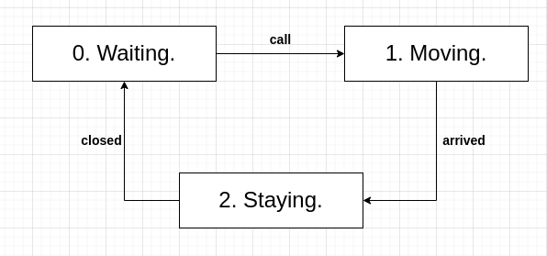

|  |  |  |  |
| --- | --- | --- | --- |
|  | call | arrived | closed |
| 0. Waiting. | 1 | - | - |
| 1. 1. Moving. | - | 2 | - |
| 2. Staying. | - | - | 0 |

Двери (Doors)

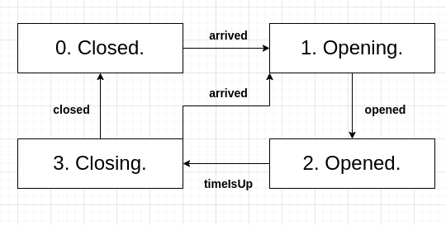

|  |  |  |  |  |
| --- | --- | --- | --- | --- |
|  | arrived | opened | timeIsUp | closed |
| 0. Closed. | 1 | - | - | - |
| 1. 1. Opening. | - | 2 | - | - |
| 2. Opened. | - | - | 3 | - |
| 3. Closing. | 1 | - | - | 0 |

Кнопка (Button)

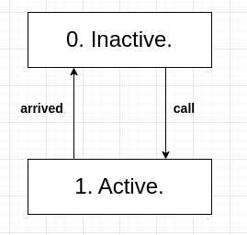

|  |  |  |
| --- | --- | --- |
|  | call | arrived |
| 0. Inactive. | 1 | - |
| 1. Active. | - | 0 |

Контроллер (Controller)

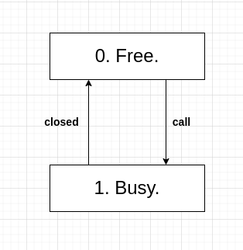

|  |  |  |
| --- | --- | --- |
|  | call | closed |
| 0. Free. | 1 | - |
| 1. Busy. | - | 0 |