The Ministry of Education of the Republic of Belarus

education institution
Belarusian State University
Informatics and Radio Electronics

Department of Computer Systems and Networks

Software Department of Information Technologies

report

on laboratory work

on the topic of:

Iteration Cycles

Complied  Student gr. 751006 |  | A.S. Pankratiev
Checked |  | Ass. E.E. Fadeeva

Minsk, 2017
- Theoretical information on laboratory work
Classification cycles
In accordance with the mutual position of the cycles in the body of the program or algorithm distinguishes between the following cycles:

- simple - cycles that do not contain within itself the other cycles;
- complex - rings containing within itself other cycles;
- Nested (internal) - cycles included in the other cycles (cycle in the cycle);
- external - cycles that are not part of the other cycles, but containing in its composition the inner loops.
Depending on the location of the loop conditions are following cycles:

- Cycles with a precondition;
- Cycles with postcondition.
In accordance with the view of the conditions of execution cycles are divided into the following types:

- cycles with the parameter;
- iterative cycles.

Cycle parameter allows you to execute a set of commands a fixed number of times, ie, the number of iterations must be known before the start of the cycle.

The iterative cycle - a cycle for which the number of repetitions of the loop body is not known in advance. In iterative cycles at each step of the calculation is a sequential approach and check the conditions to achieve the desired result. Out of the iteration cycle is carried out in the case of performing the predetermined condition.

The task for lab work

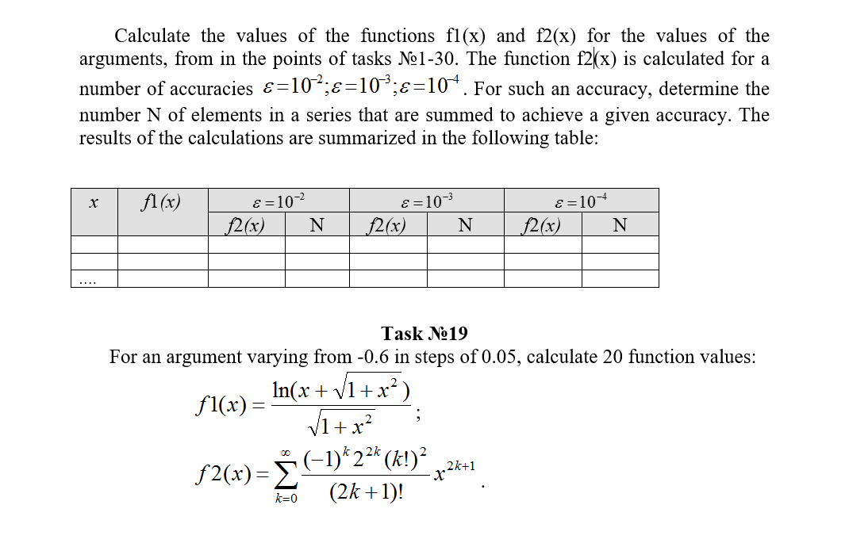
- Performance
  - Development of an algorithm
Table 3.1 used the identifiers
identifier name | appointment | identifier type | The initial value | The law changes
x | The current value of the function argument | real | -0.6 | x: = x + dx
dx | Step change function | real | 0.05 | -
z | Meaning of a term in a function f1 | real | - | Sqrt (1 + sqr (x))
f1 | The value of the function f1 | real | - | Ln (x + z) / z
ExecutionsNum | The required number of changes to the variable x | byte | 20 | -
CurrentNum | Current number of changes to the variable x | byte | 1 | Inc (CurrentNum)
k | The parameter k | integer | 1 | Inc (k)
PrevTerm | Previous term | real | x | PrevTerm: = CurrTerm;
CurrTerm | current term | real | - | PrevTerm * (k * k) * coef / ((2 * k + 1) * 2 * k)
prevf2 | The previous value of the function f2 | real | - | prevf2: = f2
coef | The coefficient of the function f2 (taken out of the cycle limits in order to optimize the program) | real | (-1) * 4 * x * x | (-1) * 4 * x * x
f2 | Current value of the function | real | x | f2: = f2 + CurrTerm
epsilon | required accuracy | real | 10-2 | epsilon: = epsilon / 10
ecurrent | Current accuracy | real | 1 | Abs (f2-prevf2)
steps | The current step of successful execution of the function f2 (where to find the required accuracy) | Byte | 1 | Inc (steps)

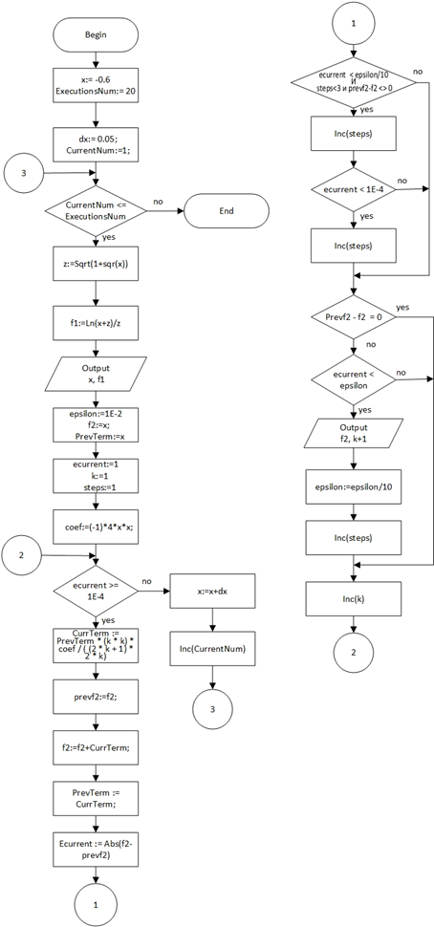
Figure 3.1 - Scheme of the work program
Description of the algorithm: The algorithm with two cycles: a parameter and iteration
  - Text of the program and its description

- program lab3;

- {$ APPTYPE CONSOLE}

- uses
- SysUtils;

- var x, dx, f1, z, epsilon, prev, Curr, prevf2, f2, ecurrent:real;
- ExecutionsNum, CurrentNum, k:Byte;
- begin
- x: = -0.6; // initial values
- ExecutionsNum: = 20; // number of function values ​​to be found
- dx: = 0.05; // step
- CurrentNum: =1;
- writeln('------------------------------------------------- ----------------------- ');
- writeln('| | | e = 10 ^ -2 | e = 10 ^ -3 | e = 10 ^ -4 | ');
- writeln('| x | f1 (x) | --------------------------------------------- --------- ');
- writeln('| | | f2 (x) | N | f2 (x) | N | f2 (x) | N | ');
- writeln('------------------------------------------------- ----------------------- ');

- while(CurrentNum <= ExecutionsNum) do
- begin

- z: =Sqrt(1+sqr(X));

- f1: =Ln(X + z) / z;
- write('|', X:7:2.'|', F1:8:4.'|');

- epsilon: =1E-2;
- f2: = x;
- prev: = x;
- ecurrent: =1;
- k: =1;

- while(Ecurrent> =1E-4) do
- begin
- curr: = prev * ((-1) *4* K * k * x * x) / ((2* K +1) *2* K);
- prevf2: = f2;
- f2: = f2 + curr;
- prev: = curr;
- ecurrent: =Abs(F2-prevf2);
- if (Prevf2-f2 = 0) then Write('The function does not change')
- else begin

- if(Ecurrent <epsilon) then
- begin
- // Writeln ( 'f2 =', f2, 'epsilon =', ecurrent, '/', epsilon);
- write(F2:8:4.'|', (K +1):8.'|');
- epsilon: = epsilon /10;
- end;
- end;
- inc(K);
- end;
- writeln;
- writeln('------------------------------------------------- ----------------------- ');
- x: = x + dx;
- Inc(CurrentNum);
- end;
- Writeln;
- Writeln;
- Writeln('Press Enter to exit.');
- Readln;
- end.

Program Description: The program displays a table with the values ​​of f1 and f2 for a given x, and determines the number of steps required to achieve a given accuracy of functions f2
  - Testing and debugging programs

Table 3.2 the test program
test number | Inputs | Expected Result | The result
1 | - | The correct value of the function, the correct display of the table | 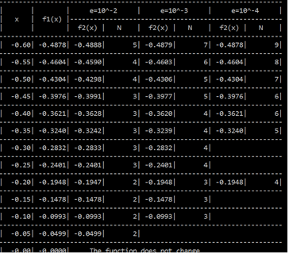  If the accuracy of the function at a particular value x "is growing" too fast, the values ​​of "stand" is not in place. Fixed in claim 1
Corrections of claim 1 conducted
2 | - | The correct value of the function, the correct display of the table | 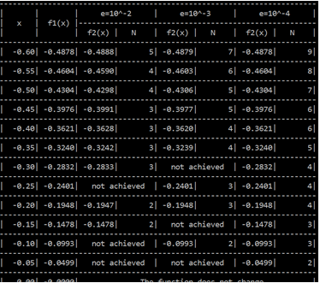  Test passed
Analysis of passing the tests, the causes of the errors, changes to the algorithm and the program text
The program has been successfully tested with the introduction of changes

The changes:

Claim 1. For some values ​​of x the accuracy of calculation of the function f2 increased so rapidly that some intermediate precision not achieved, or even from the first step reaches the maximum required accuracy. For correction of such display lines in checking the accuracy of growth was introduced table (comparison with the following current accuracy required) (lines 45-65 final program text)

  - The final text of the program

- program lab3;

- {$ APPTYPE CONSOLE}

- uses
- SysUtils;

- var x, dx, f1, f2, z, epsilon, PrevTerm, CurrTerm, prevf2, coef, ecurrent:real;
- k:integer;
- j, ExecutionsNum, CurrentNum, steps:Byte;
- begin
- x: = -0.6; // initial values
- ExecutionsNum: = 20; // number of function values ​​to be found
- dx: = 0.05; // step
- CurrentNum: =1;

- writeln('------------------------------------------------- ----------------------- ');
- writeln('| | | e = 10 ^ -2 | e = 10 ^ -3 | e = 10 ^ -4 | ');
- writeln('| x | f1 (x) | --------------------------------------------- --------- ');
- writeln('| | | f2 (x) | N | f2 (x) | N | f2 (x) | N | ');
- writeln('------------------------------------------------- ----------------------- ');

- while(CurrentNum <= ExecutionsNum) do
- begin

- z: =Sqrt(1+sqr(X));
- f1: =Ln(X + z) / z; // get the value of the first function
- write('|'(Trunc(X *1E6) /1E6):7:2.'|', F1:8:4.'|');

- epsilon: =1E-2; // Required accuracy
- f2: = x;
- PrevTerm: = x;
- ecurrent: =1;
- k: =1;
- steps: =1;
- coef: = (-1) *4* X * x;
- while(Ecurrent> =1E-4) do
- begin
- CurrTerm: = PrevTerm * (k * k) * coef / ((2* K +1) *2* K);
- prevf2: = f2;
- f2: = f2 + CurrTerm;
- PrevTerm: = CurrTerm;
- ecurrent: =Abs(F2-prevf2);
- if (Ecurrent <epsilon /10) and (Steps <3) and (Prevf2-f2 <> 0) then
- begin
- {
- If the current accuracy is already
- more than the accuracy of the next cell,
- the current cell is skipped
- }
- write('Not achieved':17.'|');
- Inc(Steps);
- if (Ecurrent <1E-4) then
- begin
- {
- If required final accuracy already
- reached, then all previous blank
- cells are skipped
- }
- for j: =1 to (3-steps) do
- write('Not achieved':17.'|');
- Inc(Steps);
- end;
- end;
- if (Prevf2-f2 = 0) then
- Write('The function does not change |':54)
- else
- begin

- if((Ecurrent <epsilon)) then
- begin
- write(F2:8:4.'|', (K +1):8.'|');
- epsilon: = epsilon /10;
- Inc(Steps);
- end

- end;
- inc(K);
- end;

- writeln;
- writeln('------------------------------------------------- ----------------------- ');
- x: = x + dx;
- Inc(CurrentNum);
- end;
- Writeln;
- Writeln;
- Writeln('Press Enter to exit.');
- Readln;
- end.

