The Ministry of Education of the Republic of Belarus

education institution
Belarusian State University
Informatics and Radio Electronics

Department of Computer Systems and Networks

Software Department of Information Technologies

report
on laboratory work

on the topic of:

Working with single-dimensional arrays

complied  Student gr. 751006 |  | A.S. Pankratiev
checked |  | Ass. E.E. Fadeev

Minsk, 2017
- Theoretical information on laboratory work

Array - ordered set of the same elements that have a common name. This name is called a complete variable, as its value is the entire array.
Type of array is called the base type of the array.
indices (index expression) used for the isolation of individual array elements. The index sets the rule for calculating the number of the desired array element
A one-dimensional array can be represented as a vector A [1], A [2], A [3], ..., A [N]
Number of elements, their ordering and type must be specified clearly in the description of the array before the start of the program and can not be changed at runtime.
The task for lab work

Task №60
Given a sequence of N integers, of which no two are alike. Required to delete the minimum possible amount of numbers so that the rest went in ascending order.

- Performance
  - Development of an algorithm
Table 3.1 used the identifiers
ID name | appointment | Id type | The initial value | The law changes
global
n | The number of array elements | integer constant | 10 | -
maxNum | The maximum number in randomness | integer constant | 20 | -
MainArray | The initial array | TArray | - | -
EditedArray | Edited by increasing the array with the largest number of CMV elements | TArray | - | -
i, j | cycle parameters | integer | 1 | Inc (i)  Inc (j)
k | Current repeat inside recursive procedure | integer | 0 | Inc (k)
count | Number of current array elements | integer | 0 | Inc (count)
val | Generated randomness value | integer | - | RANDOM (maxNum) -10
maxsize | Current greatest number of array elements | integer | 0 | Inc (maxsize)
Local functions checkRepeatValue
isRepeat | Do val element is present in the array arr | Boolen | false | True / false
k | cycle parameters | byte | 1 | Inc (k)
Local functions isIncreases
i, j | cycle parameters | Integer | I: = 1  j: = i + 1 | Inc (i)  Inc (j)
isIncr | whether the function increases | Boolean | false | True / false
Local getMainArray procedures
i, j, m, p | cycle parameters | Integer | 1 | Inc (i), inc (j), inc (m), inc (p)
TempArr | side array | TArray | MainArray

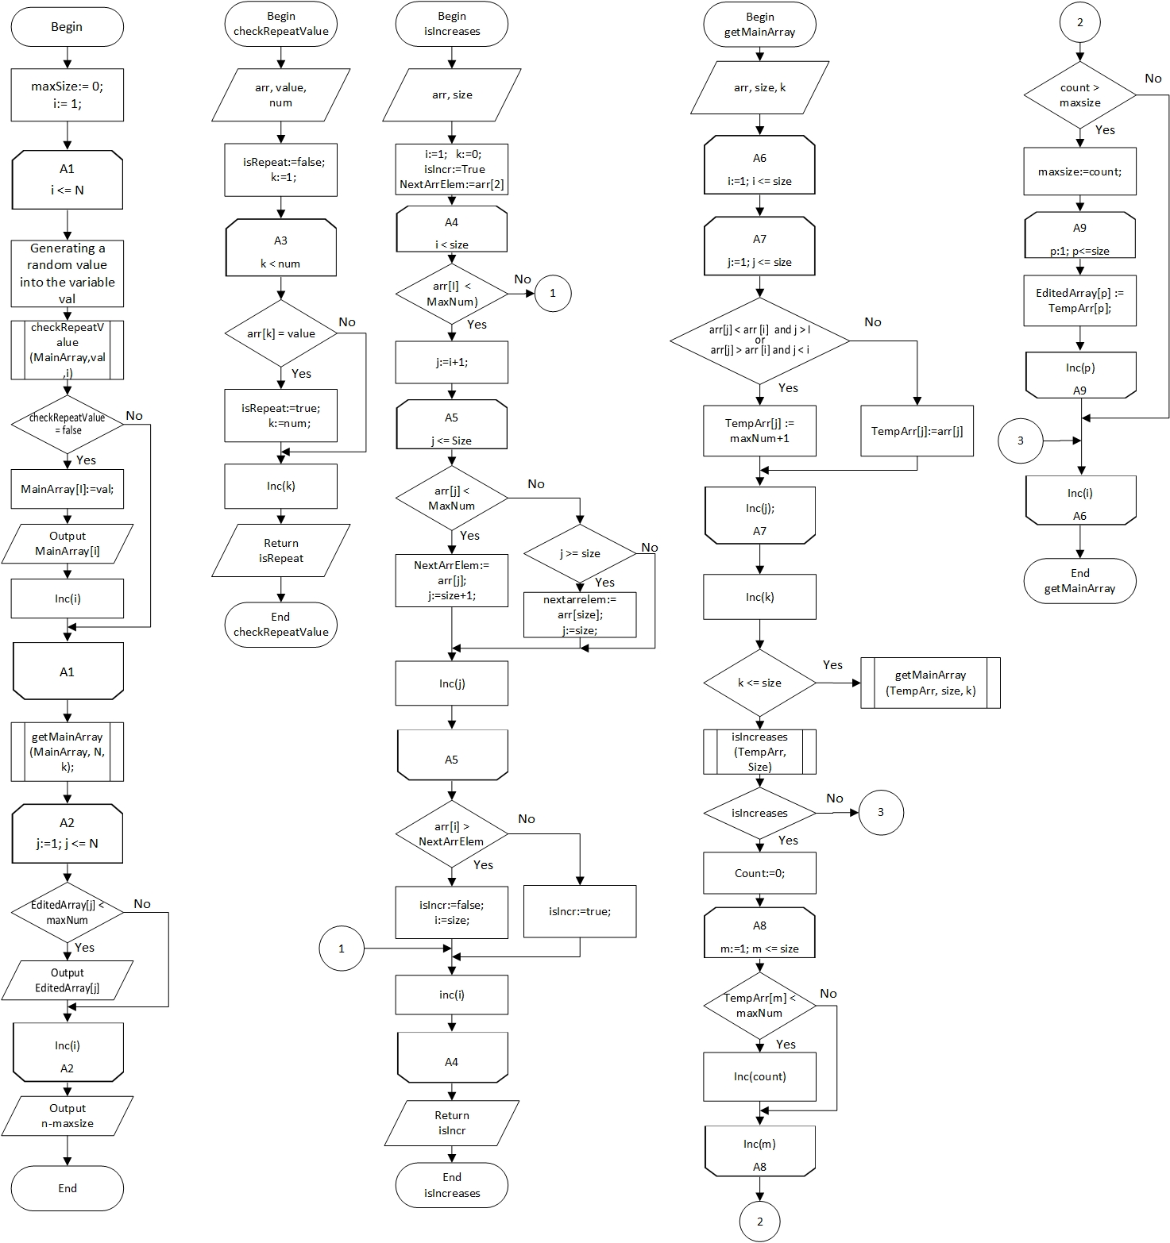

Figure 3.1 - Scheme of the work program

Description of the algorithm: The algorithm comprises 8 cycles and uses 3-dimensional array with a size of integer values ​​[1..N]
  - Text of the program and its description

- program lab4;
- {$APPTYPE CONSOLE}
- const n=10; maxNum=20;
- resourcestring
- PrimArr = 'Primary array: ';
- EdArr = 'Edited array: ';
- Del = 'Deleted';
- El = 'elements';
- type TArray = array[1..N] of Integer;
- var MainArray, EditedArray: TArray;
- i,j,k, count, val, maxsize:Integer;

- function checkRepeatValue(arr:TArray;value,num:integer):Boolean;
- { ==========================
- The function checks if
- the received value is
- in the arr array.
- In the case of repetition,
- returns true
- ========================== }
- var isRepeat:Boolean; k:byte;
- begin
- isRepeat:=false;
- k:=1;
- while(k < num) do
- begin
- if (arr[k] = value) then
- begin
- isRepeat:=true;
- k:=num;
- end;
- Inc(k);
- end;
- checkRepeatValue:=isRepeat;
- end;

- function isIncreases(arr: TArray; size: Integer):boolean;
- { =============================
- The function checks to see if
- the items of array are sorted
- =============================}
- var i,j, NextArrElem: Integer;
- isIncr: boolean;
- begin
- i:=1;
- k:=0;
- isIncr:=True;
- NextArrElem:=arr[2];
- while (i < size) do
- begin
- if(arr[i] < MaxNum) then
- begin
- j:=i+1;
- while(j <= Size) do
- begin
- if(arr[j] < MaxNum) then
- begin
- NextArrElem:= arr[j];
- j:=size+1;
- end
- else
- begin
- if (j >= size) then
- begin
- nextarrelem:=arr[size];
- j:=size;
- end;
- end;
- Inc(j);
- end;
- if (arr[i] > NextArrElem) then
- begin
- isIncr:=false;
- i:=size;
- end
- else
- isIncr:=true;
- end;
- inc(i);
- end;
- isIncreases:=isIncr;
- end;

- procedure getMainArray(arr: TArray; size,k: integer);
- { =================================
- The function recursively remove
- repeated value of array to obtain
- an ascending array with minimal
- deleted elements
- =================================}
- var TempArr: TArray;
- i,j,m,p:Integer;
- begin
- for i:=1 to size do
- begin
- for j:=1 to size do
- begin
- if (((arr[j] < arr [i]) and (j > i))
- or
- ((arr[j] > arr [i]) and (j < i)))
- then
- TempArr[j] := maxNum+1 // To delete an item,
- // a value greater than the maximum value
- else
- TempArr[j]:=arr[j];
- end;
- Inc(k);
- if (k <= size) then
- begin
- getMainArray(TempArr, size, k)
- end
- else
- begin
- if(isIncreases(TempArr, Size)) then
- begin
- count:=0;
- for m:=1 to size do
- begin
- if(TempArr[m] < maxNum) then // Skipping deleted items
- begin
- Inc(count);
- end;
- end;
- if (count > maxsize) then
- begin
- maxsize:=count;
- for p:=1 to size do
- EditedArray[p] := TempArr[p];
- end;
- end;
- end;
- end;
- end;

- begin
- maxSize:=0;
- Randomize;
- i:=1;
- Writeln(PrimArr);
- while(i <= N) do
- begin
- val:=RANDOM(maxNum)-10;
- if(checkRepeatValue(MainArray,val,i)=false) then
- begin
- MainArray[I]:=val;
- write(MainArray[i]:4);
- inc(i);
- end;
- end;
- writeln;
- getMainArray(MainArray, N, k);
- Writeln(EdArr);
- for j:=1 to n do
- begin
- if(EditedArray[j] < maxNum) then // Array output with missing elements
- write(EditedArray[j]:4);
- end;
- writeln;
- Writeln(Del,' ', n-maxsize,' ', el);
- Readln;
- end.

Program Description: The program deletes the minimum number of elements in the original array so that the other elements are in ascending order

  - Testing and debugging programs

Table 3.2 the test program
test number | Inputs | The generated array | Expected Result | The result
1 | -  Tired-claimed  Kostant:  n = 10; maxNum = 20 | 5 9 -3 -1 0 6 -2 8 -9 3 | Remove elements 5 | Edited array:  -3 -1 0 6 8  Deleted 5 elements
2 | -  Tired-claimed  Kostant:  n = 10; maxNum = 20 | -1 1 9 -4 -3 2 0 -10 7 -5 | Remove 6 elements | Edited array:  -1 1 2 7  Deleted 6 elements
3 | -  Tired-claimed  Kostant:  n = 10; maxNum = 20 | -1 -4 8 -7 -2 -8 -6 -9 4 0 | Remove 7 Elements | Edited array:  -4 -2 4  Deleted elements 7
4 | -  Tired-claimed  Kostant:  n = 10; maxNum = 20 | -8 3 4 -4 -2 -6 8 0 -9 7 | Remove elements 5 | Edited array:  -8 -4 -2 0 7  Deleted 5 elements
5 | -  Tired-claimed  Kostant:  n = 10; maxNum = 20 | -8 -4 6 -3 2 0 -2 -9 4 1 | Remove elements 5 | Edited array:  -8 -4 -3 2 4  Deleted 5 elements
6 | -  Tired-claimed  Kostant:  n = 10; maxNum = 10 | -9 -6 -5 -7 -4 -10 -3 -8 -1 -2 | Remove element 4 | Edited array:  -9 -6 -5 -4 -3 -1  Deleted 4 elements
7 | -  Tired-claimed  Kostant:  n = 15; maxNum = 20 | -5 -4 2 3 -6 9 -2 0 -3 5 4 -10 -1 7 8 | Remove elements 8 | Edited array:  -5 -4 2 3 5 7 8  Deleted 8 elements
8 | -  Tired-claimed  Kostant:  n = 15; maxNum = 20 | 8 -7 -1 6 -10 9 -8 -9 0 2 -4 -6 7 -2 -5 | Remove 10 elements | Edited array:  -7 -1 0 2 7  Deleted 10 elements
9 | -  Tired-claimed  Kostant:  n = 15; maxNum = 40 | 27 18 19 11 8 4 29 17 20 -9 -3 0 -6 12 7 | Remove 11 elements | Edited array:  -9 -3 0 12  Deleted 11 elements
10 | -  Tired-claimed  Kostant:  n = 15; maxNum = 15 | -10 -4 2 -7 0 3 -6 1 4 -3 -2 -1 -8 -5 -9 | Remove 9 elements | Edited array:  -10 -7 -6 -3 -2 -1  Deleted 9 elements
eleven | -  Tired-claimed  Kostant:  n = 20; maxNum = 40 | -7 10 16 12 6 -8 -4 2 15 8 -3 4 13 -10 1 7 0 17 18 -6 | Remove 13 elements | Edited array:  -7 -4 -3 1 7 17 18  Deleted 13 elements
12 | -  Tired-claimed  Kostant:  n = 5; maxNum = 20 | -3 0 5 2 7 | Delete 1 item | Edited array:  -3 0 May 7  Deleted 1 elements
13 | -  Tired-claimed  Kostant:  n = 5; maxNum = 20 | 0 -6 -9 -1 9 | Remove 2 elements | -6 -1 9  Deleted 2 elements
Analysis of passing the tests, the causes of the errors, changes to the algorithm and the program text
The program has been successfully tested

  - The final text of the program

- program lab4;
- {$APPTYPE CONSOLE}
- const n=10; maxNum=20;
- resourcestring
- PrimArr = 'Primary array: ';
- EdArr = 'Edited array: ';
- Del = 'Deleted';
- El = 'elements';
- type TArray = array[1..N] of Integer;
- var MainArray, EditedArray: TArray;
- i,j,k, count, val, maxsize:Integer;

- function checkRepeatValue(arr:TArray;value,num:integer):Boolean;
- { ==========================
- The function checks if
- the received value is
- in the arr array.
- In the case of repetition,
- returns true
- ========================== }
- var isRepeat:Boolean; k:byte;
- begin
- isRepeat:=false;
- k:=1;
- while(k < num) do
- begin
- if (arr[k] = value) then
- begin
- isRepeat:=true;
- k:=num;
- end;
- Inc(k);
- end;
- checkRepeatValue:=isRepeat;
- end;

- function isIncreases(arr: TArray; size: Integer):boolean;
- { =============================
- The function checks to see if
- the items of array are sorted
- =============================}
- var i,j, NextArrElem: Integer;
- isIncr: boolean;
- begin
- i:=1;
- k:=0;
- isIncr:=True;
- NextArrElem:=arr[2];
- while (i < size) do
- begin
- if(arr[i] < MaxNum) then
- begin
- j:=i+1;
- while(j <= Size) do
- begin
- if(arr[j] < MaxNum) then
- begin
- NextArrElem:= arr[j];
- j:=size+1;
- end
- else
- begin
- if (j >= size) then
- begin
- nextarrelem:=arr[size];
- j:=size;
- end;
- end;
- Inc(j);
- end;
- if (arr[i] > NextArrElem) then
- begin
- isIncr:=false;
- i:=size;
- end
- else
- isIncr:=true;
- end;
- inc(i);
- end;
- isIncreases:=isIncr;
- end;

- procedure getMainArray(arr: TArray; size,k: integer);
- { =================================
- The function recursively remove
- repeated value of array to obtain
- an ascending array with minimal
- deleted elements
- =================================}
- var TempArr: TArray;
- i,j,m,p:Integer;
- begin
- for i:=1 to size do
- begin
- for j:=1 to size do
- begin
- if (((arr[j] < arr [i]) and (j > i))
- or
- ((arr[j] > arr [i]) and (j < i)))
- then
- TempArr[j] := maxNum+1 // To delete an item,
- // a value greater than the maximum value
- else
- TempArr[j]:=arr[j];
- end;
- Inc(k);
- if (k <= size) then
- begin
- getMainArray(TempArr, size, k)
- end
- else
- begin
- if(isIncreases(TempArr, Size)) then
- begin
- count:=0;
- for m:=1 to size do
- begin
- if(TempArr[m] < maxNum) then // Skipping deleted items
- begin
- Inc(count);
- end;
- end;
- if (count > maxsize) then
- begin
- maxsize:=count;
- for p:=1 to size do
- EditedArray[p] := TempArr[p];
- end;
- end;
- end;
- end;
- end;

- begin
- maxSize:=0;
- Randomize;
- i:=1;
- Writeln(PrimArr);
- while(i <= N) do
- begin
- val:=RANDOM(maxNum)-10;
- if(checkRepeatValue(MainArray,val,i)=false) then
- begin
- MainArray[I]:=val;
- write(MainArray[i]:4);
- inc(i);
- end;
- end;
- writeln;
- getMainArray(MainArray, N, k);
- Writeln(EdArr);
- for j:=1 to n do
- begin
- if(EditedArray[j] < maxNum) then // Array output with missing elements
- write(EditedArray[j]:4);
- end;
- writeln;
- Writeln(Del,' ', n-maxsize,' ', el);
- Readln;
- end.

