Locksmith Lab
Design
Nikola Panayotov

Table of Contents

1 Introduction
2 Technology choices
3 System architecture
4 Frontend design
5 Database design
6 API design
7 Unsecured design
8 Secured design
9 Deployment design
10 Design verification
11 Conclusion
References

1. Introduction

1.1 Purpose
This document specifies the technical design of SecureNotes, a small networked web application for demonstrating how common application and server vulnerabilities arise and how their risks can be reduced.
The project delivers an Unsecured version for controlled vulnerability demonstrations, and a Secured version that addresses the identified weaknesses. The Unsecured application must remain isolated; the Secured application is intended for deployment on an Ubuntu VPS behind Nginx.

1.2 Design objectives
SecureNotes must support registration, login, logout, and creating, viewing, editing and deleting personal notes. The design must separate frontend, API and database responsibilities, make security tests reproducible, and support a before-and-after comparison using the same test cases.

2. Technology choices
Component | Technology | Role
Frontend | React + TypeScript | Browser UI
API | Node.js + Express + TypeScript | Routes, sessions, application logic
Database | PostgreSQL | Users and notes
Containers | Docker | Reproducible environment
Reverse proxy (Secured) | Nginx | HTTPS and request forwarding
Host (Secured) | Ubuntu VPS | Deployment environment

3. System architecture

3.1 Overall arrangement
The frontend (React, n.d.) sends HTTP requests to the Express REST API (Express, n.d.). The API enforces application rules and uses repositories to query PostgreSQL (PostgreSQL Global Development Group, n.d.). For the Secured deployment, Nginx (Nginx, n.d.) terminates HTTPS and forwards API traffic internally.
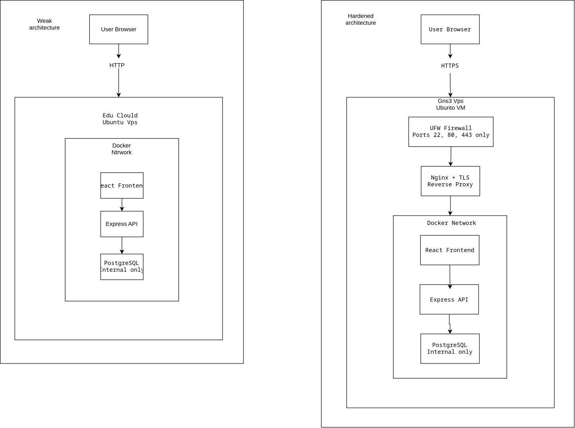
Figure 1. System architecture diagram.

3.2 Backend layers and dependencies
Layer | Purpose
Routes | Map endpoints to controllers; attach middleware
Authentication middleware | Check that the request has an authenticated session
Controllers | Read requests and create HTTP responses
Services | Implement authentication and note operations
Repositories | Execute SQL against PostgreSQL

Authentication flow: AuthRoutes → AuthController → AuthService → UserRepository → PostgreSQL. Note flow: NoteRoutes → NoteController → NoteService → NoteRepository → PostgreSQL. NoteRoutes uses AuthMiddleware, which reads Express Session; it does not directly query the user or note tables.
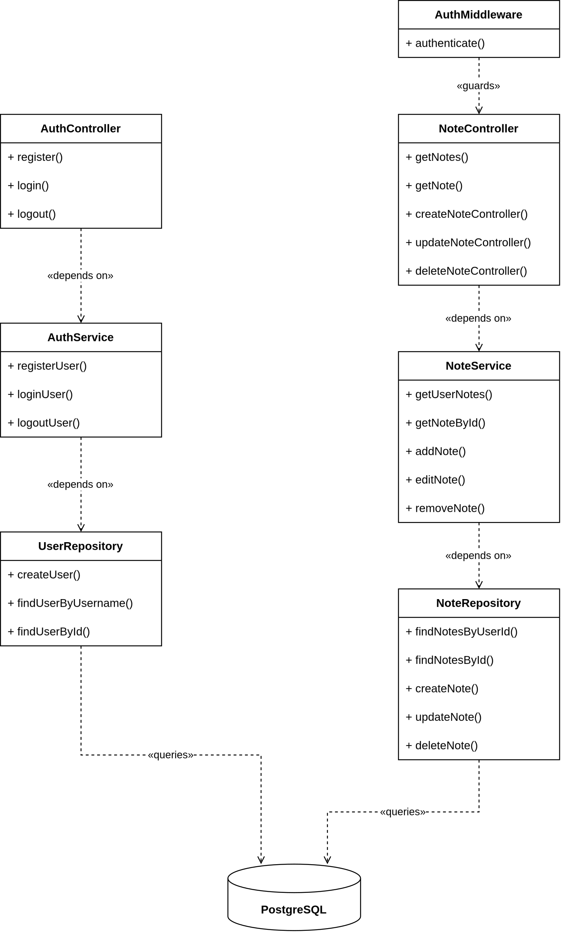
Figure 2. UML diagram of application components and dependencies.

4. Frontend design
Component | User interaction
RegisterPage | Create an account
LoginPage | Enter credentials and start a session
NotesPage | Display and manage personal notes
App | Switch between login, registration and notes views

The frontend handles presentation and API calls only. Authorization decisions must be enforced by the backend; hiding or disabling a button in the browser is not an access-control mechanism.

5. Database design

5.1 Users
Field | Type | Constraint
id | SERIAL / INTEGER | Primary key
username | VARCHAR(100) | Unique, not null
password | VARCHAR(255) | Not null; Secured stores a password hash
created_at | TIMESTAMP | Default current timestamp

5.2 Notes
Field | Type | Constraint
id | SERIAL / INTEGER | Primary key
user_id | INTEGER | Foreign key to users.id, not null
title | VARCHAR(255) | Not null
content | TEXT | Not null
created_at | TIMESTAMP | Default current timestamp
updated_at | TIMESTAMP | Default current timestamp

A user can own multiple notes. A note belongs to one user. The notes.user_id foreign key uses ON DELETE CASCADE.

5.3 Unsecured DB_Diagram
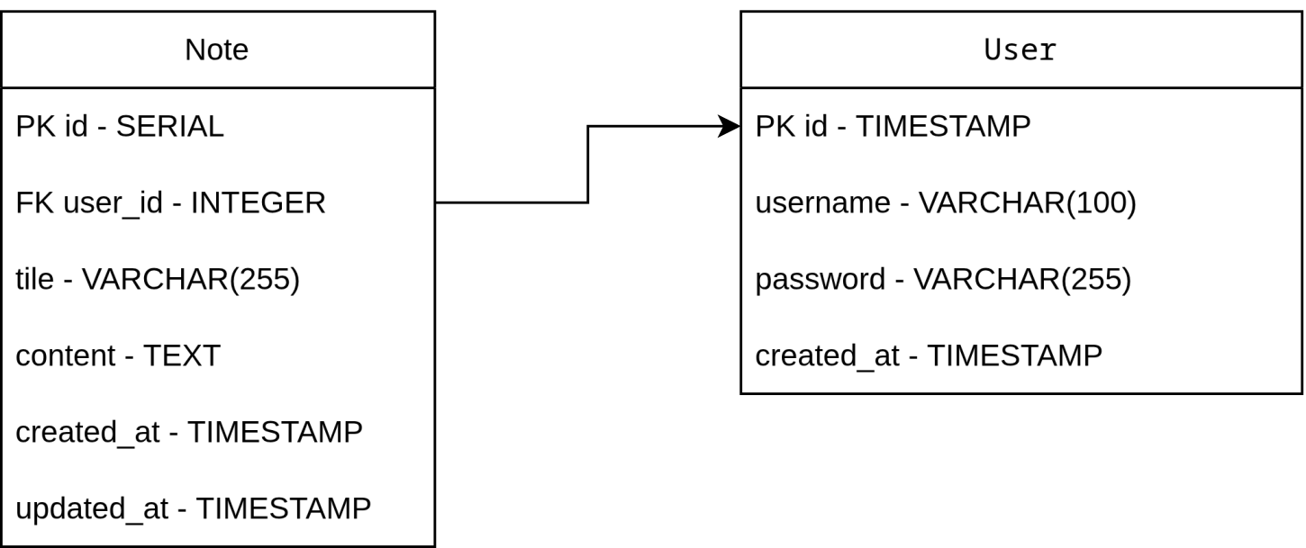
Figure 3. Unsecured database diagram.

5.4 Secured DB_Diagram
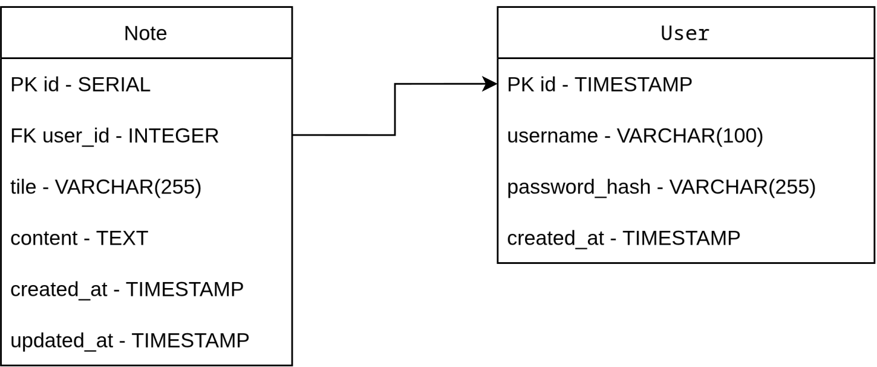
Figure 4. Secured database diagram.

6. REST API design
Method | Endpoint | Purpose
POST | /api/auth/register | Register
POST | /api/auth/login | Login
POST | /api/auth/logout | Logout
GET | /api/notes | List notes
GET | /api/notes/:id | Retrieve note
POST | /api/notes | Create note
PUT | /api/notes/:id | Update note
DELETE | /api/notes/:id | Delete note
GET | /api/health | Database health check

All note routes use the authenticate middleware. In the existing Unsecured implementation, middleware checks for req.session.userId, while certain note operations do not check whether the requesting user owns the note. The Secured version must enforce ownership in note-specific database operations.

7. Unsecured design

7.1 Intended usage
The Unsecured version is intentionally weak and operates only on locally controlled or otherwise authorized isolated infrastructure. Its purpose is to reproduce weaknesses and document their effect, not to serve real users on the public internet.

7.2 Existing weaknesses visible in the code
Area | Existing design | Risk
SQL queries | User and note repositories interpolate values into query strings | SQL injection
Authentication | Credentials are compared in SQL | Authentication bypass if query is manipulated
Passwords | Passwords stored without hashing | Credential disclosure
Authorization | Note lookup, update and deletion do not consistently scope by session user | Cross-user access
Session cookie | Current configuration has httpOnly: false and secure: false | Session exposure
Transport | Local HTTP is used during development | Unencrypted traffic

Cross-site scripting and other input validation issues are planned test areas (OWASP Foundation, 2021), but their exploitability must be established through testing rather than assumed from this design.

8. Secured design

8.1 Security controls
Area | Planned control
SQL injection | Parameterized queries with bound values
Authentication | Secure password verification, session renewal and strong session secrets
Passwords | Appropriate one-way password hashing
Authorization | Scope all note-specific operations to the authenticated session user
Validation | Server-side validation of field types, lengths and identifiers
XSS | Safe text rendering and avoidance of unsafe HTML injection
Cookies | HttpOnly, Secure and appropriate SameSite settings
Network | HTTPS via Nginx; PostgreSQL not publicly exposed
Host | UFW with only required ports accessible
Monitoring | Relevant error and security-event logging without secrets

8.2 Authorization model
The API obtains the user ID from the server-side session (OWASP Foundation, n.d.). When viewing, updating or deleting a note, both the note ID and authenticated user ID are checked. Client-supplied owner IDs are never accepted as proof of ownership. Unauthorized requests must not return another user’s note contents.

8.3 Security implementation status
These are design requirements for the Secured version. They should be checked against the completed implementation and supported with validation evidence; they are not presented here as already implemented.

9. Deployment design

9.1 Unsecured environment
Run Unsecured only on an isolated Docker network (Docker, n.d.), local VM or authorized EDU Cloud environment. Limit access to test users and test systems. Do not expose its intentionally vulnerable services to the public internet.

9.2 Secured environment
Deploy Secured on Ubuntu VPS. Nginx acts as reverse proxy and HTTPS entry point; the Express API and PostgreSQL should use restricted internal communication. Keep credentials and session secrets in deployment configuration outside the repository. Apply firewall rules with UFW (Ubuntu, n.d.).

10. Design verification
ID | Requirement | Evidence
D1 | Registration and login function | Functional tests
D2 | Note CRUD functions | Functional tests
D3 | Unsecured vulnerabilities reproducible in isolation | Test case evidence
D4 | Secured SQL injection controls work | Retest injection scenarios
D5 | Secured note authorization enforced | Two-user ownership tests
D6 | Passwords protected at rest | Inspect stored representation
D7 | Secured network exposure limited | Port and configuration checks
D8 | Same scenarios compared between versions | Before/after test summary

11. Conclusion
SecureNotes uses a layered frontend, API and PostgreSQL architecture. Unsecured provides a restricted environment for demonstrating vulnerabilities. Secured is designed to preserve the same core functionality while reducing identified risks. Implementation and validation evidence will establish whether the Secured design objectives have been achieved.

References
Docker. (n.d.). Docker docs. https://docs.docker.com/
Express. (n.d.). Express - Node.js web application framework. https://expressjs.com/
Nginx. (n.d.). Nginx documentation. https://nginx.org/en/docs/
OWASP Foundation. (n.d.). OWASP Cheat Sheet Series. https://cheatsheetseries.owasp.org/
OWASP Foundation. (2021). OWASP Top 10:2021. https://owasp.org/Top10/
PostgreSQL Global Development Group. (n.d.). PostgreSQL documentation. https://www.postgresql.org/docs/
React. (n.d.). React. https://react.dev/
Ubuntu. (n.d.). UFW. https://help.ubuntu.com/community/UFW

