Breakout
Design
Nikola Panayotov

Table of Contents
Table of Contents 2
1. Introduction 3
2. UML Class Diagram 3
3. Screen-Flow Diagram 3
4. UI Wireframes 4
5. Data Model 4
6. Collision Design 4
7. Quality and Optional Requirements 5

1. Introduction
This document contains the Design deliverables for the Breakout project. Design is the third of the five LO2 activities (Analyse, Advise, Design, Realise, Validate): it translates the requirements and technology choice from the Analysis & Advice document into the structure, behaviour, and appearance of the actual game, so it can be built (Realise) and checked (Validate) against a clear plan.
Three design products are included: a UML class diagram (structure), a screen-flow diagram (behaviour/navigation), and UI wireframes (appearance).

2. UML Class Diagram
The class diagram below shows the structure of the system: BreakoutGame holds the currently active IScreen; StartScreen, GameScreen, GameOverScreen, WinScreen, and PauseScreen all implement the IScreen interface; and GameScreen owns Paddle, Ball, and an array of Brick objects. Ball, Brick, and Paddle share a common GameConfig for shared constants such as world size and wall positions.
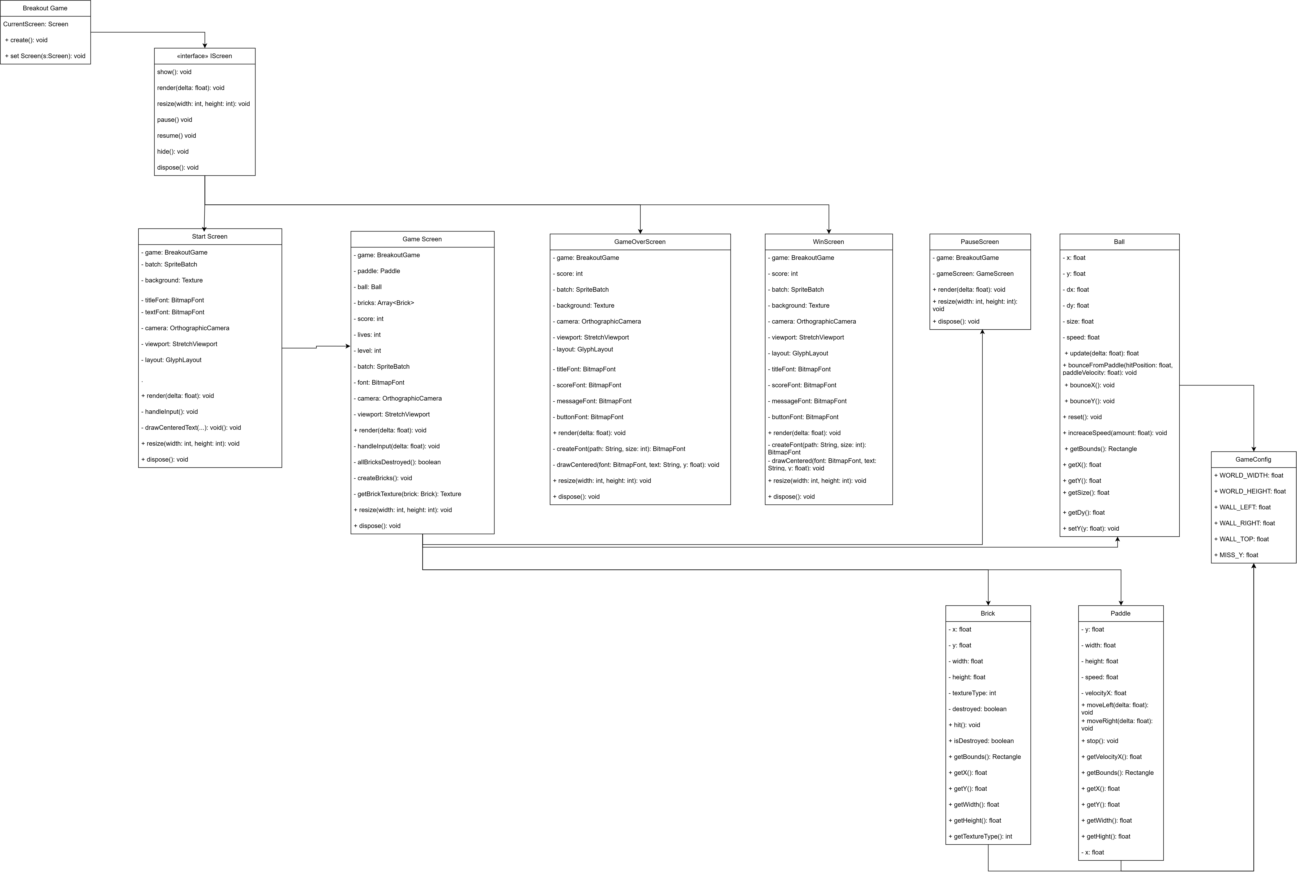

3. Screen-Flow Diagram
The diagram below shows how the game's screens connect, and what triggers each transition, including opening the game from the desktop and pausing/resuming mid-game.
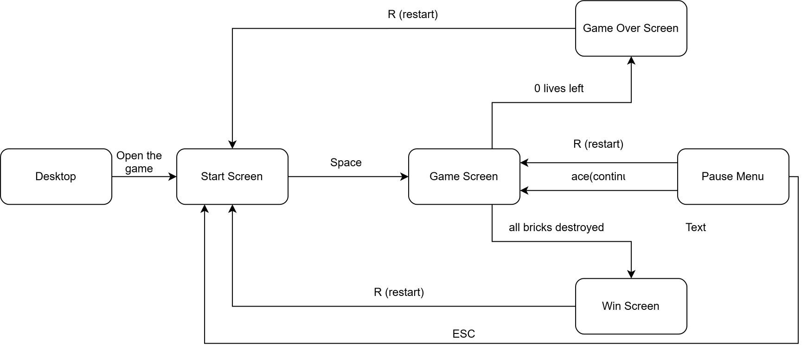

4. UI Wireframes
The wireframes below show the Start, Game, Pause, Game Over, and Win screens, worked out before implementation to settle the layout of each screen (score/lives placement, button text, overall composition) before writing any rendering code.
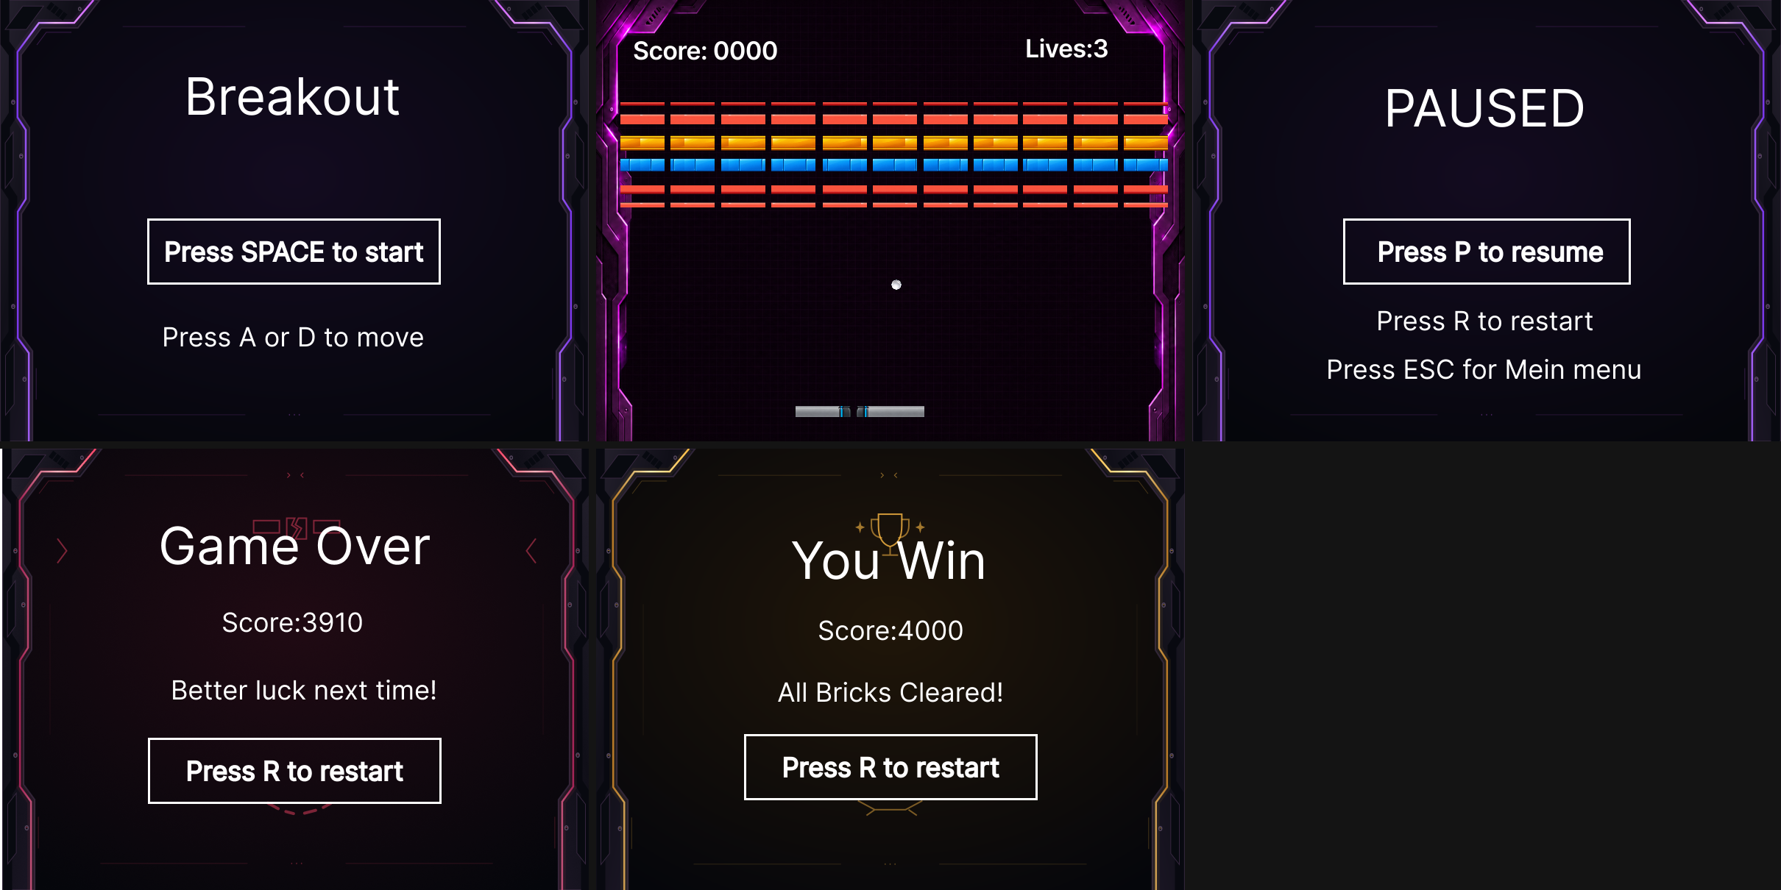
.

5. Data Model
This project does not use a database or any persistent storage, so no Entity-Relationship Diagram (ERD) is included. The equivalent role — describing what data the system holds and how it's organised — is instead fulfilled by the class diagram in section 2: for example, GameScreen holds the score and lives as fields, and owns the list of Brick objects that make up the game's in-memory state.

6. Collision Design
Collision detection uses axis-aligned bounding boxes (AABB). Each game object (Paddle, Ball, Brick) exposes a getBounds(): Rectangle method, and GameScreen checks the ball's bounds against the paddle, each brick, and the screen edges every frame using Rectangle.overlaps().
- Walls: overlapping the left/right edge inverts the ball's horizontal direction; overlapping the top edge inverts its vertical direction. Passing below the paddle costs a life instead.
- Bricks: on the first overlap with a non-destroyed brick, the brick is destroyed, the score increases, and the ball's vertical direction is reversed.
- Paddle: rather than a fixed bounce angle, the response blends where on the paddle the ball landed with the paddle's own velocity at the moment of contact, giving a "flick" effect (see requirement S01).
AABB was chosen over a full physics engine (e.g. LibGDX's Box2D) because all objects in this game are effectively rectangular, so overlap checks are fast and simple to reason about — a physics engine would add unnecessary setup for a game this size, without making the specific game-like bounce behaviour above any easier to achieve.

