OPD/dispensary KIOSK

Github link : <https://github.com/N1kunj1998/Synergy-Hackathon>

Idea/motivation:

Our project is based on the issues arising in dispensary/opd while registering patients.

Usually there is a need for a human operator that is tasked to register the incoming patient using their basic details, such as name, dob, gender.

This creates us a need for trained person at each small dispensary which on large scale causes huge resource requirements. Also during the pandemic this problem became worse as there was a necessary interaction between patient and registration desk.

Solution:

We have designed a full stack system that works in following fashion:

1. Patient/User will display his/her aadhar card into the camera and simply press the screenshot button, which will then allow us to get all the meta-data of the patient.
2. Now system will transition to next screen where there are cards of common symptoms with images and text, patient can select symptoms as per his/her choice.
3. Now the health card will be printed using which patient can visit doctor.

Tracks:

1. Heath care: This system reduces the burden on stretched out healthcare system as man-power is decreased, also reduction in human to human contact. Also as all the records are digitally stored so we can now help in creating a national health database and contributing to **Ayushman Bharat Health Account**.
2. Task Automation: we have effectively removed the use of Registration desk as we are automating the whole registration process.
3. Social Issues: we are tackling the problem of human contact resulting in reducing severity of pandemic in the society and at the same time we are digitizing the registration process resulting in contribution to **Digital India**.

Engineering:

1. For the frontend part we have used React.js. In this user will bring his/her Aadhar card in front of camera and will take screenshot of the same. Next if aadhar is successfully detected then there are cards of common symptoms that needs to be selected by patient, once that has been don our registration is complete and we are finally transitioned to last screen where we will print our receipt/health card. 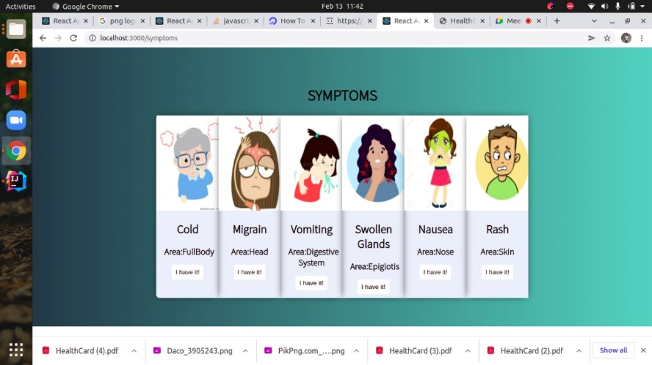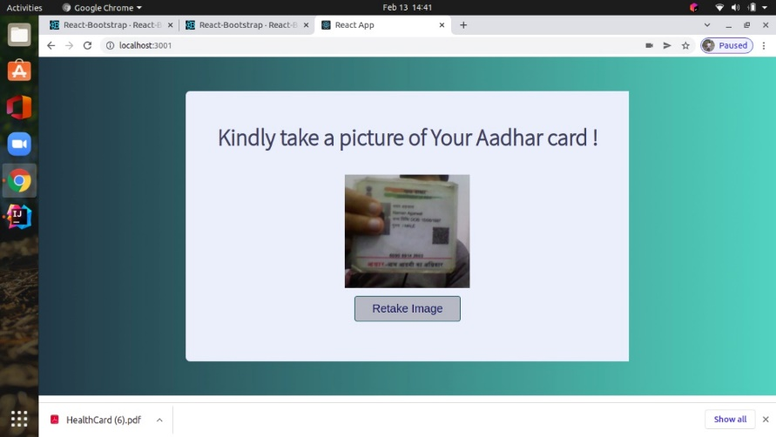
2. For backend we start with receiving aadhar screenshot, this is then fed into python script that extracts the meta-data from image, this metadata is stored in the database, then we send OK status to frontend and against this we receive symptoms from frontend. Now we send the whole meta-data to front-end to be printed in health card.
3. For Ml we used opencv and tesseract. First we detect and crop out the aadhar card from screenshot using contours detection. Then from this aadhar card image we extract text using tesseract, then carefully using regex we take out the exact meta-data we want.