Amazon India Product & Pricing Analysis
About the Project
This project is about analyzing product data from Amazon India.
The main aim is to understand product categories, prices, discounts, and ratings using data analysis tools.
For this project, I used:
- MySQL – to store and analyze the data
- Excel – for data cleaning, analysis, pivot tables and charts
- Power BI – to create the final dashboard
Objectives
- To clean the Amazon product data.
- To find the number of products in each category.
- To analyze product prices.
- To analyze discounts.
- To study product ratings.
- To create charts and dashboards.
- To find useful insights from the data.
Dataset
The dataset contains Amazon India product information such as:
- Product name
- Category
- Product price
- Original price
- Discount
- Product rating
- Number of ratings
- Number of offers
- Prime status
- Best Seller status
- Amazon Choice status
Tools Used
Tool | Use
MySQL | Data storage and SQL queries
Excel | Cleaning and analysis
Power BI | Dashboard and charts
Work Done in Excel
In Excel, I worked on:
- Cleaned Data
- Data Quality
- Category Analysis
- Price Analysis
- Discount Analysis
- Rating Analysis
- Insights
- Pivot Tables
- Charts
Work Done in MySQL
I created a database called:
amazon_india
and a table called:
amazon_india_products
I used SQL queries to find:
- Total number of products
- Products in each category
- Average price by category
- Lowest and highest prices
- Products with highest discounts
- Most expensive products
- Products with the highest number of ratings
- Overall product summary
Power BI Dashboard
I created a Power BI dashboard called:
Amazon India Product & Pricing Analysis
The dashboard shows:
- Total Products – 623
- Average Price – ₹28.23K
- Average Discount – 40.95%
- Average Rating – 3.92
It also contains charts for:
- Products by Category
- Average Price by Category
- Products by Rating Range
There are also filters for:
- Price Range
- Category
- Rating Range

Excel Screenshots (Insights)
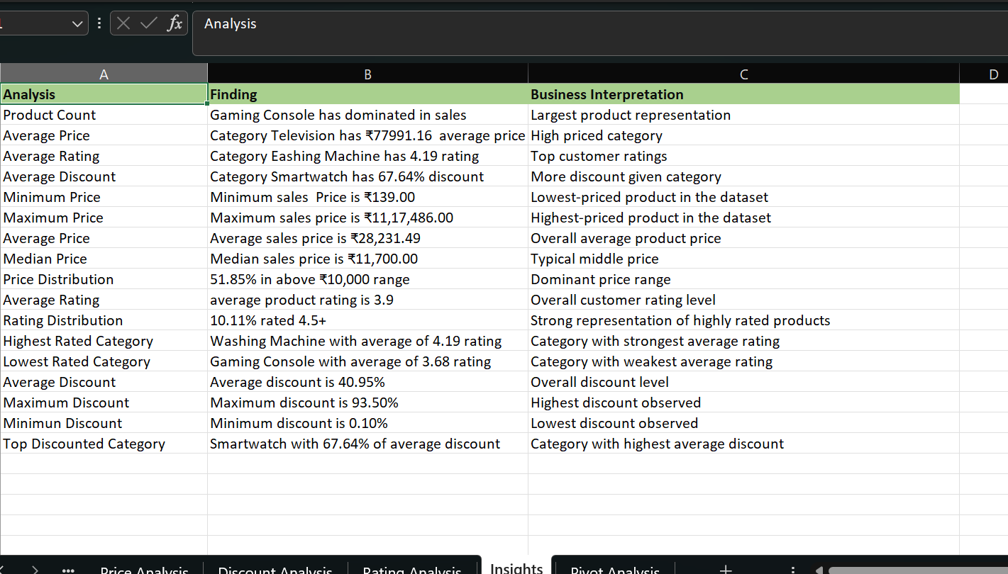

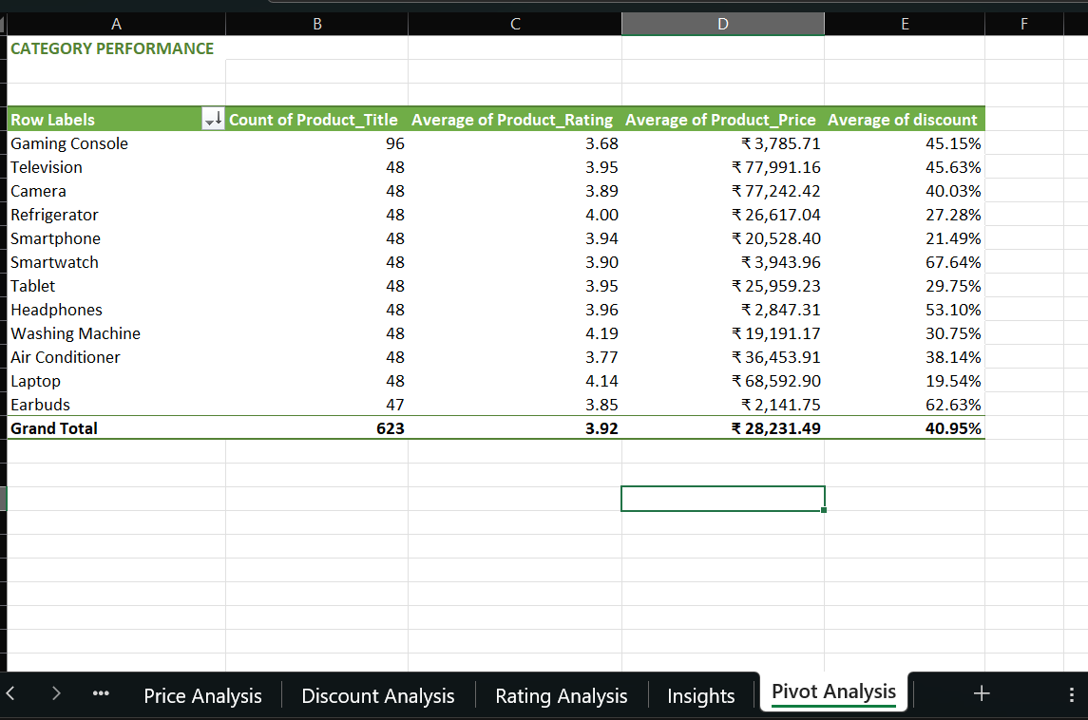

Power B I-Dashboard
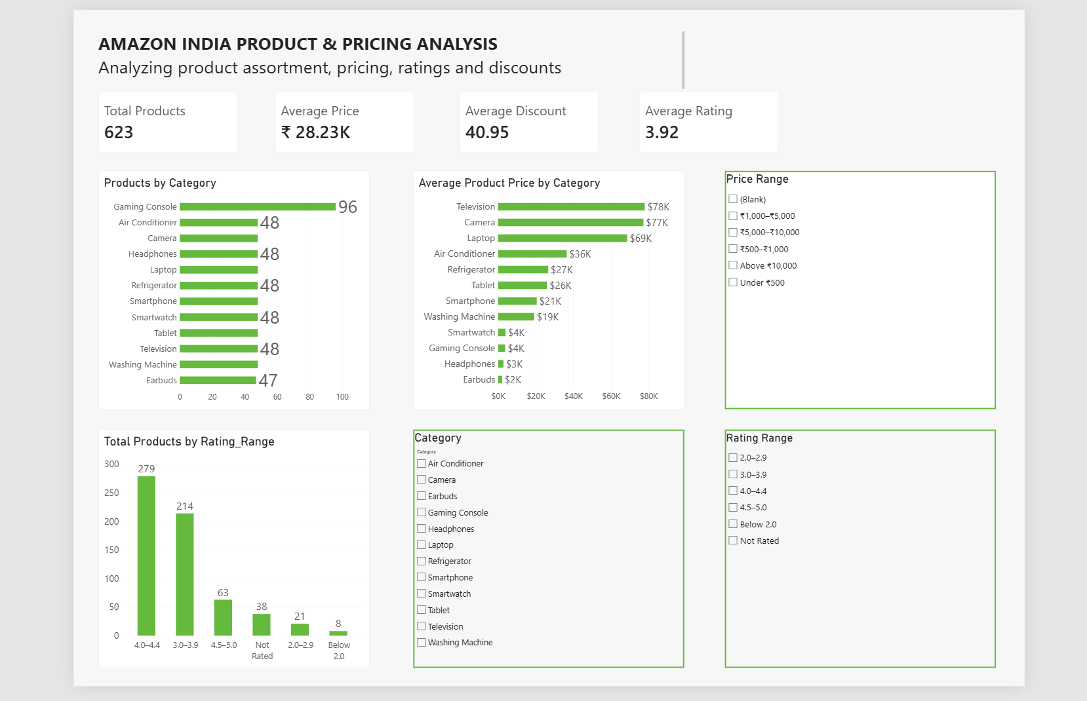

Conclusion
This project helped me understand how data can be cleaned, analyzed and presented using different tools.
MySQL was used for SQL analysis, Excel was used for cleaning and detailed analysis, and Power BI was used to create the dashboard.
Overall, the project helped me learn the basic process of data analysis using real-world product data.

