ShopEase : E-Commerce Checkout Abandonment Analysis & Optimization
Project Type: Business Analysis Case Study
Role: Business Analyst

1. Problem Statement
ShopEase, an e-commerce platform, is experiencing a high level of customer abandonment during the checkout process.
Customers are successfully adding products to their shopping carts and starting the checkout process, but a significant number leave before completing their purchases.
The business currently lacks sufficient visibility into the specific stages and factors contributing to checkout abandonment.
Potential contributing factors may include a lengthy checkout process, mandatory account creation, unexpected shipping charges, payment failures, and difficulties with the mobile checkout experience.
The business needs to identify the key causes of checkout abandonment and determine which improvements should be prioritized to improve checkout conversion and customer experience.

2. Business Objective
The objective of this project is to analyze and optimize the ShopEase e-commerce checkout process.
The project aims to:
- Identify where customers are dropping out of the checkout journey.
- Identify the major causes of checkout abandonment.
- Understand differences in checkout behavior across devices and payment methods.
- Identify process gaps in the current checkout experience.
- Recommend improvements that can increase checkout completion.
- Define business and functional requirements for the proposed improvements.
- Establish measurable KPIs to evaluate the success of the solution.
The initial business target is to improve checkout completion from an assumed baseline of 60% to approximately 70%.

Stakeholder | Role
Product Manager | Manages the checkout experience
Business Owner | Focuses on sales and revenue
Business Analyst | Analyzes the problem and gathers requirements
Development Team | Implements the solution
UX Designer | Improves the checkout design
Customers | Use the checkout process

4. Scope
In scope:
- Checkout process
- Payment
- Shipping charges
- Customer experience
- Checkout abandonment
- Mobile vs desktop
Out of scope:
- Inventory
- Marketing
- Warehouse
- Order delivery

5. Business Requirements
ID | Business Requirement
01 | Reduce checkout abandonment.
02 | Improve the checkout experience for mobile users.
03 | Reduce payment-related checkout failures.
04 | Make shipping charges clear before customers make payment.
05 | Make the checkout process faster and easier for customers.

6. User Stories
01 : Guest Checkout
As a customer, I want to complete my purchase without creating an account, so that I can checkout quickly and conveniently.
02 : Delivery Address
As a customer, I want to enter and edit my delivery address, so that my order can be delivered to the correct location.
03 : Shipping Charges
As a customer, I want to see the shipping charges before making payment, so that I know the total cost of my order.
04 : Payment Method
As a customer, I want to choose my preferred payment method, so that I can complete my purchase using a convenient payment option.
05 : Payment Retry
As a customer, I want to retry a failed payment, so that I can complete my purchase without restarting the checkout process.
06 : Order Confirmation
As a customer, I want to receive an order confirmation after successful payment, so that I know my order has been placed successfully.

7. Acceptance Criteria
User Story | Acceptance Criteria
US-01 | Given the customer has items in the cart, when they proceed to checkout, then they should be able to continue as a guest without creating an account.
US-02 | Given the customer is at the address stage, when they enter their delivery details, then they should be able to save and edit the address before continuing.
US-03 | Given the customer has reached checkout, when shipping is calculated, then the applicable shipping charges should be displayed before payment.
US-04 | Given the customer is at the payment stage, when payment options are displayed, then the customer should be able to select an available payment method.
US-05 | Given a payment attempt has failed, when the customer chooses to retry, then the system should allow another payment attempt without restarting checkout.
US-06 | Given the payment is successful, when the order is placed, then the customer should receive an order confirmation.

8. AS-IS Process
The current checkout process at ShopEase follows these steps:
Customer → Add to Cart → View Cart → Login / Sign Up → Enter Address → Select Delivery → Payment → Order Confirmation
Current Pain Points
- Customers may leave when they are asked to log in or create an account.
- Shipping charges may not be clear before payment.
- Payment failures may cause customers to abandon the checkout.
- The checkout process may contain more steps than necessary.
Process Summary
The customer starts by adding a product to the cart and then proceeds through login, address, delivery, and payment before receiving order confirmation. At different stages, customers may abandon the checkout process.

9. Gap Analysis
Current Situation | Gap / Problem | Required Improvement
Customers may need to create an account before checkout | Some customers may leave the process | Allow guest checkout
Shipping charges may not be clear early | Customers may be surprised by additional costs | Show shipping charges before payment
Payment can fail | Customers may abandon the purchase | Allow payment retry
Checkout has several steps | Process may take too long | Simplify the checkout process
Mobile experience may be difficult | Mobile users may abandon checkout | Improve mobile checkout experience
The main gaps identified are related to checkout complexity, payment failures, shipping cost visibility, and the mobile experience. Addressing these gaps may help reduce checkout abandonment.

10. TO-BE Process
The proposed checkout process is designed to make checkout simpler and more transparent for customers.
Customer → Add to Cart → View Cart → Start Checkout → Guest/Login → Address → Delivery → Order Summary + Shipping Charges → Payment → Order Confirmation
Proposed Improvements
- Allow customers to checkout as guests.
- Display shipping charges and the final order total before payment.
- Provide multiple payment options.
- Allow customers to retry failed payments.
- Simplify the checkout experience for mobile users.

11. Data Analysis Findings
Finding 1 : Checkout Completion Rate
The overall checkout completion rate is 63.60%, compared with the assumed business target of 70%. This represents a gap of 6.40 percentage points and indicates an opportunity to improve checkout conversion.
Finding 2 : Payment Failure Rate
The overall payment failure rate is 12.80%. Payment-method analysis shows that Wallet has the highest failure rate at 14.53%, followed by UPI at 14.29%, while Card has the lowest failure rate at 10.87%. This indicates that payment related issues may be contributing to checkout abandonment and should be investigated further.
Finding 3 : Average Checkout Time
The average checkout time is 4.46 minutes. This provides a baseline for evaluating future checkout-process improvements and determining whether changes to the checkout journey can reduce the time required to complete an order.
Finding 4 : Device-wise Checkout Performance
Checkout completion varies across devices. Mobile has the highest completion rate at 67.24%, while Desktop has the lowest at 61.11%. Tablet has a completion rate of 64.34%, while Laptop has a rate of 62.02%. This indicates that device-specific checkout behavior should be investigated further.
Finding 5 : Shipping Fee and Checkout Completion
Checkout completion rates vary across shipping-fee levels:
- ₹0 : 61.76%
- ₹49 : 66.40%
- ₹99 : 62.18%
- ₹149 : 64.17%
No consistent relationship was observed between higher shipping fees and lower checkout completion. Therefore, shipping fee alone does not appear to be a strong predictor of checkout abandonment in the analyzed dataset.
Finding 6 : Average Cart Value
The average cart value is 2,645.29. This provides a baseline for understanding the typical value of a customer's cart during the checkout journey and can be used to evaluate the potential revenue impact of improving checkout completion.
12. Overall Analysis Summary
The analysis indicates that ShopEase has a 63.60% checkout completion rate, which is below the assumed 70% target. Payment failures represent a notable potential contributor, with an overall failure rate of 12.80% and higher failure rates observed for Wallet and UPI. Checkout performance also varies by device, with Desktop showing the lowest completion rate. However, the shipping-fee analysis does not show a clear relationship between shipping charges and checkout abandonment.
These findings suggest that payment reliability, checkout experience, and device-specific usability should receive greater attention when prioritizing checkout improvements.

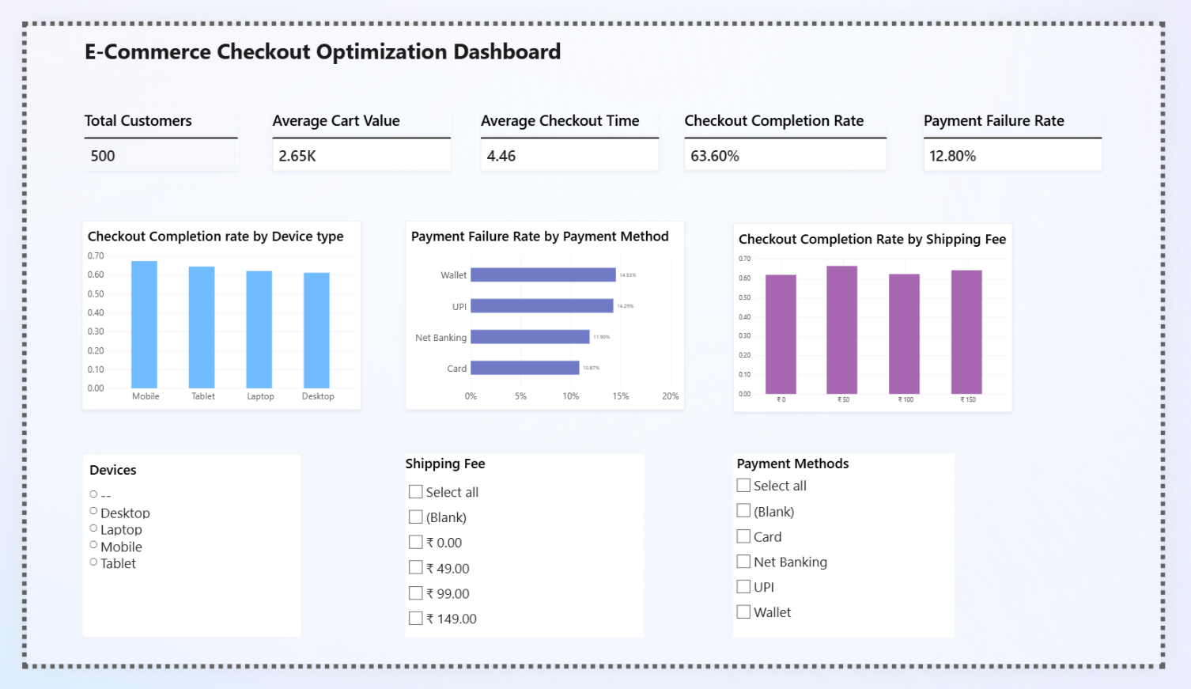
13.Dashboard (Power B I)

Excel
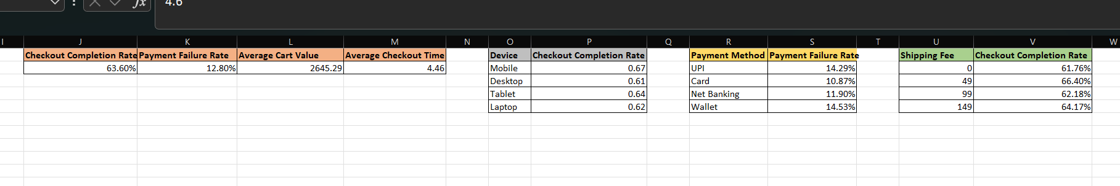

14. Analysis Summary
Metric | Result
Checkout Completion Rate | 63.60%
Target Completion Rate | 70%
Gap to Target | 6.40 percentage points
Payment Failure Rate | 12.80%
Average Cart Value | 2,645.29
Average Checkout Time | 4.46 minutes
Best Device | Mobile : 67.24%
Lowest Device | Desktop : 61.11%
Highest Payment Failure | Wallet : 14.53%
Lowest Payment Failure | Card : 10.87%

