***CO1 PROGRAMS***

**PROGRAM1**

n=int(input("enter limit:"))

squarelist=[i**2 for i in range(1,n+1)]

print("square of N numbers:",squarelist)

OUTPUT**PROGRAM2**

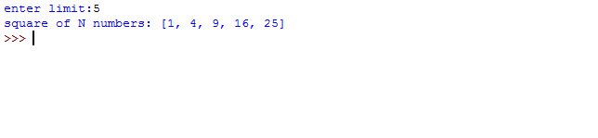

word=str(input("enter the word:"))

print("the original string is:"+word)

print("the vowels are :",end="")

for i in word:

if i in 'aeiouAEIOU':

print([i],end="")

OUTPUT

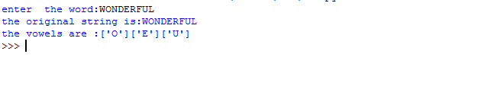

**PROGRAM3**

w=input("enter a word:")

print("ordinal values corresponding to each element is")

for i in w:

print(i,end=":")

print(ord(i),end=" ")

OUTPUT

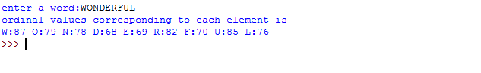

**PROGRAM4**

str1=input("enter a string")

wordlist=str1.split()

count=[]

for w in wordlist:

count.append(wordlist.count(w))

print("count of occurence:"+str(list(zip(wordlist,count))))

OUTPUT

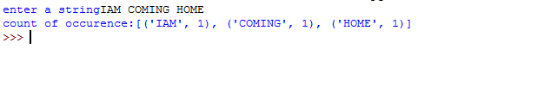

**PROGRAM5**

n=[]

s=int(input("enter a limit"))

print("enter {s} values")

for i in range (0,s):

n.append(int(input()))

print("\nthe list is after asssigning:\n")

for i in range(0,len(n)):

if n[i]>=100:

print("over")

else:

print(n[i])

OUTPUT

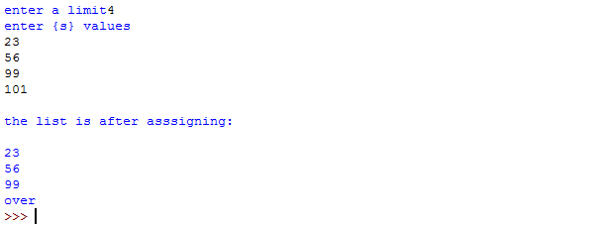

**PROGRAM6**

a_list=("a","b","a")

occ=a_list.count("a")

print("count of occurnces of a :",occ)

OUTPUT

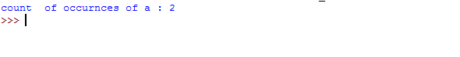

**PROGRAM7**

lst=[1,3,5,7,9,11,34]

lst1=[5,13,45,7,20,65,1]

s=int(0)

c=int(0)

if(len(lst)==len(lst1)):

print("lists are of same length")

else:

print("lists have diff length")

for i in range(0,len(lst) and len(lst1)):

s=s+lst[i]

c=c+lst1[i]

if(s==c):

print("equal sum")

else:

print("not same sum")

print("elements that matched are:")

l=[]

for i in range(0,len(lst)):

for j in range(0,len(lst1)):

if lst[i]==lst1[j]:

l.append(lst[i] and lst1[j])

else:

continue

print(l)

OUTPUT

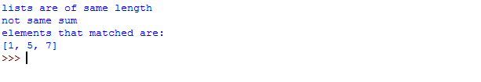

**PROGRAM8**

str1=input("enter a string:")

char=str1[0]

str1=str1.replace(char,'$')

str1=char+str1[1:]

print(str1)

OUTPUT



**PROGRAM9**

str=input("enter a string")

new_str=str[-1:]+str[1:-1]+str[:1]

print("new string:",new_str)

OUTPUT

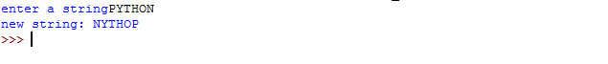

**PROGRAM10**

pi=3.14

r=float(input("input the radius of circle:"))

result=3.14*r**2

print("the area of circLe with radius is:",result)

OUTPUT

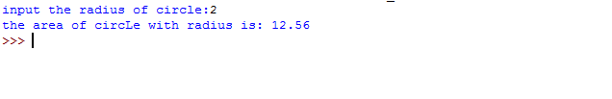

**PROGRAM11**

x=int(input("enter 1st number"))

y=int(input("enter 2nd number:"))

z=int(input("enter 3rd number"))

if(x>y) and (x>z):

largest=x

elif(y>x) and (y>z):

largest=y

else:

largest=z

print("largest no is",largest)

OUTPUT

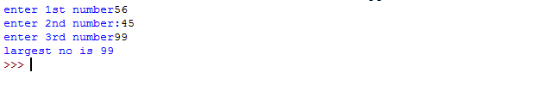

**PROGRAM12**

file=input("enter filename:")

f=file.split(".")

print("extension of file is:"+f[-1])

OUTPUT

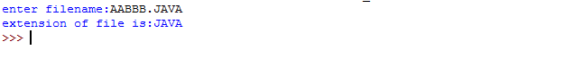

**PROGRAM13**

a=[]

for i in range(3):

b=input("enter the color")

a.append(b)

print(a)

print(a[0])

print(a[2])

OUTPUT

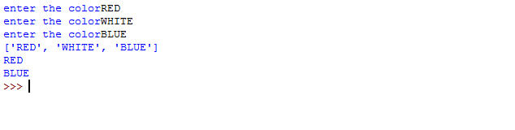

**PROGRAM14**

n=int(input("enter a number:"))

x=int("%s"%n)

y=int("%s%s"%(n,n))

z=int("%s%s%s"%(n,n,n))

print("n+nn+nnn:",x+y+z)

OUTPUT

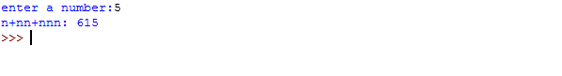

**PROGRAM15**

color_list_1=set(["white","pink","red","blue"])

color_list_2=set(["red","green","pink"])

print(color_list_1.difference(color_list_2))

OUTPUT



**PROGRAM16**

a="python"

b="java"

p1=a[0]

p2=b[0]

c=b[0]+a[1:len(a)]+" "+a[0]+b[1:len(b)]

print(a[1:len(a)])

print(c)

OUTPUT



**PROGRAM17**

import operator

d={1:2,3:4,4:3,2:1,0:0}

print('original dictionary:',d)

sorted_d=sorted(d.items(),key=operator.itemgetter(1))

print('dictionary in acending order by value',sorted_d)

sorted_d=dict(sorted(d.items(),key=operator.itemgetter(1),reverse=True))

print('dictionary in descending order by value:',sorted_d)

OUTPUT

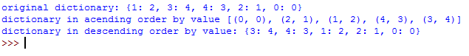

**PROGRAM18**

d1={'a':100,'b':200}

d2={'x':300,'y':200}

print("dictionary1=:",d1)

print("dictionary2=:",d2)

d=d1.copy()

d.update(d2)

print("merged dictionary:",d)

OUTPUT

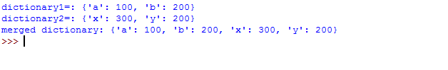

**PROGRAM19**

x=int(input("enter 1st no"))

y=int(input("enter 2nd no"))

i=1

while(i<=x and i<=y):

if(x%i==0 and y%i==0):

gcd=i

i=i+1

print("gcd:",gcd)

OUTPUT

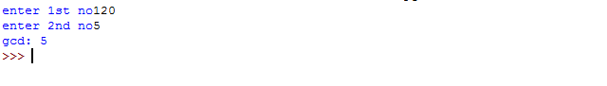

**PROGRAM20**

num=[7,8,120,25,44,20,27]

print("original list:",num)

num=[x for x in num if x%2!=0]

print("list after remooving even nos",num)

OUTPUT

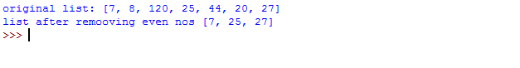

**PROGRAM-LEAP**

s=int(input("enter start year"))

e=int(input("enter end year:"))

if(s<e):

print("leap years are:",end="")

for i in range(s,e):

if i%4==0 and i%100!=0:

print(i,end=" ")

OUTPUT

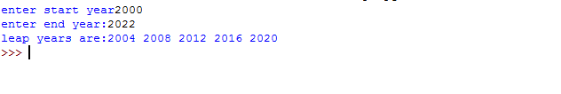

**PROGRAM-LIST**

list1=[-10,20,35,-67,70]

re=[num for num in list1 if num>=0]

print(re)

OUTPUT

