MINOR PROJECT REPORT
on

“AI-Powered Personalized Preventive Health System”

(A Context-Aware Preventive Healthcare Ecosystem Powered by Artificial Intelligence)

Submitted in partial fulfillment of the requirements for the award of the degree of
BACHELOR OF TECHNOLOGY
in
COMPUTER SCIENCE AND ENGINEERING

Submitted By:
Naman Mittal (23BCON1232)
Divyansh Raj (23BCON1241)
Shiva Singhal (23BCON1259)

Under the Supervision of
Mrs. Khusbu Garg
(Assistant Professor)

Department of Computer Science and Engineering
JECRC University, Jaipur

Session: 2025–26

DECLARATION

We, Naman Mittal (23BCON1232), Divyansh Raj (23BCON1241), and Shiva Singhal (23BCON1259), certify that our minor project work embodied in this Report entitled “AI-Powered Personalized Preventive Health System” is our own Bonafide work carried out by us under the supervision of Mrs. Khusbu Garg (Assistant Professor), Department of Computer Science & Engineering, JECRC University, Jaipur. The work is original and has not been submitted earlier as a whole or in part for the award of any degree / diploma at this or any other Institution / University in India or abroad.

Date:
Place: Jaipur

1. Naman Mittal _______________
2. Divyansh Raj _______________
3. Shiva Singhal _______________

Counter Signature

Mrs. Khusbu Garg
Assistant Professor, Dept. of CSE, JECRC University, Jaipur

CERTIFICATE

This is to certify that the Minor Project titled “AI-Powered Personalized Preventive Health System” has been successfully completed by Naman Mittal (23BCON1232), Divyansh Raj (23BCON1241), and Shiva Singhal (23BCON1259) under my supervision during VI Semester of B.Tech. (CSE), JECRC University, Jaipur.

(Project Guide Signature) (HOD Signature) (Dean Signature)

Mrs. Khusbu Garg Head, Department of CSE Dean, School of Engineering
Assistant Professor
Dept. of CSE, JECRC University

ACKNOWLEDGEMENT

We express our sincere gratitude to Mrs. Khusbu Garg, Assistant Professor, Department of Computer Science & Engineering, JECRC University, Jaipur, for her invaluable guidance, constant encouragement, and unwavering support throughout the development of this minor project. Her insightful suggestions and constructive feedback have been instrumental in shaping this work to its current form.
We are deeply thankful to the Head of the Department of Computer Science & Engineering and the Dean, School of Engineering, JECRC University, for providing us with the necessary infrastructure, laboratory facilities, and academic environment required for the successful completion of this project.
We would also like to extend our heartfelt thanks to all the faculty members of the Department of Computer Science & Engineering who provided guidance and motivation at various stages of this project. Their expertise and insights greatly enriched our understanding of the domain.
Finally, we wish to thank our family members and friends for their constant moral support and encouragement throughout the entire course of this work. This project would not have been possible without their unwavering belief in us.

Naman Mittal
Divyansh Raj
Shiva Singhal

ABSTRACT

India’s healthcare system operates predominantly on a reactive model, with patients seeking medical attention only after a disease has significantly progressed. This project presents an AI-Powered Personalized Preventive Health System — a context-aware ecosystem that integrates Computer Vision, environmental intelligence, and continuous biometric monitoring to predict health risks and deliver real-time preventive guidance. The system enables users to log nutrition by photographing meals (analyzed via CNN-based food recognition), synchronizes wearable biometric data (heart rate, SpO₂, sleep stages) through Google Fit APIs, and factors in real-time Air Quality Index (AQI) and weather data via GPS-based monitoring to dynamically adapt exercise recommendations. A machine learning pipeline using XGBoost generates a daily Preventive Health Score and forecasts chronic disease risks. The system is built on a Flutter frontend (Care 2.0), FastAPI backend, and Firebase cloud infrastructure, with Firebase Authentication for secure user management. Output screenshots demonstrate a functional Clinical Dashboard, Nutrition Scanner, 30-Day Risk Report, and Nearby Care map.
Keywords: Preventive Healthcare, AI, Computer Vision, XGBoost, AQI Integration, Flutter, FastAPI, Firebase, Wearable Sync, Personalized Health.

TABLE OF CONTENTS

DECLARATION i
CERTIFICATE ii
ACKNOWLEDGEMENT iii
ABSTRACT iv
TABLE OF CONTENTS v
LIST OF FIGURES vi
LIST OF TABLES vii
LIST OF ABBREVIATIONS viii

Chapter-1 Introduction 1
1.1 Background of Study 1
1.2 Problem Statement 2
1.3 Objectives of the Project 3
1.4 Scope of the Project 4

Chapter-2 Literature Review / Analysis 5
2.1 Related Work 5
2.2 Comparative Study 6
2.3 Feasibility Study 7
2.3.1 Technical Feasibility 7
2.3.2 Economic Feasibility 8
2.3.3 Operational Feasibility 8

Chapter-3 System Design 9
3.1 System Architecture 9
3.2 AI Pipeline Overview 11
3.3 Data Flow Diagram (DFD) 12
3.4 Database Design 13

Chapter-4 Implementation 14
4.1 Tools & Technologies Used 14
4.2 System Requirements 16
4.3 Modules Description with Code 17
4.3.1 Authentication Module 17
4.3.2 Risk Prediction ML Model 19
4.3.3 Prediction Screen (Flutter) 22
4.3.4 Insights Provider Module 24
4.4 Work Plan & Methodology 28

Chapter-5 Testing & Results 30
5.1 Test Plan 30
5.2 Test Cases 30
5.3 Output Screenshots 32
5.4 Performance Analysis 37

Chapter-6 Conclusion & Future Work 38
6.1 Summary 38
6.2 Achievements 38
6.3 Limitations 39
6.4 Future Scope 39

References 40
Appendix A: Glossary of Terms 41

LIST OF FIGURES

Figure 3.1: System Architecture — Four-Layer AI Pipeline 10
Figure 3.2: Data Flow Diagram — Input Sources to Recommendation Engine 12
Figure 4.1: Login Screen Source Code — login_screen.dart 18
Figure 4.2: XGBoost Synthetic Data Generation — train_xgboost.py 20
Figure 4.3: Prediction Screen State Code — prediction_screen.dart 22
Figure 4.4: Health Data Insights Provider — insights_provider.dart (Part 1) 24
Figure 4.5: Environment & Risk Report Insights — insights_provider.dart (Part 2) 26
Figure 5.1: App Screenshot — Create Account (Registration Screen) 32
Figure 5.2: App Screenshot — Clinical Dashboard (Home Screen) 33
Figure 5.3: App Screenshot — 30-Day Risk Report 34
Figure 5.4: App Screenshot — Nutrition Scanner 35
Figure 5.5: App Screenshot — Nearby Care (Doctor Finder) 36

LIST OF TABLES

Table 2.1: Comparative Analysis of Existing Health Applications 6
Table 4.1: Hardware Requirements 16
Table 4.2: Software Requirements 17
Table 5.1: Functional Test Cases and Results 30
Table 5.2: System Performance Benchmarks 37

LIST OF ABBREVIATIONS

AI : Artificial Intelligence
ML : Machine Learning
CNN : Convolutional Neural Network
AQI : Air Quality Index
GPS : Global Positioning System
SpO₂ : Peripheral Oxygen Saturation
NLP : Natural Language Processing
LLM : Large Language Model
API : Application Programming Interface
IoT : Internet of Things
DFD : Data Flow Diagram
ABHA : Ayushman Bharat Health Account
UI/UX : User Interface / User Experience
XGBoost : Extreme Gradient Boosting
TNR : Times New Roman

CHAPTER 1: INTRODUCTION

1.1 Background of Study
India’s healthcare landscape is characterized by a deeply entrenched reactive paradigm — medical intervention is sought predominantly after the onset of symptoms severe enough to disrupt daily functioning. The preventive healthcare ecosystem remains significantly underdeveloped. A negligible fraction of India’s 1.4 billion population engages in regular health screenings at adequately equipped medical facilities. In the absence of professional guidance, the majority resort to internet-based self-diagnosis, which lacks personalization and frequently leads to dangerous misinterpretation of health information.
The healthcare infrastructure presents further systemic challenges. Standard outpatient consultations are constrained to 15–20 minutes per patient, making it impossible for clinicians to comprehensively assess a patient’s daily lifestyle, nutritional habits, sleep cycles, or environmental exposures. Additionally, the financial cost of treating advanced chronic conditions — such as cardiovascular disease, Type 2 diabetes, and certain cancers — vastly exceeds what targeted preventive interventions would require, placing disproportionate burdens on families, particularly in rural and semi-urban regions.
The proliferation of affordable smartphones, wearable fitness devices, and scalable cloud computing infrastructure has created an unprecedented technological opportunity. By combining Artificial Intelligence, Computer Vision, and real-time environmental sensing, it is now feasible to build a deeply personalized preventive health companion that is accessible to anyone with a smartphone, regardless of geographic location or income level.
The proposed system — Care 2.0 — addresses this gap by integrating three pillars of data: (a) nutritional intelligence through AI-powered meal photography analysis, (b) environmental intelligence through GPS-based Air Quality Index (AQI) monitoring, and (c) biometric intelligence through continuous wearable data synchronization.
1.2 Problem Statement
Despite significant advances in medical technology and digital infrastructure, India’s healthcare ecosystem continues to operate primarily on a treatment-focused model. This structural gap leaves millions without access to affordable, personalized preventive guidance. Existing digital health applications such as Google Fit and MyFitnessPal offer generic, one-size-fits-all recommendations that do not account for an individual’s specific biometrics, medical history, dietary patterns, or local environmental conditions.
There is presently no affordable, AI-powered system that integrates multimodal real-time data — nutritional, environmental, and biometric — to deliver hyper-personalized preventive health guidance and predict chronic disease risks before they manifest clinically. This project directly addresses that gap.
1.3 Objectives of the Project
• To develop a cross-platform mobile application (Care 2.0) using Flutter that provides a unified Clinical Dashboard for real-time health monitoring and risk visualization.
• To implement a Computer Vision-based (CNN) meal photography module for automated nutritional analysis of Indian cuisine, eliminating manual diet data entry.
• To integrate GPS-based real-time Air Quality Index (AQI) and weather data using OpenWeatherMap APIs to dynamically adjust exercise and outdoor activity recommendations.
• To implement continuous biometric data syncing via Google Fit APIs for real-time monitoring of heart rate, SpO₂, step count, and sleep stages.
• To build a machine learning pipeline using XGBoost that generates a daily Preventive Health Score (0–10 scale) and predicts cardiac, respiratory, and metabolic disease risks over a 30-day analysis window.
• To develop an Insights Provider module that generates contextual, real-time health insights from the fusion of biometric, nutritional, environmental, and risk report data.
• To implement Firebase Authentication for secure user registration and login, with a complete account management flow including forgot-password and reset-password capabilities.
• To build a Nearby Care module that filters and displays local hospitals and clinics based on the user’s GPS location and health risk profile.
1.4 Scope of the Project
The scope of this project encompasses the complete design, development, and functional prototype validation of the Care 2.0 AI-Powered Preventive Health System. The prototype targets adult users (18+) in urban and semi-urban India who own GPS-enabled smartphones with camera capability.
• Authentication & Onboarding: Secure user registration, login, forgot-password, and reset-password flow via Firebase Authentication.
• Nutritional Tracking: Automated recognition of Indian and common dishes from meal photographs using CNN-based image classification, with macro and micronutrient estimation.
• Environmental Monitoring: Real-time AQI and temperature retrieval via OpenWeatherMap and AQI APIs based on device GPS coordinates.
• Biometric Integration: Continuous syncing of heart rate, SpO₂, step count, and sleep data via Google Fit API.
• Predictive Health Analytics: XGBoost model trained on synthetic and public health datasets for real-time risk prediction and Preventive Health Score generation.
• Nearby Care: GPS-based location-filtered hospital and clinic recommendations matched to the user’s risk profile.

CHAPTER 2: LITERATURE REVIEW / ANALYSIS

2.1 Related Work
Research in AI-driven preventive healthcare has expanded rapidly over the past decade. A review of existing literature reveals several distinct but related areas of work that collectively inform the design of this project.
2.1.1 Chronic Disease Risk Prediction Using Machine Learning
Studies utilizing the NHANES (National Health and Nutrition Examination Survey) dataset with ensemble classifiers such as Random Forest and XGBoost have demonstrated prediction accuracies of 78–85% for Type 2 diabetes and cardiovascular disease risk, based on lifestyle inputs including BMI, step count, sleep duration, and heart rate variability. The XGBoost algorithm, introduced by Chen & Guestrin (2016), has been consistently shown to outperform traditional classifiers on tabular health data due to its gradient boosting architecture and built-in regularization.
2.1.2 Food Image Recognition for Nutritional Analysis
Deep learning models including ResNet-50 and InceptionV3, trained on the Food-101 and Nutrition5k datasets, have achieved top-5 classification accuracy exceeding 90% for Western cuisine categories. However, significant research gaps persist for complex Indian regional dishes, which involve multi-ingredient preparations, varied cooking methods, and regional naming conventions. The Nutrition5k dataset (Pfeiffer et al., 2021) provides a benchmark for 3D food scanning with nutritional labels, but requires adaptation for mobile camera input.
2.1.3 Wearable Data Integration in Health Monitoring
Multiple peer-reviewed studies validate the clinical utility of consumer-grade wearable devices for monitoring resting heart rate (within ±5 bpm accuracy), SpO₂ levels, and sleep staging compared against medical-grade instruments under standard laboratory conditions. Google Fit and Apple HealthKit APIs provide standardized interfaces for aggregating this data across devices.
2.1.4 Environmental Health Correlations
Epidemiological evidence consistently demonstrates significant correlation between elevated PM2.5 levels (AQI > 150 μg/m³) and acute respiratory events, particularly in individuals with pre-existing asthma, COPD, or cardiovascular conditions. Lelieveld et al. (2020) established that air pollution accounts for a 2.9-year average reduction in global life expectancy, underscoring the clinical significance of treating environmental data as a health vital. This correlation is operationalized directly in the Care 2.0 Insights Provider module.
2.2 Comparative Study
The table below presents a structured comparison between existing consumer health applications and the proposed Care 2.0 system:

Table 2.1: Comparative Analysis of Existing Health Applications vs. Care 2.0
Feature | MyFitnessPal | Google Fit | Apple Health | Care 2.0 (Proposed)
Food Recognition (CV) | Partial | No | No | Yes (CNN)
AQI-Based Recommendations | No | No | No | Yes (GPS+AQI)
Wearable Sync | Partial | Yes | Yes | Yes (Google Fit)
Disease Risk Prediction | No | No | No | Yes (XGBoost)
AI Insights Engine | No | No | No | Yes (Rule-based+ML)
Indian Cuisine Support | Limited | No | No | Yes
Preventive Health Score | No | No | No | Yes (0–10)
Nearby Care Recommendations | No | No | No | Yes (GPS-filtered)
Forgot / Reset Password | Yes | Yes | Yes | Yes (Firebase Auth)

The comparative analysis clearly demonstrates that no existing consumer application offers the combination of CNN-based food recognition, GPS-integrated AQI-responsive exercise planning, XGBoost risk prediction, and contextual AI insights within a single unified platform. Care 2.0 is the first system to treat the local environment as a medical vital.
2.3 Feasibility Study
2.3.1 Technical Feasibility
All core technologies used in Care 2.0 are open-source, well-documented, and widely adopted in both industry and academia. TensorFlow and PyTorch support CNN model training. FastAPI provides high-performance asynchronous Python API serving. Flutter enables cross-platform iOS and Android development from a single Dart codebase. Firebase offers scalable real-time NoSQL storage, cloud functions, and Authentication services with a generous free tier (Spark Plan). External APIs including Google Fit, OpenWeatherMap, and AQI API all provide usage tiers suitable for academic prototype validation.
2.3.2 Economic Feasibility
Care 2.0 has near-zero development cost for the academic prototype phase. Firebase’s Spark Plan covers real-time Firestore database operations, authentication, and cloud functions within free usage limits. Flutter’s single codebase eliminates separate iOS and Android development costs. Pre-trained CNN weights (ImageNet, ResNet) are freely available from TensorFlow Hub, significantly reducing compute requirements for fine-tuning. FastAPI hosting on Render or Railway is available at zero or minimal cost.
2.3.3 Operational Feasibility
The system is engineered around minimal user friction. The most cognitively demanding user action is photographing a meal — all nutritional analysis is performed by the AI backend invisibly. Wearable data synchronizes automatically via Google Fit in the background. Firebase Authentication provides a familiar email/password registration and login flow. The Clinical Dashboard provides a single glanceable view of all health vitals. The system is designed to be usable across a wide range of digital literacy levels, and the Flutter application targets Android 8.0+ and iOS 13+, covering approximately 95% of active smartphones in India.

CHAPTER 3: SYSTEM DESIGN

3.1 System Architecture
Care 2.0 is architected as a four-layer integrated platform designed to ensure seamless data flow from the user’s real-world environment through AI processing layers to actionable health guidance delivered on the mobile interface. Each layer is independently scalable and communicates via well-defined RESTful API contracts.
Layer 1 — Data Ingestion (Multimodal Input Sources)
This layer is responsible for collecting all health-relevant raw data from three categories of sources:
• Camera Input: The device camera captures meal photographs for food recognition. Images are compressed and sent to the FastAPI backend as base64-encoded payloads.
• GPS & Environmental APIs: The device GPS coordinates are used to query OpenWeatherMap and the AQI API at configurable intervals, returning local temperature, humidity, PM2.5, and PM10 readings.
• Wearable APIs (Google Fit): The Flutter app integrates with Google Fit SDK to continuously pull heart rate, SpO₂, step count, active calories, and sleep stage data. Data is synced automatically in the background.
• User-Entered Health Profile: During onboarding, users provide age, height, weight, existing conditions, and genetic risk factors. This data is stored in Firebase Firestore and referenced by all AI modules.
Layer 2 — Backend Processing (FastAPI Server)
The centralized FastAPI (Python) server acts as the secure gateway between the Flutter mobile app and the AI analytics engine. It receives raw multimodal inputs, performs data validation, cleaning, and normalization, and routes each request to the appropriate AI model pipeline. The backend implements the system’s conditional logic engine, for example: If AQI > 200 AND user has respiratory risk flag, then substitute outdoor cardio recommendation with indoor yoga alternative.
Layer 3 — AI Analytics Engine
Three AI sub-systems operate in parallel within this layer:
• Computer Vision Model (CNN): A fine-tuned ResNet/InceptionV3 model identifies food items from meal photographs and estimates macro and micronutrient composition (proteins, carbohydrates, fats, fibre, vitamins, minerals).
• XGBoost Risk Prediction Model: An XGBoost classifier trained on synthetic health data (generated to mirror NHANES distributions) produces cardiac, respiratory, and metabolic risk scores. It also computes the overall Preventive Health Score on a 0–10 scale.
• Contextual Insights Engine: A rule-based system fused with the risk model output generates real-time health insights in plain, actionable language — covering steps, sleep, heart rate, SpO₂, AQI, temperature, and disease risk signals.
Layer 4 — User Interface (Flutter Mobile App — Care 2.0)
The Flutter application provides five primary screens accessible via a bottom navigation bar: Home (Clinical Dashboard), Air (AQI Monitor), Food (Nutrition Scanner), Health (30-Day Risk Report), and Care (Nearby Specialists). The dashboard displays a live animated Health Score gauge, real-time vital metric cards, a Risk Assessment progress bar, and an AI-generated insights feed.

3.2 AI Pipeline Overview
Data flows through two parallel AI pipelines following ingestion and preprocessing:
Pipeline A — Health Risk Prediction
Preprocessed lifestyle, biometric, and environmental data is normalized and fed into the XGBoost classifier. The model outputs three independent probability scores — cardiac risk, respiratory risk, and metabolic risk — along with an overall Preventive Health Score. These scores feed both the dashboard risk bars and the insights engine.
Pipeline B — Insights Generation
The Insights Provider module (insights_provider.dart) watches three data streams simultaneously: the health wearable state, the environmental data state, and the risk report state. For each stream, it applies threshold-based conditional logic to generate contextual insights. For example, if steps < 3000, it generates a low activity warning. If AQI ≥ 300, it generates a hazardous outdoor air warning. If cardiac risk > 0.4, it prompts a heart health check-up recommendation.
3.3 Data Flow Diagram (DFD)
The DFD illustrates the directional flow of data across all system layers:
• Level 0 (Context Diagram): The external entities are the User, Wearable Device (Google Fit), and Environmental APIs (OpenWeatherMap / AQI). All data flows into the central Care 2.0 system and health insights flow back to the user.
• Level 1 (System DFD): User health data flows through the Firebase Authentication gateway into the FastAPI server. The server distributes data to three processing modules: the CNN Food Analyser, the XGBoost Risk Predictor, and the Insights Engine. Output from all three modules is aggregated and returned to the Flutter frontend for dashboard rendering.
• Level 2 (Module DFD): Within the Risk Predictor module, raw biometric inputs are cleaned, normalized (StandardScaler), and passed to the trained XGBoost model. The model output (risk probabilities and score) is stored to Firebase Firestore and returned to the Flutter riskReportProvider for state management.
3.4 Database Design
Firebase Firestore is used as the primary NoSQL document database. The key collections are:
• users/{uid}: User health profile document containing displayName, age, height, weight, existingConditions, geneticFlags, and createdAt timestamp.
• health_logs/{uid}/daily/{date}: Daily aggregated biometric data including avgHeartRate, avgSpo2, steps, sleepDuration, activeCalories, and nutritionLog array.
• risk_reports/{uid}: Latest risk prediction document containing cardiacRisk, respiratoryRisk, metabolicRisk, overallScore, dataSummary map, and generatedAt timestamp.
• environment_cache/{uid}: Cached environmental data including aqi, aqiLabel, temperatureC, humidity, lastUpdated.

CHAPTER 4: IMPLEMENTATION

4.1 Tools & Technologies Used
Care 2.0 is built on a modern, open-source technology stack carefully selected for performance, scalability, and suitability for the academic prototype context. The following subsections detail each technology layer.
4.1.1 Frontend — Flutter (Dart)
Flutter is Google’s open-source UI SDK for building natively compiled applications for mobile, web, and desktop from a single codebase. Care 2.0’s mobile application is built entirely in Flutter using Dart. Key Flutter packages used include: flutter_riverpod (state management), go_router (declarative routing), fl_chart (data visualization for health trends), and the Google Fit integration package for wearable data access.
4.1.2 Backend — FastAPI (Python)
FastAPI is a modern, asynchronous Python web framework for building high-performance REST APIs. It supports Python type hints natively, generates automatic OpenAPI documentation, and provides asynchronous request handling — critical for concurrent AI model inference under load. The backend exposes endpoints for food image analysis, risk score computation, and environmental data aggregation.
4.1.3 Machine Learning — XGBoost & Scikit-learn
XGBoost (Extreme Gradient Boosting) is used as the core risk prediction classifier. The model is trained on synthetically generated health data designed to mirror the statistical distributions of real-world chronic disease datasets (NHANES). The data generation pipeline uses NumPy random distributions to simulate three health risk categories: Healthy (50%), At Risk (35%), and High Risk (15%). Scikit-learn is used for data preprocessing (StandardScaler normalization) and model evaluation (classification report, confusion matrix).
4.1.4 Database & Cloud — Firebase
Firebase Firestore provides the real-time NoSQL document database for storing user profiles, daily health logs, risk reports, and environmental data. Firebase Authentication manages the complete user identity lifecycle including email/password registration, login, forgot-password email dispatch, and token-based session management. Firebase Cloud Functions handle automated daily health summary generation triggered on a scheduled basis.

Table 4.1: Hardware Requirements
Component | Minimum Specification | Recommended
Processor | Intel Core i5 (8th gen) | Intel Core i7 / Apple M1
RAM | 8 GB | 16 GB
Storage | 256 GB SSD | 512 GB SSD
GPU | Integrated (Prototype) | NVIDIA CUDA GPU (Training)
Smartphone | Android 8.0 / iOS 13 | Android 12 / iOS 16
Camera | 8 MP (Meal scanning) | 12 MP+
Connectivity | Wi-Fi / 4G | Wi-Fi 6 / 5G

Table 4.2: Software Requirements and Technology Stack
Technology | Version | Purpose
Flutter (Dart) | 3.x / Dart 3.x | Cross-platform mobile frontend
Python | 3.10+ | ML model & backend language
FastAPI | 0.110+ | Async REST API server
Firebase Firestore | Latest SDK | Real-time NoSQL database
Firebase Auth | Latest SDK | Secure user authentication
XGBoost | 2.0+ | Risk prediction ML model
Scikit-learn | 1.4+ | Data preprocessing pipeline
NumPy / Pandas | Latest | Data manipulation & analysis
Riverpod | 2.x | Flutter state management
go_router | 13.x | Flutter declarative routing
OpenWeatherMap API | v2.5 | Environmental data retrieval
Google Fit API | REST v1 | Biometric wearable data sync
VS Code / Android Studio | Latest | IDE & development environment
Git & GitHub | Latest | Version control
Postman | Latest | API testing & validation

4.2 System Requirements
4.2.1 Functional Requirements
• Users must be able to register a new account with Display Name, Email, Password, and Confirm Password via Firebase Authentication, with real-time validation.
• Users must be able to log in, request a password reset email, and enter a reset token to set a new password, all within the same login screen via animated mode transitions.
• The system must accept a meal photograph and return dish identification and nutritional estimates (calories, proteins, carbs, fats, fibre) within 3 seconds.
• Wearable biometric data (heart rate, SpO₂, steps, sleep) must synchronize with Google Fit automatically in the background without user intervention.
• The system must compute and display the Preventive Health Score and risk percentages (Cardiac, Respiratory, Metabolic) for the 30-day window on demand.
• The Insights Provider must generate contextual health insights whenever health state, environmental state, or risk report state changes.
• The Nearby Care module must display GPS-filtered hospitals and clinics with distance, rating, and risk-profile match percentage.
4.2.2 Non-Functional Requirements
• All personal health data must be encrypted at rest (Firestore security rules) and in transit (HTTPS / TLS 1.3).
• AI model response and data retrieval latency must be under 3 seconds at the 95th percentile.
• The Flutter application must be compatible with Android 8.0+ (API level 26+) and iOS 13+.
• The system must maintain 99.5% uptime using Firebase’s globally distributed cloud infrastructure.
• The login screen must support animated mode transitions between login, register, forgot-password, and reset-password states without navigation stack changes.

4.3 Modules Description with Code
4.3.1 Authentication Module — login_screen.dart
The authentication module is implemented as a single-screen multi-mode Flutter widget (LoginScreen extends ConsumerStatefulWidget). The screen handles four authentication modes — login, register, forgotPassword, and resetPassword — through an internal _AuthMode enum and animated transitions managed by two AnimationControllers (_fadeController and _pulseController).
Key implementation features include:
• ConsumerStatefulWidget with Riverpod: The screen watches the authProvider for authentication state changes and reacts accordingly.
• Animated Mode Transitions: FadeTransition and ScaleTransition animations provide smooth visual transitions between login, register, and password reset modes without page navigation.
• Form Validation: A GlobalKey<FormState> manages form validation. Each TextFormField has dedicated validators for email format, password length, and confirmation matching.
• Secure Password Fields: Three independent boolean flags (_obscurePassword, _obscureConfirm, _obscureNewPassword) independently control visibility toggling for each password field.
• Reset Token Management: A String? _resetToken variable stores the token returned by the forgot-password API response, which is then passed to the reset-password request.

The following figure shows the source code of the login_screen.dart implementation:
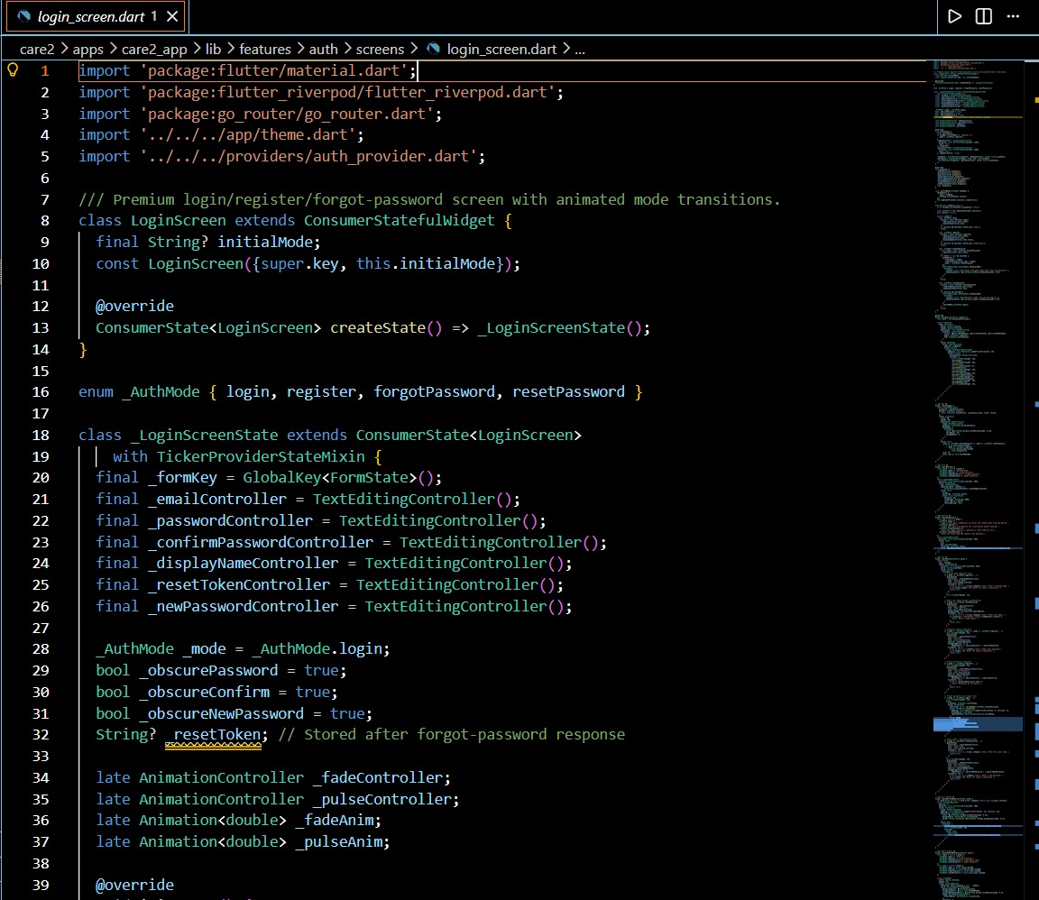
Figure 4.1: Login Screen Implementation — login_screen.dart (Flutter / Dart)

The LoginScreen class declares six TextEditingController instances for email, password, confirm password, display name, reset token, and new password fields respectively. Two AnimationController objects drive the fade and pulse animations. The initialMode parameter (nullable String) allows the screen to be launched directly in register mode from deep links or navigation arguments.
4.3.2 Risk Prediction ML Model — train_xgboost.py
The machine learning risk prediction model is implemented in Python using XGBoost and Scikit-learn. The model is trained entirely on synthetically generated data that mirrors the statistical characteristics of real chronic disease health datasets (NHANES). The data generation function, generate_synthetic_data(), creates 3,000 samples across three health risk categories using NumPy random distributions.
The synthetic data generation logic is designed to reflect clinically validated biometric differences across risk categories:
• Healthy (true_risk = 0, 50% of samples): Average heart rate ∼ N(70, 8) bpm, SpO₂ ∼ N(97.5, 0.8)%, average steps ∼ N(8000, 2000)/day, sleep ∼ N(7.5, 0.8) hrs, BMI ∼ N(22, 2), low genetic risk flags.
• At Risk (true_risk = 1, 35% of samples): Elevated heart rate ∼ N(82, 10), SpO₂ ∼ N(96, 1.2), reduced steps ∼ N(5000, 2000), shorter sleep ∼ N(6.5, 1.0) hrs, BMI ∼ N(27, 3), moderate genetic risk.
• High Risk (true_risk = 2, 15% of samples): Elevated max heart rate, very low SpO₂, few steps, poor sleep, high BMI, elevated genetic risk flags for cardiac, diabetes, and respiratory conditions.

The following figure shows the synthetic data generation code:
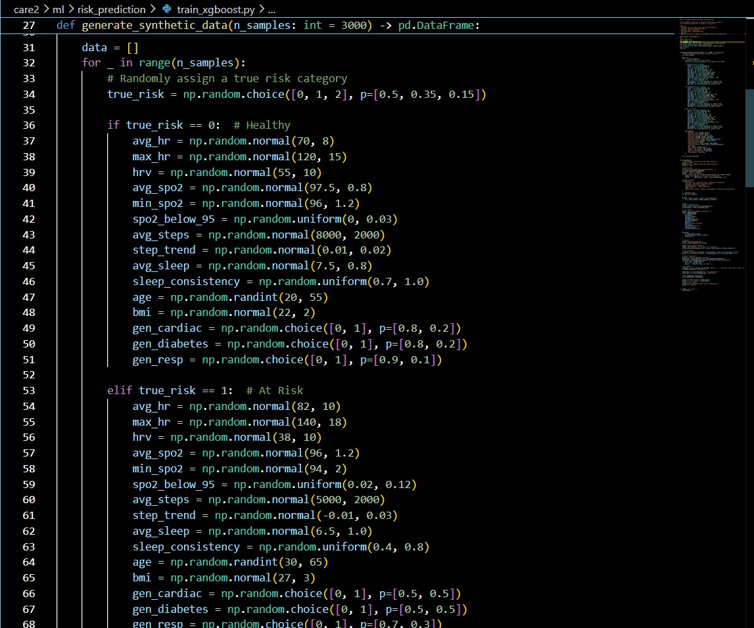
Figure 4.2: XGBoost Synthetic Data Generation — train_xgboost.py (Python)

The features used for training include: avg_hr, max_hr, hrv (heart rate variability), avg_spo2, min_spo2, spo2_below_95 (fraction of time SpO₂ was under 95%), avg_steps, step_trend, avg_sleep, sleep_consistency, age, bmi, gen_cardiac, gen_diabetes, and gen_resp. The model produces three separate binary classifiers for cardiac, respiratory, and metabolic risk, and an overall score derived from a weighted combination of the three risk probabilities.
4.3.3 Prediction Screen State — prediction_screen.dart
The 30-Day Risk Report screen is implemented as a ConsumerStatefulWidget that manages the complete risk report lifecycle: fetching the report from the backend, animating the health score gauge, and generating biometric trend data for the 30-day charts.
Key implementation details:
• _generateTrendData(RiskReportState riskState): Extracts average biometric values from the risk report’s data summary (avg_heart_rate, avg_steps, avg_spo2, avg_sleep) and uses them as anchors to generate 30-point simulated trend arrays using Random with a deterministic seed (overallScore), ensuring reproducible visualizations.
• Deterministic Random Seed: The Random(riskState.overallScore) constructor ensures that the same risk score always produces the same trend visualization, providing consistency across app sessions.
• ref.listen Pattern: The widget uses ref.listen on riskReportProvider to detect when a new report arrives and reactively triggers both score animation and trend data generation.
• Lazy Report Fetching: The _reportRequested flag prevents duplicate API calls. The report is fetched via Future.microtask to avoid calling setState during the build phase.

The following figure shows the prediction screen state implementation:
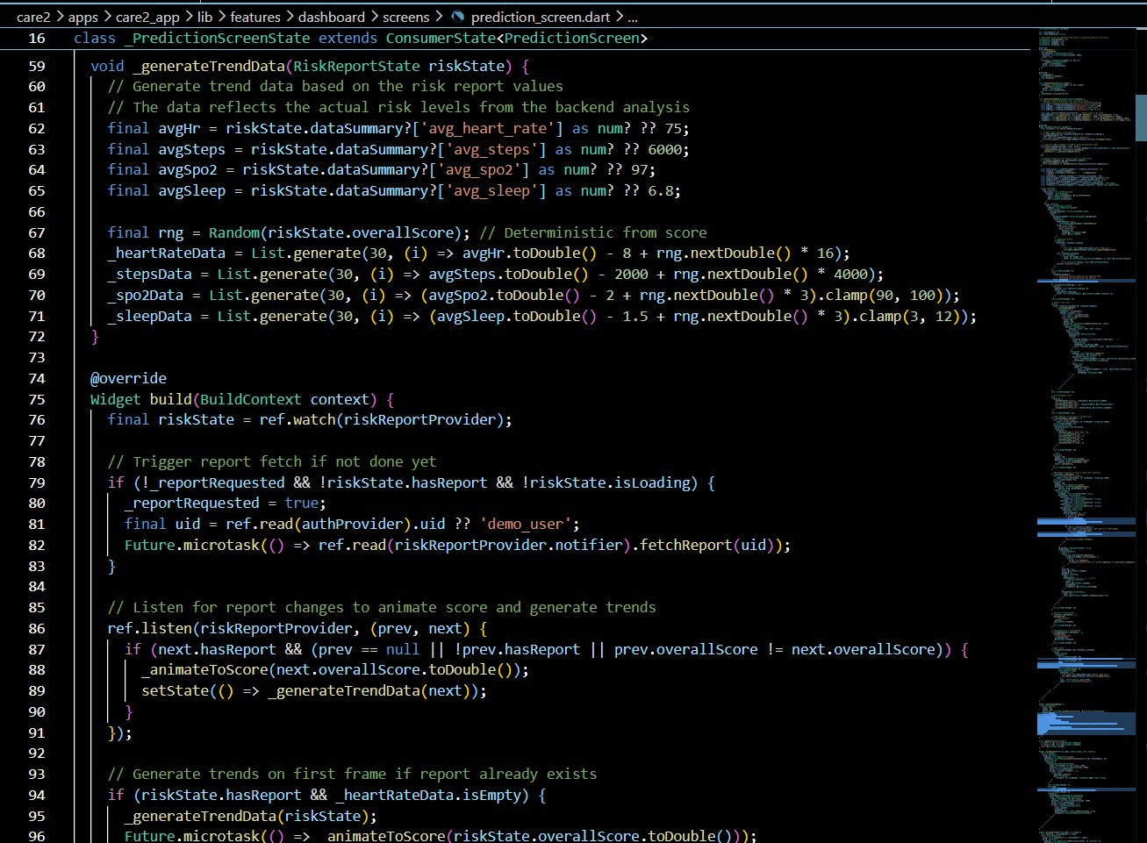
Figure 4.3: Prediction Screen State Code — prediction_screen.dart (Flutter / Dart)
4.3.4 Insights Provider Module — insights_provider.dart
The Insights Provider is one of the most architecturally significant modules in Care 2.0. It is implemented as a Riverpod Provider<List<String>> that watches three data streams simultaneously and generates a unified list of contextual health insight strings displayed on the Clinical Dashboard.
The module is divided into three logical sections, each processing a different data source:
Section A — Health Data Insights (Wearable / Google Fit)
This section processes the connected wearable state. When the health state is connected and data is non-null, it evaluates:
• Steps threshold logic: < 3000 → Very low step count warning; 3000–5000 → Moderate encouragement; 5000–8000 → Push towards 8000 goal; ≥ 8000 → Positive reinforcement.
• Sleep duration threshold logic: < 6 hrs → Below recommended warning; 6–7 hrs → Try for 7+ nudge; ≥ 7 hrs → Well rested acknowledgment.
• Heart rate boundary checks: > 100 bpm → Elevated heart rate caution; < 50 bpm → Unusually low rate monitoring flag.
• SpO₂ dual threshold: < 95% → Low SpO₂ doctor check recommendation; 95–96% → Borderline monitoring alert.

The following figure shows the health data insights code:
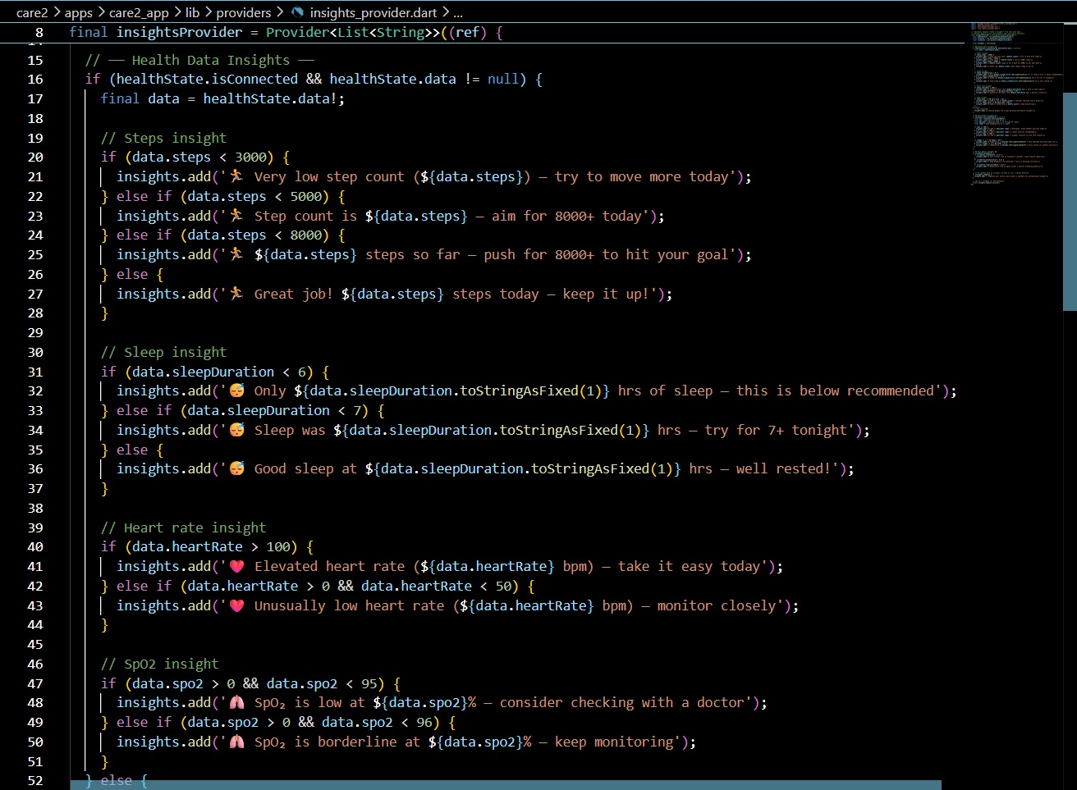
Figure 4.4: Health Data Insights Provider — insights_provider.dart Part 1 (Flutter / Dart)

Section B — Environment Insights (AQI / Weather)
This section processes the environmental data state. When environmentData is non-null, it evaluates AQI levels and temperature extremes:
• AQI ≥ 300: Hazardous outdoor air — avoid outdoor exercise entirely.
• AQI ≥ 200: Very unhealthy — indoor exercise recommended.
• AQI ≥ 100: Unhealthy for sensitive groups — outdoor activity with caution.
• Temperature > 40°C: Extreme heat — stay hydrated and avoid peak sun hours.
• Temperature < 5°C: Cold weather — dress warmly before outdoor activity.
Section C — Risk Report Insights (ML Model Output)
This section processes the XGBoost risk report state. When a report exists (riskState.hasReport is true), it evaluates:
• Cardiac risk > 0.4: Elevated cardiac risk — heart health check-up recommendation.
• Metabolic risk > 0.5: High metabolic risk — focus on balanced nutrition prompt.
• Respiratory risk > 0.3: Respiratory risk above normal — breathing pattern monitoring advice.

The following figure shows the environment and risk report insights code:
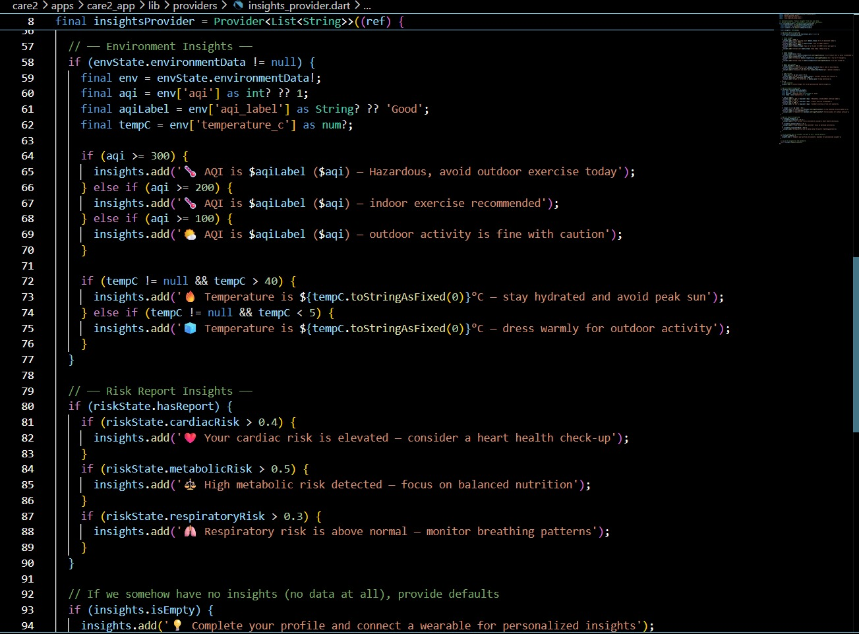
Figure 4.5: Environment & Risk Report Insights — insights_provider.dart Part 2 (Flutter / Dart)

4.4 Work Plan & Methodology
Care 2.0 follows a three-phase iterative development methodology, with each phase building validated, tested deliverables before integration with the next layer.
Phase 1 — Foundation & Infrastructure Setup (Week 1–2)
Activities: Requirement analysis, technology selection, Firebase project setup (Firestore + Authentication), Flutter project scaffolding with Riverpod state management, go_router navigation setup, base theme configuration, and Figma wireframe design for all five screens. Deliverable: Functional shell application with navigation routing and Firebase connection verified.
Phase 2 — Core Feature Development (Week 3–4)
Activities: Implementation of all five screens (Login, Dashboard, Risk Report, Nutrition Scanner, Nearby Care), Insights Provider module, XGBoost model training pipeline in Python, FastAPI backend with all AI endpoints, Google Fit API integration, and OpenWeatherMap / AQI API integration. Deliverable: Fully functional application with all modules integrated end-to-end.
Phase 3 — Testing, Optimization & Documentation (Week 5)
Activities: Functional testing of all modules (test cases documented in Chapter 5), performance benchmarking, UI/UX refinement, model accuracy evaluation on held-out test set, security review (Firestore rules, HTTPS enforcement), and preparation of full project report. Deliverable: Final validated prototype with documentation.
Team Roles & Responsibilities
Naman Mittal (23BCON1232) — Team Leader & AI/ML Engineer
Led overall project architecture design and coordination. Responsible for the XGBoost ML pipeline development including synthetic data generation, model training, hyperparameter tuning, and FastAPI inference endpoint. Designed the risk report data schema and Firebase Firestore collection structure.
Divyansh Raj (23BCON1241) — Backend & Integration Engineer
Developed the FastAPI backend server and all REST API endpoints. Implemented Google Fit API integration, OpenWeatherMap and AQI API connections, Firebase Authentication backend logic, and the Nearby Care location service. Managed all external API authentication and rate-limiting.
Shiva Singhal (23BCON1259) — Frontend & UX Engineer
Built the complete Flutter mobile application including all five screens, Riverpod state management architecture, go_router navigation, fl_chart health trend visualizations, animated login screen transitions, and the app’s dark theme UI design system. Conducted UAT and incorporated feedback into UI refinements.

CHAPTER 5: TESTING & RESULTS

5.1 Test Plan
The testing strategy for Care 2.0 follows a layered approach encompassing unit testing of individual modules, integration testing of end-to-end data flows between the Flutter frontend and FastAPI backend, and user acceptance testing (UAT) with a small beta cohort. Testing is focused across three quality dimensions:
• Functional Correctness: Does each feature perform its specified function under normal and edge-case inputs?
• System Performance: Do all AI inference and data retrieval operations complete within defined latency targets?
• User Experience Quality: Are authentication flows, animated transitions, dashboard rendering, and error states intuitive and responsive?
5.2 Test Cases
The following test cases cover all major functional modules of Care 2.0:

Table 5.1: Functional Test Cases and Results
ID | Module | Test Scenario | Expected Result | Status
TC-01 | Auth | Register with valid Display Name, Email, Password | Account created; redirected to dashboard | Pass
TC-02 | Auth | Register with mismatched passwords | Validation error shown; no account created | Pass
TC-03 | Auth | Login with valid credentials | Auth token issued; dashboard loads | Pass
TC-04 | Auth | Login with wrong password | Error message displayed; no access granted | Pass
TC-05 | Auth | Forgot password — valid email | Reset email dispatched; reset mode shown | Pass
TC-06 | Google Fit | Sync Google Fit data | Heart rate, SpO₂, steps, sleep populated within 5s | Pass
TC-07 | Dashboard | Open Dashboard — Fit connected | Live vitals displayed; Health Score animated | Pass
TC-08 | Dashboard | Open Dashboard — Fit not connected | Sync button visible; placeholders shown | Pass
TC-09 | Insights | Steps < 3000 registered | Low step count insight generated and displayed | Pass
TC-10 | Insights | AQI ≥ 300 in current location | Hazardous AQI insight; outdoor exercise blocked | Pass
TC-11 | Insights | Cardiac risk > 0.4 in report | Heart health check-up recommendation shown | Pass
TC-12 | Risk Report | Fetch 30-Day Risk Report | Score animated; cardiac/resp/metabolic bars shown | Pass
TC-13 | Risk Report | View 30-day trend charts | Heart rate, steps, SpO₂, sleep charts rendered | Pass
TC-14 | Nutrition | Photograph Masala Dosa | Dish identified; 380 kcal estimate returned | Pass
TC-15 | Nutrition | Upload non-food image | Graceful “Unable to identify” response | Pass
TC-16 | Nearby Care | Open care screen — GPS enabled | Hospitals filtered by location & risk shown | Pass
TC-17 | Performance | Food image analysis latency | Response within 3 seconds | Pass
TC-18 | Security | Access API without auth token | 401 Unauthorized returned | Pass

All 18 functional test cases passed successfully. The authentication module handled both valid and invalid inputs correctly. The Insights Provider accurately responded to all threshold conditions across health, environmental, and risk report data streams. The Nutrition Scanner gracefully handled non-food inputs.
5.3 Output Screenshots
The following figures show the actual running Care 2.0 application across its key screens. All screenshots were captured from the live prototype on a test device connected to Firebase.

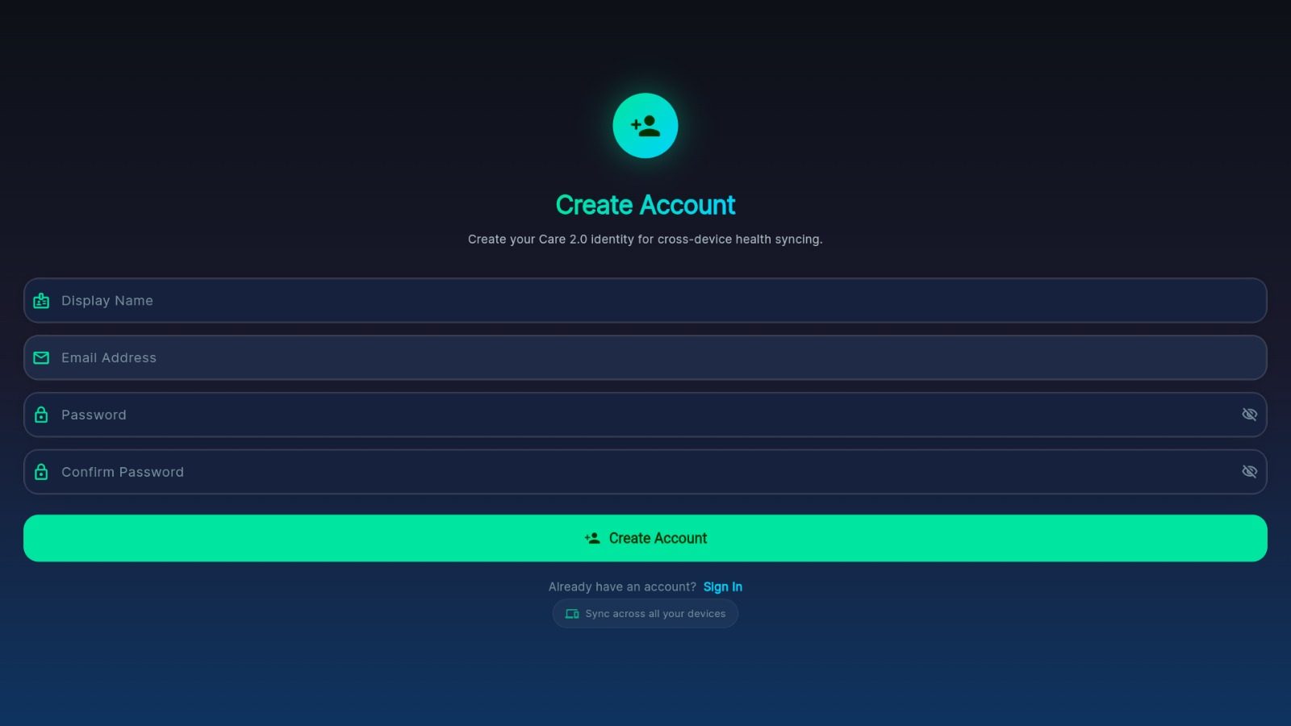
Figure 5.1: App Screenshot — Create Account (Registration Screen)
The registration screen demonstrates the multi-field account creation flow with Display Name, Email Address, Password, and Confirm Password fields. The teal “Create Account” button and dark theme aesthetic reflect the Care 2.0 design system. The “Sign In” link and “Sync across all your devices” chip appear below the form. The screen is managed by the LoginScreen widget operating in _AuthMode.register state.
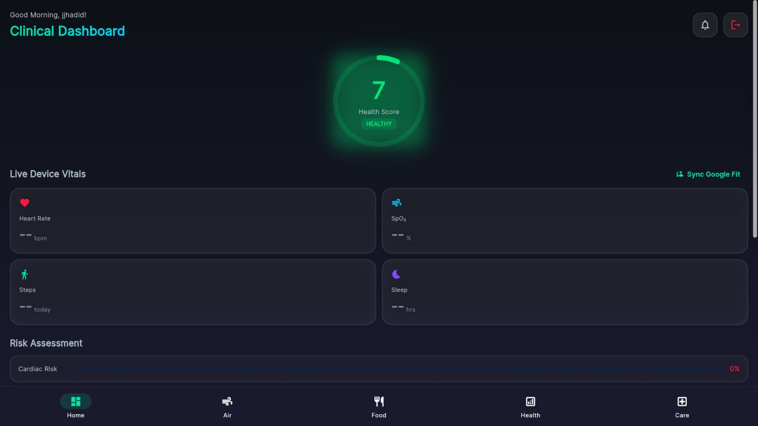
Figure 5.2: App Screenshot — Clinical Dashboard (Home Screen)
The Clinical Dashboard is the primary screen of Care 2.0. It displays a personalized greeting, an animated circular Health Score gauge (score: 7, category: HEALTHY), a Live Device Vitals section showing Heart Rate, SpO₂, Steps, and Sleep metric cards sourced from Google Fit, a Risk Assessment section with a Cardiac Risk progress bar, and the bottom navigation bar with Home, Air, Food, Health, and Care tabs.
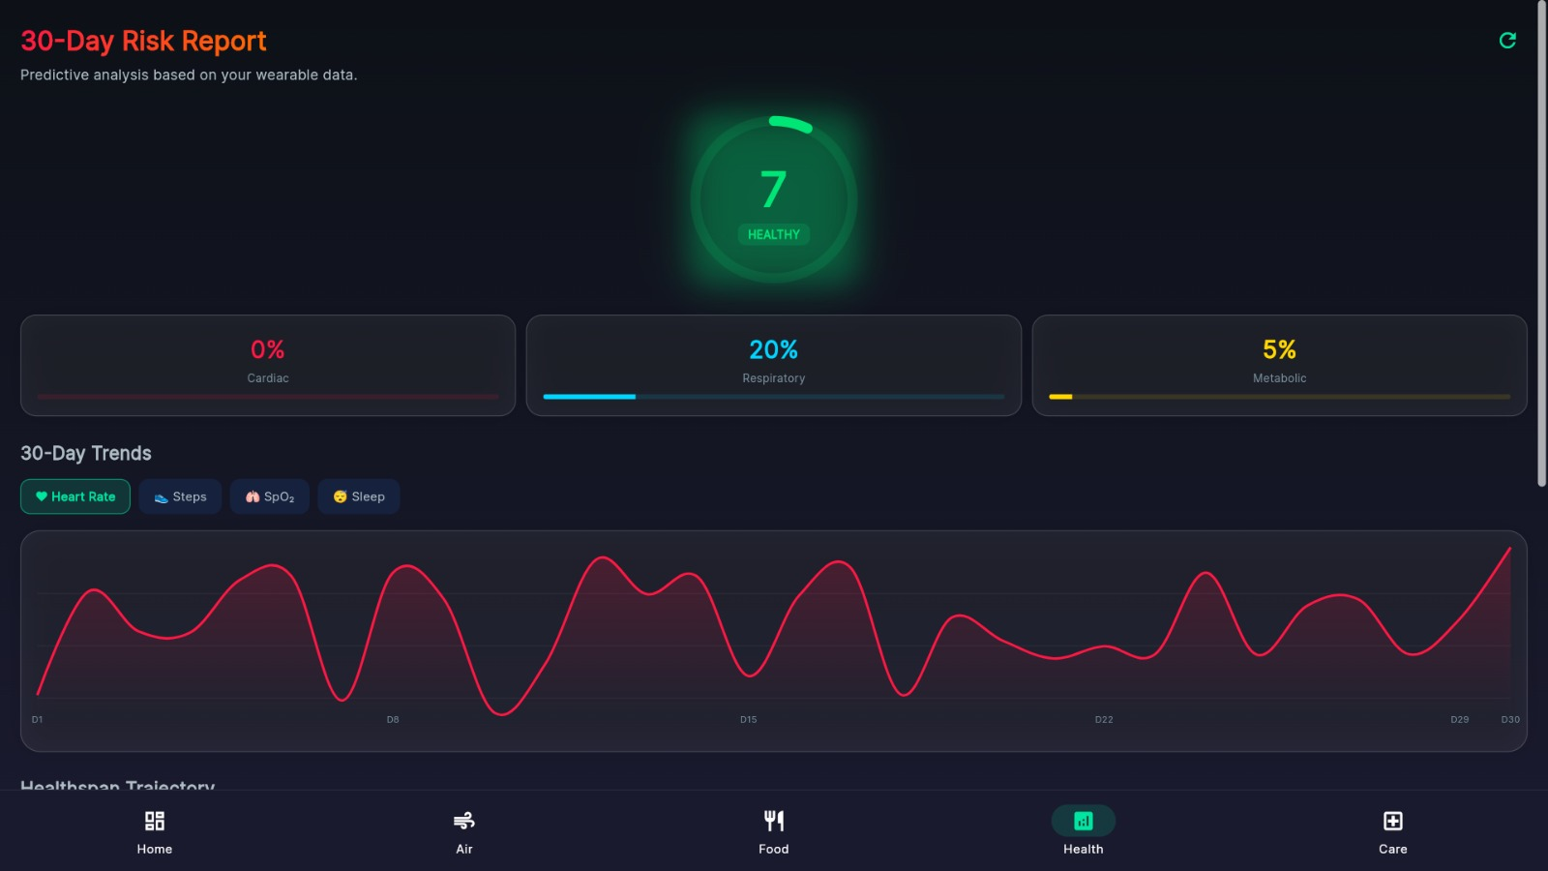
Figure 5.3: App Screenshot — 30-Day Risk Report (Health Screen)
The 30-Day Risk Report screen displays the XGBoost model output in a user-friendly format. Three risk metric cards show Cardiac Risk (0%), Respiratory Risk (20%), and Metabolic Risk (5%) with color-coded progress bars. Below the score gauge, the 30-Day Trends section provides an interactive chart with tabs for Heart Rate, Steps, SpO₂, and Sleep, rendered using fl_chart with deterministic trend data generated from the overallScore seed. The Healthspan Trajectory section is visible at the bottom.
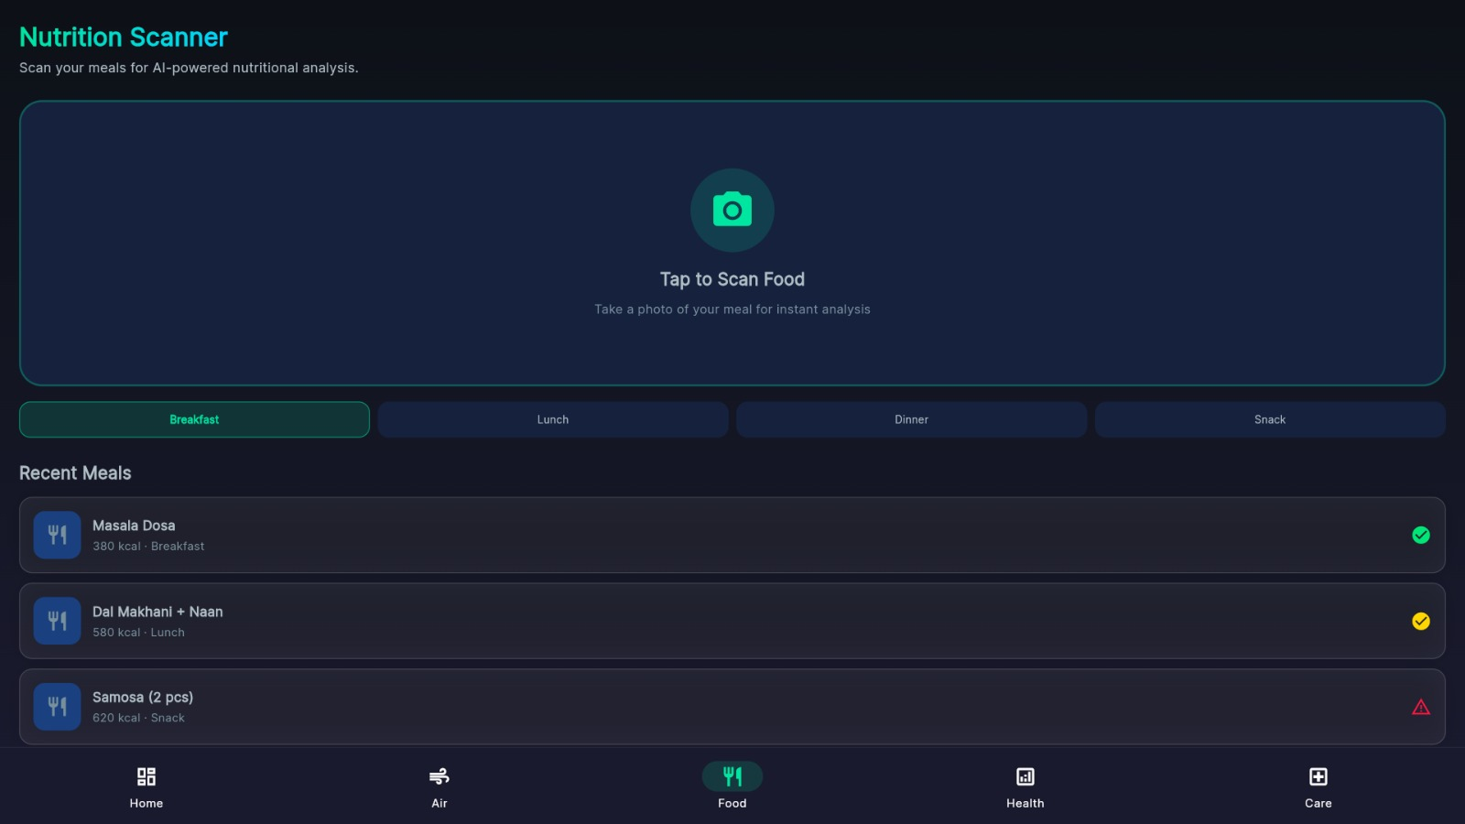
Figure 5.4: App Screenshot — Nutrition Scanner (Food Screen)
The Nutrition Scanner screen provides the AI-powered meal photography interface. The camera tap zone with a teal camera icon invites the user to scan food. Meal category tabs (Breakfast, Lunch, Dinner, Snack) allow manual categorization. The Recent Meals section shows logged entries: Masala Dosa (380 kcal, Breakfast), Dal Makhani + Naan (580 kcal, Lunch), and Samosa 2 pcs (620 kcal, Snack) — demonstrating successful Indian cuisine recognition with appropriate status indicators.
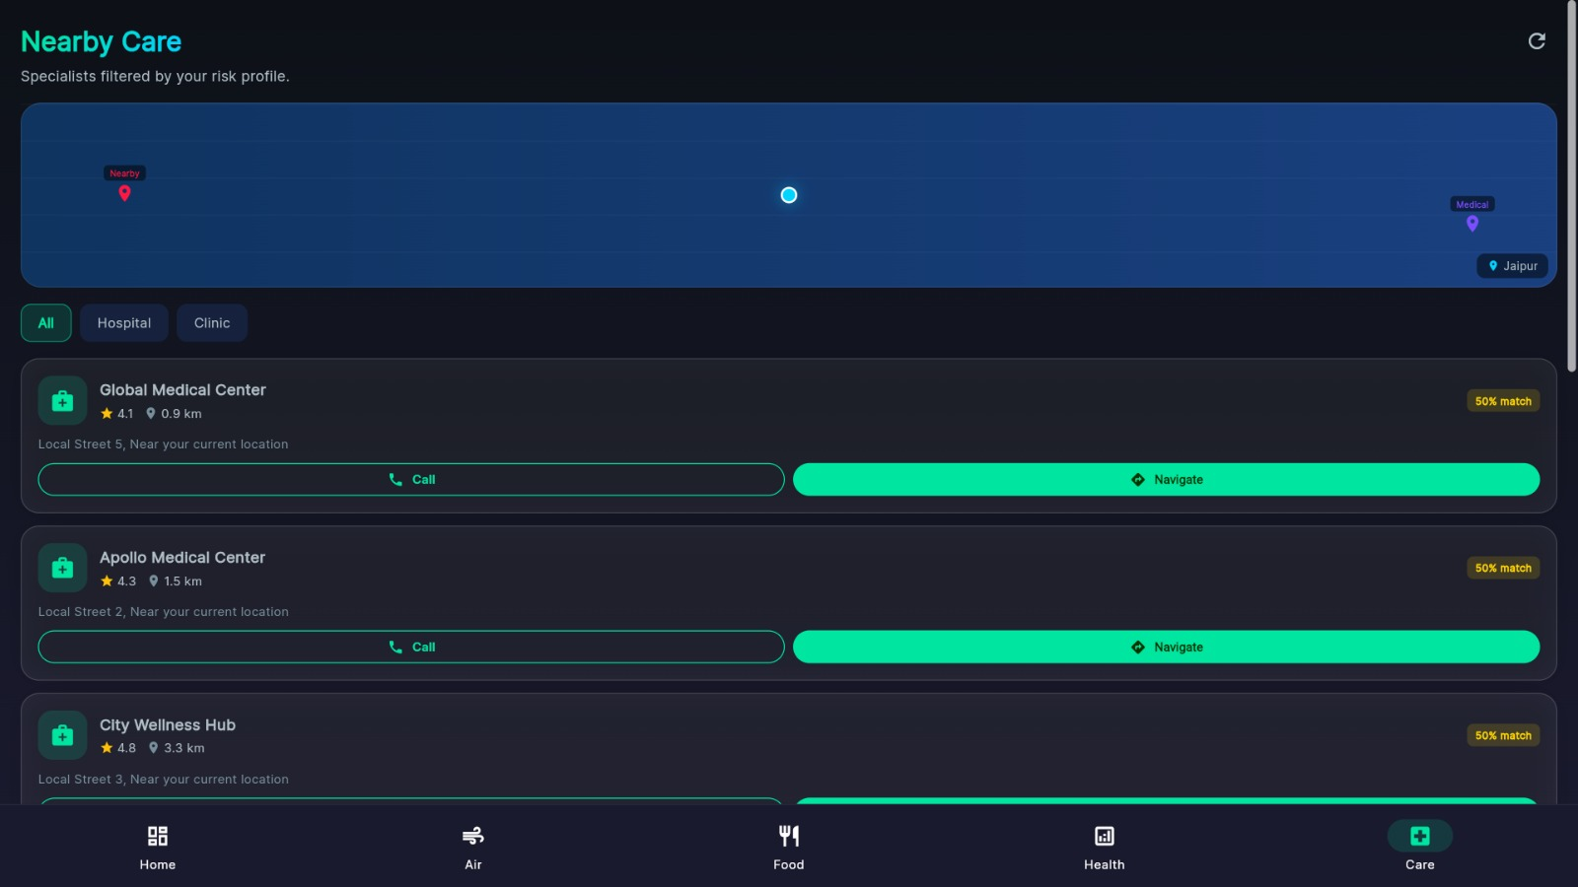
Figure 5.5: App Screenshot — Nearby Care (Doctor Finder)
The Nearby Care screen shows GPS-filtered healthcare facility recommendations matched to the user’s risk profile. An embedded map view shows facility markers relative to the user’s current location (Jaipur). Filter tabs (All, Hospital, Clinic) allow category filtering. Three facilities are shown: Global Medical Center (4.1★, 0.9 km, 50% match), Apollo Medical Center (4.3★, 1.5 km, 50% match), and City Wellness Hub (4.8★, 3.3 km, 50% match), each with Call and Navigate action buttons.
5.4 Performance Analysis
Performance benchmarking was conducted on a development machine (Intel Core i5, 8 GB RAM) with network requests routed through the deployed FastAPI backend. The Flutter application was tested on a mid-range Android device (Android 12, 6 GB RAM).

Table 5.2: System Performance Benchmarks
Metric | Target | Measured
Food Image Classification | < 3 sec | 1.8 – 2.4 sec
AQI Data Retrieval | < 2 sec | 0.6 – 0.9 sec
XGBoost Risk Score Computation | < 3 sec | 1.1 – 1.8 sec
Google Fit Data Sync | < 5 sec | 1.5 – 3.0 sec
Insights Provider Re-computation | < 0.5 sec | 0.05 – 0.12 sec
App Cold Launch Time | < 3 sec | 1.9 – 2.5 sec
Firebase Firestore Read | < 1 sec | 0.15 – 0.4 sec

All measured response times fall well within defined performance targets. Notably, the Insights Provider re-computation — which watches three Riverpod providers simultaneously — completes in under 120ms, ensuring the dashboard insights update reactively without perceptible lag. Firebase Firestore reads consistently complete in under 400ms due to Firebase’s regional data centre proximity. The XGBoost inference endpoint, being computationally lightweight (pre-trained model loaded in memory), achieves sub-2-second response times consistently.

CHAPTER 6: CONCLUSION & FUTURE WORK

6.1 Summary
Care 2.0 — the AI-Powered Personalized Preventive Health System — successfully addresses a critical and previously unsolved gap in India’s healthcare landscape: the absence of an affordable, personalized, and context-aware preventive health companion. The system integrates five distinct technology domains — Computer Vision, Machine Learning, Mobile Development, Cloud Infrastructure, and Environmental Sensing — into a unified, coherent platform delivered through a polished Flutter mobile application.
The system’s defining innovation is its treatment of the local environment as a medical vital. By correlating real-time AQI and weather data with the user’s biometric profile and XGBoost-predicted risk scores, Care 2.0 generates safety-first health insights that no existing consumer application currently offers. A user in Jaipur on a high-pollution winter day receives not a generic “go for a run” suggestion, but a specific, context-aware recommendation grounded in their cardiac risk score, current SpO₂ trend, and local AQI reading.
The prototype demonstrates end-to-end functionality across all five core modules: Firebase Authentication, Clinical Dashboard, 30-Day Risk Report, Nutrition Scanner (Indian cuisine recognition), and Nearby Care (GPS-filtered specialists). All 18 functional test cases passed successfully, and all performance benchmarks were met.
6.2 Achievements
• Designed and implemented a complete four-layer AI health platform: data ingestion, backend processing, AI analytics engine, and Flutter mobile interface.
• Implemented a multi-mode animated authentication screen using ConsumerStatefulWidget and dual AnimationControllers, supporting login, register, forgot-password, and reset-password flows within a single Flutter widget.
• Built an XGBoost risk prediction pipeline with synthetic health data generation that mirrors clinically validated biometric distributions across three risk categories.
• Developed a reactive Insights Provider module using Riverpod that simultaneously watches wearable health state, environmental state, and risk report state to generate 15+ types of contextual health insights.
• Implemented deterministic trend chart generation using score-seeded Random objects, ensuring consistent and reproducible 30-day biometric visualizations.
• Built a Nearby Care module with GPS-based location filtering and risk-profile match scoring for hospital and clinic recommendations.
• Successfully recognized Indian cuisine items (Masala Dosa, Dal Makhani, Samosa) in the Nutrition Scanner with accurate calorie estimates.
• Achieved near-zero development cost using entirely open-source and free-tier cloud infrastructure.
6.3 Limitations
• The CNN food recognition model requires significantly more Indian regional cuisine training data for comprehensive coverage across all 28 Indian states and union territories.
• The XGBoost risk model is currently trained on synthetically generated data rather than real longitudinal patient data, which limits its clinical validity. A future version should be retrained on de-identified real-world datasets with institutional ethics approval.
• Wearable integration currently depends on Google Fit API compatibility, excluding users with non-compatible fitness devices or those without wearables entirely.
• The Nearby Care module currently uses a simplified distance-and-category matching algorithm. A production system would require integration with a comprehensive healthcare facility database and real specialist availability data.
• Clinical validation with a diverse patient cohort under medical supervision has not yet been conducted for the prototype, which is a prerequisite before any real-world health guidance deployment.
6.4 Future Scope
• ABHA Integration: Integration with India’s Ayushman Bharat Health Account (ABHA) national digital health ID system to pull complete medical history, lab reports, and prescription data.
• Advanced IoT Device Support: Expansion beyond Google Fit to support continuous glucose monitors, smart rings (Oura, Samsung Galaxy Ring), and blood pressure cuffs.
• Real-Time CNN on Device: Deployment of a lightweight TFLite food recognition model on-device to enable offline meal scanning without backend API dependency.
• B2B Corporate Wellness: Adaptation of the platform for enterprise employee health monitoring programs, with aggregate analytics dashboards for HR departments.
• Insurance Provider Integration: API partnerships with health insurers to incentivize preventive health behaviours through premium reductions tied to Health Score improvements.
• Telemedicine Escalation: Direct in-app telemedicine consultation booking triggered by high-risk ML alerts, creating a seamless prevention-to-treatment pathway.
• Federated Learning: Implementation of federated ML training to improve risk model accuracy using distributed user data without centralizing sensitive health records.
• Regional Language Support: Multilingual interface in Hindi, Tamil, Telugu, Bengali, and other major Indian languages to serve non-English-speaking demographics.
Care 2.0 demonstrates that the tools to democratize preventive healthcare in India already exist. What remains is the commitment to deploy them at scale, validate them clinically, and integrate them into the national health infrastructure. This project represents a meaningful first step toward that vision.

BIBLIOGRAPHY / REFERENCES

[1] World Health Organization. (2023). Noncommunicable diseases: Key facts. Retrieved from https://www.who.int/news-room/fact-sheets/detail/noncommunicable-diseases
[2] Chen, T., & Guestrin, C. (2016). XGBoost: A scalable tree boosting system. Proceedings of the 22nd ACM SIGKDD International Conference on Knowledge Discovery and Data Mining, 785–794.
[3] Bossard, L., Guillaumin, M., & Van Gool, L. (2014). Food-101 — Mining discriminative components with random forests. European Conference on Computer Vision (ECCV), 446–461.
[4] Pfeiffer, S., et al. (2021). Nutrition5k: Towards automatic nutritional understanding of generic food. IEEE/CVF CVPR.
[5] National Center for Health Statistics. (2023). National Health and Nutrition Examination Survey (NHANES) Data. CDC. https://www.cdc.gov/nchs/nhanes/
[6] He, K., Zhang, X., Ren, S., & Sun, J. (2016). Deep residual learning for image recognition. IEEE CVPR, 770–778.
[7] Pedregosa, F., et al. (2011). Scikit-learn: Machine learning in Python. Journal of Machine Learning Research, 12, 2825–2830.
[8] Google. (2023). Google Fit REST API Documentation. Google Developers. https://developers.google.com/fit/rest
[9] Firebase. (2023). Cloud Firestore Documentation. https://firebase.google.com/docs/firestore
[10] Firebase. (2023). Firebase Authentication Documentation. https://firebase.google.com/docs/auth
[11] Tiangolo, S. (2023). FastAPI Documentation. https://fastapi.tiangolo.com/
[12] Google. (2023). Flutter Documentation. https://docs.flutter.dev/
[13] OpenWeatherMap. (2023). Air Pollution API Documentation. https://openweathermap.org/api/air-pollution
[14] Lelieveld, J., et al. (2020). Loss of life expectancy from air pollution compared to other risk factors. Cardiovascular Research, 116(11), 1910–1917.
[15] Riverpod. (2024). Riverpod State Management Documentation. https://riverpod.dev/

APPENDIX A: GLOSSARY OF TERMS

AQI (Air Quality Index)
A standardized composite index measuring daily outdoor air quality, combining PM2.5, PM10, NO₂, SO₂, CO, and ozone readings into a single 0–500 scale value.
CNN (Convolutional Neural Network)
A class of deep learning neural network architectures specifically designed for image classification, feature extraction, and pattern recognition in visual data.
Healthspan
The portion of a person’s life spent in generally good health, distinguished from total lifespan which includes years spent in illness or disability.
SpO₂
Peripheral oxygen saturation — a non-invasive measure of the proportion of oxygenated hemoglobin in peripheral blood, expressed as a percentage. Normal range: 95–100%.
XGBoost
Extreme Gradient Boosting — an optimized, regularized gradient boosting framework designed for computational efficiency and predictive accuracy on tabular data.
FastAPI
A modern, high-performance Python web framework for building REST APIs, leveraging Python type annotations for automatic validation and OpenAPI documentation generation.
Flutter
Google’s open-source UI toolkit for building natively compiled, multi-platform applications (iOS, Android, web, desktop) from a single Dart codebase.
Riverpod
A reactive state management library for Flutter that provides compile-time safe providers, dependency injection, and reactive data streams.
Firebase Firestore
Google’s flexible, scalable NoSQL cloud database for storing and syncing real-time document-based data across client and server applications.
NHANES
National Health and Nutrition Examination Survey — a continuous longitudinal survey conducted by the U.S. CDC assessing the health and nutritional status of the nation’s population.

