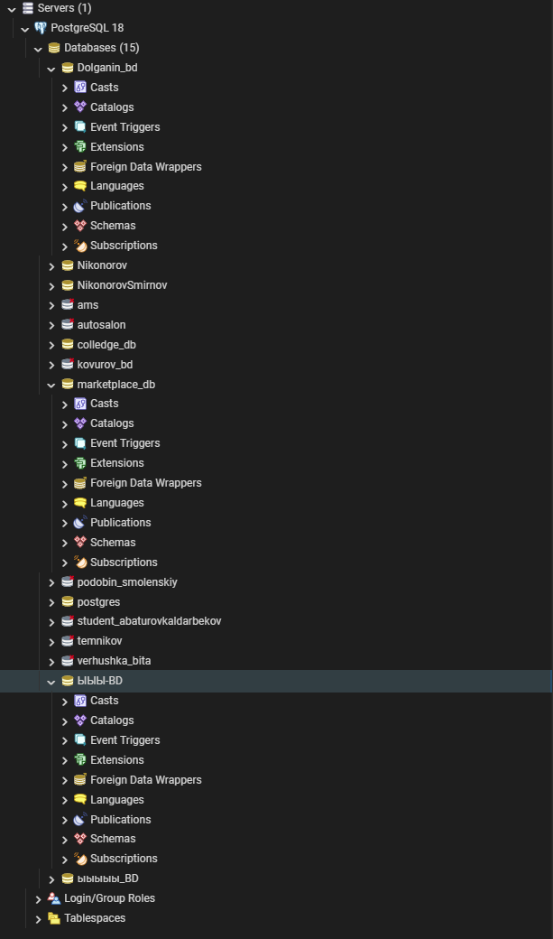
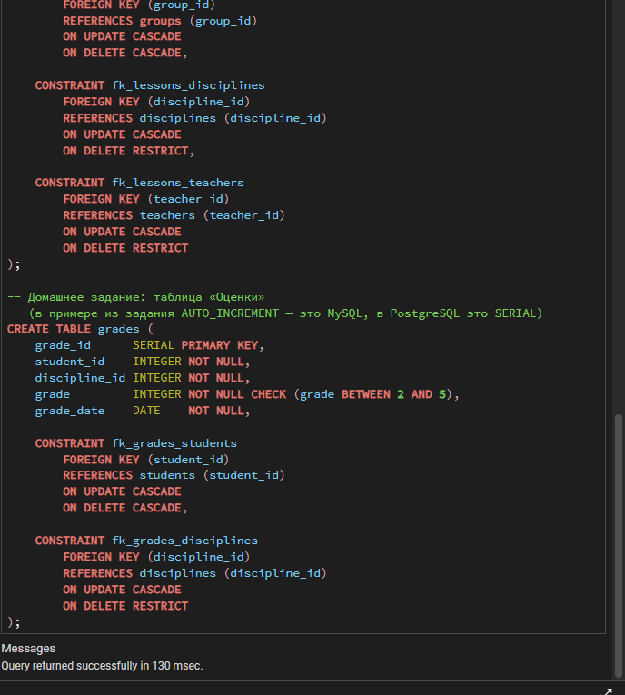
Код:
DROP TABLE IF EXISTS grades CASCADE;
DROP TABLE IF EXISTS lessons CASCADE;
DROP TABLE IF EXISTS students CASCADE;
DROP TABLE IF EXISTS disciplines CASCADE;
DROP TABLE IF EXISTS teachers CASCADE;
DROP TABLE IF EXISTS groups CASCADE;

CREATE TABLE groups (
group_id SERIAL PRIMARY KEY,
group_name VARCHAR(20) NOT NULL UNIQUE,
specialty VARCHAR(100) NOT NULL,
admission_year INTEGER NOT NULL
CHECK (admission_year BETWEEN 2000 AND 2100)
);

CREATE TABLE students (
student_id SERIAL PRIMARY KEY,
last_name VARCHAR(50) NOT NULL,
first_name VARCHAR(50) NOT NULL,
middle_name VARCHAR(50), -- NULL разрешён
birth_date DATE NOT NULL,
group_id INTEGER NOT NULL,

CONSTRAINT fk_students_groups
FOREIGN KEY (group_id)
REFERENCES groups (group_id)
ON UPDATE CASCADE
ON DELETE CASCADE
);

CREATE TABLE teachers (
teacher_id SERIAL PRIMARY KEY,
last_name VARCHAR(50) NOT NULL,
first_name VARCHAR(50) NOT NULL,
department VARCHAR(100) NOT NULL
);

CREATE TABLE disciplines (
discipline_id SERIAL PRIMARY KEY,
discipline_name VARCHAR(100) NOT NULL UNIQUE,
hours INTEGER NOT NULL CHECK (hours > 0)
);

CREATE TABLE lessons (
lesson_id SERIAL PRIMARY KEY,
group_id INTEGER NOT NULL,
discipline_id INTEGER NOT NULL,
teacher_id INTEGER NOT NULL,
lesson_date DATE NOT NULL,
lesson_type VARCHAR(30) NOT NULL,

CONSTRAINT fk_lessons_groups
FOREIGN KEY (group_id)
REFERENCES groups (group_id)
ON UPDATE CASCADE
ON DELETE CASCADE,

CONSTRAINT fk_lessons_disciplines
FOREIGN KEY (discipline_id)
REFERENCES disciplines (discipline_id)
ON UPDATE CASCADE
ON DELETE RESTRICT,

CONSTRAINT fk_lessons_teachers
FOREIGN KEY (teacher_id)
REFERENCES teachers (teacher_id)
ON UPDATE CASCADE
ON DELETE RESTRICT
);

CREATE TABLE grades (
grade_id SERIAL PRIMARY KEY,
student_id INTEGER NOT NULL,
discipline_id INTEGER NOT NULL,
grade INTEGER NOT NULL CHECK (grade BETWEEN 2 AND 5),
grade_date DATE NOT NULL,

CONSTRAINT fk_grades_students
FOREIGN KEY (student_id)
REFERENCES students (student_id)
ON UPDATE CASCADE
ON DELETE CASCADE,

CONSTRAINT fk_grades_disciplines
FOREIGN KEY (discipline_id)
REFERENCES disciplines (discipline_id)
ON UPDATE CASCADE
ON DELETE RESTRICT
);
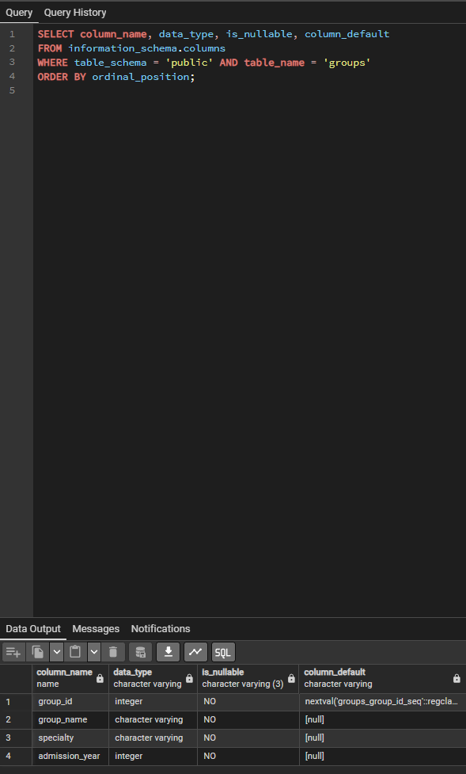
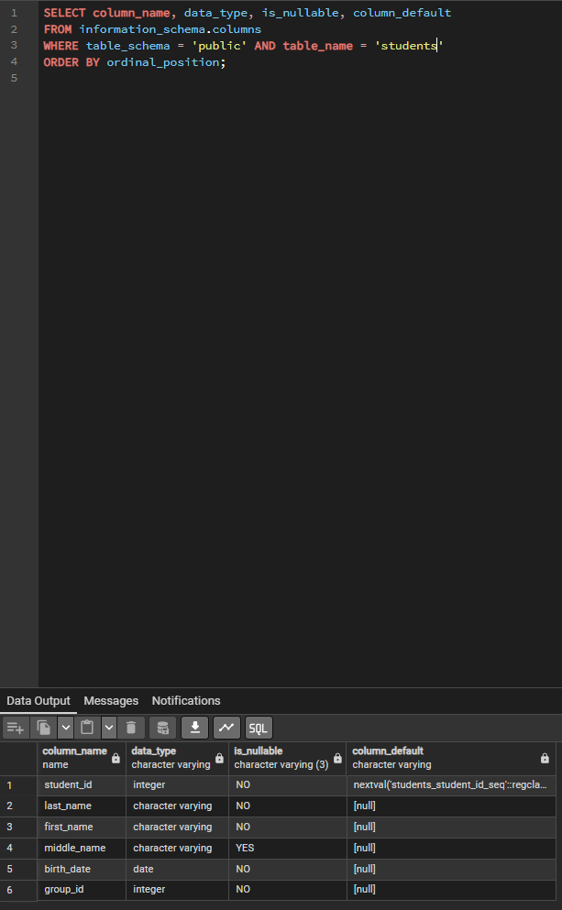
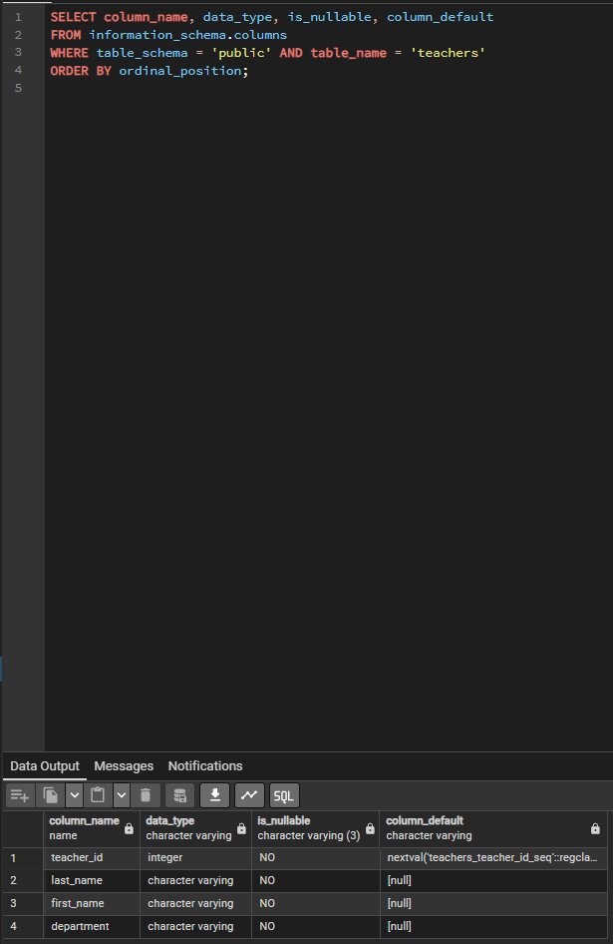
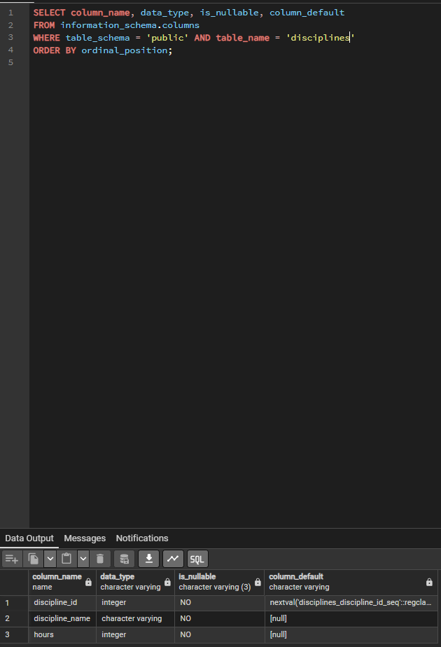
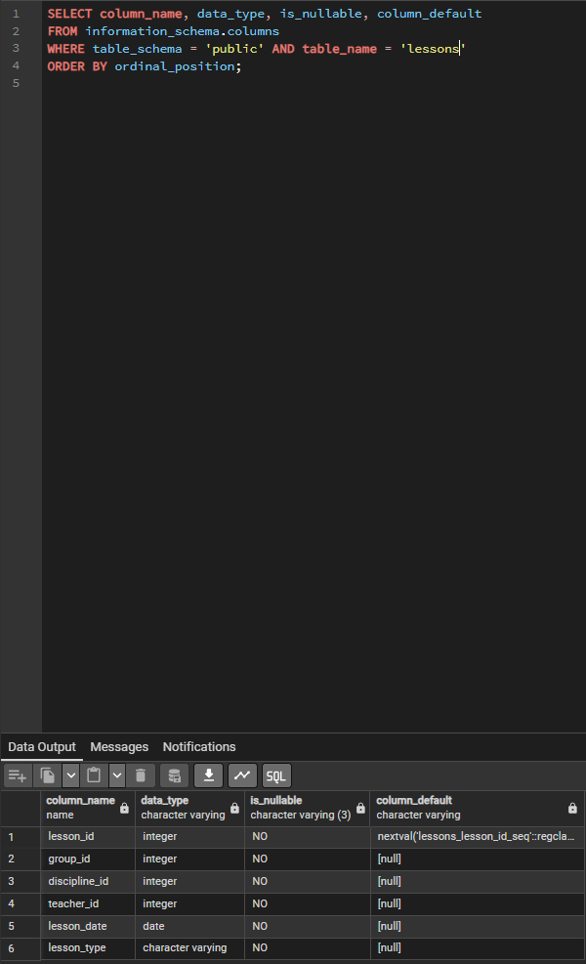
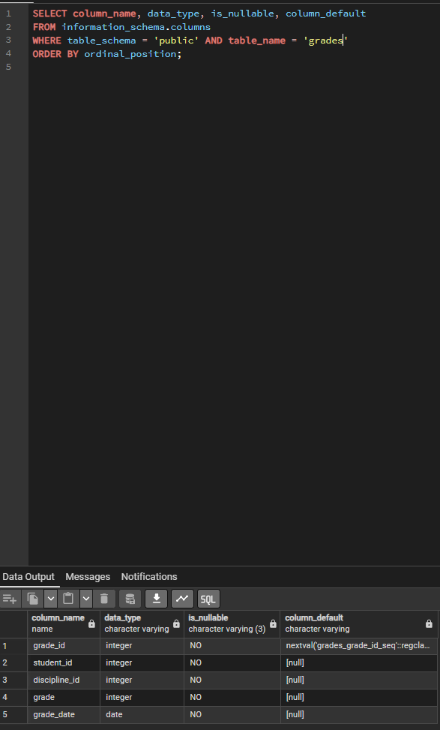
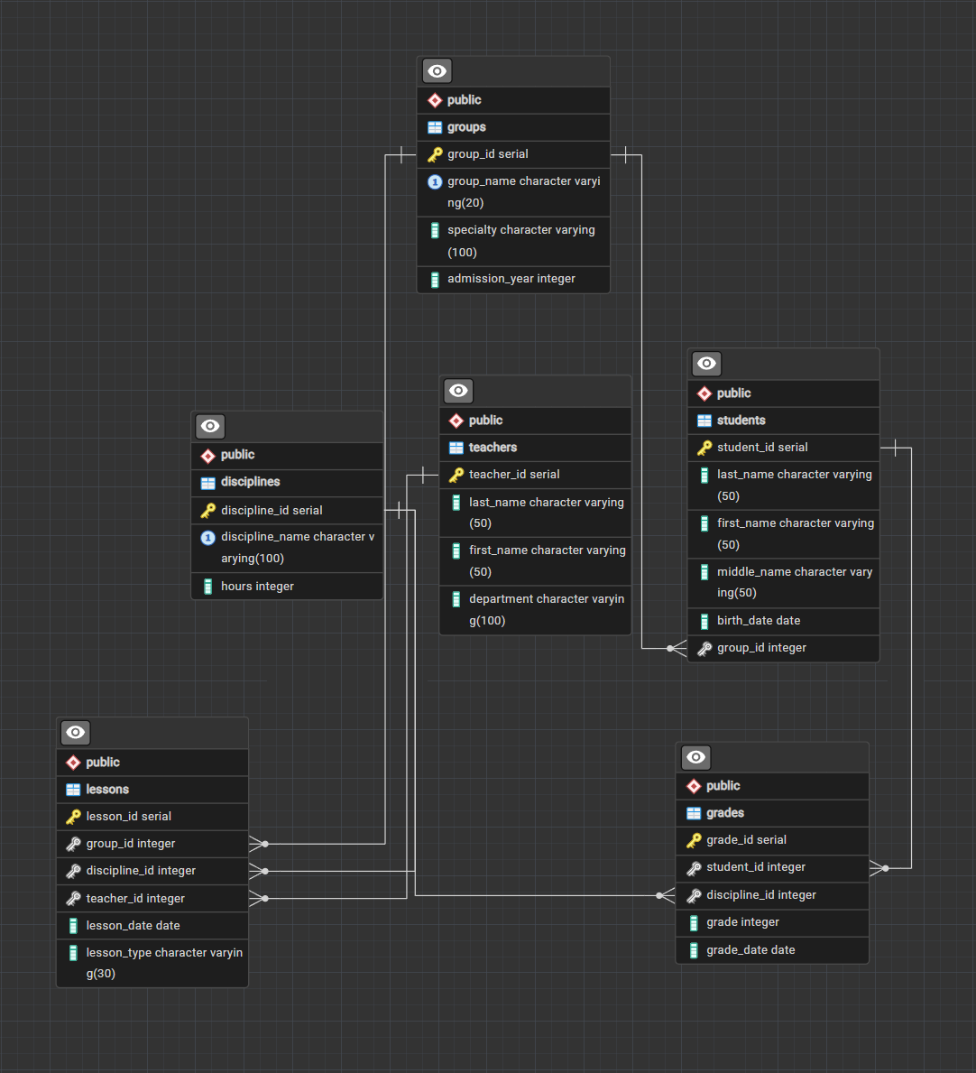
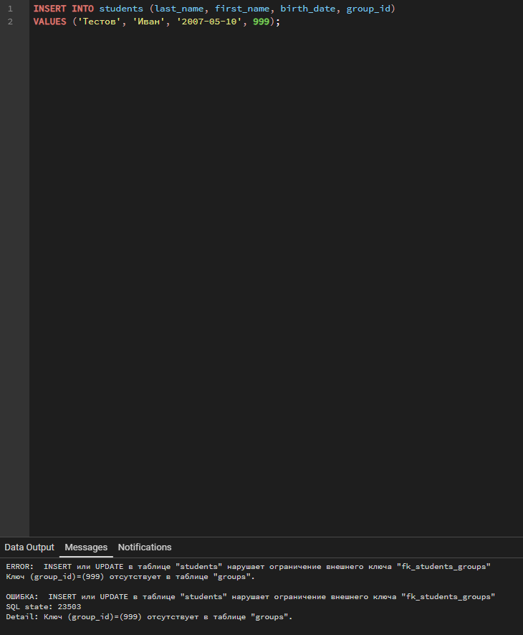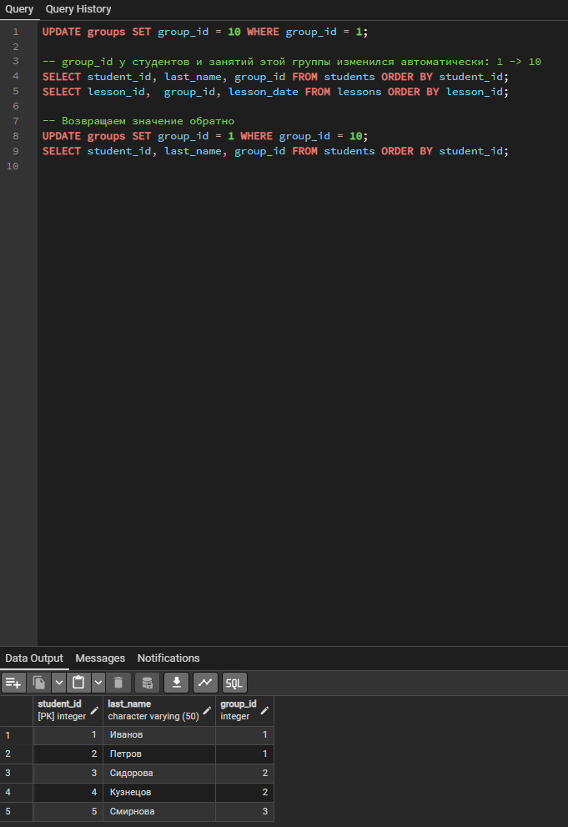
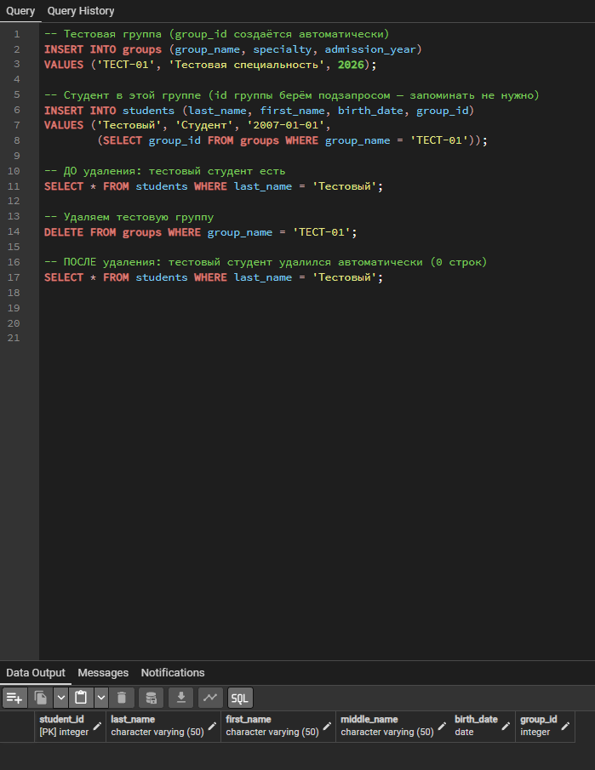
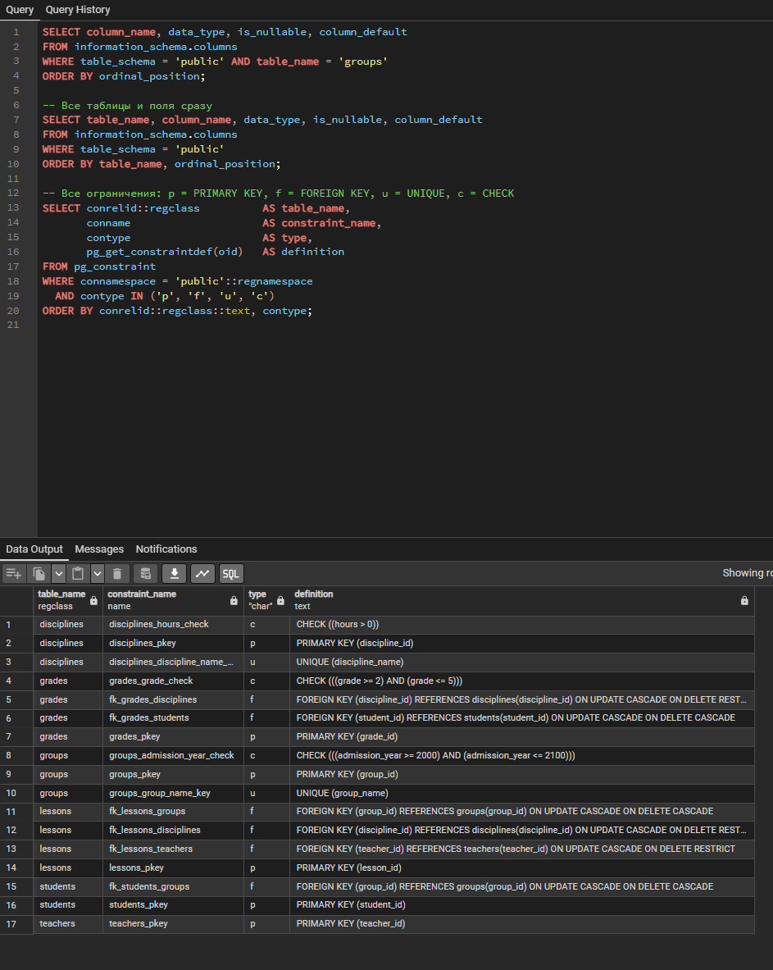
1. Первичные ключи: groups.group_id, students.student_id,
-- teachers.teacher_id, disciplines.discipline_id,
-- lessons.lesson_id, grades.grade_id.
-- 2. Внешние ключи: students.group_id -> groups;
-- lessons.group_id -> groups; lessons.discipline_id -> disciplines;
-- lessons.teacher_id -> teachers; grades.student_id -> students;
-- grades.discipline_id -> disciplines.
-- 3. Автоинкремент (SERIAL; в MySQL это AUTO_INCREMENT) — во всех
-- первичных ключах: group_id, student_id, teacher_id,
-- discipline_id, lesson_id, grade_id.
-- 4. NOT NULL: почти все поля; НЕ используется только в
-- students.middle_name (отчество может отсутствовать).
-- 5. UNIQUE: groups.group_name, disciplines.discipline_name.
-- 6. CHECK: disciplines.hours > 0; grades.grade от 2 до 5;
-- groups.admission_year от 2000 до 2100.
-- 7. Связи (1:N): groups—students, groups—lessons,
-- disciplines—lessons, teachers—lessons,
-- students—grades, disciplines—grades.
--
-- СХЕМА ДАННЫХ: в pgAdmin ПКМ по базе college_db -> «Generate ERD».
-- Связи нарисуются сами по внешним ключам (рисовать их руками не надо).
-- Нужные связи: ГРУППЫ 1:N СТУДЕНТЫ; ГРУППЫ 1:N ЗАНЯТИЯ;
-- ДИСЦИПЛИНЫ 1:N ЗАНЯТИЯ; ПРЕПОДАВАТЕЛИ 1:N ЗАНЯТИЯ.

